UNITED STATES
SECURITIES AND EXCHANGE COMMISSION
WASHINGTON, D.C. 20549
________________________
FORM 10-Q
________________________
(Mark One)
x |  |  | QUARTERLY REPORT PURSUANT TO SECTION 13 OR 15(d) OF THE SECURITIES EXCHANGE ACT OF 1934
For the quarterly period ended March 31, 2026
or
o |  |  | TRANSITION REPORT PURSUANT TO SECTION 13 OR 15(d) OF THE SECURITIES EXCHANGE ACT OF 1934
For the transition period from ___________________ to ___________________
Commission File Number: 001-41072
________________________
IREN Limited
(Exact name of registrant as specified in its charter)
________________________
Australia |  |  | [Not Applicable]
(State or other jurisdiction of  incorporation or organization) |  |  | (I.R.S. Employer  Identification No.)
Level 5, 55 Market Street  Sydney, NSW 2000 Australia |  |  | 2000
(Address of principal executive offices) |  |  | (Zip Code)
+61 2 7906 8301
(Registrant’s telephone number, including area code)
________________________
Securities registered pursuant to Section 12(b) of the Act:
Title of each class |  |  | Trading Symbol(s) |  |  | Name of each exchange on which registered
Ordinary shares, no par value |  |  | IREN |  |  | The Nasdaq Global Select Market
Securities registered pursuant to Section 12(g) of the Act: None
Indicate by check mark whether the registrant: (1) has filed all reports required to be filed by Section 13 or 15(d) of the Securities Exchange Act of 1934 during the preceding 12 months (or for such shorter period that the registrant was required to file such reports); and (2) has been subject to such filing requirements for the past 90 days. Yes x No o
Indicate by check mark whether the registrant has submitted electronically every Interactive Data File required to be submitted pursuant to Rule 405 of Regulation S-T (§232.405 of this chapter) during the preceding 12 months (or for such shorter period that the registrant was required to submit such files). Yes x No o
Indicate by check mark whether the registrant is a large accelerated filer, an accelerated filer, a non-accelerated filer, a smaller reporting company, or an emerging growth company. See the definitions of “large accelerated filer,” “accelerated filer,” “smaller reporting company,” and “emerging growth company” in Rule 12b-2 of the Exchange Act.

Large accelerated filer |  |  | x |  |  | Accelerated filer |  |  | o
Non-accelerated filer |  |  | o |  |  | Smaller reporting company |  |  | o
 |  |  |  |  |  | Emerging growth company |  |  | o
If an emerging growth company, indicate by check mark if the registrant has elected not to use the extended transition period for complying with any new or revised financial accounting standards provided pursuant to Section 13(a) of the Exchange Act. o
Indicate by check mark whether the registrant is a shell company (as defined in Rule 12b-2 of the Act). Yes o No x
As of April 30, 2026, the registrant had 357,378,674 of its Ordinary shares outstanding.

TABLE OF CONTENTS
 |  |  | Page
Part I - Financial Information
Item 1. Financial Statements |  |  | 9
Item 2. Management's Discussion and Analysis of Financial Condition and Results of Operations |  |  | 44
Item 3. Quantitative and Qualitative Disclosures About Market Risk |  |  | 60
Item 4. Controls and Procedures |  |  | 60
Part II - Other Information
Item 1. Legal Proceedings |  |  | 62
Item 1A. Risk Factors |  |  | 62
Item 2. Unregistered Sales of Equity Securities and Use of Proceeds |  |  | 62
Item 3. Defaults Upon Senior Securities |  |  | 63
Item 4. Mine Safety Disclosures |  |  | 63
Item 5. Other Information |  |  | 63
Item 6. Exhibits |  |  | 65
Signatures |  |  | 67

CAUTIONARY NOTE REGARDING FORWARD-LOOKING STATEMENTS
This Quarterly Report on Form 10-Q (this “Quarterly Report”) contains forward-looking statements within the meaning of Section 27A of the Securities Act of 1933, as amended (“Securities Act”), and Section 21E of the Securities Exchange Act of 1934, as amended (“Exchange Act”), that involve substantial risks and uncertainties. Forward-looking statements include information concerning possible or assumed future results of operations, including descriptions of our business plan and strategies and trends we expect to affect our business. These statements often include words such as “anticipate,” “expect,” “suggest,” “plan,” “believe,” “intend,” “estimate,” “target,” “project,” “should,” “potential,” “could,” “would,” “may,” “will,” “forecast,” and other similar expressions. Forward-looking statements may also be made, verbally or in writing, by members of our Board or management team in connection with this Quarterly Report. Such statements are subject to the same limitations, uncertainties, assumptions and disclaimers set out in this document. We base these forward-looking statements or projections on our current expectations, plans and assumptions that we have made in light of our experience in the industry, as well as our perceptions of historical trends, current conditions, expected future developments and other factors we believe are appropriate under the circumstances and at such time. The forward-looking statements are subject to and involve risks, uncertainties and assumptions and you should not place undue reliance on these forward-looking statements. Although we believe that these forward-looking statements are based on reasonable assumptions at the time they are made, you should be aware that many factors could affect our actual financial results or results of operations, and could cause actual results to differ materially from those expressed in the forward-looking statements. Factors that may materially affect such forward-looking statements include, but are not limited to:
•our ability to obtain additional capital on commercially reasonable terms and in a timely manner to meet our capital needs and facilitate our expansion plans;
•the amount and terms of any future financing or grant of security, or any refinancing, restructuring or modification to the terms of any existing or future financing or grant of security, which could require us to comply with onerous covenants, restrictions or guarantees, and our ability to service our debt obligations;
•our ability to successfully execute on our growth strategies and operating plans, including our ability to continue to develop our existing data center sites, design and deploy direct-to-chip liquid cooling systems, provide software, and operate and expand our high-performance computing (“HPC”) business (including our AI Cloud Services business and, potentially, colocation services such as powered shell, build-to-suit and turnkey data centers (“Colocation Services”) (collectively “HPC and AI services”));
2

•our limited experience with respect to new markets and geographies we have entered or may seek to enter, including the market for HPC and AI services, the expansion of our capabilities to include software offerings, and our expansion into new geographies for data centers such as Australia and Europe;
•our ability to remain competitive in dynamic and rapidly evolving industries;
•expectations with respect to the useful life and obsolescence of hardware (including GPUs, hardware for Bitcoin mining and any current or future HPC and AI services we offer) and the related impairment charges we may incur upon retirement thereof, which could be material;
•ability to, and costs associated with, re-purpose data centers historically used for Bitcoin mining for use in any current or future HPC and AI services, along with the related impairment charges we may incur upon retirement of existing Bitcoin mining hardware, which could be material;
•delays, increases in costs or reductions in the supply of equipment used in our operations including as a result of tariffs and duties, and certain equipment (including GPUs and any other hardware for any current or future HPC and AI services we offer) being in high demand due to global supply chain constraints, and our ability to secure additional hardware (including GPUs and any other hardware for any current or future HPC and AI services we offer), on commercially reasonable terms or at all;
•expectations with respect to the profitability, viability, operability, security, popularity and public perceptions of any current and future HPC and AI services we offer, including GPU rental rates;
•our ability to secure and retain customers on commercially reasonable terms or at all, particularly as it relates to our strategy to expand our AI Cloud Services business and potentially diversify into markets for other HPC and AI services;
•our ability to establish and maintain a customer base for our HPC and AI services business and customer concentration;
•our ability to manage counterparty risk (including credit risk) associated with any current or future customers, including customers of our HPC and AI services and other counterparties;
•the risk that any current or future customers, including customers of our HPC and AI services or other counterparties, may terminate, default on or underperform their contractual obligations;
•our ability to perform under, and observe our obligations pursuant to, service level agreements and other contractual obligations with counterparties, including customers of our HPC and AI services;
•changing political and geopolitical conditions, including changing international trade policies and the implementation of wide-ranging, reciprocal and retaliatory tariffs, surtaxes and other similar import or export duties, or trade restrictions;
•Bitcoin price, Bitcoin global hashrate and foreign currency exchange rate fluctuations;
•expectations with respect to the ongoing profitability, viability, operability, security, popularity and public perceptions of the Bitcoin network;
•our ability to secure renewable energy, renewable energy certificates, power capacity, timely grid connections, facilities and sites on commercially reasonable terms or at all;
•delays and costs associated with, or failure to obtain or complete, permitting approvals, grid connections and other development activities customary for greenfield or brownfield infrastructure projects in various jurisdictions, including as a result of the Electric Reliability Council of Texas’s (“ERCOT”) announced amendments to the approval process for large load interconnection requests;
•our reliance on power, network and utilities providers, third party mining pools, exchanges, banks, insurance providers and our ability to maintain relationships with such parties;
3

•expectations regarding availability and pricing of electricity;
•our participation and ability to successfully participate in demand response products and services and other load management programs run, operated or offered by electricity network operators, regulators or electricity market operators;
•the availability, reliability and/or cost of electricity supply, hardware and electrical and data center infrastructure, including with respect to any electricity outages and any laws and regulations that may restrict the electricity supply available to us;
•any variance between the actual operating performance of our miner hardware achieved compared to the nameplate performance including hashrate;
•electricity market risks relating to changes in laws, regulations and requirements of market operators, network operators and/or regulatory bodies in the jurisdictions in which we operate, including with respect to interconnection of facilities of large electrical loads to the ERCOT grid (for example, via a process that may batch multiple large load interconnection requests), grid stability, voltage ride-through, frequency ride-through and curtailment obligations;
•heightened complexity and additional constraints in energy markets, including international energy markets with which we are less familiar, including load ramp requirements by utilities or grid operators which may not align with our planned data center development and commissioning timelines;
•our ability to curtail our electricity consumption and/or monetize electricity depending on market conditions, including changes in Bitcoin mining economics and prevailing electricity prices;
•actions undertaken or inaction by electricity network and market operators, regulators, governments or communities in the regions in which we operate, including such actions that could result in the estimated power availability at secured sites being materially less than initially expected, available too late, delayed, conditioned upon technical or operational requirements or not available in each case whether at sustainable cost or at all;
•our ability to secure connection agreements to access power sources and permits or to maintain in good standing the operating and other permits, approvals and/or licenses required for our operations, construction activities and business which could be delayed by regulatory approval processes, may not be successful or may be cost prohibitive;
•the availability, suitability, reliability and cost of internet connections at our facilities;
•the pending acquisitions of Mirantis, Inc. (“Mirantis”) and of the Ingenostrum, S.L. (trading as Nostrum Group) (“Nostrum Group”), as well as any other pending or future acquisitions, dispositions, joint ventures or other strategic transactions, including our ability to obtain the requisite regulatory approvals, satisfy the applicable closing conditions and to consummate any such transactions on terms favorable to the Group or at all, as well as to successfully integrate and achieve the anticipated benefits of any such acquisition that may be completed;
•unanticipated costs or liabilities associated with the pending acquisition of Mirantis or Nostrum Group, or any other pending or future acquisitions, dispositions, joint ventures or other strategic transactions, and any failure to comply with laws, rules, regulations or business practices that we may become subject to as a result of any expansion of our business in connection with the pending acquisition of Mirantis or Nostrum Group or any other such acquisition, joint venture or other strategic transaction;
•our ability to operate in an evolving regulatory environment;
•our ability to successfully operate and maintain our property and infrastructure;
•reliability and performance of our infrastructure compared to expectations;
•malicious attacks on our property, infrastructure or IT systems;
4

•our ability to obtain, maintain, protect and enforce our intellectual property rights and confidential information;
•any intellectual property infringement and product liability claims;
•whether the secular trends we expect to drive growth in our business materialize to the degree we expect them to, or at all;
any pending or future acquisitions, dispositions, joint ventures or other strategic transactions, including our ability to consummate any such transactions on terms favorable to the Group or at all;
•the occurrence of any environmental, health and safety incidents at our sites, and any material costs relating to environmental, health and safety requirements or liabilities;
•damage to our property and infrastructure and the risk that any insurance we maintain may not fully cover all potential exposures;
•settlement and termination of proceedings relating to the default under certain equipment financing facilities, ongoing securities litigation, and any future litigation, claims and/or regulatory investigations, and the costs, expenses, use of resources, diversion of management time and efforts, liability and damages that may result therefrom;
•our failure to comply with any laws including the anti-corruption and sanctions laws, rules and regulations of the United States and various international jurisdictions;
•any failure of our compliance and risk management methods;
•any laws, regulations and ethical standards that may relate to our business, including those that relate to data centers, HPC and AI services, Bitcoin and the Bitcoin mining industry and those that relate to any other services we offer, including laws and regulations related to data privacy, cybersecurity and the storage, use or processing of information and consumer laws;
•our ability to attract, motivate and retain senior management and qualified employees;
•increased risks to our global operations including, but not limited to, political instability, outbreak of war, acts of terrorism, theft and vandalism, cyberattacks and other cybersecurity incidents and unexpected regulatory and economic sanctions changes, among other things;
•climate change, severe weather conditions and natural and man-made disasters that may materially adversely affect our business, financial condition and results of operations;
•public health crises, including an outbreak of an infectious disease and any governmental or industry measures taken in response;
•damage to our brand and reputation;
•evolving stakeholder expectations and requirements relating to environmental, social or governance (“ESG”) issues or reporting, including actual or perceived failure to comply with such expectations and requirements;
•volatility with respect to the market price of our ordinary shares (“Ordinary shares”);
•that we do not currently pay any cash dividends on our Ordinary shares, and may not in the foreseeable future and, accordingly, your ability to achieve a return on your investment in our Ordinary shares will depend on appreciation, if any, in the price of our Ordinary shares; and
•other risk factors disclosed under “Part I. Item 1A. Risk Factors” in our Annual Report on Form 10-K for the year ended June 30, 2025 (the “Annual Report”) and “Part II. Item 1A. Risk Factors” in our Quarterly Report on Form 10-Q for the quarter ended September 30, 2025, as such factors may be updated from time to time in our other
5

filings with the SEC, including under the caption “Risk Factors” in this Quarterly Report, accessible on the SEC’s website at www.sec.gov and the Investor Relations section of the Company’s website at https://investors.iren.com.
The foregoing list of factors is not exhaustive and does not necessarily include all of the important factors that could cause actual results to differ materially from those expressed in any of our forward-looking statements.
These and other important factors could cause actual results to differ materially from those indicated by the forward-looking statements made in this Quarterly Report. Any forward-looking statement that the Company makes in this Quarterly Report speaks only as of the date of such statement. Except as required by law, the Company disclaims any obligation to update or revise, or to publicly announce any update or revision to, any of the forward-looking statements, whether as a result of new information, future events or otherwise.

6

GLOSSARY OF TERMS AND CONCEPTS
This Quarterly Report includes a number of terms and concepts which are defined as follows:
•AI Cloud Services: platforms that provide access to AI/ML capabilities through cloud-based infrastructure.
•AI/ML: Artificial Intelligence and Machine Learning. Artificial Intelligence (“AI”) is computer software that mimics human cognitive abilities in order to perform complex tasks, such as decision making, data analysis, language translation and a variety of tools and services across the emergent AI industry that have been developed to leverage AI capabilities. Machine Learning (“ML”) is a subset of AI in which algorithms are trained on data sets to become machine learning models capable of performing specific tasks.
•ASICs: An Application Specific Integrated Circuit is a type of integrated circuit that is custom-designed for a particular use, rather than intended for general-purpose use.
•Bitcoin: A system of global, decentralized, scarce, digital money as initially introduced in a white paper titled Bitcoin: A Peer-to-Peer Electronic Cash System by Satoshi Nakamoto.
•Bitcoin network: The collection of all nodes running the Bitcoin protocol. This includes miners that use computing power to maintain the ledger and add new blocks to the blockchain.
•block: A bundle of transactions analogous with digital pages in a ledger. Transactions are bundled into blocks, which are then added to the ledger. Miners are rewarded for “mining” a new block.
•blockchain: A software program containing a cryptographically secure digital ledger that maintains a record of all transactions that occur on the network, that enables peer-to-peer transmission of transaction information, and that follows a consensus protocol for confirming new blocks to be added to the blockchain.
•Board: The board of directors of the Company.
•Co-Founders and Co-Chief Executive Officers: Daniel Roberts and William Roberts.
•Company: IREN Limited.
•cryptocurrency or digital asset: Bitcoin and alternative coins, or “altcoins,” launched after the success of Bitcoin. This category is designed to serve functions including as a medium of exchange, store of value, and/or to power applications.
•difficulty: In the context of Bitcoin mining, a measure of the relative complexity of the algorithmic solution required for a miner to mine a block and receive the Bitcoin reward. An increase in global hashrate will temporarily result in faster block times as the mining algorithm is solved quicker - and vice versa if the global hashrate decreases. The Bitcoin network protocol adjusts the network difficulty every 2,016 blocks (approximately every two weeks) to maintain a target block time of 10 minutes.
•EH/s: Exahash per second. 1 EH/s equals one quintillion hashes per second (1,000,000,000,000,000,000 h/s).
•fiat currency: A government issued currency that is not backed by a physical commodity, such as gold or silver, but rather by the government that issued it.
•GPUs: Graphics processing units are a type of computing technology designed for parallel processing, which can be used in a wide range of applications, including graphics and video rendering, gaming, creative production and AI.
•Group: The Company and the entities it controlled at the end of, or during, the quarter ended March 31, 2026.
•hash: To compute a function that takes an input, and then outputs an alphanumeric string known as the “hash value.”
7

•hashrate: The speed at which a miner can produce computations (hashes) using the Bitcoin network’s algorithm, expressed in hashes per second. The hashrate of all miners on a particular network is referred to as the global hashrate.
•HPC: High-performance computing, which refers to the aggregation of computing power to achieve higher performance levels, often utilized to perform complex calculations in fields including science, engineering, finance, AI/ML, and business. It typically involves using supercomputers or clusters of computers, often employing parallel processing, to perform calculations simultaneously, thereby greatly reducing computation time.
•miner: Individuals or entities who operate a computer or group of computers that compete to mine blocks. Bitcoin miners who successfully mine blocks are rewarded with new Bitcoin as well as any transaction fees.
•mining: The process by which new Bitcoin blocks are created, and thus new transactions are added to the blockchain in the Bitcoin network.
•mining pools: Mining pools are platforms for miners to contribute their hashrate in exchange for digital assets, including Bitcoin, and in some cases regardless of whether the pool effectively mines any block. Miners tend to join pools to increase payout frequency, with pools generally offering daily payouts, and to externalize to the pool the risk of a block taking longer than statistically expected from the network difficulty. Mining pools offer these services in exchange for a fee.
•MW: Megawatts. 1MW equals 1,000 kilowatts.

8

PART I-FINANCIAL INFORMATION

ITEM 1. FINANCIAL STATEMENTS AND SUPPLEMENTARY DATA

INDEX TO THE UNAUDITED CONDENSED CONSOLIDATED FINANCIAL STATEMENTS
 |  |  | Page
Unaudited Financial Statements
Unaudited Condensed Consolidated Balance Sheets |  |  | 10
Unaudited Condensed Consolidated Statements of Operations and Comprehensive Income (Loss) |  |  | 11
Unaudited Condensed Consolidated Statements of Stockholders’ Equity |  |  | 12
Unaudited Condensed Consolidated Statements of Cash Flows |  |  | 14
Notes to the Unaudited Condensed Consolidated Financial Statements |  |  | 15

9

IREN Limited |  |  | 
Condensed Consolidated Balance Sheets
(Unaudited, in USD thousands, except share and per share data)
 |  |  | Note |  |  | March 31,  2026 |  |  |  |  |  | June 30,  2025
Assets
Current assets
Cash and cash equivalents |  |  |  |  |  | $ | 2,213,274 |  |  |  |  | $ | 564,526
Accounts receivable, net |  |  |  |  |  | 69,087 |  |  |  |  |  | 1,564
Deposits and prepaid expenses |  |  | 7 |  |  | 89,958 |  |  |  |  |  | 45,908
Derivative assets |  |  | 10 |  |  | — |  |  |  |  |  | 5,756
Income taxes receivable |  |  | 20 |  |  | — |  |  |  |  |  | 2,581
Assets held for sale |  |  | 9 |  |  | 6,491 |  |  |  |  |  | —
Other assets and other receivables |  |  |  |  |  | 45,675 |  |  |  |  |  | 20,838
Total current assets |  |  |  |  |  | 2,424,486 |  |  |  |  |  | 641,173
Non-current assets
Property, plant and equipment, net |  |  | 9 |  |  | 4,369,862 |  |  |  |  |  | 1,930,567
Intangible assets, net |  |  | 12 |  |  | 108,803 |  |  |  |  |  | —
Operating lease right-of-use asset, net |  |  | 14 |  |  | 2,948 |  |  |  |  |  | 1,463
Deposits and prepaid expenses |  |  | 7 |  |  | 161,805 |  |  |  |  |  | 32,916
Financial assets |  |  | 8 |  |  | — |  |  |  |  |  | 211,617
Derivative assets |  |  | 10 |  |  | 192,000 |  |  |  |  |  | 122,100
Other non-current assets |  |  |  |  |  | 4,994 |  |  |  |  |  | 486
Total non-current assets |  |  |  |  |  | 4,840,411 |  |  |  |  |  | 2,299,150
Total assets |  |  |  |  |  | $ | 7,264,897 |  |  |  |  | $ | 2,940,323
Liabilities and stockholders’ equity
Current liabilities
Accounts payable and accrued expenses |  |  | 13 |  |  | $ | 461,836 |  |  |  |  | $ | 144,115
Operating lease liability, current portion |  |  | 14 |  |  | 540 |  |  |  |  |  | 404
Finance lease liability, current portion |  |  | 9, 14 |  |  | 122,168 |  |  |  |  |  | —
Income taxes payable, current portion |  |  | 20 |  |  | 910 |  |  |  |  |  | —
Deferred revenue, current portion |  |  | — |  |  | 21,790 |  |  |  |  |  | 884
Other liabilities, current portion |  |  | 15 |  |  | 44,112 |  |  |  |  |  | 3,945
Total current liabilities |  |  |  |  |  | 651,356 |  |  |  |  |  | 149,347
Non-current liabilities
Operating lease liability, less current portion |  |  | 14 |  |  | 2,285 |  |  |  |  |  | 1,063
Finance lease liability, less current portion |  |  | 9, 14 |  |  | 152,088 |  |  |  |  |  | —
Convertible notes payable |  |  | 16 |  |  | 3,687,832 |  |  |  |  |  | 962,765
Deferred revenue, less current portion |  |  | 5 |  |  | 98,598 |  |  |  |  |  | —
Deferred tax liabilities |  |  | 20 |  |  | 640 |  |  |  |  |  | 7,971
Income taxes payable, less current portion |  |  | 20 |  |  | 2,662 |  |  |  |  |  | 1,454
Other liabilities, less current portion |  |  | 15 |  |  | 4,907 |  |  |  |  |  | 234
Total non-current liabilities |  |  |  |  |  | 3,949,013 |  |  |  |  |  | 973,488
Total liabilities |  |  |  |  |  | 4,600,369 |  |  |  |  |  | 1,122,835
Commitments and contingencies (See Note 21)
Stockholders’ equity
Ordinary shares, no par value; 340,979,966 and 258,103,209 shares issued and outstanding as of March 31, 2026 and June 30, 2025, respectively |  |  | 17 |  |  | 5,047,083 |  |  |  |  |  | 2,355,056
B Class shares, no par value; 2 shares authorized; and 2 shares issued and outstanding as of March 31, 2026 and June 30, 2025 |  |  | 17 |  |  | — |  |  |  |  |  | —
Additional paid-in capital |  |  |  |  |  | (1,728,367) |  |  |  |  |  | 88,672
Retained earnings (accumulated deficit) |  |  |  |  |  | (614,790) |  |  |  |  |  | (596,167)
Accumulated other comprehensive income (loss) |  |  |  |  |  | (39,398) |  |  |  |  |  | (30,073)
Total stockholders’ equity |  |  |  |  |  | 2,664,528 |  |  |  |  |  | 1,817,488
Total liabilities and stockholders’ equity |  |  |  |  |  | $ | 7,264,897 |  |  |  |  | $ | 2,940,323
See accompanying Notes to the Unaudited Condensed Consolidated Financial Statements.

10

IREN Limited
Condensed Consolidated Statements of Operations and Comprehensive Income (Loss)
(Unaudited, in USD thousands, except share and per share data)
 |  |  |  |  |  | Three Months Ended  March 31, |  |  |  |  |  |  |  |  |  |  |  | Nine Months Ended  March 31,
 |  |  | Note |  |  | 2026 |  |  |  |  |  | 2025 |  |  |  |  |  | 2026 |  |  |  |  |  | 2025
Revenue:
Bitcoin mining revenue |  |  |  |  |  | $ | 111,160 |  |  |  |  | $ | 141,242 |  |  |  |  | $ | 511,502 |  |  |  |  | $ | 304,300
AI Cloud Services revenue |  |  |  |  |  | 33,635 |  |  |  |  |  | 3,581 |  |  |  |  |  | 58,280 |  |  |  |  |  | 9,431
Total revenue |  |  |  |  |  | 144,795 |  |  |  |  |  | 144,823 |  |  |  |  |  | 569,782 |  |  |  |  |  | 313,731
Cost of revenue (exclusive of depreciation and amortization shown below):
Bitcoin mining |  |  | 3 |  |  | (35,336) |  |  |  |  |  | (41,615) |  |  |  |  |  | (178,649) |  |  |  |  |  | (105,261)
AI Cloud Services |  |  | 3 |  |  | (4,597) |  |  |  |  |  | (336) |  |  |  |  |  | (7,720) |  |  |  |  |  | (843)
Total cost of revenue |  |  |  |  |  | (39,933) |  |  |  |  |  | (41,951) |  |  |  |  |  | (186,369) |  |  |  |  |  | (106,104)
Operating (expenses) income:
Selling, general and administrative expenses |  |  | 4 |  |  | (81,750) |  |  |  |  |  | (29,097) |  |  |  |  |  | (320,864) |  |  |  |  |  | (83,161)
Depreciation and amortization |  |  | 9 |  |  | (121,245) |  |  |  |  |  | (47,311) |  |  |  |  |  | (305,647) |  |  |  |  |  | (117,319)
Impairment of assets |  |  | 9 |  |  | (140,411) |  |  |  |  |  | — |  |  |  |  |  | (188,423) |  |  |  |  |  | (6,942)
Gain (loss) on disposal of property, plant and equipment |  |  | 9 |  |  | 234 |  |  |  |  |  | 1,526 |  |  |  |  |  | 228 |  |  |  |  |  | 1,678
Other operating expenses |  |  |  |  |  | (39) |  |  |  |  |  | (1,865) |  |  |  |  |  | (5,507) |  |  |  |  |  | (10,264)
Other operating income |  |  |  |  |  | 4,826 |  |  |  |  |  | 3,090 |  |  |  |  |  | 10,469 |  |  |  |  |  | 7,820
Total operating (expenses) income |  |  |  |  |  | (338,385) |  |  |  |  |  | (73,657) |  |  |  |  |  | (809,744) |  |  |  |  |  | (208,188)
Operating (loss) income |  |  |  |  |  | (233,523) |  |  |  |  |  | 29,215 |  |  |  |  |  | (426,331) |  |  |  |  |  | (561)
Other (expense) income:
Finance expense |  |  |  |  |  | (14,837) |  |  |  |  |  | (4,119) |  |  |  |  |  | (34,785) |  |  |  |  |  | (5,863)
Interest income |  |  |  |  |  | 21,799 |  |  |  |  |  | 1,925 |  |  |  |  |  | 44,702 |  |  |  |  |  | 5,801
Increase (decrease) in fair value of assets held for sale |  |  |  |  |  | (2,035) |  |  |  |  |  | (95) |  |  |  |  |  | (8,484) |  |  |  |  |  | (2,161)
Realized gain (loss) on financial instruments |  |  | 8, 10 |  |  | — |  |  |  |  |  | — |  |  |  |  |  | (8,666) |  |  |  |  |  | (4,215)
Unrealized gain (loss) on financial instruments |  |  | 8, 10 |  |  | (23,700) |  |  |  |  |  | (37,900) |  |  |  |  |  | 533,942 |  |  |  |  |  | (70,200)
Debt conversion inducement expense |  |  |  |  |  | — |  |  |  |  |  | — |  |  |  |  |  | (111,799) |  |  |  |  |  | —
Foreign exchange gain (loss) |  |  |  |  |  | (1,865) |  |  |  |  |  | (318) |  |  |  |  |  | (5,369) |  |  |  |  |  | (3,691)
Other non-operating income |  |  |  |  |  | 75 |  |  |  |  |  | 186 |  |  |  |  |  | 75 |  |  |  |  |  | 480
Total other (expense) income |  |  |  |  |  | (20,563) |  |  |  |  |  | (40,321) |  |  |  |  |  | 409,616 |  |  |  |  |  | (79,849)
Income (loss) before taxes |  |  |  |  |  | (254,086) |  |  |  |  |  | (11,106) |  |  |  |  |  | (16,715) |  |  |  |  |  | (80,410)
Income tax (expense) benefit |  |  | 20 |  |  | 6,259 |  |  |  |  |  | (5,038) |  |  |  |  |  | (1,907) |  |  |  |  |  | (9,325)
Net income (loss) |  |  |  |  |  | $ | (247,827) |  |  |  |  | $ | (16,144) |  |  |  |  | $ | (18,622) |  |  |  |  | $ | (89,735)
Net income (loss) per share of Ordinary shares:
Basic net income (loss) per share of Ordinary shares |  |  | 19 |  |  | $ | (0.74) |  |  |  |  | $ | (0.07) |  |  |  |  | $ | (0.06) |  |  |  |  | $ | (0.44)
Basic weighted-average shares used in computing net income (loss) per share of Ordinary shares |  |  | 19 |  |  | 333,734,176 |  |  |  |  |  | 218,659,835 |  |  |  |  |  | 300,366,927 |  |  |  |  |  | 206,039,370
Diluted net income (loss) per share of Ordinary shares |  |  | 19 |  |  | $ | (0.74) |  |  |  |  | $ | (0.07) |  |  |  |  | $ | (0.06) |  |  |  |  | $ | (0.44)
Diluted weighted-average shares used in computing net income (loss) per share of Ordinary shares |  |  | 19 |  |  | 333,734,176 |  |  |  |  |  | 218,659,835 |  |  |  |  |  | 300,366,927 |  |  |  |  |  | 206,039,370
Net income (loss) |  |  |  |  |  | $ | (247,827) |  |  |  |  | $ | (16,144) |  |  |  |  | $ | (18,622) |  |  |  |  | $ | (89,735)
Other comprehensive income (loss):
Change in foreign currency translation adjustments |  |  |  |  |  | (7,108) |  |  |  |  |  | 24 |  |  |  |  |  | (9,325) |  |  |  |  |  | (10,081)
Total comprehensive income (loss) |  |  |  |  |  | $ | (254,935) |  |  |  |  | $ | (16,120) |  |  |  |  | $ | (27,947) |  |  |  |  | $ | (99,816)
See accompanying Notes to the Unaudited Condensed Consolidated Financial Statements.

11

IREN Limited
Condensed Consolidated Statements of Stockholders’ Equity
(Unaudited, in USD thousands, except share and per share data)
Nine Months Ended March 31, 2026

 |  |  | Ordinary shares |  |  |  |  |  |  |  |  |  |  |  | Additional Paid-in Capital |  |  |  |  |  | Accumulated  Deficit |  |  |  |  |  | Accumulated Other  Comprehensive  Income (Loss) |  |  |  |  |  | Total  Stockholders’  Equity
 |  |  | Shares |  |  |  |  |  | Amount
Balance, June 30, 2025 |  |  | 257,211,899 |  |  |  |  |  | $ | 2,355,056 |  |  |  |  | $ | 88,672 |  |  |  |  | $ | (596,167) |  |  |  |  | $ | (30,073) |  |  |  |  | $ | 1,817,488
Issuance of Ordinary shares – at-the-market offering, net of issuance costs |  |  | 23,041,102 |  |  |  |  |  | 599,918 |  |  |  |  |  | — |  |  |  |  |  | — |  |  |  |  |  | — |  |  |  |  |  | 599,918
Issuance of Ordinary shares – restricted stock units |  |  | 314,237 |  |  |  |  |  | 1,787 |  |  |  |  |  | — |  |  |  |  |  | — |  |  |  |  |  | — |  |  |  |  |  | 1,787
Issuance of Ordinary shares – stock options |  |  | 2,309,065 |  |  |  |  |  | 8,827 |  |  |  |  |  | — |  |  |  |  |  | — |  |  |  |  |  | — |  |  |  |  |  | 8,827
Stock-based compensation |  |  |  |  |  |  |  |  | — |  |  |  |  |  | 68,994 |  |  |  |  |  | — |  |  |  |  |  | — |  |  |  |  |  | 68,994
Change in foreign currency translation adjustments |  |  | — |  |  |  |  |  | — |  |  |  |  |  | — |  |  |  |  |  | — |  |  |  |  |  | (5,458) |  |  |  |  |  | (5,458)
Net income (loss) |  |  | — |  |  |  |  |  | — |  |  |  |  |  | — |  |  |  |  |  | 384,611 |  |  |  |  |  | — |  |  |  |  |  | 384,611
Balance, September 30, 2025 |  |  | 282,876,303 |  |  |  |  |  | 2,965,588 |  |  |  |  |  | 157,666 |  |  |  |  |  | (211,556) |  |  |  |  |  | (35,531) |  |  |  |  |  | 2,876,167
Issuance of Ordinary shares – at-the-market offering, net of issuance costs |  |  | — |  |  |  |  |  | — |  |  |  |  |  | — |  |  |  |  |  | — |  |  |  |  |  | — |  |  |  |  |  | —
Issuance of Ordinary shares – Equity Offering, net of issuance costs |  |  | 39,699,102 |  |  |  |  |  | 1,634,847 |  |  |  |  |  | — |  |  |  |  |  | — |  |  |  |  |  | — |  |  |  |  |  | 1,634,847
Issuance of Ordinary shares – restricted stock units |  |  | 9,122,733 |  |  |  |  |  | 67,806 |  |  |  |  |  | — |  |  |  |  |  | — |  |  |  |  |  | — |  |  |  |  |  | 67,806
Issuance of Ordinary shares – stock options |  |  | 61,039 |  |  |  |  |  | 131 |  |  |  |  |  | — |  |  |  |  |  | — |  |  |  |  |  | — |  |  |  |  |  | 131
Stock-based compensation |  |  | — |  |  |  |  |  | — |  |  |  |  |  | (9,574) |  |  |  |  |  | — |  |  |  |  |  | — |  |  |  |  |  | (9,574)
Repurchase of the 2030 Convertible Notes and 2029 Convertible Notes |  |  | — |  |  |  |  |  | — |  |  |  |  |  | (981,018) |  |  |  |  |  | — |  |  |  |  |  | — |  |  |  |  |  | (981,018)
Reclassification of 2030 Prepaid Forward Contract and 2029 Prepaid Forward Contract |  |  | — |  |  |  |  |  | — |  |  |  |  |  | (665,400) |  |  |  |  |  | — |  |  |  |  |  | — |  |  |  |  |  | (665,400)
Reclassification of 2030 Capped Call Transactions and 2029 Capped Call Transactions |  |  | — |  |  |  |  |  | — |  |  |  |  |  | (259,600) |  |  |  |  |  | — |  |  |  |  |  | — |  |  |  |  |  | (259,600)
Change in foreign currency translation adjustments |  |  | — |  |  |  |  |  | — |  |  |  |  |  | — |  |  |  |  |  | — |  |  |  |  |  | 3,241 |  |  |  |  |  | 3,241
Net income (loss) |  |  | — |  |  |  |  |  | — |  |  |  |  |  | — |  |  |  |  |  | (155,407) |  |  |  |  |  | — |  |  |  |  |  | (155,407)
Balance, December 31, 2025 |  |  | 331,759,177 |  |  |  |  |  | 4,668,372 |  |  |  |  |  | (1,757,926) |  |  |  |  |  | (366,963) |  |  |  |  |  | (32,290) |  |  |  |  |  | 2,511,193
Issuance of Ordinary shares – at-the-market offering, net of issuance costs |  |  | 8,857,303 |  |  |  |  |  | 376,806 |  |  |  |  |  | — |  |  |  |  |  | — |  |  |  |  |  | — |  |  |  |  |  | 376,806
Issuance of Ordinary shares – restricted stock units |  |  | 363,486 |  |  |  |  |  | 1,905 |  |  |  |  |  | — |  |  |  |  |  | — |  |  |  |  |  | — |  |  |  |  |  | 1,905
Issuance of Ordinary shares – stock options |  |  | — |  |  |  |  |  | — |  |  |  |  |  | — |  |  |  |  |  | — |  |  |  |  |  | — |  |  |  |  |  | —
Stock-based compensation |  |  | — |  |  |  |  |  | — |  |  |  |  |  | 29,559 |  |  |  |  |  | — |  |  |  |  |  | — |  |  |  |  |  | 29,559
Change in foreign currency translation adjustments |  |  | — |  |  |  |  |  | — |  |  |  |  |  | — |  |  |  |  |  | — |  |  |  |  |  | (7,108) |  |  |  |  |  | (7,108)
Net income (loss) |  |  | — |  |  |  |  |  | — |  |  |  |  |  | — |  |  |  |  |  | (247,827) |  |  |  |  |  | — |  |  |  |  |  | (247,827)
Balance, March 31, 2026 |  |  | 340,979,966 |  |  |  |  |  | 5,047,083 |  |  |  |  |  | (1,728,367) |  |  |  |  |  | (614,790) |  |  |  |  |  | (39,398) |  |  |  |  |  | 2,664,528

12

IREN Limited
Condensed Consolidated Statements of Stockholders’ Equity (continued)
(Unaudited, in USD thousands, except share and per share data)
Nine Months Ended March 31, 2025
 |  |  | Ordinary shares |  |  |  |  |  |  |  |  |  |  |  | Additional Paid-in Capital |  |  |  |  |  | Accumulated  Deficit |  |  |  |  |  | Accumulated Other  Comprehensive  Income (Loss) |  |  |  |  |  | Total  Stockholders’  Equity
 |  |  | Shares |  |  |  |  |  | Amount
Balance, June 30, 2024 |  |  | 186,367,686 |  |  |  |  |  | $ | 1,764,289 |  |  |  |  | $ | 51,286 |  |  |  |  | $ | (683,109) |  |  |  |  | $ | (34,994) |  |  |  |  | $ | 1,097,471
Issuance of Ordinary shares – at-the-market offering, net of issuance costs |  |  | 9,138,867 |  |  |  |  |  | 73,145 |  |  |  |  |  | — |  |  |  |  |  | — |  |  |  |  |  | — |  |  |  |  |  | 73,145
Issuance of Ordinary shares – restricted stock units |  |  | 1,132,733 |  |  |  |  |  | 4,758 |  |  |  |  |  | — |  |  |  |  |  | — |  |  |  |  |  | — |  |  |  |  |  | 4,758
Issuance of Ordinary shares – stock options |  |  | 490,196 |  |  |  |  |  | 991 |  |  |  |  |  | — |  |  |  |  |  | — |  |  |  |  |  | — |  |  |  |  |  | 991
Stock-based compensation |  |  |  |  |  |  |  |  | — |  |  |  |  |  | 3,160 |  |  |  |  |  | — |  |  |  |  |  | — |  |  |  |  |  | 3,160
Change in foreign currency translation adjustments |  |  | — |  |  |  |  |  | — |  |  |  |  |  | — |  |  |  |  |  | — |  |  |  |  |  | 1,854 |  |  |  |  |  | 1,854
Net income (loss) |  |  | — |  |  |  |  |  | — |  |  |  |  |  | — |  |  |  |  |  | (51,703) |  |  |  |  |  | — |  |  |  |  |  | (51,703)
Balance, September 30, 2024 |  |  | 197,129,482 |  |  |  |  |  | 1,843,183 |  |  |  |  |  | 54,446 |  |  |  |  |  | (734,812) |  |  |  |  |  | (33,140) |  |  |  |  |  | 1,129,677
Issuance of Ordinary shares – at-the-market offering, net of issuance costs |  |  | 16,268,604 |  |  |  |  |  | 141,818 |  |  |  |  |  | — |  |  |  |  |  | — |  |  |  |  |  | — |  |  |  |  |  | 141,818
Issuance of Ordinary shares – restricted stock units |  |  | 14,940 |  |  |  |  |  | 5 |  |  |  |  |  | — |  |  |  |  |  | — |  |  |  |  |  | — |  |  |  |  |  | 5
Issuance of Ordinary shares – stock options |  |  | 91,962 |  |  |  |  |  | 99 |  |  |  |  |  | — |  |  |  |  |  | — |  |  |  |  |  | — |  |  |  |  |  | 99
Stock-based compensation |  |  | — |  |  |  |  |  | — |  |  |  |  |  | 7,893 |  |  |  |  |  | — |  |  |  |  |  | — |  |  |  |  |  | 7,893
Change in foreign currency translation adjustments |  |  | — |  |  |  |  |  | — |  |  |  |  |  | — |  |  |  |  |  | — |  |  |  |  |  | (11,959) |  |  |  |  |  | (11,959)
Net income (loss) |  |  | — |  |  |  |  |  | — |  |  |  |  |  | — |  |  |  |  |  | (21,888) |  |  |  |  |  | — |  |  |  |  |  | (21,888)
Balance, December 31, 2024 |  |  | 213,504,988 |  |  |  |  |  | $ | 1,985,105 |  |  |  |  | $ | 62,339 |  |  |  |  | $ | (756,700) |  |  |  |  | $ | (45,099) |  |  |  |  | $ | 1,245,645
Issuance of Ordinary shares – at-the-market offering, net of issuance costs |  |  | 10,022,708 |  |  |  |  |  | 107,263 |  |  |  |  |  | — |  |  |  |  |  | — |  |  |  |  |  | — |  |  |  |  |  | 107,263
Issuance of Ordinary shares – restricted stock units |  |  | 29,881 |  |  |  |  |  | 140 |  |  |  |  |  | — |  |  |  |  |  | — |  |  |  |  |  | — |  |  |  |  |  | 140
Issuance of Ordinary shares – stock options |  |  | — |  |  |  |  |  | — |  |  |  |  |  | — |  |  |  |  |  | — |  |  |  |  |  | — |  |  |  |  |  | —
Stock-based compensation |  |  | — |  |  |  |  |  | — |  |  |  |  |  | 7,630 |  |  |  |  |  | — |  |  |  |  |  | — |  |  |  |  |  | 7,630
Change in foreign currency translation adjustments |  |  | — |  |  |  |  |  | — |  |  |  |  |  | — |  |  |  |  |  | — |  |  |  |  |  | 24 |  |  |  |  |  | 24
Net income (loss) |  |  | — |  |  |  |  |  | — |  |  |  |  |  | — |  |  |  |  |  | (16,144) |  |  |  |  |  | — |  |  |  |  |  | (16,144)
Balance, March 31, 2025 |  |  | 223,557,577 |  |  |  |  |  | $ | 2,092,508 |  |  |  |  | $ | 69,969 |  |  |  |  | $ | (772,844) |  |  |  |  | $ | (45,075) |  |  |  |  | $ | 1,344,558
See accompanying Notes to the Unaudited Condensed Consolidated Financial Statements.

13

IREN Limited
Condensed Consolidated Statements of Cash Flows
(Unaudited, in USD thousands)
Nine Months Ended
March 31,
 |  |  | 2026 |  |  |  |  |  | 2025
Operating activities
Net income (loss) |  |  | $ | (18,622) |  |  |  |  | $ | (89,735)
Adjustments to reconcile net income (loss) to net cash from (used in) operating activities:
Depreciation and amortization |  |  | 305,647 |  |  |  |  |  | 117,319
Impairment of assets |  |  | 188,423 |  |  |  |  |  | 6,942
Change in fair value of assets held for sale |  |  | 8,484 |  |  |  |  |  | 2,161
Realized (gain) loss on financial instruments |  |  | 8,666 |  |  |  |  |  | 4,215
Unrealized (gain) loss on financial instruments |  |  | (533,942) |  |  |  |  |  | 70,200
Debt conversion inducement expense |  |  | 111,799 |  |  |  |  |  | —
Other (income) expense |  |  | — |  |  |  |  |  | 3,176
(Gain) loss on disposal of property, plant and equipment |  |  | (228) |  |  |  |  |  | (1,678)
Foreign exchange loss (gain) |  |  | 6,961 |  |  |  |  |  | 6,474
Stock-based compensation expense |  |  | 162,123 |  |  |  |  |  | 23,929
Amortization of debt issuance costs |  |  | 6,125 |  |  |  |  |  | 702
Changes in assets and liabilities:
Accounts receivable and other receivables |  |  | (92,361) |  |  |  |  |  | (8,210)
Other assets |  |  | (4,507) |  |  |  |  |  | (39)
Financial asset, current |  |  | — |  |  |  |  |  | 6,530
Tax related liabilities |  |  | 219 |  |  |  |  |  | 6,716
Accounts payable and accrued expenses |  |  | 6,861 |  |  |  |  |  | 10,229
Other liabilities |  |  | 44,840 |  |  |  |  |  | 9,987
Deferred revenue |  |  | 119,504 |  |  |  |  |  | (887)
Prepayments and deposits |  |  | (32,024) |  |  |  |  |  | (25,667)
Operating lease liabilities |  |  | 1,358 |  |  |  |  |  | 381
Net cash from (used in) operating activities |  |  | 289,326 |  |  |  |  |  | 142,745
Investing activities
Payments for property, plant and equipment, net of computer hardware |  |  | (1,669,157) |  |  |  |  |  | (389,342)
Payments for computer hardware |  |  | (685,777) |  |  |  |  |  | (625,413)
Payments for intangible assets |  |  | (107,573) |  |  |  |  |  | —
Payments for other prepayments and deposits |  |  | (159,059) |  |  |  |  |  | (5,996)
Proceeds from disposal of property, plant and equipment |  |  | 22,819 |  |  |  |  |  | 9,970
Proceeds from release of deposits |  |  | — |  |  |  |  |  | 470
Deposits paid for right-of-use assets |  |  | (10,184) |  |  |  |  |  | —
Net cash from (used in) investing activities |  |  | (2,608,931) |  |  |  |  |  | (1,010,311)
Financing activities
Payment of offering costs for the issuance of Ordinary shares |  |  | (23,979) |  |  |  |  |  | (1,150)
Proceeds from the issuance of Ordinary shares |  |  | 2,630,814 |  |  |  |  |  | 339,272
Payment for induced conversion of convertible notes |  |  | (1,623,484) |  |  |  |  |  | —
Proceeds from loan funded shares |  |  | 658 |  |  |  |  |  | 858
Proceeds from exercise of options |  |  | 6,597 |  |  |  |  |  | —
Proceeds from convertible notes |  |  | 3,299,555 |  |  |  |  |  | 311,646
Payment of capped call transactions |  |  | (252,252) |  |  |  |  |  | —
Payment of borrowing transaction costs |  |  | (51,528) |  |  |  |  |  | (1,815)
Repayment of lease liabilities |  |  | (17,612) |  |  |  |  |  | —
Net cash from (used in) financing activities |  |  | 3,968,769 |  |  |  |  |  | 648,811
Net increase (decrease) in cash and cash equivalents |  |  | 1,649,164 |  |  |  |  |  | (218,755)
Cash and cash equivalents at the beginning of the period |  |  | 564,526 |  |  |  |  |  | 404,601
Effects of exchange rate changes on cash and cash equivalents |  |  | (416) |  |  |  |  |  | (1,513)
Cash and cash equivalents at the end of period |  |  | $ | 2,213,274 |  |  |  |  | $ | 184,333
See accompanying Notes to the Unaudited Condensed Consolidated Financial Statements
IREN Limited
Condensed Consolidated Statements of Cash Flows (continued)
(Unaudited, in USD thousands)
Nine Months Ended
March 31,
 |  |  | 2026 |  |  |  |  |  | 2025
Supplemental cash flow information:
Cash paid for interest |  |  | $ | 21,162 |  |  |  |  | $ | 97
Cash paid for income taxes |  |  | 603 |  |  |  |  |  | 2,357
Supplemental schedule of non-cash investing and financing activities:
Additions to right-of-use assets in exchange for lease liability |  |  | 291,592 |  |  |  |  |  | —
Property, plant and equipment in accounts payable and accrued expenses |  |  | 412,469 |  |  |  |  |  | 156,382
Reclassification of property, plant and equipment to assets held for sale |  |  | 35,077 |  |  |  |  |  | 23,222
Issuance of Ordinary shares - stock-based compensation settlements |  |  | 73,201 |  |  |  |  |  | 5,135
See accompanying Notes to the Unaudited Condensed Consolidated Financial Statements

14
IREN Limited
Notes to the condensed consolidated financial statements
(Unaudited)

Note 1. Organization
Nature of operations and corporate information
The Group is a vertically integrated provider of AI Cloud Services, delivering large-scale data centers and GPU clusters for AI training and inference. The Company’s platform is underpinned by an expansive portfolio of grid-connected land and power in renewable-rich regions across the globe.

Note 2. Basis of presentation, summary of significant accounting policies and recent accounting pronouncements
Basis of presentation and principles of consolidation
Effective July 1, 2025, the Company is required to report to the United States Securities and Exchange Commission (“SEC”) on domestic forms and comply with domestic company rules in the United States. As a result, the Group transitioned from International Financial Reporting Standards as issued by the International Accounting Standards Board (“IFRS”) to accounting principles generally accepted in the United States (“GAAP”) effective June 30, 2025, and has retroactively restated comparative periods.
The accompanying Unaudited Condensed Consolidated Financial Statements have been prepared in accordance with GAAP for interim financial reporting. While these statements reflect all normal recurring adjustments which are, in the opinion of management, necessary for fair presentation of the results of the interim period, they do not include all the information and notes required by GAAP for complete financial statements. As such, the information included in this Quarterly Report should be read in conjunction with the Group’s Consolidated Financial Statements for the year ended June 30, 2025, and related notes thereto, included in the Annual Report. The results of operations for the interim periods are not necessarily indicative of the results to be expected for any future fiscal periods.
These Unaudited Condensed Consolidated Financial Statements of the Group include the accounts of the Company and its controlled subsidiaries. Consolidated subsidiaries’ results are included from the date the subsidiary was formed or acquired. Intercompany balances and transactions have been eliminated in consolidation.
The U.S. Dollar is the functional and presentation currency of the Company.
Use of estimates and assumptions
The preparation of financial statements in conformity with GAAP requires management to make estimates and assumptions about future events that affect the amounts reported in the financial statements and accompanying notes.
Future events and their effects cannot be determined with absolute certainty. Therefore, the determination of estimates requires the exercise of judgment. Management bases its estimates on historical experience and on various other assumptions believed to be reasonable, the results of which form the basis for making judgments about the carrying values of assets and liabilities. Actual results inevitably will differ from those estimates, and such differences may be material to the financial statements. The most significant accounting estimates inherent in the preparation of the Group’s Unaudited Condensed Consolidated Financial Statements include estimates associated with determining the useful lives and recoverability of long-lived assets, valuation of derivatives and financial assets classified under Level 3 of the fair value hierarchy, stock-based compensation, legal accruals and contingent liabilities, and current and deferred income tax assets (including the associated valuation allowance) and liabilities.
Significant accounting policies
Except as described below, there have been no material changes to our significant accounting policies disclosed in Note 2. Basis of presentation, summary of significant accounting policies and recent accounting pronouncements, of the Notes to the Consolidated Financial Statements included in our Annual Report.
15
IREN Limited
Notes to the condensed consolidated financial statements
(Unaudited)
Segment information
An operating segment is a component of an enterprise that engages in business activities from which it may earn revenues and incur expenses, for which discrete financial information is available, whose operating results are regularly evaluated by the chief operating decision maker (“CODM”) to assess performance and allocate resources. The Group’s CODM is William Roberts, the Co-Chief Executive Officer (“Mr. Roberts”). As of March 31, 2026, the Company has identified two reportable segments, each evaluated separately by the CODM: Bitcoin mining and AI Cloud Services. The segments are organized by product lines rather than geographical location. The Bitcoin mining segment generates revenue by mining Bitcoin with the Group’s ASIC hardware, whereas the AI Cloud Services segment earns revenue from providing AI Cloud Services to third-party customers.
During the quarter ended September 30, 2025, the Group disaggregated its reportable segments to better align with its evolving business operations and strategic objectives. Accordingly, comparative information for prior periods has been recast to conform to the current-period presentation. Previously, the Group operated and reported as a single segment.
Mr. Roberts evaluates performance and allocates resources primarily using segment gross profit (loss), which is defined as segment revenue less segment cost of revenue (exclusive of depreciation and amortization expenses). Mr. Roberts is not provided with segment-specific operating expenses beyond cost of revenue; all other expenses are managed on a consolidated basis. Accordingly, the only expense category included in segment gross profit (loss) is cost of revenue, as there are no other segment items for the reportable segments. Mr. Roberts does not evaluate performance or allocate resources based on segment asset or liability information. Entity-wide disclosures are presented in the Company’s annual Form 10-K, consistent with Accounting Standards Codification (“ASC”) Topic 280, Segment Reporting requirements.
Finance leases
For leases that are classified as finance leases, the Group recognizes a right-of-use asset and a corresponding finance lease liability at lease commencement, measured at the present value of future lease payments, using the interest rate implicit in the lease, or where that rate cannot be readily determined, its incremental borrowing rate.
The Group assesses at lease commencement whether it is reasonably certain to exercise a purchase option, considering factors such as the option price relative to the asset’s expected fair value, the significance of leasehold improvements, and operational requirements. When exercise is reasonably certain, the option price is included in the measurement of the right-of-use asset and lease liability.
The Group accounts for certain finance leases related to GPU financing arrangements using a portfolio approach under ASC Topic 842, Leases (“ASC 842”). Specifically, the Group applies the lease accounting model to a portfolio of leases with similar characteristics (including underlying asset type, contractual terms, payment structure and end-of-term provisions) when management reasonably expects that applying ASC 842 at a portfolio level will not differ materially from applying the guidance to the individual leases. The Group uses common assumptions for the portfolio and reassesses the appropriateness of the portfolio approach when there are changes in facts and circumstances, including changes to contractual terms, commencement timing, or other factors that could result in material differences compared to individual-lease accounting.
The finance lease right-of-use asset is included within “Property, plant and equipment, net” on the Condensed Consolidated Balance Sheets and is depreciated on a straight-line basis over the estimated useful life of the underlying asset, as the Group is reasonably certain to exercise its purchase options. Interest expense on finance lease liabilities is recognized using the effective interest method over the lease term and is generally presented within “Finance expense” in the Condensed Consolidated Statements of Operations and Comprehensive Income (Loss).
The Group’s finance leases primarily relate to GPU hardware.
16
IREN Limited
Notes to the condensed consolidated financial statements
(Unaudited)
Finite-lived intangible assets
Intangible assets with finite lives are comprised of connection rights which represent contractual rights to access and use electricity, network and/or other infrastructure capacity at specific sites. These rights are recognized as intangible assets when the Group obtains control of the rights and it is probable that the expected future economic benefits will flow to the Group.
Connection rights acquired in a business combination are initially recognized at their fair value as of the acquisition date. Connection rights acquired separately are initially measured at cost, which includes any directly attributable costs necessary to bring the asset to the condition and location necessary for its intended use.
Connection rights are classified as finite-lived intangible assets and are amortized on a straight-line basis over the shorter of their contractual term and their estimated period of economic benefit. The Group reviews the useful lives, residual values and amortization methods of connection rights at least annually, and adjusts them prospectively if expectations change.
Connection rights are carried at cost (or acquisition-date fair value) less accumulated amortization and accumulated impairment losses. The Group evaluates connection rights for impairment whenever events or changes in circumstances indicate that their carrying amount may not be recoverable. When such indicators exist, the Group compares the carrying amount of the asset (or asset group) with its estimated undiscounted future cash flows. If the carrying amount exceeds the undiscounted cash flows, an impairment loss is recognized for the excess of the carrying amount over the asset’s fair value, with the loss recorded in “Impairment of assets” in the Condensed Consolidated Statements of Operations and Comprehensive Income (Loss).
Recent accounting pronouncements
The Group continually assesses any new accounting pronouncements to determine their applicability. When it is determined that a new accounting pronouncement affects the Group’s financial reporting, the Group undertakes a study to determine the consequences of the change to its Unaudited Condensed Consolidated Financial Statements and ensures that there are proper controls in place to ascertain that the Group’s Unaudited Condensed Consolidated Financial Statements properly reflect the change.
In December 2023, the Financial Accounting Standards Board (the “FASB”) issued ASU No. 2023-09, Income Taxes (Topic 740): Improvements to Income Tax Disclosures (“ASU 2023-09”). ASU 2023-09 expands existing income tax disclosures (1) for rate reconciliations by requiring disclosure of certain specific categories and additional reconciling items that meet quantitative thresholds and (2) for income taxes paid by requiring disaggregation by certain jurisdictions. ASU 2023-09 is effective for annual periods beginning after December 15, 2024; early adoption is permitted. The Group adopted ASU 2023-09 for its annual period beginning July 1, 2025, which did not have a material impact on the Unaudited Condensed Consolidated Financial Statements.
In November 2024, the FASB issued ASU 2024-04, Debt (Subtopic 470-20): Debt with Conversion and Other Options (“ASU 2024-04”). ASU 2024-04 clarifies the assessment of whether a transaction should be accounted for as an induced conversion or extinguishment of convertible debt when changes are made to conversion features as part of an offer to settle the instrument. ASU 2024-04 is effective for reporting periods beginning after December 15, 2025, and interim periods within those annual reporting periods. The Group early adopted ASU 2024-04 on July 1, 2025, using the prospective transition approach. As a result of our adoption, the Group accounted for the repurchase of the 3.25% Convertible Senior Notes due 2030 (the “2030 Convertible Notes”) and 3.50% Convertible Senior Notes due 2029 (the “2029 Convertible Notes”), as an induced conversion. Refer to Note 16 Convertible notes payable for additional details.
In July 2025, the FASB issued ASU 2025-05, Financial Instruments—Credit Losses (Topic 326): Measurement of Credit Losses for Accounts Receivable and Contract Assets (“ASU 2025-05”). ASU 2025-05 provides entities with a practical expedient in developing reasonable and supportable forecasts as part of estimating expected credit losses, where entities may elect a practical expedient that assumes that current conditions as of the balance sheet date do not change for the remaining life of the asset. ASU 2025-05 is effective for reporting periods beginning after December 15, 2025, and interim periods within those annual reporting periods. Early adoption is permitted. The Group early adopted ASU 2025-05 on July
17
IREN Limited
Notes to the condensed consolidated financial statements
(Unaudited)
1, 2025, using the prospective transition approach, which did not have a material impact on the Unaudited Condensed Consolidated Financial Statements.
In December 2025, the FASB issued ASU 2025-11, Interim Reporting (Topic 270): Narrow-Scope Improvements (“ASU 2025-11”). ASU 2025-11 updates the guidance in Topic 270 by improving navigability of the required interim disclosures, clarifying when that guidance is applicable and requiring entities to disclose events since the end of the last annual reporting period that have a material impact on the entity. ASU 2025-11 is effective for annual periods beginning after December 15, 2027 and interim periods within annual reporting periods beginning after December 15, 2028; early adoption is permitted. The Group is currently assessing the impact of adopting the standard.

Note 3. Cost of revenue
The components of cost of revenue (exclusive of depreciation and amortization) are as follows:
 |  |  | Three Months Ended March 31, 2026
(in USD thousands) |  |  | Bitcoin mining |  |  |  |  |  | AI Cloud Services |  |  |  |  |  | Total
Electricity |  |  | $ | 30,645 |  |  |  |  | $ | 1,612 |  |  |  |  | $ | 32,257
Employee benefits |  |  | 3,548 |  |  |  |  |  | 2,182 |  |  |  |  |  | 5,730
Other direct expenses |  |  | 1,143 |  |  |  |  |  | 803 |  |  |  |  |  | 1,946
Total cost of revenue |  |  | $ | 35,336 |  |  |  |  | $ | 4,597 |  |  |  |  | $ | 39,933
 |  |  | Three Months Ended March 31, 2025
(in USD thousands) |  |  | Bitcoin mining |  |  |  |  |  | AI Cloud Services |  |  |  |  |  | Total
Electricity |  |  | $ | 39,314 |  |  |  |  | $ | 88 |  |  |  |  | $ | 39,402
Employee benefits |  |  | 1,719 |  |  |  |  |  | 174 |  |  |  |  |  | 1,893
Other direct expenses |  |  | 582 |  |  |  |  |  | 74 |  |  |  |  |  | 656
Total cost of revenue |  |  | $ | 41,615 |  |  |  |  | $ | 336 |  |  |  |  | $ | 41,951
 |  |  | Nine Months Ended March 31, 2026
(in USD thousands) |  |  | Bitcoin mining |  |  |  |  |  | AI Cloud Services |  |  |  |  |  | Total
Electricity |  |  | $ | 165,390 |  |  |  |  | $ | 2,515 |  |  |  |  | $ | 167,905
Employee benefits |  |  | 9,959 |  |  |  |  |  | 3,859 |  |  |  |  |  | 13,818
Other direct expenses |  |  | 3,300 |  |  |  |  |  | 1,346 |  |  |  |  |  | 4,646
Total cost of revenue |  |  | $ | 178,649 |  |  |  |  | $ | 7,720 |  |  |  |  | $ | 186,369
 |  |  | Nine Months Ended March 31, 2025
(in USD thousands) |  |  | Bitcoin mining |  |  |  |  |  | AI Cloud Services |  |  |  |  |  | Total
Electricity |  |  | $ | 99,210 |  |  |  |  | $ | 184 |  |  |  |  | $ | 99,394
Employee benefits |  |  | 4,540 |  |  |  |  |  | 488 |  |  |  |  |  | 5,028
Other direct expenses |  |  | 1,511 |  |  |  |  |  | 171 |  |  |  |  |  | 1,682
Total cost of revenue |  |  | $ | 105,261 |  |  |  |  | $ | 843 |  |  |  |  | $ | 106,104

18
IREN Limited
Notes to the condensed consolidated financial statements
(Unaudited)
Note 4. Selling, general, and administrative expenses
The components of selling, general and administrative expenses are as follows:
 |  |  | Three Months Ended  March 31, |  |  |  |  |  |  |  |  |  |  |  | Nine Months Ended  March 31,
(in USD thousands) |  |  | 2026 |  |  |  |  |  | 2025 |  |  |  |  |  | 2026 |  |  |  |  |  | 2025
Employee benefits |  |  | $ | 11,292 |  |  |  |  | $ | 4,955 |  |  |  |  | $ | 28,209 |  |  |  |  | $ | 14,919
Payroll taxes on stock-based compensation |  |  | 3,889 |  |  |  |  |  | 617 |  |  |  |  |  | 43,506 |  |  |  |  |  | 2,223
Professional fees |  |  | 5,498 |  |  |  |  |  | 3,973 |  |  |  |  |  | 21,564 |  |  |  |  |  | 10,351
Stock based compensation |  |  | 31,487 |  |  |  |  |  | 7,770 |  |  |  |  |  | 162,123 |  |  |  |  |  | 23,929
Insurance |  |  | 5,697 |  |  |  |  |  | 4,927 |  |  |  |  |  | 14,693 |  |  |  |  |  | 12,569
Renewable energy certificates |  |  | 1,936 |  |  |  |  |  | 1,565 |  |  |  |  |  | 7,465 |  |  |  |  |  | 3,614
Property taxes |  |  | 770 |  |  |  |  |  | 295 |  |  |  |  |  | 4,294 |  |  |  |  |  | 851
Non-refundable provincial sales tax |  |  | 5,255 |  |  |  |  |  | 1,420 |  |  |  |  |  | 8,699 |  |  |  |  |  | 3,722
Sponsorships and marketing |  |  | 8,843 |  |  |  |  |  | 619 |  |  |  |  |  | 13,920 |  |  |  |  |  | 2,054
Other selling, general and administrative expenses |  |  | 7,083 |  |  |  |  |  | 2,956 |  |  |  |  |  | 16,391 |  |  |  |  |  | 8,929
Total selling, general and administrative expenses |  |  | $ | 81,750 |  |  |  |  | $ | 29,097 |  |  |  |  | $ | 320,864 |  |  |  |  | $ | 83,161

Note 5. Revenue
Disaggregation of Revenue
The Group primarily generates its revenue through Bitcoin mining and AI Cloud Services. The Group’s revenues are disaggregated by geographical region based on the location of the contracting entity and type of service or goods. For the periods presented in the Condensed Consolidated Statements of Operations and Comprehensive Income (Loss), all Bitcoin mining revenue was generated in Australia and all AI Cloud Services revenue was generated in Canada.
Contract Balances
The timing of revenue recognition, billings and cash collections result in accounts receivable and deferred revenue. A receivable is recorded at the invoice amount, net of an allowance for credit losses, and is recognized in the period when the Group has the right to invoice its customers and when its right to consideration is unconditional. Payment terms and conditions vary by contract type, although terms generally include a requirement of payment within 5-10 days.
Deferred revenue, including current and non-current balances as of March 31, 2026 and June 30, 2025, was $120,388,000 and $884,000, respectively. For the three and nine months ended March 31, 2026, revenue recognized from deferred revenue at the beginning of the period was $4,855,000 and $862,000, respectively. For the three and nine months ended March 31, 2025, revenue recognized from deferred revenue at the beginning of the period was $1,610,000 and $480,000, respectively.
Remaining Performance Obligations (“RPO”)
As of March 31, 2026, the Group had $710,272,000 of unsatisfied RPO, of which $307,950,000 is expected to be recognized over the initial 12 months ending March 31, 2027, $265,198,000 between months 13 and 24, and the remaining balance recognized between months 25 and 60.
Strategic Customer Agreement
On November 2, 2025, the Group entered into an agreement with Microsoft Corporation (the “Microsoft Agreement”) to provide dedicated GPU services in tranches at data center facilities located in Childress, Texas, over an average term of
19
IREN Limited
Notes to the condensed consolidated financial statements
(Unaudited)
five years. The total contract value is approximately $9.7 billion over the term of the agreement, with 20% of the contract value to be paid prior to the applicable delivery date of each tranche.
The Group includes amounts in unsatisfied RPO only for tranches that have been delivered and accepted, of which there have been nil as of the reporting date. Consideration related to future tranches is not included in unsatisfied RPO until those tranches are delivered.
Significant Financing Component
Certain customer contracts include significant advance prepayments. The Group assessed whether these terms create a significant financing component under ASC Topic 606, Revenue from Contracts with Customers. Interest expense related to significant financing components was nil for each of the periods ended March 31, 2026 and March 31, 2025, respectively.

20
IREN Limited
Notes to the condensed consolidated financial statements
(Unaudited)
Note 6. Segment information
The Group’s significant expense categories and amounts that are regularly provided to, and used by, the CODM in assessing performance and allocating resources and that are included in each reported measure of segment profit or loss are presented by reportable segments in Note 3 — Cost of revenue.
The following table presents revenue and cost of revenue for the Group’s reportable segments, reconciled to the Condensed Consolidated Statements of Operations and Comprehensive Income (Loss):
(in USD thousands) |  |  | Three Months Ended  March 31, |  |  |  |  |  |  |  |  |  |  |  | Nine Months Ended  March 31,
 |  |  | 2026 |  |  |  |  |  | 2025 |  |  |  |  |  | 2026 |  |  |  |  |  | 2025
Reportable segment revenue
Bitcoin mining revenue |  |  | $ | 111,160 |  |  |  |  | $ | 141,242 |  |  |  |  | $ | 511,502 |  |  |  |  | $ | 304,300
AI Cloud Services revenue |  |  | 33,635 |  |  |  |  |  | 3,581 |  |  |  |  |  | 58,280 |  |  |  |  |  | 9,431
Total segment and consolidated revenue |  |  | 144,795 |  |  |  |  |  | 144,823 |  |  |  |  |  | 569,782 |  |  |  |  |  | 313,731
Reportable segment cost of revenue (exclusive of depreciation and amortization shown below):
Bitcoin mining |  |  | (35,336) |  |  |  |  |  | (41,615) |  |  |  |  |  | (178,649) |  |  |  |  |  | (105,261)
AI Cloud Services |  |  | (4,597) |  |  |  |  |  | (336) |  |  |  |  |  | (7,720) |  |  |  |  |  | (843)
Total segment and consolidated cost of revenue |  |  | (39,933) |  |  |  |  |  | (41,951) |  |  |  |  |  | (186,369) |  |  |  |  |  | (106,104)
Segment gross profit (loss) |  |  | 104,862 |  |  |  |  |  | 102,872 |  |  |  |  |  | 383,413 |  |  |  |  |  | 207,627
Reconciling items:
Selling, general and administrative expenses |  |  | (81,750) |  |  |  |  |  | (29,097) |  |  |  |  |  | (320,864) |  |  |  |  |  | (83,161)
Depreciation and amortization |  |  | (121,245) |  |  |  |  |  | (47,311) |  |  |  |  |  | (305,647) |  |  |  |  |  | (117,319)
Impairment of assets |  |  | (140,411) |  |  |  |  |  | — |  |  |  |  |  | (188,423) |  |  |  |  |  | (6,942)
Gain (loss) on disposal of property, plant and equipment |  |  | 234 |  |  |  |  |  | 1,526 |  |  |  |  |  | 228 |  |  |  |  |  | 1,678
Other operating expenses |  |  | (39) |  |  |  |  |  | (1,865) |  |  |  |  |  | (5,507) |  |  |  |  |  | (10,264)
Other operating income |  |  | 4,826 |  |  |  |  |  | 3,090 |  |  |  |  |  | 10,469 |  |  |  |  |  | 7,820
Finance expense |  |  | (14,837) |  |  |  |  |  | (4,119) |  |  |  |  |  | (34,785) |  |  |  |  |  | (5,863)
Interest income |  |  | 21,799 |  |  |  |  |  | 1,925 |  |  |  |  |  | 44,702 |  |  |  |  |  | 5,801
Increase (decrease) in fair value of assets held for sale |  |  | (2,035) |  |  |  |  |  | (95) |  |  |  |  |  | (8,484) |  |  |  |  |  | (2,161)
Realized gain (loss) on financial instruments |  |  | — |  |  |  |  |  | — |  |  |  |  |  | (8,666) |  |  |  |  |  | (4,215)
Unrealized gain (loss) on financial instruments |  |  | (23,700) |  |  |  |  |  | (37,900) |  |  |  |  |  | 533,942 |  |  |  |  |  | (70,200)
Debt conversion inducement expense |  |  | — |  |  |  |  |  | — |  |  |  |  |  | (111,799) |  |  |  |  |  | —
Foreign exchange gain (loss) |  |  | (1,865) |  |  |  |  |  | (318) |  |  |  |  |  | (5,369) |  |  |  |  |  | (3,691)
Other non-operating income |  |  | 75 |  |  |  |  |  | 186 |  |  |  |  |  | 75 |  |  |  |  |  | 480
Income tax (expense) benefit |  |  | 6,259 |  |  |  |  |  | (5,038) |  |  |  |  |  | (1,907) |  |  |  |  |  | (9,325)
Net income (loss) |  |  | $ | (247,827) |  |  |  |  | $ | (16,144) |  |  |  |  | $ | (18,622) |  |  |  |  | $ | (89,735)

21
IREN Limited
Notes to the condensed consolidated financial statements
(Unaudited)
Note 7. Deposits and prepayments
The components of deposits and prepaid expenses are as follows:
(in USD thousands) |  |  | March 31,  2026 |  |  |  |  |  | June 30,  2025
Current
Security deposits |  |  | 45,172 |  |  |  |  |  | 12,894
Prepayments |  |  | $ | 44,786 |  |  |  |  | $ | 33,015
Total current deposits and prepaid expenses |  |  | $ | 89,958 |  |  |  |  | $ | 45,908
Non-current
Security deposits |  |  | $ | 156,868 |  |  |  |  | $ | 29,847
Prepayments |  |  | 4,937 |  |  |  |  |  | $ | 3,068
Total non-current deposits and prepaid expenses |  |  | $ | 161,805 |  |  |  |  | $ | 32,916
Total deposits and prepaid expenses |  |  | $ | 251,763 |  |  |  |  | $ | 78,824
Prepayments
Prepayments at March 31, 2026 and June 30, 2025 primarily include electricity, insurance and lease prepayments made.
Security deposits
Security deposits at March 31, 2026 and June 30, 2025, include deposits paid for development projects.
Computer hardware prepayments
Computer hardware prepayments represent payments made by the Group for the purchase of mining and AI hardware that are yet to be delivered as of March 31, 2026 and June 30, 2025. These prepayments are in accordance with payment schedules set out in relevant purchase agreements with hardware manufacturers.

Note 8. Financial assets
The following table presents the Group’s Condensed Consolidated Balance Sheets classification of financial assets carried at fair value:
(in USD thousands)
Financial assets |  |  |  |  |  | Balance Sheet Line |  |  |  |  |  | March 31,  2026 |  |  |  |  |  |  |  | June 30,  2025
2030 Prepaid forward contract |  |  |  |  |  | Financial assets - Non current |  |  |  |  |  | $ | — |  |  |  |  |  |  | $ | 83,117
2029 Prepaid forward contract |  |  |  |  |  | Financial assets - Non current |  |  |  |  |  | — |  |  |  |  |  |  |  | 128,500
Total financial assets |  |  |  |  |  |  |  |  |  |  |  | $ | — |  |  |  |  |  |  | $ | 211,617
22
IREN Limited
Notes to the condensed consolidated financial statements
(Unaudited)
The following table presents the effect of financial assets on the Group’s Condensed Consolidated Statements of Operations and Comprehensive Income (Loss):
(in USD thousands) |  |  |  |  |  |  |  |  |  |  |  | Three Months Ended  March 31, |  |  |  |  |  |  |  |  |  |  |  | Nine Months Ended  March 31,
Financial assets |  |  |  |  |  | Statement of Operations Line |  |  |  |  |  | 2026 |  |  |  |  |  | 2025 |  |  |  |  |  | 2026 |  |  |  |  |  | 2025
2030 Prepaid forward contract |  |  |  |  |  | Unrealized gain (loss) on financial instruments |  |  |  |  |  | $ | — |  |  |  |  | $ | (21,300) |  |  |  |  | $ | 178,183 |  |  |  |  | $ | (39,000)
2029 Prepaid forward contract |  |  |  |  |  | Unrealized gain (loss) on financial instruments |  |  |  |  |  | — |  |  |  |  |  | — |  |  |  |  |  | 275,600 |  |  |  |  |  | —
Electricity financial asset |  |  |  |  |  | Realized (loss) on financial instruments |  |  |  |  |  | — |  |  |  |  |  | — |  |  |  |  |  | — |  |  |  |  |  | (4,215)
Total financial assets |  |  |  |  |  |  |  |  |  |  |  | $ | — |  |  |  |  | $ | (21,300) |  |  |  |  | $ | 453,783 |  |  |  |  | $ | (43,215)
The following tables show the valuation techniques used in measuring Level 2 fair values for the financial instruments in the Condensed Consolidated Statements of Operations and Comprehensive Income (Loss), as well as the significant unobservable inputs used:
Fair Value Hierarchy Level |  |  | Asset Description |  |  | Valuation Technique |  |  | Significant Inputs
Level 2 |  |  | 2030 Prepaid forward contract |  |  | Analytical formula |  |  | Share price, risk free rate, dividend yield
Level 2 |  |  | 2029 Prepaid forward contract |  |  | Analytical formula |  |  | Share price, risk free rate, dividend yield
Level 2 |  |  | Prepaid Electricity - Financial asset |  |  | Forward Price Approach |  |  | Forward Prices from OTC Global Holdings
Prepaid Forward Contracts
2030 Prepaid Forward Contract
On December 6, 2024, the Group issued $440,000,000 in aggregate principal amount of the 2030 Convertible Notes. In conjunction with the offering of the 2030 Convertible Notes, the Group also entered into a prepaid forward share purchase contract (“2030 Prepaid Forward Contract”) transactions with a financial institution (“2030 Forward Counterparty”). The 2030 Prepaid Forward Contract is a separate transaction to the 2030 Convertible Notes entered into by the Group with the 2030 Forward Counterparty and is not part of the terms of the 2030 Convertible Notes and will not affect any holder’s rights under the 2030 Convertible Notes. Holders of the 2030 Convertible Notes will not have any rights with respect to the 2030 Prepaid Forward Contract.
2029 Prepaid Forward Contract
On June 13, 2025, the Group issued $550,000,000 in aggregate principal amount of the 2029 Convertible Notes. In conjunction with the offering of the 2029 Convertible Notes, the Group also entered into a prepaid forward share purchase contract (“2029 Prepaid Forward Contract”) transactions with a financial institution (“2029 Forward Counterparty”). The 2029 Prepaid Forward Contract is a separate transaction to the 2029 Convertible Notes entered into by the Group with the 2029 Forward Counterparty and is not part of the terms of the 2029 Convertible Notes and will not affect any holder’s rights under the 2029 Convertible Notes. Holders of the 2029 Convertible Notes will not have any rights with respect to the 2029 Prepaid Forward Contract.
The following table summarizes the key terms of the 2030 Prepaid Forward Contract and 2029 Prepaid Forward Contract (collectively, the “Prepaid Forward Transactions”):
23
IREN Limited
Notes to the condensed consolidated financial statements
(Unaudited)
 |  |  |  |  |  | 2030 Prepaid Forward Contract |  |  |  |  |  | 2029 Prepaid Forward Contract
Contractual expiration |  |  |  |  |  | August 15, 2030 |  |  |  |  |  | February 15, 2030
Net proceeds used to purchase the contract (in thousands) |  |  |  |  |  | $ | 73,717 |  |  |  |  | $ | 92,500
Aggregate number of Ordinary shares underlying the contract |  |  |  |  |  | 5,700,000 |  |  |  |  |  | 8,818,000
Pricing date of the Ordinary shares underlying the contract |  |  |  |  |  | December 3, 2024 |  |  |  |  |  | June 10, 2025
Reclassification to equity
On November 19, 2025, the Company’s shareholders approved the repurchase of the Company’s Ordinary shares underlying the Prepaid Forward Transactions, if so elected. Following shareholder approval at the Company’s annual general meeting, the Prepaid Forward Transactions met the conditions for equity classification under ASC Topic 815-40, Contracts in Entity’s Own Equity (“ASC 815-40”). Accordingly, the Prepaid Forward Transactions were reclassified to stockholders’ equity as a reduction of additional paid-in capital at their fair value on the date of shareholder approval of $665,400,000.
All of the Prepaid Forward Transactions were outstanding as of March 31, 2026.

Note 9. Property, plant and equipment, net
The components of property, plant and equipment were as follows:
(in USD thousands) |  |  | March 31,  2026 |  |  |  |  |  | June 30,  2025
Mining hardware |  |  | $ | 1,041,767 |  |  |  |  | $ | 1,135,584
GPU hardware |  |  | 811,390 |  |  |  |  |  | 76,001
Buildings |  |  | 690,060 |  |  |  |  |  | 639,750
Right-of-use assets - Finance lease |  |  | 301,776 |  |  |  |  |  | —
Plant and equipment |  |  | 8,827 |  |  |  |  |  | 10,002
Land |  |  | 43,756 |  |  |  |  |  | 13,086
Leasehold improvements |  |  | 34 |  |  |  |  |  | 43
Construction in progress |  |  | 2,089,371 |  |  |  |  |  | 237,734
Property, plant and equipment, gross |  |  | 4,986,981 |  |  |  |  |  | 2,112,200
Less: Accumulated depreciation |  |  | (445,617) |  |  |  |  |  | (181,246)
Less: Impairment |  |  | (171,502) |  |  |  |  |  | (385)
Property, plant and equipment, net |  |  | $ | 4,369,862 |  |  |  |  | $ | 1,930,567
Depreciation and amortization expense related to property, plant and equipment was $121,245,000 and $47,311,000 for the three months ended March 31, 2026 and 2025, respectively, and $305,647,000 and $117,319,000 for the nine months ended March 31, 2026 and 2025, respectively.
During the nine months ended March 31, 2026, the Group entered into lease financing arrangements for the acquisition of GPUs, together with related ancillary equipment. The arrangements provide financing for 100% of the purchase price and are structured as 36-month and 24-month leases, respectively. A portion of the leases commenced during the quarter ended March 31, 2026, at which time the corresponding right-of-use assets and lease liabilities were recognized. The lease commencement dates for the remaining GPUs are expected to occur subsequent to March 31, 2026, at which time the corresponding right-of-use assets and lease liabilities will be recognized.
24
IREN Limited
Notes to the condensed consolidated financial statements
(Unaudited)
Impairment
Impairment of property, plant and equipment totaled $140,411,000 and $188,423,000 for the three and nine months ended March 31, 2026, respectively. The impairment for the three months ended March 31, 2026 relates to Bitcoin miners, as well as certain IT and electrical equipment in Childress and British Columbia. This primarily reflects assets displaced from the Group’s data centers as part of the Group’s strategic focus on expanding its AI Cloud Services. Management performed an impairment assessment as of March 31, 2026, resulting in a charge to reduce their carrying amount to estimated fair value. The estimated fair value was lower than the net carrying amount and was determined using Level 3 inputs, based on prices for similar assets.
Impairment of property, plant and equipment totaled nil and $6,942,000 for the three and nine months ended March 31, 2025, respectively, and was primarily related to the initial classification of the S19j Pro miners as held for sale, as discussed under ‘Assets held for sale’ below.
Change in estimated useful life
On December 31, 2025, the Group reassessed the estimated useful life of its S21 Pro miners in Canal Flats in connection with its strategic focus on expanding AI Cloud Services and consistent with the impairment charges discussed above. As a result, the estimated remaining useful life of the miners has been reduced, and the estimated residual value has been revised to approximately $9.5 million, reflecting the expected secondary market price at the anticipated disposal date. The estimated fair value was determined using Level 3 inputs.
The impact of these changes on the actual and expected depreciation expense is as follows:
 |  |  | Years ended June 30,
(in USD thousands) |  |  | 2026 |  |  |  |  |  | 2027 |  |  |  |  |  | 2028 |  |  |  |  |  | 2029
December 31, 2025 change in useful life |  |  | $ | 4,349 |  |  |  |  | $ | (4,166) |  |  |  |  | $ | (8,444) |  |  |  |  | $ | (1,213)
Construction in progress
The increase in construction in progress is primarily related to accumulated costs related to the development of data center infrastructure at Childress, Texas and the Sweetwater development projects in Texas, U.S., along with other early-stage development costs. Depreciation will commence on the development assets as each phase of the underlying infrastructure becomes available for use.
Assets held for sale
On March 31, 2026, the Group classified approximately 5,800 S21 Pro miners as held for sale in accordance with ASC Topic 360, Property, Plant and Equipment (“ASC 360-10-45-9”) as the miners were no longer in use, were actively marketed for sale, and their sale was deemed highly probable. Upon classification as held for sale, the Group recognized a loss on change in fair value of $2,035,000 to adjust the carrying value of the miners to their estimated fair value less costs to sell as at March 31, 2026.

25
IREN Limited
Notes to the condensed consolidated financial statements
(Unaudited)
Note 10. Derivatives
The following table presents the Group’s Condensed Consolidated Balance Sheets classification of derivatives carried at fair value:
(in USD thousands) |  |  |  |  |  |  |  |  |  |  |  | March 31, 2026 |  |  |  |  |  |  |  |  |  |  |  | June 30, 2025
Derivative |  |  |  |  |  | Balance Sheet Line |  |  |  |  |  | Asset |  |  |  |  |  | Liability |  |  |  |  |  | Asset |  |  |  |  |  | Liability
Derivatives not designated as hedging instruments:
Bitcoin purchase option |  |  |  |  |  | Derivative assets - Current |  |  |  |  |  | $ | — |  |  |  |  | $ | — |  |  |  |  | $ | 5,756 |  |  |  |  | $ | —
Capped call transactions - 2030 Convertible Notes |  |  |  |  |  | Derivative assets - Non current |  |  |  |  |  | — |  |  |  |  |  | — |  |  |  |  |  | 46,400 |  |  |  |  |  | —
Capped call transactions - 2029 Convertible Notes |  |  |  |  |  | Derivative assets - Non current |  |  |  |  |  | — |  |  |  |  |  | — |  |  |  |  |  | 75,700 |  |  |  |  |  | —
Capped call transactions - 2031 Convertible Notes |  |  |  |  |  | Derivative assets - Non current |  |  |  |  |  | 29,700 |  |  |  |  |  | — |  |  |  |  |  | — |  |  |  |  |  | —
Capped call transactions - 2032 Convertible Notes |  |  |  |  |  | Derivative assets - Non current |  |  |  |  |  | 83,600 |  |  |  |  |  | — |  |  |  |  |  | — |  |  |  |  |  | —
Capped call transactions - 2033 Convertible Notes |  |  |  |  |  | Derivative assets - Non current |  |  |  |  |  | 78,700 |  |  |  |  |  | — |  |  |  |  |  | — |  |  |  |  |  | —
Total derivatives |  |  |  |  |  |  |  |  |  |  |  | $ | 192,000 |  |  |  |  | $ | — |  |  |  |  | $ | 127,856 |  |  |  |  | $ | —
The following table presents the effect of derivatives on the Group’s Condensed Consolidated Statements of Operations and Comprehensive Income (Loss):
(in USD thousands) |  |  |  |  |  |  |  |  |  |  |  | Three Months Ended March 31, |  |  |  |  |  |  |  |  |  |  |  | Nine Months Ended  March 31,
Derivative |  |  |  |  |  | Statement of Operations Line |  |  |  |  |  | 2026 |  |  |  |  |  | 2025 |  |  |  |  |  | 2026 |  |  |  |  |  | 2025
Derivatives not designated as hedging instruments:
Bitcoin purchase option |  |  |  |  |  | Realized gain (loss) on financial instruments |  |  |  |  |  | $ | — |  |  |  |  | $ | — |  |  |  |  | $ | (8,666) |  |  |  |  | $ | —
Bitcoin purchase option |  |  |  |  |  | Unrealized gain (loss) on financial instruments |  |  |  |  |  | — |  |  |  |  |  | — |  |  |  |  |  | 2,910 |  |  |  |  |  | —
Capped call transactions - 2030 Convertible Notes |  |  |  |  |  | Unrealized gain (loss) on financial instruments |  |  |  |  |  | — |  |  |  |  |  | (16,600) |  |  |  |  |  | 57,500 |  |  |  |  |  | (31,200)
Capped call transactions - 2029 Convertible Notes |  |  |  |  |  | Unrealized gain (loss) on financial instruments |  |  |  |  |  | — |  |  |  |  |  | — |  |  |  |  |  | 80,000 |  |  |  |  |  | —
Capped call transactions - 2031 Convertible Notes |  |  |  |  |  | Unrealized gain (loss) on financial instruments |  |  |  |  |  | (3,800) |  |  |  |  |  | — |  |  |  |  |  | (25,582) |  |  |  |  |  | —
Capped call transactions - 2032 Convertible Notes |  |  |  |  |  | Unrealized gain (loss) on financial instruments |  |  |  |  |  | (10,300) |  |  |  |  |  | — |  |  |  |  |  | (18,202) |  |  |  |  |  | —
Capped call transactions - 2033 Convertible Notes |  |  |  |  |  | Unrealized gain (loss) on financial instruments |  |  |  |  |  | (9,600) |  |  |  |  |  | — |  |  |  |  |  | (16,467) |  |  |  |  |  | —
Total gain (loss) on derivatives |  |  |  |  |  |  |  |  |  |  |  | $ | (23,700) |  |  |  |  | $ | (16,600) |  |  |  |  | $ | 71,493 |  |  |  |  | $ | (31,200)
26
IREN Limited
Notes to the condensed consolidated financial statements
(Unaudited)
Capped Call Transactions
2030 Capped Call Transactions
In conjunction with the offering of the 2030 Convertible Notes, the Group entered into the capped call transactions with certain financial institutions (the “2030 Capped Call Transactions”). The 2030 Capped Call Transactions are generally expected to reduce potential dilution to holders of the Group’s Ordinary shares upon any conversion of the 2030 Convertible Notes and/or offset any cash payments the Group is required to make in excess of the principal amount of the 2030 Convertible Notes upon conversion of the 2030 Convertible Notes in the event that the market price per share of our Ordinary shares is greater than the strike price of the 2030 Capped Call Transactions, with such reduction and/or offset subject to a cap.
2029 Capped Call Transactions
In conjunction with the offering of the 2029 Convertible Notes, the Group entered into the capped call transactions with certain financial institutions (the “2029 Capped Call Transactions”). The 2029 Capped Call Transactions are generally expected to reduce potential dilution to holders of the Group's Ordinary shares upon any conversion of the 2029 Convertible Notes and/or offset any cash payments the Group is required to make in excess of the principal amount of the 2029 Convertible Notes upon conversion of the 2029 Convertible Notes in the event that the market price per share of our Ordinary shares is greater than the strike price of the 2029 Capped Call Transactions, with such reduction and/or offset subject to a cap.
2031 Capped Call Transactions
In conjunction with the Group’s offering of 0.00% Convertible Senior Notes due 2031 (the “2031 Convertible Notes”), the Group entered into the capped call transactions with certain financial institutions (the “2031 Capped Call Transactions”). The 2031 Capped Call Transactions are generally expected to reduce potential dilution to holders of the Group's Ordinary shares upon any conversion of the 2031 Convertible Notes and/or offset any cash payments the Group is required to make in excess of the principal amount of the 2031 Convertible Notes upon conversion of the 2031 Convertible Notes in the event that the market price per share of our Ordinary shares is greater than the strike price of the 2031 Capped Call Transactions, with such reduction and/or offset subject to a cap.
2032 and 2033 Capped Call Transactions
In conjunction with the Group’s offering of 0.25% Convertible Senior Notes due 2032 (the “2032 Convertible Notes”) and 1.00% Convertible Senior Notes due 2033 (the “2033 Convertible Notes”), the Group entered into the capped call transactions with certain financial institutions (the “2032 Capped Call Transactions” and the “2033 Capped Call Transactions”, respectively). The 2032 Capped Call Transactions and 2033 Capped Call Transactions are generally expected to reduce potential dilution to holders of the Group's Ordinary shares upon any conversion of the 2032 Convertible Notes and 2033 Convertible Notes and/or offset any cash payments the Group is required to make in excess of the principal amount of the 2032 Convertible Notes and 2033 Convertible Notes upon conversion of the 2032 Convertible Notes and 2033 Convertible Notes in the event that the market price per share of our Ordinary shares is greater than the strike price of the 2032 Capped Call Transactions or 2033 Capped Call Transactions, with such reduction and/or offset subject to a cap.
27
IREN Limited
Notes to the condensed consolidated financial statements
(Unaudited)
The following tables summarize the key terms of the Capped Call Transactions:
 |  |  |  |  |  |  |  |  | 2031  Capped Call |  |  |  |  |  | 2032  Capped Call |  |  |  |  |  | 2033  Capped Call
Net proceeds used to purchase the Capped Call Transactions (in thousands) |  |  |  |  |  |  |  |  | $ | 56,700 |  |  |  |  | $ | 104,305 |  |  |  |  | $ | 96,715
Transaction costs expensed (in thousands) |  |  |  |  |  |  |  |  | $ | 1,418 |  |  |  |  | $ | 2,503 |  |  |  |  | $ | 1,547
Initial cap price |  |  |  |  |  |  |  |  | $ | 120.18 |  |  |  |  | $ | 82.24 |  |  |  |  | $ | 82.24
Last reported sale price of Ordinary shares |  |  |  |  |  |  |  |  | $ | 60.09 |  |  |  |  | $ | 41.12 |  |  |  |  | $ | 41.12
Date of last reported sale price of Ordinary shares |  |  |  |  |  |  |  |  | October 8, 2025 |  |  |  |  |  | December 2, 2025 |  |  |  |  |  | December 2, 2025
Reclassification to equity
On November 19, 2025, the Company’s shareholders approved the repurchase of the Company’s Ordinary shares underlying the 2030 Capped Call Transactions and the 2029 Capped Call Transactions, if so elected. Following shareholder approval, the 2030 Capped Call Transactions and the 2029 Capped Call Transactions met the conditions for equity classification under ASC 815-40. Accordingly, the 2030 Capped Call Transactions and the 2029 Capped Call Transactions were reclassified to stockholders’ equity as a reduction of additional paid-in capital at their fair value on the date of shareholder approval of $259,600,000.
 |  |  |  |  |  | 2030  Capped Call |  |  |  |  |  | 2029  Capped Call
Net proceeds used to purchase the Capped Call Transactions (in thousands) |  |  |  |  |  | $ | 44,352 |  |  |  |  | $ | 53,790
Transaction costs expensed (in thousands) |  |  |  |  |  | $ | 1,452 |  |  |  |  | $ | 2,790
Initial cap price |  |  |  |  |  | $ | 25.86 |  |  |  |  | $ | 20.98
Last reported sale price of Ordinary shares |  |  |  |  |  | $ | 12.93 |  |  |  |  | $ | 10.49
Date of last reported sale price of Ordinary shares |  |  |  |  |  | December 3,  2024 |  |  |  |  |  | June 10,  2025
Prior to their reclassification to equity, the Group estimated the fair value of the 2030 Capped Call Transactions and 2029 Capped Call Transactions using the Black-Scholes-Merton pricing model, which includes several inputs and assumptions including the risk-free interest rate, dividend yield, and the expected stock-price volatility. The following table represents the significant and unobservable fair value assumptions used for Capped Call Transactions as at the date of shareholder approval:
 |  |  | 2030  Capped Call |  |  |  |  |  | 2029  Capped Call
Closing share price |  |  | $45.83 |  |  |  |  |  | $45.83
Long strike price |  |  | $ | 16.81 |  |  |  |  | $ | 13.64
Short strike price |  |  | $ | 25.86 |  |  |  |  | $ | 20.98
Risk free interest rate |  |  | 3.62 |  | % |  |  |  | 3.59 |  | %
Dividend yield |  |  | nil |  |  |  |  |  | nil
Expected volatility |  |  | 62.5 |  | % |  |  |  | 62.5 |  | %
Level 3 derivative assets
The Group determined that the 2031 Capped Call Transactions, 2032 Capped Call Transactions, and 2033 Capped Call Transactions are a Level 3 derivative asset given significant unobservable inputs are included in its valuation. The Group
28
IREN Limited
Notes to the condensed consolidated financial statements
(Unaudited)
estimates the fair value of the derivative using the Black-Scholes-Merton pricing model, which includes several inputs and assumptions including the risk-free interest rate, dividend yield, and the expected stock-price volatility. The following table represents the significant fair value assumptions used for Capped Call Transactions as at March 31, 2026:
 |  |  | 2031  Capped Call |  |  |  |  |  | 2032  Capped Call |  |  |  |  |  | 2033  Capped Call
Closing share price |  |  | $ | 34.28 |  |  |  |  | $ | 34.28 |  |  |  |  | $ | 34.28
Long strike price |  |  | $ | 85.63 |  |  |  |  | $ | 51.40 |  |  |  |  | $ | 51.40
Short strike price |  |  | $ | 120.18 |  |  |  |  | $ | 82.24 |  |  |  |  | $ | 82.24
Risk free interest rate |  |  | 3.86 |  | % |  |  |  | 3.93 |  | % |  |  |  | 4.00 |  | %
Dividend yield |  |  | nil |  |  |  |  |  | nil |  |  |  |  |  | nil
Expected volatility |  |  | 65.0 |  | % |  |  |  | 60.0 |  | % |  |  |  | 60.0 |  | %
Volatility is a measure of the expected change in variables over a fixed period of time. Some financial instruments benefit from an increase in volatility and others benefit from a decrease in volatility. Generally, for a long position in an option, an increase in volatility would result in an increase in the fair values of financial instruments.
The following table reconciles the movement in the fair value of the Capped Call Transactions:
(in USD thousands) |  |  |  |  |  | 2030 Capped Call |  |  |  |  |  | 2029 Capped Call |  |  |  |  |  | 2031 Capped Call |  |  |  |  |  | 2032 Capped Call |  |  |  |  |  | 2033 Capped Call |  |  |  |  |  | Total
Balance as at July 1, 2025 |  |  |  |  |  | $ | 46,400 |  |  |  |  | $ | 75,700 |  |  |  |  | $ | - |  |  |  |  | $ | - |  |  |  |  | $ | - |  |  |  |  | $ | 122,100
Initial recognition on October 14, 2025 |  |  |  |  |  | - |  |  |  |  |  | - |  |  |  |  |  | 55,282 |  |  |  |  |  | - |  |  |  |  |  | - |  |  |  |  |  | 55,282
Initial recognition on December 8, 2025 |  |  |  |  |  | - |  |  |  |  |  | - |  |  |  |  |  | - |  |  |  |  |  | 101,802 |  |  |  |  |  | 95,167 |  |  |  |  |  | 196,969
Unrealized gain (loss) recognized |  |  |  |  |  | 57,500 |  |  |  |  |  | 80,000 |  |  |  |  |  | (25,582) |  |  |  |  |  | (18,202) |  |  |  |  |  | (16,467) |  |  |  |  |  | 77,249
Reclassification to equity |  |  |  |  |  | (103,900) |  |  |  |  |  | (155,700) |  |  |  |  |  | - |  |  |  |  |  | - |  |  |  |  |  | - |  |  |  |  |  | (259,600)
Balance as at March 31, 2026 |  |  |  |  |  | $ | - |  |  |  |  | $ | - |  |  |  |  | $ | 29,700 |  |  |  |  | $ | 83,600 |  |  |  |  | $ | 78,700 |  |  |  |  | $ | 192,000
Bitcoin purchase option
In June 2025, the Group entered into a supplemental agreement with Bitmain Technologies Delaware Limited (“Bitmain”) relating to outstanding payments under existing purchase option arrangements for mining hardware. Upon settlement of the outstanding obligation, the Group is entitled to a Bitcoin purchase option. The option allows the Group to acquire Bitcoin at a mutually agreed-upon price, subject to a six-month purchase period commencing on the date of payment. The Group may exercise the option in two equal tranches, with the right to purchase 50% of the Bitcoin at the end of each three-month interval during the purchase period.
The embedded Bitcoin purchase option was bifurcated from the host contract and is accounted for separately as a derivative financial instrument. It is initially and subsequently measured at fair value, with changes in fair value and any settlements recognized in the Condensed Consolidated Statements of Operations and Comprehensive Income (Loss). As of December 31, 2025, the Bitcoin purchase options were unexercised and had expired, and the derivative’s carrying value was reduced to nil.
29
IREN Limited
Notes to the condensed consolidated financial statements
(Unaudited)
The following tables show the valuation techniques used in measuring Level 2 fair values for the Bitmain purchase option in the Condensed Consolidated Balance Sheets, as well as the significant unobservable inputs used:
Fair Value Hierarchy Level |  |  | Asset Description |  |  | Valuation Technique |  |  | Significant Input
Level 2 |  |  | Bitcoin purchase option |  |  | Monte Carlo simulation option pricing model and Black-Scholes option pricing model |  |  | Strike Bitcoin price, spot Bitcoin price, risk free rate, volatility

Note 11. Fair value measurement
Assets and liabilities that are measured in the Condensed Consolidated Balance Sheets at fair value are categorized into a three-level hierarchy based on the priority of the inputs to the valuation. The categorization within the hierarchy is based on the lowest level input that is significant to the fair value measurement, being:
Level 1: Quoted prices (unadjusted) in active markets for identical assets or liabilities that the entity can access at the measurement date.
Level 2: Inputs other than quoted prices included within Level 1 that are observable for the asset or liability, either directly or indirectly.
Level 3: Unobservable inputs for the asset or liability.
The following tables present the Group’s assets and liabilities measured at fair value on a recurring basis:
 |  |  | Fair value measured as of March 31, 2026
(in USD thousands) |  |  | Total carrying value |  |  |  |  |  | Quoted prices in active markets (Level 1) |  |  |  |  |  | Significant other observable inputs  (Level 2) |  |  |  |  |  | Significant unobservable inputs  (Level 3)
Derivative assets
2031 Capped Call Transactions |  |  | $ | 29,700 |  |  |  |  | $ | - |  |  |  |  | $ | - |  |  |  |  | $ | 29,700
2032 Capped Call Transactions |  |  | 83,600 |  |  |  |  |  | - |  |  |  |  |  | - |  |  |  |  |  | 83,600
2033 Capped Call Transactions |  |  | 78,700 |  |  |  |  |  | - |  |  |  |  |  | - |  |  |  |  |  | 78,700
Total derivative assets |  |  | $ | 192,000 |  |  |  |  | $ | - |  |  |  |  | $ | - |  |  |  |  | $ | 192,000
30
IREN Limited
Notes to the condensed consolidated financial statements
(Unaudited)
 |  |  | Fair value measured as of June 30, 2025
(in USD thousands) |  |  | Total carrying value |  |  |  |  |  | Quoted prices in active markets (Level 1) |  |  |  |  |  | Significant other observable inputs  (Level 2) |  |  |  |  |  | Significant unobservable inputs  (Level 3)
Financial assets
2030 Prepaid Forward Contract |  |  | $ | 83,117 |  |  |  |  | $ | - |  |  |  |  | $ | 83,117 |  |  |  |  | $ | -
2029 Prepaid Forward Contract |  |  | 128,500 |  |  |  |  |  | - |  |  |  |  |  | 128,500 |  |  |  |  |  | -
Total financial assets |  |  | $ | 211,617 |  |  |  |  | $ | - |  |  |  |  | $ | 211,617 |  |  |  |  | $ | -
Derivative assets
2030 Capped Call Transactions |  |  | $ | 46,400 |  |  |  |  | $ | - |  |  |  |  | $ | - |  |  |  |  | $ | 46,400
2029 Capped Call Transactions |  |  | 75,700 |  |  |  |  |  | - |  |  |  |  |  | - |  |  |  |  |  | 75,700
Bitcoin purchase option |  |  | 5,756 |  |  |  |  |  | - |  |  |  |  |  | 5,756 |  |  |  |  |  | -
Total derivative assets |  |  | $ | 127,856 |  |  |  |  | $ | - |  |  |  |  | $ | 5,756 |  |  |  |  | $ | 122,100
Fair value of financial instruments not recognized at fair value
The following tables present information about the Group’s financial instruments that are not recognized at fair value on the Condensed Consolidated Balance Sheets:
 |  |  | Fair value measured as of March 31, 2026
(in USD thousands) |  |  | Total carrying value |  |  |  |  |  | Quoted prices in active markets (Level 1) |  |  |  |  |  | Significant other observable inputs  (Level 2) |  |  |  |  |  | Significant unobservable inputs  (Level 3)
2030 Convertible Notes |  |  | $ | 207,345 |  |  |  |  | $ | 478,240 |  |  |  |  | $ | - |  |  |  |  | $ | -
2029 Convertible Notes |  |  | 228,005 |  |  |  |  |  | 639,022 |  |  |  |  |  | - |  |  |  |  |  | -
2031 Convertible Notes |  |  | 980,905 |  |  |  |  |  | 717,787 |  |  |  |  |  | - |  |  |  |  |  | -
2032 Convertible Notes |  |  | 1,135,846 |  |  |  |  |  | 1,019,139 |  |  |  |  |  | - |  |  |  |  |  | -
2033 Convertible Notes |  |  | 1,135,731 |  |  |  |  |  | 1,005,685 |  |  |  |  |  | - |  |  |  |  |  | -
Total |  |  | $ | 3,687,832 |  |  |  |  | $ | 3,859,873 |  |  |  |  | $ | - |  |  |  |  | $ | -
 |  |  | Fair value measured as of June 30, 2025
(in USD thousands) |  |  | Total carrying value |  |  |  |  |  | Quoted prices in active markets (Level 1) |  |  |  |  |  | Significant other observable inputs  (Level 2) |  |  |  |  |  | Significant unobservable inputs  (Level 3)
2030 Convertible Notes |  |  | $ | 427,837 |  |  |  |  | $ | 483,089 |  |  |  |  | $ | - |  |  |  |  | $ | -
2029 Convertible Notes |  |  | 534,928 |  |  |  |  |  | 712,844 |  |  |  |  |  | - |  |  |  |  |  | -
Total |  |  | $ | 962,765 |  |  |  |  | $ | 1,195,933 |  |  |  |  | $ | - |  |  |  |  | $ | -
There were no transfers between Level 1, 2 or 3 during the periods presented.
31
IREN Limited
Notes to the condensed consolidated financial statements
(Unaudited)
Refer to Note 8. Financial assets and Note 10. Derivatives for the significant fair value assumptions and the related movements and balances of financial instruments measured and recorded at fair value on a recurring basis.

Note 12. Intangible assets, net
The components of intangible assets are as follows:
 |  |  | March 31, 2026
(in USD thousands) |  |  |  |  |  | Acquired  Intangibles,  Gross |  |  |  |  |  | Accumulated  Amortization |  |  |  |  |  | Acquired  Intangibles,  Net |  |  |  |  |  | Weighted-Average Lives (in years)
Connection rights for electricity services |  |  |  |  |  | $ | 105,123 |  |  |  |  | $ | — |  |  |  |  | $ | 105,123 |  |  |  |  | 12
Land purchase options |  |  |  |  |  | $ | 2,500 |  |  |  |  | $ | — |  |  |  |  | $ | 2,500 |  |  |  |  | —
Goodwill |  |  |  |  |  | $ | 1,180 |  |  |  |  | $ | — |  |  |  |  | $ | 1,180 |  |  |  |  | —
Total |  |  |  |  |  | $ | 108,803 |  |  |  |  | $ | — |  |  |  |  | $ | 108,803 |  |  |  |  | 12
The Group did not have any intangible assets as of June 30, 2025.
During the three months ended December 31, 2025, the Group acquired contractual rights to acquire land parcels and secured connection rights for electricity in Oklahoma. These transactions are accounted for as an asset acquisition. The total cost of the asset acquisition was $112.0 million. Amounts paid to obtain purchase rights are capitalized as intangible assets and reclassified to land upon exercise of the land purchase rights. The connection right is amortized on a straight-line basis over 12 years, the contractual term, and is expected to begin in the fourth quarter of fiscal year 2028. The estimated amortization expense for each fiscal year is approximately $8.8 million.
During the three months ended March 31, 2026, the Group recorded goodwill in connection with a business combination. The price payable of $1.2 million is not material to the Group’s condensed consolidated financial statements.
For the three and nine months ended March 31, 2026 and 2025, there was nil amortization expense related to finite-lived intangible assets.

Note 13. Accounts payable and accrued expenses
The components of accounts payable and accrued expenses are as follows:
(in USD thousands) |  |  | March 31,  2026 |  |  |  |  |  | June 30,  2025
Accounts payable |  |  | $ | 97,049 |  |  |  |  | $ | 81,747
Accrued expenses |  |  | 364,787 |  |  |  |  |  | 42,368
Loss contingencies |  |  | — |  |  |  |  |  | 20,000
Total accounts payable and accrued expenses |  |  | $ | 461,836 |  |  |  |  | $ | 144,115
Loss contingencies
Non-Recourse SPVs
NYDIG, who was the lender under limited recourse equipment financing loans to IE CA 3 Holdings Ltd. and IE CA 4 Holdings Ltd. (bankrupt entities for which PricewaterhouseCoopers (“PwC”) is currently acting as receiver and trustee) (“Non-Recourse SPVs”), had brought claims against the Non-Recourse SPVs and the Company. All claims except the oppression remedy, which had been dismissed by the Trial Court, were unsuccessful. In addition, PwC, as receiver and
32
IREN Limited
Notes to the condensed consolidated financial statements
(Unaudited)
trustee of the Non-Recourse SPVs’ estates continued its investigation of the affairs of the Non-Recourse SPVs in Canada and Australia. On August 12, 2025, the Company entered into a settlement agreement with NYDIG, PwC, the Non-Recourse SPVs and their local representatives in Australia to terminate all current proceedings and release all claims related to the financing loans and the subsequent receivership and bankruptcies. The Company has agreed to pay a settlement amount to NYDIG of $20 million and such amount was recorded as a loss contingency in the Group’s consolidated financial statements as of June 30, 2025. The settlement amount was subsequently paid during the quarter ended September 30, 2025.

Note 14. Leases
The Group has finance leases that are material to the condensed consolidated financial statements and has provided the related interim disclosures below. The Group also has operating leases that are not material and have not changed materially since the Group’s Annual Report for the year ended June 30, 2025. For additional information regarding operating leases, refer to Note 17 in the Group’s Annual Report.
The following table shows the right-of-use assets and lease liabilities as of March 31, 2026 and June 30, 2025:
(in USD thousands) |  |  | March 31,  2026 |  |  |  |  |  | June 30,  2025
Right-of-use assets:
Finance leases |  |  | 290,459 |  |  |  |  |  | —
Total right-of-use assets |  |  | $ | 290,459 |  |  |  |  | $ | —
Lease liabilities:
Finance leases |  |  | 274,256 |  |  |  |  |  | —
Total lease liabilities |  |  | $ | 274,256 |  |  |  |  | $ | —
The Group’s lease costs are comprised of the following:
 |  |  | Three Months Ended  March 31, |  |  |  |  |  |  |  |  |  |  |  | Nine Months Ended  March 31,
(in USD thousands) |  |  | 2026 |  |  |  |  |  | 2025 |  |  |  |  |  | 2026 |  |  |  |  |  | 2025
Finance lease cost:
Amortization of ROU asset |  |  | 10,566 |  |  |  |  |  | — |  |  |  |  |  | 11,317 |  |  |  |  |  | —
Interest on lease liabilities |  |  | 4,920 |  |  |  |  |  | — |  |  |  |  |  | 5,287 |  |  |  |  |  | —
Total lease expense |  |  | $ | 15,486 |  |  |  |  | $ | — |  |  |  |  | $ | 16,604 |  |  |  |  | $ | —
33
IREN Limited
Notes to the condensed consolidated financial statements
(Unaudited)
The following table presents supplemental lease information:
Nine Months Ended
March 31,
(in USD thousands) |  |  |  |  |  | 2026 |  |  |  |  |  | 2025
Operating cash flows from finance leases |  |  |  |  |  | $ | 4,280 |  |  |  |  | $ | —
Investing cash flows from finance leases |  |  |  |  |  | $ | 10,184 |  |  |  |  | $ | —
Financing cash flows from finance leases |  |  |  |  |  | $ | 17,612 |  |  |  |  | $ | —
Right-of-use assets obtained in exchange for finance lease liabilities |  |  |  |  |  | $ | 291,592 |  |  |  |  | $ | —
Weighted-average remaining lease term (in years):
Finance leases |  |  |  |  |  | 2.2 |  |  |  |  |  | 0
Weighted-average discount rate:
Finance leases |  |  |  |  |  | 9.7 |  | % |  |  |  | — |  | %
The following table presents the Group’s future minimum lease payments as of March 31, 2026:
(in USD thousands) |  |  |  |  |  | Finance  Leases
Financial Year 2026 |  |  |  |  |  | $ | 35,999
Financial Year 2027 |  |  |  |  |  | 143,997
Financial Year 2028 |  |  |  |  |  | 98,668
Financial Year 2029 |  |  |  |  |  | 29,184
Financial Year 2030 |  |  |  |  |  | —
Thereafter |  |  |  |  |  | —
Total undiscounted lease payments |  |  |  |  |  | $ | 307,849
Less present value discount |  |  |  |  |  | (33,592)
Present value of lease liabilities |  |  |  |  |  | $ | 274,256

34
IREN Limited
Notes to the condensed consolidated financial statements
(Unaudited)
Note 15. Other liabilities
The components of other liabilities are as follows:
(in USD thousands) |  |  | March 31,  2026 |  |  |  |  |  | June 30,  2025
Current
Employee benefits |  |  | $ | 14,330 |  |  |  |  | $ | 1,834
Payroll taxes |  |  | 14,845 |  |  |  |  |  | 566
Accrued interest payable |  |  | 9,133 |  |  |  |  |  | 1,545
Other liabilities |  |  | 5,804 |  |  |  |  |  | —
Total current other liabilities |  |  | $ | 44,112 |  |  |  |  | $ | 3,945
Non-current
Employee benefits |  |  | $ | 339 |  |  |  |  | $ | 234
Payroll taxes |  |  | $ | 4,568 |  |  |  |  | —
Total non-current other liabilities |  |  | $ | 4,907 |  |  |  |  | $ | 234
Total other liabilities |  |  | $ | 49,020 |  |  |  |  | $ | 4,179

Note 16. Convertible notes payable
Details of the Group’s notes payable are as follows:
 |  |  |  |  |  | 2030 Convertible Notes |  |  |  |  |  | 2029 Convertible Notes |  |  |  |  |  | 2031 Convertible Notes |  |  |  |  |  | 2032 Convertible Notes |  |  |  |  |  | 2033 Convertible Notes |  |  |  |  |  | Total
Balance at July 1, 2025 |  |  |  |  |  | $ | 427,837 |  |  |  |  | $ | 534,928 |  |  |  |  | $ | — |  |  |  |  | $ | — |  |  |  |  | $ | — |  |  |  |  | $ | 962,765
Initial recognition on October 14, 2025 |  |  |  |  |  | — |  |  |  |  |  | — |  |  |  |  |  | 979,252 |  |  |  |  |  | — |  |  |  |  |  | — |  |  |  |  |  | 979,252
Initial recognition on December 8, 2025 |  |  |  |  |  | — |  |  |  |  |  | — |  |  |  |  |  | — |  |  |  |  |  | 1,135,136 |  |  |  |  |  | 1,135,134 |  |  |  |  |  | 2,270,270
Change in estimate related to accrued debt issuance costs |  |  |  |  |  | 104 |  |  |  |  |  | — |  |  |  |  |  | (20) |  |  |  |  |  | — |  |  |  |  |  | — |  |  |  |  |  | 84
Interest expenses |  |  |  |  |  | 9,773 |  |  |  |  |  | 12,785 |  |  |  |  |  | 1,673 |  |  |  |  |  | 1,612 |  |  |  |  |  | 4,207 |  |  |  |  |  | 30,050
Coupon interest payable |  |  |  |  |  | (8,423) |  |  |  |  |  | (10,990) |  |  |  |  |  | — |  |  |  |  |  | (902) |  |  |  |  |  | (3,610) |  |  |  |  |  | (23,925)
Induced conversion of notes |  |  |  |  |  | (221,946) |  |  |  |  |  | (308,718) |  |  |  |  |  | — |  |  |  |  |  | — |  |  |  |  |  | — |  |  |  |  |  | (530,664)
Convertible notes outstanding as at March 31, 2026 |  |  |  |  |  | 207,345 |  |  |  |  |  | 228,005 |  |  |  |  |  | 980,905 |  |  |  |  |  | 1,135,846 |  |  |  |  |  | 1,135,731 |  |  |  |  |  | 3,687,832
Convertible notes due within one year |  |  |  |  |  | — |  |  |  |  |  | — |  |  |  |  |  | — |  |  |  |  |  | — |  |  |  |  |  | — |  |  |  |  |  | —
Total convertible notes, net of portion due within one year |  |  |  |  |  | $ | 207,345 |  |  |  |  | $ | 228,005 |  |  |  |  | $ | 980,905 |  |  |  |  | $ | 1,135,846 |  |  |  |  | $ | 1,135,731 |  |  |  |  | $ | 3,687,832
35
IREN Limited
Notes to the condensed consolidated financial statements
(Unaudited)
The following table summarizes the key terms of the convertible notes:
 |  |  |  |  |  | 2030 Convertible Notes |  |  |  |  |  | 2029 Convertible Notes |  |  |  |  |  | 2031 Convertible Notes |  |  |  |  |  | 2032 Convertible Notes |  |  |  |  |  | 2033 Convertible Notes
Issuance date |  |  |  |  |  | December 6,  2024 |  |  |  |  |  | June 13,  2025 |  |  |  |  |  | October 14,  2025 |  |  |  |  |  | December 8,  2025 |  |  |  |  |  | December 8,  2025
Maturity date |  |  |  |  |  | June 15,  2030 |  |  |  |  |  | December 15,  2029 |  |  |  |  |  | July 1,  2031 |  |  |  |  |  | June 1,  2032 |  |  |  |  |  | June 1,  2033
Remaining principal (in thousands) |  |  |  |  |  | $ | 212,310 |  |  |  |  | $ | 233,389 |  |  |  |  | $ | 1,000,000 |  |  |  |  | $ | 1,150,000 |  |  |  |  | $ | 1,150,000
Stated interest rate |  |  |  |  |  | 3.25 |  | % |  |  |  | 3.50 |  | % |  |  |  | 0% |  |  |  |  |  | 0.25% |  |  |  |  |  | 1.00%
Interest payment dates |  |  |  |  |  | June 15 & December 15 |  |  |  |  |  | June 15 & December 15 |  |  |  |  |  | N/A |  |  |  |  |  | June 1 & December 1 |  |  |  |  |  | June 1 & December 1
Effective interest rate |  |  |  |  |  | 3.87 |  | % |  |  |  | 4.22 |  | % |  |  |  | 0.37% |  |  |  |  |  | 0.45% |  |  |  |  |  | 1.18%
Net proceeds (in thousands)1 |  |  |  |  |  | $ | 311,646 |  |  |  |  | $ | 392,393 |  |  |  |  | $ | 927,300 |  |  |  |  | $ | 1,033,189 |  |  |  |  | $ | 1,040,779
Initial conversion rate2 |  |  |  |  |  | 59.4919 |  |  |  |  |  | 73.3299 |  |  |  |  |  | 11.6784 |  |  |  |  |  | 19.4553 |  |  |  |  |  | 19.4553
Initial conversion price |  |  |  |  |  | $ | 16.81 |  |  |  |  | $ | 13.64 |  |  |  |  | $ | 85.63 |  |  |  |  | $ | 51.40 |  |  |  |  | $ | 51.40
Principal amount per note |  |  |  |  |  | $ | 1,000 |  |  |  |  | $ | 1,000 |  |  |  |  | $ | 1,000 |  |  |  |  | $ | 1,000 |  |  |  |  | $ | 1,000
1 Net proceeds after deducting offering and issuance costs related to the convertible note and related financial instruments, where applicable.
2 Initial conversion rate of shares is per $1,000 principal amount of the relevant note.
Repurchase of the 2030 Convertible Notes and 2029 Convertible Notes
On December 2, 2025, the Company entered into separate, privately negotiated transactions with a limited number of holders of outstanding 2030 Convertible Notes and 2029 Convertible Notes to repurchase a portion of the 2030 Convertible Notes and 2029 Convertible Notes (the “Repurchase”) for cash. The settlement of the conversion of the 2030 Convertible Notes and 2029 Convertible Notes is through cash, ordinary shares, or a combination of both, at the Group’s election.
The total repurchase cost was approximately $1,632.4 million, which includes accrued and unpaid interest of $8.9 million. The repurchase was accounted for as an induced conversion in accordance with ASU 2024-04. The Company recorded an inducement expense of $111.8 million within “Debt conversion inducement expense” in the Condensed Consolidated Statements of Operations and Comprehensive Income (Loss) for the three and nine months ended March 31, 2026 and a charge to additional paid-in capital of $981.0 million within stockholders’ equity.
As of March 31, 2026, the Group has $445.7 million of aggregate principal amount of the 2030 Convertible Notes and 2029 Convertible Notes outstanding.
In conjunction with the issuance of the above 2032 Convertible Notes and 2033 Convertible Notes and Repurchase, on December 2, 2025, the Company entered into certain share purchase agreements. Refer to Note 17.

Note 17. Stockholders’ equity
We do not have a limit on our authorized share capital and do not recognize the concept of par value under Australian law.
The total number of Ordinary shares outstanding (including loan-funded shares) was 341,501,172 and 258,103,209 as at March 31, 2026 and June 30, 2025, respectively.
At-the-Market facility
On January 21, 2025, the Company filed a registration statement, including an accompanying at-the-market prospectus supplement relating to the offer and sale of $1,000,000,000 additional Ordinary shares. As of December 31, 2025, the Company had issued 66,707,732 Ordinary shares under an At Market Sales Agreement (the “Sales Agreement”) generating
36
IREN Limited
Notes to the condensed consolidated financial statements
(Unaudited)
an aggregate of approximately $999,999,452 in proceeds through September 2025, with no further amounts remaining available for sale under its prospectus supplement relating to the Sales Agreement and related prospectus supplement.

On March 4, 2026, the Company filed a new prospectus supplement relating to the offer and sale of up to $6,000,000,000 of its Ordinary shares under the Sales Agreement. The newly filed prospectus supplement replaces and supersedes the prospectus supplement above relating to the offer and sale of up to $1,000,000,000. As of March 31, 2026, the Company has issued 8,857,303 Ordinary shares under the new prospectus supplement generating an aggregate of approximately $380,022,000 in gross proceeds.

Equity Offering
In conjunction with the Repurchase, on December 2, 2025, the Company entered into certain share purchase agreements, by and between the Company and certain purchasers, pursuant to which the Company agreed to sell 39,699,102 Ordinary shares in a registered direct offering at a price of $41.12 per share (the “Equity Offering”). The issuance and sale of 39,699,102 Ordinary shares was completed on December 8, 2025.
Loan-funded shares
As at March 31, 2026 and June 30, 2025, there were 521,206 and 842,291 restricted ordinary shares issued to management under the Employee Share Plans as well as certain non-employee founders of PodTech Innovation Inc, which are treated as stock options for accounting purposes.
Dividends
No dividends were declared during the three and nine months ended March 31, 2026 and 2025.

Note 18. Stock-based compensation
In June 2023, the Board approved the 2023 Long-Term Incentive Plan (“2023 LTIP”) under which participating employees and directors are typically granted RSUs in three tranches: two tranches with time-based vesting conditions and a third tranche with a performance-based vesting condition. As of March 31, 2026, the Company had an aggregate of 0 Ordinary shares reserved for future issuance under the 2023 LTIP.
In November 2025, the Company’s shareholders approved the 2025 Omnibus Incentive Plan (“2025 Omnibus Plan”) under which employees and directors may be granted equity compensation awards with time-based vesting conditions and performance-based vesting conditions. As of March 31, 2026, the Company had an aggregate of 17.5 million Ordinary shares reserved for future issuance under the 2025 Omnibus Plan.

The Group’s stock-based compensation expense recognized during the three and nine months ended March 31, 2026 and 2025, is included in selling, general and administrative expenses in the Condensed Consolidated Statements of Operations and Comprehensive Income (Loss) as follows:
 |  |  | Three Months Ended  March 31, |  |  |  |  |  |  |  |  |  |  |  | Nine Months Ended  March 31,
(in USD thousands) |  |  | 2026 |  |  |  |  |  | 2025 |  |  |  |  |  | 2026 |  |  |  |  |  | 2025
Stock options |  |  | $ | 2,161 |  |  |  |  | $ | 3,004 |  |  |  |  | $ | 23,432 |  |  |  |  | $ | 9,372
Service-based RSUs |  |  | 25,857 |  |  |  |  |  | 4,285 |  |  |  |  |  | 102,507 |  |  |  |  |  | 13,118
Performance-based RSUs |  |  | 3,469 |  |  |  |  |  | 481 |  |  |  |  |  | 36,184 |  |  |  |  |  | 1,439
Total stock-based compensation |  |  | $ | 31,487 |  |  |  |  | $ | 7,770 |  |  |  |  | $ | 162,123 |  |  |  |  | $ | 23,929
37
IREN Limited
Notes to the condensed consolidated financial statements
(Unaudited)
Restricted stock units with service conditions
Stock-based compensation expense related to share-settled RSUs with service conditions is based on the fair value of the Group’s Ordinary shares on the date of grant. The Group recognizes stock-based compensation expense associated with such share-settled RSU awards on a straight-line basis over the vesting period of each service-based tranche.
The following table presents a summary of activity for the RSUs with service conditions under all plans during the nine months ended March 31, 2026:
(in USD thousands, except share and per share amounts) |  |  | Number of  units |  |  |  |  |  | Weighted average  grant-date  fair value |  |  |  |  |  | Aggregate  intrinsic value
Outstanding as of June 30, 2025 |  |  | 15,567,267 |  |  |  |  |  | $ | 7.68 |  |  |  |  | $ | 226,815
Granted |  |  | 5,165,594 |  |  |  |  |  | 17.27
Forfeited |  |  | (222,382) |  |  |  |  |  | 11.24
Exercised |  |  | (5,758,627) |  |  |  |  |  | 6.45
Outstanding as of March 31, 2026 |  |  | 14,751,852 |  |  |  |  |  | $ | 11.47 |  |  |  |  | $ | 505,694
Vested and exercisable as of March 31, 2026 |  |  | 379,741 |  |  |  |  |  | $ | 5.74 |  |  |  |  | $ | 13,018
The Group had approximately $86,167,000 of total unrecognized compensation expense related to unvested service condition RSUs granted, which is expected to be recognized over a weighted-average remaining vesting period of approximately 1.19 years.
Restricted stock units with market conditions
Stock-based compensation expense related to share-settled RSUs with market conditions is based on the Monte Carlo valuation method, which utilizes multiple input variables to determine the probability of the Group achieving the market condition and the fair value of the award. Compensation expense is recognized on a graded basis over the performance period regardless of whether the market condition and requisite service period are met.
The following table presents a summary of activity for the RSUs with market conditions under all plans during the nine months ended March 31, 2026:
(in USD thousands, except share and per share amounts) |  |  | Number of  units |  |  |  |  |  | Weighted average  grant-date  fair value |  |  |  |  |  | Aggregate  intrinsic value
Outstanding as of June 30, 2025 |  |  | 6,158,567 |  |  |  |  |  | $ | 5.28 |  |  |  |  | $ | 89,730
Granted |  |  | 3,732,114 |  |  |  |  |  | 10.34
Forfeited |  |  | (233,865) |  |  |  |  |  | 6.56
Exercised |  |  | (4,041,829) |  |  |  |  |  | 6.37
Outstanding as of March 31, 2026 |  |  | 5,614,987 |  |  |  |  |  | $ | 7.81 |  |  |  |  | $ | 192,482
Vested and exercisable as of March 31, 2026 |  |  | 95,773 |  |  |  |  |  | $ | 5.37 |  |  |  |  | $ | 3,283
During the nine months ended March 31, 2026, the Group issued the following RSUs with market conditions:
•3,732,114 RSUs which are scheduled to vest after three years based on total shareholder return measured against the Russell 2000 index (and continued service over the vesting period).
38
IREN Limited
Notes to the condensed consolidated financial statements
(Unaudited)
The Group had approximately $29,636,000 of total unrecognized compensation expense related to unvested market condition RSUs granted, which is expected to be recognized over a weighted-average remaining vesting period of approximately 1.65 years.
Stock options
The following table presents a summary of the option activity under all plans:
(in USD thousands, except share and per share amounts and years) |  |  | Number of  shares |  |  |  |  |  | Weighted average  exercise price  (per share) |  |  |  |  |  | Aggregate  intrinsic value |  |  |  |  |  | Weighted  average remaining  contractual life  (in years)
Outstanding as of June 30, 2025 |  |  | 7,878,554 |  |  |  |  |  | $ | 47.07 |  |  |  |  | $ | 34,648 |  |  |  |  | 5.80
Granted |  |  | — |  |  |  |  |  | —
Forfeited or canceled |  |  | — |  |  |  |  |  | —
Exercised |  |  | (2,370,104) |  |  |  |  |  | 3.17
Outstanding as of March 31, 2026 |  |  | 5,508,450 |  |  |  |  |  | $ | 65.98 |  |  |  |  | $ | 20,838 |  |  |  |  | 7.07
Vested and exercisable as of March 31, 2026 |  |  | 640,266 |  |  |  |  |  | $ | 4.29 |  |  |  |  | $ | 19,356 |  |  |  |  | 4.19
The Group had approximately $38,211,000 of total unrecognized compensation expense related to unvested stock options as of March 31, 2026, which is expected to be recognized over a weighted-average remaining vesting period of approximately 4.40 years, subject to the early achievement of any associated performance-based vesting hurdles.
No options were granted during the nine months ended March 31, 2026.

Note 19. Net income (loss) per share of Ordinary shares
The following table presents potentially dilutive securities that were not included in the computation of diluted net income (loss) per share of Ordinary shares as their inclusion would have been anti-dilutive:
 |  |  | Three Months Ended  March 31, |  |  |  |  |  |  |  |  |  |  |  | Nine Months Ended  March 31,
 |  |  | 2026 |  |  |  |  |  | 2025 |  |  |  |  |  | 2026 |  |  |  |  |  | 2025
Stock options |  |  | 5,508,450 |  |  |  |  |  | 7,888,554 |  |  |  |  |  | 5,508,450 |  |  |  |  |  | 7,888,554
Restricted stock units |  |  | 19,715,580 |  |  |  |  |  | 8,845,658 |  |  |  |  |  | 24,856,461 |  |  |  |  |  | 8,845,658
Convertible notes |  |  | 86,170,707 |  |  |  |  |  | — |  |  |  |  |  | 59,671,727 |  |  |  |  |  | —
Capped call transactions |  |  | 66,508,582 |  |  |  |  |  | — |  |  |  |  |  | 32,157,996 |  |  |  |  |  | —
Prepaid forward transactions |  |  | 14,519,103 |  |  |  |  |  | — |  |  |  |  |  | 6,994,604 |  |  |  |  |  | —
Total |  |  | 192,422,422 |  |  |  |  |  | 16,734,212 |  |  |  |  |  | 129,189,238 |  |  |  |  |  | 16,734,212
39
IREN Limited
Notes to the condensed consolidated financial statements
(Unaudited)
The following is a reconciliation of the denominator of the basic and diluted net income (loss) per share of Ordinary shares for the periods presented:
(in thousands, except share and per share amounts) |  |  | Three Months Ended  March 31, |  |  |  |  |  |  |  |  |  |  |  | Nine Months Ended  March 31,
 |  |  | 2026 |  |  |  |  |  | 2025 |  |  |  |  |  | 2026 |  |  |  |  |  | 2025
Numerator:
Net income (loss) |  |  | $ | (247,827) |  |  |  |  | $ | (16,144) |  |  |  |  | $ | (18,622) |  |  |  |  | $ | (89,735)
Convertible notes interest expense, net of tax |  |  | — |  |  |  |  |  | — |  |  |  |  |  | — |  |  |  |  |  | —
Numerator for diluted net income (loss) per share of Ordinary shares |  |  | $ | (247,827) |  |  |  |  | $ | (16,144) |  |  |  |  | $ | (18,622) |  |  |  |  | $ | (89,735)
Denominator:
Basic weighted-average shares used in computing net income (loss) per share of Ordinary shares |  |  | 333,734,176 |  |  |  |  |  | 218,659,835 |  |  |  |  |  | 300,366,927 |  |  |  |  |  | 206,039,370
Effects of dilutive securities:
Options |  |  | — |  |  |  |  |  | — |  |  |  |  |  | — |  |  |  |  |  | —
Restricted stock units |  |  | — |  |  |  |  |  | — |  |  |  |  |  | — |  |  |  |  |  | —
Convertible notes |  |  | — |  |  |  |  |  | — |  |  |  |  |  | — |  |  |  |  |  | —
Diluted weighted-average shares used in computing net income (loss) per share of Ordinary shares |  |  | 333,734,176 |  |  |  |  |  | 218,659,835 |  |  |  |  |  | 300,366,927 |  |  |  |  |  | 206,039,370
Basic net income (loss) per share of Ordinary shares |  |  | $ | (0.74) |  |  |  |  | $ | (0.07) |  |  |  |  | $ | (0.06) |  |  |  |  | $ | (0.44)
Diluted net income (loss) per share of Ordinary shares |  |  | $ | (0.74) |  |  |  |  | $ | (0.07) |  |  |  |  | $ | (0.06) |  |  |  |  | $ | (0.44)

Note 20. Income taxes
The effective income tax rate was 2.5% and (11.4)% for the three and nine months ended March 31, 2026 compared to (45.4)% and (11.6)% for the three and nine months ended March 31, 2025.
The movement in effective tax rates for the three and nine months ended March 31, 2026 is primarily attributable to changes in permanent differences and other period specific tax items during the respective reporting periods.
The Company’s effective tax rate may vary from quarter to quarter due to both recurring and non-recurring factors, including the geographical mix of income or losses, changes in valuation allowances, stock-based compensation, and changes in tax laws or rates. These items can create volatility in the effective tax rate because they may be recognized discretely in a particular period or may not scale proportionately with pre-tax earnings.
The Company had no material unrecognized tax benefits as of March 31, 2026.

Note 21. Commitments and contingencies
Commitments
As at March 31, 2026 and June 30, 2025, the Group had commitments of $11,902,471,000 and $368,805,000, respectively.
40
IREN Limited
Notes to the condensed consolidated financial statements
(Unaudited)
The committed amounts are payable as set out below:
(in USD thousands) |  |  | March 31,  2026 |  |  |  |  |  | June 30,  2025
Commitments
Amounts payable within 12 months of balance date: |  |  | $ | 11,899,054 |  |  |  |  | $ | 368,805
Amounts payable after 12 months of balance date: |  |  | 3,417 |  |  |  |  |  | —
Total commitments |  |  | $ | 11,902,471 |  |  |  |  | $ | 368,805
Legal and regulatory matters
The Group is subject at times to various claims, lawsuits and governmental proceedings relating to the Group’s business and transactions arising in the ordinary course of business. The Group cannot predict the final outcome of such proceedings. Where appropriate, the Group vigorously defends such claims, lawsuits and proceedings. Some of these claims, lawsuits and proceedings seek damages, including, consequential, exemplary or punitive damages, in amounts that could, if awarded, be significant. Certain of the claims, lawsuits and proceedings arising in ordinary course of business are covered by the Group’s insurance program. The Group maintains property and various types of liability insurance in an effort to protect the Group from such claims. In terms of any matters where there is no insurance coverage available to the Group, or where coverage is available and the Group maintains a retention or deductible associated with such insurance, the Group may establish an accrual for such loss, retention or deduction based on current available information.
In accordance with accounting guidance, if it is probable that a liability has been incurred as of the date of the financial statements, and the amount of loss is reasonably estimable, then an accrual for the cost to resolve or settle these claims is recorded by the Group in the accompanying Condensed Consolidated Balance Sheets. Expenses related to the defense of such claims are recorded by the Group as incurred and included in the accompanying Condensed Consolidated Statements of Operations and Comprehensive Income (Loss). Management, with the assistance of outside counsel, may from time to time adjust such accruals according to new developments in the matter, court rulings, or changes in the strategy affecting the Group’s defense of such matters.
On the basis of current information, the Group does not believe there is a reasonable possibility that any material loss will result from any claims, lawsuits and proceedings to which the Group is subject to either individually, or in the aggregate.
Contingencies
U.S. importation tariff
In April 2025, the Group received a Notice of Action (‘NOA’) from U.S. Customs and Border Protection challenging the country of origin of mining hardware imported by the Group to the U.S. between April 2024 and February 2025. The NOA asserted that the country of origin of the mining hardware is China and notified the Group of an assessment of a U.S. importation tariff of 25%. The seller has represented to the Group that the country of origin of the mining hardware was not China. Certificates of origin and/or commercial invoices and shipping documents for all mining hardware shipments assessed in the NOA have been provided to the Group to support this claim. The Group has contested the NOA and the associated tariff cost of approximately $100 million. While the outcome of this matter is uncertain at this time, the Group has determined it is not probable that it will result in a future cash outflow and, as such, no loss contingency was recorded as of March 31, 2026. Based on the preliminary nature of this proceeding, the Group cannot reasonably predict the outcome of this matter at this time.
Non-Refundable Sales Tax
The Canada Revenue Agency (“CRA”) asserts that 5% Goods and Services Tax (“GST”) should be applied to services exported to the Australian parent under an intercompany services agreement. The CRA’s position is based on its
41
IREN Limited
Notes to the condensed consolidated financial statements
(Unaudited)
determination that the Australian parent has a permanent establishment in Canada, thereby requiring the Canadian subsidiaries to charge and remit GST on those services.
On March 31, 2025, the Group received a Notice of Confirmation from the CRA upholding this assessment. In response, the Group filed a Notice of Appeal with the Tax Court of Canada to dispute the assessment.
As at March 31, 2026, the total amount of GST under dispute related to the services supplied to the Australian parent entity is approximately $27.7 million.
Based on the current status of the dispute and the strength of the Group’s legal position, the Group has concluded that it is reasonably possible, but not probable, that an outflow of economic resources will be required as at March 31, 2026. Accordingly, the Group has not recorded a loss contingency as at March 31, 2026, in respect of this matter.

Note 22. Subsequent events
The Group has completed an evaluation of all subsequent events after the balance sheet date up to the date that the Unaudited Condensed Consolidated Financial Statements were available to be issued. Except as described above and below, the Group has concluded no other subsequent events have occurred that require disclosure.
Commercial agreement for GPU services

On May 7, 2026, the Group entered into an agreement with NVIDIA Corporation ("NVIDIA") to provide dedicated GPU services in tranches at data center facilities located in Childress, Texas, over a five year term. The total contract value is approximately $3.4 billion over the term of the agreement.
NVIDIA Private Placement

On May 7, 2026, the Company entered into a securities purchase agreement (the “Securities Purchase Agreement”) with NVIDIA. Pursuant to the Securities Purchase Agreement, the Company agreed to sell investment rights to purchase an aggregate 30 million Ordinary shares (the “Investment Rights”), subject to certain adjustments in accordance with the terms of the Investment Rights, in a private placement for aggregate gross proceeds of up to approximately $2.1 billion (if fully exercised and subject to any regulatory limitations). The Investment Rights are exercisable at a purchase price of $70.00 per Ordinary share (the “Exercise Price”). The Investment Rights will be exercisable in tranches that vest based on achieving certain volumes of deliveries of up to 600,000 NVIDIA GPUs. Subject to certain terms and conditions, the Investment Rights are exercisable through May 7, 2031. The shares delivered upon exercise of each vested tranche are subject to a 6-month restriction period following the issue date, during which NVIDIA may not sell or transfer the underlying shares.
AI Cloud Expansion

Subsequent to March 31, 2026, the Group announced a strategic initiative to transition its remaining Bitcoin mining operations to AI Cloud Services as part of its broader AI strategy. The initiative is expected to accelerate the Group’s AI Cloud Services capacity expansion through the retrofit and repurposing of certain air-cooled data centers currently supporting Bitcoin mining operations at the Childress campus. The transition also includes the development of 150MW of additional direct-to-chip liquid cooling data centers at the Childress campus (Horizons 5 and 6). As part of the transition, the Group expects all Bitcoin mining operations at Childress to cease over time as existing data centers are redeployed to support AI Cloud Services.
As at March 31, 2026, the assets were deemed recoverable on a continued use basis. However, following the strategic initiative to transition to AI Cloud Services, the Group estimates that additional impairment charges associated with the transition could total approximately $520 million, based on information currently available and preliminary management assessments. These charges are expected to be incurred subsequent to March 31, 2026. The ultimate accounting impact remains subject to further evaluation by management, including final project scope, deployment timing, recoverability assessments and other accounting analyses related to the transition.

42
IREN Limited
Notes to the condensed consolidated financial statements
(Unaudited)

Hedge arrangements

In May 2026, the Group entered into power hedges at a fixed price over a 5-year term, intended to reduce the Group’s exposure to variability in power prices with respect to delivery of the Microsoft contract at Horizons 1-4. As these instruments were executed after March 31, 2026, they have not been reflected in the accompanying unaudited condensed consolidated financial statements.
Business combinations

On May 4, 2026, the Company entered into a merger agreement pursuant to which the Company will acquire 100% of Mirantis, Inc. (“Mirantis”), a US-based cloud software and services provider, as part of a business combination transaction. The transaction is subject to certain customary termination rights and the satisfaction of certain customary closing conditions, including regulatory approvals. The aggregate consideration payable by the Company under the merger agreement is approximately $625 million payable at closing through the issuance of a fixed number the Company’s Ordinary shares determined at signing, provided that a portion of the consideration (currently estimated to be approximately 10%) is payable in cash to holders of shares of Mirantis capital stock that are unaccredited investors.
On May 07, 2026, the Group entered into a sale and purchase agreement for the acquisition of 100% of Ingenostrum, S.L. (trading as Nostrum Group), a Spanish-based data center developer. The transaction is subject to the satisfaction of certain closing conditions. The aggregate purchase consideration was approximately EUR 165 million, subject to customary adjustments, comprised of approximately 65% in cash and 35% in the form of the Company’s Ordinary shares, subject to customary post-closing adjustments.
As of the date of issuance of these unaudited condensed consolidated financial statements, the initial accounting for the acquisitions are not yet finalized. Accordingly, the Group has not finalized the allocation of the purchase price to the assets acquired and liabilities assumed, including the identification and measurement of goodwill and acquired intangible assets. The Group expects to provide the required acquisition-related disclosures in a subsequent filing once the initial accounting has been completed.
ATM Facility

Subsequent to March 31, 2026, the Company issued a further 15,877,502 Ordinary shares for total gross proceeds of approximately $683,483,000.
The Group concluded that the foregoing subsequent event matters above represent non-recognized subsequent events under ASC 855 Subsequent Events because the events arose after the balance sheet date and do not provide additional evidence about conditions that existed as of March 31, 2026. Accordingly, no adjustments have been made to the March 31, 2026, unaudited condensed consolidated financial statements.

43

ITEM 2. MANAGEMENT’S DISCUSSION AND ANALYSIS OF FINANCIAL CONDITION AND RESULTS OF OPERATIONS
The following discussion and analysis should be read together with our unaudited condensed consolidated financial statements and the related notes thereto included elsewhere in this Quarterly Report and with our audited consolidated financial statements included in our Annual Report. Some of the information contained in this discussion and analysis or set forth elsewhere in this Quarterly Report, including information with respect to our plans and strategy for our business, includes forward-looking statements that reflect plans, estimates and beliefs and involve numerous risks and uncertainties, including but not limited to those described in “Part II—Item 1A. Risk Factors” and “Cautionary Note Regarding Forward-Looking Statements.” Therefore, actual results may differ materially from those contained in any forward-looking statements.
As disclosed in our Annual Report, we have transitioned from International Financial Reporting Standards, as adopted by the International Accounting Standards Board (“IFRS”), to GAAP. All comparative figures in this Quarterly Report have been adjusted to GAAP for consistency. Key impacts of this transition are discussed in “Transition from IFRS to GAAP” and Note 3 to the financial statements included in our Annual Report.

Overview
We are a vertically integrated provider of AI Cloud Services, delivering large-scale data centers and GPU clusters for AI training and inference. Our platform is underpinned by an expansive portfolio of grid-connected land and power in renewable-rich regions across the globe.
We have seven data center sites with executed grid connection agreements, letters of agreement or equivalents, representing 4,510MW of total power capacity: three in Texas, United States, namely Childress (750MW), Sweetwater 1 (1,400MW) and Sweetwater 2 (600MW), one in Oklahoma (1,600MW), United States, and three in British Columbia, Canada, namely Canal Flats (30MW), Mackenzie (80MW) and Prince George (50MW). Our data centers are currently powered by 100% renewable energy (whether from clean or renewable energy sources or through the purchase of renewable energy certificates (“RECs”)).
Our AI Cloud Services operations generate revenue by providing access to cloud-based GPU computing to customers for AI training and inference workloads. As of March 31, 2026, we had approximately 150,000 GPUs installed or on order for our data centers.
Our Bitcoin mining operations generate revenue by earning Bitcoin through a combination of Block rewards and transaction fees from the operation of our Bitcoin miners and exchanging these Bitcoin for fiat currencies such as USD or CAD. We typically liquidate all the Bitcoin we mine daily and therefore did not have any Bitcoin held on our balance sheet as of March 31, 2026. As of March 31, 2026, we had installed hashrate capacity of approximately 38 EH/s.
We are also pursuing a strategy of expanding and diversifying our revenue sources into other HPC and AI services beyond AI Cloud Services, including through re-purposing data centers historically used for Bitcoin mining.
Our cash and cash equivalents were $2,213.3 million as of March 31, 2026. Our total revenue was $144.8 million and $144.8 million for the three months ended March 31, 2026 and 2025, respectively, and $569.8 million and $313.7 million for the nine months ended March 31, 2026 and 2025, respectively. We generated net income (loss) of $(247.8) million and $(16.1) million for the three months ended March 31, 2026 and 2025, respectively, and $(18.6) million and $(89.7) million for the nine months ended March 31, 2026 and 2025, respectively.
We generated EBITDA of $(139.8) million and $38.4 million for the three months ended March 31, 2026 and 2025, respectively, and $279.0 million and $37.0 million for the nine months ended March 31, 2026 and 2025, respectively. We generated Adjusted EBITDA of $59.5 million and $83.1 million for the three months ended March 31, 2026 and 2025, respectively, and $226.5 million and $148.0 million for the nine months ended March 31, 2026 and 2025, respectively. EBITDA and Adjusted EBITDA are financial measures not defined by GAAP. For a definition of EBITDA and Adjusted EBITDA, an explanation of our management’s use of these measures and a reconciliation of EBITDA and Adjusted EBITDA to loss after income tax expense, see “Key Indicators of Performance and Financial Conditions”.
44

As of March 31, 2026, 70% and 30% of the Company’s non-current assets were located in the United States of America and Canada, respectively.

Recent Developments
Business Combinations
On May 4, 2026, the Company entered into a merger agreement pursuant to which the Company will acquire 100% of Mirantis, a US-based cloud software and services provider, as part of a business combination transaction. The transaction is subject to certain customary termination rights and the satisfaction of certain customary closing conditions, including regulatory approvals. The aggregate consideration payable by the Company under the merger agreement is approximately $625 million payable at closing through the issuance of a fixed number of the Company's Ordinary shares determined at signing, provided that a portion of the consideration (currently estimated to be approximately 10%) is payable in cash to holders of shares of Mirantis capital stock that are unaccredited investors.
On May 7, 2026, the Group entered into a sale and purchase agreement for the acquisition of 100% of Ingenostrum, S.L. (trading as Nostrum Group), a Spanish data center developer. The transaction is subject to the satisfaction of certain closing conditions. The aggregate consideration payable by the Group is approximately EUR 165 million, subject to adjustment, comprised of approximately 65% in cash and 35% in the form of the Company’s Ordinary shares and subject to a customary post-closing adjustment. The acquisition will expand the Group’s footprint to Europe with the addition of approximately 490MW of power capacity in Spain and an additional global development pipeline, and adds strategic development, engineering, construction, and operations capability in support of its global AI Cloud Services strategy.
See “Part II. Item 5. Other Information” in this Quarterly Report for additional information.
Hardware Purchases
On March 4, 2026, the Group and Dell Canada Inc. (“Dell Canada”) entered into purchase documentation (the “Dell Canada Purchase Agreement”) pursuant to which Dell Canada will supply to the Group GPUs and ancillary products and services, scheduled to be delivered in phases during the second half of calendar year 2026, for an aggregate purchase price of approximately $2.3 billion payable in installments within 30 days of each tranche shipping, subject to rights to adjust the price based on independent review due to certain cost increases.
On March 4, 2026, the Group and Dell Marketing L.P. (“Dell USA”) entered into purchase documentation (the “Dell USA Purchase Agreement” and, together with the Dell Canada Purchase Agreement, the “Dell Purchase Agreements”) pursuant to which Dell USA will supply to the Group GPUs and ancillary products and services, scheduled to be delivered in phases during the second half of calendar year 2026, for an aggregate purchase price of approximately $1.2 billion payable in installments within 30 days of each tranche shipping, subject to rights to adjust the price based on independent review due to certain cost increases.
The Dell Purchase Agreements contain customary representations, warranties, covenants, indemnities and termination rights. The Company has agreed to unconditionally guarantee the obligations of IE CA Leasing and IE US Hardware 1 under the Dell Purchase Agreements.
Commitment for GPU Financing
On February 4, 2026, the Group entered into a binding commitment letter pursuant to which Goldman Sachs Bank USA and JPMorgan Chase Bank, N.A. have, subject to certain conditions, committed to underwrite a delayed draw financing of approximately $3.6 billion to support satisfaction of the Group’s obligations under the Microsoft Agreement. The proposed facility is expected to be secured by the GPUs the Group proposes to utilize to service, and the cash flows to be generated from, the Microsoft Agreement, with phased drawdowns through 2026, and remains subject to execution of definitive agreements and customary closing conditions. No assurances can be given that the delayed draw term loan facility will be entered into in the amount indicated above or at all.

Factors Affecting Our Performance
Our performance is currently driven by two principal businesses: AI Cloud Services, which is the strategic focus of the Group and is expected to become the main driver of our growth; and Bitcoin mining, which continues to generate a substantial portion of our revenue, but is expected to reduce over time. Near-term results continue to be affected by the
45

market value of Bitcoin, global network hashrate and mining difficulty, our hashrate capacity and mining fleet efficiency, and our cost of electricity and the transition to AI Cloud Services. As we continue to expand our AI Cloud Services business, our performance will also increasingly depend on our ability to secure customers on commercially reasonable terms, obtain GPUs and other equipment, develop and construct data centers on time and within budget, secure sufficient power and timely grid connections, energize sites on schedule, and compete effectively in the rapidly evolving AI Cloud Services market.
Ability to Secure Customers
Our growth strategy includes continuing to expand our AI Cloud Services business. We believe our vertically integrated platform, including our existing infrastructure and expertise, will allow us to continue to expand our offerings and target a range of customers across various sectors. As we enter into new markets for HPC and AI services, we will face new sources of competition, new business models and new customer relationships.
Our ability to secure and retain customers on commercially reasonable terms or at all, and specifically our ability to attract and retain customers under contracts that generate recurring revenue, will affect our expansion into HPC and AI services. Our strategy may not be successful as a result of a number of factors described under “Item 1A. Risk Factors—Risks Related to Our Business—Our increased focus on HPC and AI services may not be successful and may result in adverse consequences to our business, results of operations and financial condition” in our Annual Report.
Ability to Secure GPUs and Other Equipment
Our ability to expand our AI Cloud Services business depends in part on our ability to source GPUs and other hardware and equipment on acceptable terms and in a timely manner. The market for GPUs and related equipment remains highly competitive and supply constrained, and demand from hyperscalers and other cloud providers and consumers may limit availability, extend lead times and increase prices. Delays in obtaining GPUs, networking equipment, transformers, switchgear, cooling equipment or other critical components could delay installation, commissioning and revenue generation.
Ability to Develop, Construct and Commission Data Centers
Our ability to design, develop, construct and commission data center capacity on time and on budget will affect the expansion of our AI Cloud Services business. The development and construction of data centers is complex and subject to delays arising from permitting, design changes, labor availability, contractor performance, supply chain constraints, delivery of critical equipment, weather, site conditions and other execution challenges. If we are unable to complete construction, commissioning and customer deployment on the timelines we expect, our ability to generate AI Cloud revenue and our operating results may be adversely affected.
Ability to Secure Low-Cost Electricity and Timely Grid Connections
AI Cloud Services and Bitcoin mining consume extensive energy, including for both the computing and cooling aspects of our operations. We believe that access to reliable, cost-effective power and timely grid connections is a critical factor affecting both our AI Cloud Services business and our Bitcoin mining business. As demand for HPC and AI services increases, and as the Bitcoin network becomes more difficult due to higher global hashrate, the importance of access to power, cost effectiveness and the timing of energization is expected to increase.
Our performance depends not only on the price we pay for electricity, but also on our ability to secure additional power capacity and have sites energized on schedule. Delays in transmission upgrades, interconnection studies, utility approvals, load ramp requirements or energization milestones could delay commissioning of data center capacity and associated customer deployments. In Texas, changes to ERCOT interconnection requirements and approval processes for large electrical loads, including the batching of multiple large load interconnection requests to determine system impacts and transmission needs, may affect the timing and certainty of interconnections and energization for our projects.
The price we pay for electricity depends on numerous factors including sources of generation, the regulatory environment, electricity market structure, commodity prices, transmission cost allocation, instantaneous supply/demand balances, counterparty and procurement method. These factors may be subject to change over time and result in increased power costs. Governmental and regulatory actions affecting renewable power development, large load interconnections or
46

electricity supply to data center operators could also limit the availability of, or increase the costs we incur for, electricity in certain markets.
Furthermore, increasing demand for energy is contributing to heightened complexity and additional constraints in energy markets including load ramp requirements by utilities or grid operators, which may not align with the Company’s planned data center development and commissioning timelines. Shorter ramp schedules could result in financial penalties or loss of available capacity if required load thresholds are not met, while longer ramp schedules could delay the energization of data centers and associated operations. Any such misalignment between required load ramps and operational timing could have adverse effects on the Company’s business, financial condition, and results of operations.
Competitive Environment
We compete in AI Cloud Services with hyperscalers, neocloud providers and other large and well-capitalized operators. Competition in AI Cloud Services may affect our ability to secure customers, pricing, contract terms, utilization and returns on invested capital. Larger and more established providers may have greater access to GPUs, power, development sites, customers, engineering resources and financing, which could make our ability to compete more difficult. We also compete with a variety of Bitcoin miners globally, including individual hobbyists, mining pools and public and private companies. In Bitcoin mining, increasing competition generally leads to an increase in global hashrate, which generally reduces the percentage share of fixed Bitcoin network rewards that miners, including us, earn. Accordingly, competition across both businesses is an important factor affecting our performance.
Inflation and Macroeconomic Risk
Global economic and geopolitical conditions have been increasingly volatile due to factors such as trade restrictions, inflation, rising interest rates and supply chain disruptions, heightened geopolitical tensions, armed conflicts and the potential for further armed conflict, which may impact global supply chains, energy markets and the availability and cost of critical infrastructure and technology components. The impacts of inflation have resulted in increased operating expenses as we grow and develop our managerial, operational and financial resources and systems, consistent with its impact on the general economy. If our costs, in particular labor, information systems, technology, hardware and utilities costs, were to become subject to significant inflationary pressures, we might not be able to effectively mitigate such higher costs. In addition, inflation and broader macroeconomic conditions may impact our ability to obtain sufficient financing for future capital expenditures and at a price that is acceptable. Our inability or failure to do so could adversely affect our business, financial condition, and results of operations.
Bitcoin Mining
While we expect our primary revenue source in the near term to be AI Cloud Services, we currently continue to derive a substantial portion of our revenue from Bitcoin mining. As a result, our operating and financial results remain affected by the market value of Bitcoin, global network hashrate and mining difficulty, our hashrate capacity, the efficiency of our mining fleet and our cost of electricity.
Because the rewards we earn from mining Bitcoin are paid in Bitcoin, fluctuations in the value of Bitcoin directly affect our revenue and margins. In addition, changes in global hashrate affect mining difficulty and therefore the rewards we earn from mining Bitcoin. The periodic halving of Bitcoin block rewards also reduces the Bitcoin earned relative to hashrate capacity over time.
The transition from Bitcoin mining to AI Cloud Services may require the displacement of additional Bitcoin mining hardware and significant retrofit or replacement of data center infrastructure, which could result in additional impairment expenses and capital expenditures during the transition period. In addition, as we transition from Bitcoin mining to AI Cloud Services, we expect that revenue derived from Bitcoin mining will decline, and such decline could be material.

Impact of Tariffs
During the 2025 calendar year, the United States announced the intention to impose tariffs on various countries, including an across-the-board 10% tariff on all countries and individualized higher tariffs on certain countries, including countries from which we have historically sourced miners (including Malaysia, Indonesia, and Thailand) and other hardware and equipment. Several of such tariffs have come into effect as of the date of this report, which could result in
47

higher prices in order to obtain GPUs and other hardware and equipment, as well as limit the availability of GPUs and other hardware and equipment and could impact our timelines for installation, energization and expected revenue. In addition to those tariffs which have already come into effect, additional tariffs and trade restrictions have been suggested and others may be suggested in the future, which, if they were enacted, could further impact our business. For example, on August 7, 2025, the United States proposed a 100% tariff on semiconductors imported to the United States. Uncertainty around geopolitical conditions and international trade policies may continue to affect the movement and costs of goods, materials, services and capital. Further, we have received notices disputing the origin of Bitcoin miners imported during 2024 and 2025 from Indonesia, Thailand and Malaysia, claiming the origin of such miners is China and that an additional 25% tariff is applicable to certain shipments imported during such period. While we believe these disputes are without merit, including based on representations from the seller, and we have challenged them, if we are unsuccessful we would owe additional tariffs with respect to the import of such miners which could be material and could materially impact our business, prospects, operations and financial performance. See “Item 1A. Risk Factors—Changing political and geopolitical conditions, including changing international trade policies and the implementation of wide-ranging, reciprocal and retaliatory tariffs and trade restrictions, could adversely impact our business, prospects, operations and financial performance” in our Annual Report.
Key Indicators of Performance and Financial Condition
Key operating and financial metrics that we use, in addition to our GAAP unaudited condensed consolidated financial statements, to assess the performance of our business are set forth below for the three and nine months ended March 31, 2026 and 2025, include:
EBITDA and Adjusted EBITDA
EBITDA, EBITDA Margin, Adjusted EBITDA and Adjusted EBITDA Margin are not presented in accordance with GAAP.
EBITDA is defined as net income (loss), excluding income tax (expense) benefit, finance expense, interest income, and depreciation and amortization, which are important components of our net income (loss). EBITDA Margin is defined as EBITDA divided by revenue. As a capital-intensive business, EBITDA excludes the impact of the cost of depreciation of computer hardware equipment and other fixed assets, which allows us to measure the liquidity of our business on a current basis, which we believe provides a useful tool for comparison to our competitors in a similar industry. We believe EBITDA is a useful metric for assessing operating performance before the impact of non-cash and other items. Our presentation of EBITDA should not be construed as an inference that our future results will be unaffected by these items.
Adjusted EBITDA is defined as EBITDA, further adjusted to exclude stock-based compensation, foreign exchange gain (loss), impairment of assets, certain other non-recurring income, gain (loss) on disposal of property, plant and equipment, unrealized fair value gain (loss) on financial instruments, debt conversion inducement expense, gain (loss) on partial extinguishment of financial liabilities, increase (decrease) in fair value of assets held for sale and certain other expense items. Adjusted EBITDA Margin is defined as Adjusted EBITDA divided by revenue. Beginning in the fiscal year ended June 30, 2026, the Company has changed its definition of Adjusted EBITDA to exclude debt conversion inducement expense. This is a change from the presentation of Adjusted EBITDA in prior periods, and these adjustments did not have any impact on the calculation of Adjusted EBITDA in prior periods. We believe Adjusted EBITDA is a useful metric because it allows us to monitor the profitability of our business on a current basis and removes expenses which do not impact our ongoing profitability and which can vary significantly in comparison to other companies. Our presentation of Adjusted EBITDA should not be construed as an inference that our future results will be unaffected by these items.
We believe EBITDA, EBITDA Margin, Adjusted EBITDA and Adjusted EBITDA Margin have limitations as analytical tools. These measures should not be considered as alternatives to Net income (loss) and Net income (loss) margin, as applicable, determined in accordance with GAAP. They are supplemental measures of our operating performance only, and as a result you should not consider these measures in isolation from, or as a substitute analysis for, our net income (loss) as determined in accordance with GAAP, which we consider to be the most comparable GAAP financial measure. For example, we expect depreciation of our fixed assets will be a large recurring expense over the course of the useful life of our assets, and that stock-based compensation is an important part of compensating certain employees, officers and directors. EBITDA, EBITDA Margin, Adjusted EBITDA and Adjusted EBITDA Margin do not have any standardized meaning prescribed by GAAP and therefore are not necessarily comparable to similarly titled measures used by other companies, limiting their usefulness as a comparative tool.
48

The following table shows a reconciliation of net income (loss) to EBITDA, EBITDA Margin, Adjusted EBITDA and Adjusted EBITDA Margin:
 |  |  | Three Months Ended  March 31, |  |  |  |  |  |  |  |  |  |  |  | Nine Months Ended  March 31,
 |  |  | 2026 |  |  |  |  |  | 2025 |  |  |  |  |  | 2026 |  |  |  |  |  | 2025
 |  |  | ($ thousands) |  |  |  |  |  | ($ thousands) |  |  |  |  |  | ($ thousands) |  |  |  |  |  | ($ thousands)
Net income (loss) |  |  | (247,827) |  |  |  |  |  | (16,144) |  |  |  |  |  | (18,622) |  |  |  |  |  | (89,735)
Income tax expense (benefit) |  |  | (6,259) |  |  |  |  |  | 5,038 |  |  |  |  |  | 1,907 |  |  |  |  |  | 9,325
Finance expense |  |  | 14,837 |  |  |  |  |  | 4,119 |  |  |  |  |  | 34,785 |  |  |  |  |  | 5,863
Interest income |  |  | (21,799) |  |  |  |  |  | (1,925) |  |  |  |  |  | (44,702) |  |  |  |  |  | (5,801)
Depreciation and amortization |  |  | 121,245 |  |  |  |  |  | 47,311 |  |  |  |  |  | 305,647 |  |  |  |  |  | 117,319
EBITDA |  |  | (139,803) |  |  |  |  |  | 38,399 |  |  |  |  |  | 279,015 |  |  |  |  |  | 36,971
Revenue |  |  | 144,795 |  |  |  |  |  | 144,823 |  |  |  |  |  | 569,782 |  |  |  |  |  | 313,731
Net income (loss) margin (1) |  |  | (171 |  | %) |  |  |  | (11 |  | %) |  |  |  | (3 |  | %) |  |  |  | (29 |  | %)
EBITDA margin (2) |  |  | (97 |  | %) |  |  |  | 27 |  | % |  |  |  | 49 |  | % |  |  |  | 12 |  | %
Add (deduct) the following:
Unrealized (gain) loss on financial instruments |  |  | 23,700 |  |  |  |  |  | 37,900 |  |  |  |  |  | (533,942) |  |  |  |  |  | 70,200
Debt conversion inducement expense (3) |  |  | - |  |  |  |  |  | - |  |  |  |  |  | 111,799 |  |  |  |  |  | -
(Increase) decrease in fair value of assets held for sale (4) |  |  | 2,035 |  |  |  |  |  | 95 |  |  |  |  |  | 8,484 |  |  |  |  |  | 2,161
Stock-based compensation expense |  |  | 31,487 |  |  |  |  |  | 7,770 |  |  |  |  |  | 162,123 |  |  |  |  |  | 23,929
Impairment of assets (5) |  |  | 140,411 |  |  |  |  |  | - |  |  |  |  |  | 188,423 |  |  |  |  |  | 6,942
Foreign exchange (gain) loss |  |  | 1,865 |  |  |  |  |  | 318 |  |  |  |  |  | 5,369 |  |  |  |  |  | 3,691
Other one-off income (6) |  |  | - |  |  |  |  |  | - |  |  |  |  |  | - |  |  |  |  |  | (1,699)
(Gain) loss on disposal of property, plant and equipment |  |  | (234) |  |  |  |  |  | (1,526) |  |  |  |  |  | (228) |  |  |  |  |  | (1,678)
Other expense items (7) |  |  | - |  |  |  |  |  | 137 |  |  |  |  |  | 5,468 |  |  |  |  |  | 7,492
Adjusted EBITDA |  |  | 59,461 |  |  |  |  |  | 83,093 |  |  |  |  |  | 226,511 |  |  |  |  |  | 148,009
Adjusted EBITDA margin (8) |  |  | 41 |  | % |  |  |  | 57 |  | % |  |  |  | 40 |  | % |  |  |  | 47 |  | %
____________________
(1)Net income (loss) margin is calculated as Net income (loss) divided by Revenue.
(2)EBITDA margin is calculated as EBITDA divided by Revenue.
(3)Debt conversion inducement expense of $111.8 million for the nine months ended March 31, 2026. See “Results of Operations—Comparison of the nine months ended March 31, 2026 and 2025 —Debt conversion inducement expense” for further information on Debt conversion inducement expense.
(4)(Increase) decrease in fair value of assets held for sale for the three months ended March 31, 2026 and 2025 was $2.0 million and $0.1 million, respectively, and $8.5 million and $2.2 million for the nine months ended March 31, 2026 and 2025, respectively. See “Results of Operations—Comparison of the three months ended March 31, 2026 and 2025 —Increase (decrease) in fair value of assets held for sale ” and “Results of Operations—Comparison of the nine months ended March 31, 2026 and 2025 —Increase (decrease) in fair value of assets held for sale” for further information.
(5)Impairment of assets for the three months ended March 31, 2026 and 2025, was $140.4 million and $— million, respectively, and $188.4 million and $6.9 million for the nine months ended March 31, 2026 and 2025, respectively. See “Results of Operations—Comparison of the three months ended March 31, 2026 and 2025 —Impairment of assets” and “Results of Operations—Comparison of the nine months ended March 31, 2026 and 2025 —Impairment of assets” for further information.
49

(6)Other one-off income includes insurance proceeds relating to the theft of mining hardware in transit.
(7)Other expenses include a one-time liquidation payment incurred in August 2024 resulting from the transition to spot pricing at the Group’s site at Childress, the reversal of the unrealized loss recorded on fixed price contracted amounts outstanding at June 30, 2024, a litigation related settlement provision, loss on theft of mining hardware in transit, one-off professional fees incurred in relation to litigation matters, and transaction costs incurred on entering the capped call transactions in conjunction with the issuance of the convertible notes.
(8)Adjusted EBITDA margin is calculated as Adjusted EBITDA divided by Revenue.

50

Results of Operations
The following table summarizes our results of operation, disclosed in the Unaudited Condensed Consolidated Statements of Operations and Comprehensive Income (Loss) for the three and nine months ended March 31, 2026 and 2025.
 |  |  |  |  |  | Three Months Ended  March 31, |  |  |  |  |  |  |  |  |  |  |  | Nine Months Ended  March 31,
 |  |  |  |  |  | 2026 |  |  |  |  |  | 2025 |  |  |  |  |  | 2026 |  |  |  |  |  | 2025
 |  |  |  |  |  | ($ thousands) |  |  |  |  |  | ($ thousands) |  |  |  |  |  | ($ thousands) |  |  |  |  |  | ($ thousands)
Revenue:
Bitcoin mining revenue |  |  |  |  |  | $ | 111,160 |  |  |  |  | $ | 141,242 |  |  |  |  | $ | 511,502 |  |  |  |  | $ | 304,300
AI Cloud Services revenue |  |  |  |  |  | 33,635 |  |  |  |  |  | 3,581 |  |  |  |  |  | 58,280 |  |  |  |  |  | 9,431
Total revenue |  |  |  |  |  | 144,795 |  |  |  |  |  | 144,823 |  |  |  |  |  | 569,782 |  |  |  |  |  | 313,731
Cost of revenue (exclusive of depreciation and amortization shown below):
Bitcoin mining |  |  |  |  |  | (35,336) |  |  |  |  |  | (41,615) |  |  |  |  |  | (178,649) |  |  |  |  |  | (105,261)
AI Cloud Services |  |  |  |  |  | (4,597) |  |  |  |  |  | (336) |  |  |  |  |  | (7,720) |  |  |  |  |  | (843)
Total cost of revenue |  |  |  |  |  | (39,933) |  |  |  |  |  | (41,951) |  |  |  |  |  | (186,369) |  |  |  |  |  | (106,104)
Operating (expenses) income:
Selling, general and administrative expenses |  |  |  |  |  | (81,750) |  |  |  |  |  | (29,097) |  |  |  |  |  | (320,864) |  |  |  |  |  | (83,161)
Depreciation and amortization |  |  |  |  |  | (121,245) |  |  |  |  |  | (47,311) |  |  |  |  |  | (305,647) |  |  |  |  |  | (117,319)
Impairment of assets |  |  |  |  |  | (140,411) |  |  |  |  |  | — |  |  |  |  |  | (188,423) |  |  |  |  |  | (6,942)
Gain (loss) on disposal of property, plant and equipment |  |  |  |  |  | 234 |  |  |  |  |  | 1,526 |  |  |  |  |  | 228 |  |  |  |  |  | 1,678
Other operating expenses |  |  |  |  |  | (39) |  |  |  |  |  | (1,865) |  |  |  |  |  | (5,507) |  |  |  |  |  | (10,264)
Other operating income |  |  |  |  |  | 4,826 |  |  |  |  |  | 3,090 |  |  |  |  |  | 10,469 |  |  |  |  |  | 7,820
Total operating (expenses) income |  |  |  |  |  | (338,385) |  |  |  |  |  | (73,657) |  |  |  |  |  | (809,744) |  |  |  |  |  | (208,188)
Operating (loss) income |  |  |  |  |  | (233,523) |  |  |  |  |  | 29,215 |  |  |  |  |  | (426,331) |  |  |  |  |  | (561)
Other (expense) income:
Finance expense |  |  |  |  |  | (14,837) |  |  |  |  |  | (4,119) |  |  |  |  |  | (34,785) |  |  |  |  |  | (5,863)
Interest income |  |  |  |  |  | 21,799 |  |  |  |  |  | 1,925 |  |  |  |  |  | 44,702 |  |  |  |  |  | 5,801
Increase (decrease) in fair value of assets held for sale |  |  |  |  |  | (2,035) |  |  |  |  |  | (95) |  |  |  |  |  | (8,484) |  |  |  |  |  | (2,161)
Realized gain (loss) on financial instruments |  |  |  |  |  | — |  |  |  |  |  | — |  |  |  |  |  | (8,666) |  |  |  |  |  | (4,215)
Unrealized gain (loss) on financial instruments |  |  |  |  |  | (23,700) |  |  |  |  |  | (37,900) |  |  |  |  |  | 533,942 |  |  |  |  |  | (70,200)
Debt conversion inducement expense |  |  | — |  |  | — |  |  |  |  |  | — |  |  |  |  |  | (111,799) |  |  |  |  |  | —
Foreign exchange gain (loss) |  |  |  |  |  | (1,865) |  |  |  |  |  | (318) |  |  |  |  |  | (5,369) |  |  |  |  |  | (3,691)
Other non-operating income |  |  |  |  |  | 75 |  |  |  |  |  | 186 |  |  |  |  |  | 75 |  |  |  |  |  | 480
Total other (expense) income |  |  |  |  |  | (20,563) |  |  |  |  |  | (40,321) |  |  |  |  |  | 409,616 |  |  |  |  |  | (79,849)
Income (loss) before taxes |  |  |  |  |  | (254,086) |  |  |  |  |  | (11,106) |  |  |  |  |  | (16,715) |  |  |  |  |  | (80,410)
Income tax (expense) benefit |  |  |  |  |  | 6,259 |  |  |  |  |  | (5,038) |  |  |  |  |  | (1,907) |  |  |  |  |  | (9,325)
Net income (loss) |  |  |  |  |  | $ | (247,827) |  |  |  |  | $ | (16,144) |  |  |  |  | $ | (18,622) |  |  |  |  | $ | (89,735)

Comparison of the three months ended March 31, 2026 and 2025
Bitcoin mining revenue
Our Bitcoin mining revenue for the three months ended March 31, 2026 and 2025, was $111.2 million and $141.2 million, respectively. This revenue was generated from the mining and sale of 1,450 and 1,514 Bitcoin during the three months ended March 31, 2026 and 2025, respectively. The decrease in revenue is primarily due to lower average Bitcoin
51

price, which reduced revenue by $25.8 million, and a decrease in total Bitcoin mined, which reduced revenue by $4.2 million during the three months ended March 31, 2026. The decrease in Bitcoin mined reflects an increase in the implied global hashrate, partly offset by growth in our average operating hashrate. Our average operating hashrate increased to 36.0 EH/s for the three months ended March 31, 2026 as compared to 29.4 EH/s for the three months ended March 31, 2025.
AI Cloud Services revenue
Our AI Cloud Services revenue for the three months ended March 31, 2026 and 2025, was $33.6 million and $3.6 million, respectively. This increase was primarily due to an increase in AI Cloud Services customers and contracts, as a result of continued capacity expansion.
Cost of revenue - Bitcoin mining (exclusive of depreciation and amortization)
Cost of revenue - Bitcoin mining consist of electricity charges, employee benefits, and other direct expenses incurred in generating Bitcoin mining revenue. Cost of revenue - Bitcoin mining for the three months ended March 31, 2026 and 2025 was $35.3 million and $41.6 million, respectively. This decrease was primarily due to a $8.7 million decrease in electricity costs, due primarily to lower electricity spot prices during the three months ended March 31, 2026, offset by a $1.8 million increase in employee benefits as a result of increased site headcount.
Cost of revenue - AI Cloud Services (exclusive of depreciation and amortization)
Cost of revenue - AI Cloud Services consist of electricity charges, employee benefits, and other direct expenses incurred in generating AI Cloud Services. Cost of revenue - AI Cloud Services for the three months ended March 31, 2026 and 2025 was $4.6 million and $0.3 million, respectively. This increase was primarily due to an increase in employee benefits as a result of increased headcount, as well as continued capacity expansion.
Selling, general and administrative expenses
Selling, general and administrative expenses consist of employee benefits expense, RECs, site expenses (including property taxes), repairs and maintenance, stock-based compensation and professional fees, among other expenses. Selling, general and administrative expenses for the three months ended March 31, 2026 and 2025 was $81.7 million and $29.1 million, respectively. This increase includes a $3.3 million increase in accrued payroll tax expense relating to stock-based compensation awards, a $6.3 million increase in employee benefits expense related to a rise in the employee headcount as a result of expansion of business operations, a $0.4 million increase in the consumption of RECs as a result of higher operating capacity at the Childress site and a $23.7 million increase in stock-based compensation expense. The increase in stock-based compensation expense is primarily related to the amortization of certain stock-based payment awards modified and awarded in the fourth quarter of the fiscal year 2025, and the amortization of RSUs issued to employees and directors during the first quarter of the fiscal year 2026. The increase in selling, general and administrative expenses also included a $1.5 million increase in professional fees, an $8.2 million increase in sponsorships and marketing, a $3.8 million increase in non-refundable provincial sales tax, and a $0.5 million increase in property taxes as a result of the expansion of our business operations and ongoing expenses as a publicly listed company.
Depreciation and amortization
Depreciation and amortization consist primarily of the depreciation of Bitcoin mining hardware, GPU hardware and data centers. Depreciation expense for the three months ended March 31, 2026 and 2025 was $121.2 million and $47.3 million respectively. This increase was primarily due to higher operating capacity at Childress compared to the three months ended March 31, 2025, and additional GPUs placed into service during the nine months ended March 31, 2026.
Impairment of assets
Impairment of assets for the three months ended March 31, 2026 and 2025 was $140.4 million and nil, respectively. The impairment for the three months ended March 31, 2026 relates to Bitcoin miners, as well as certain IT and electrical equipment in Childress and British Columbia. This primarily reflects assets displaced from the Group’s data centers as part of the Group’s strategic focus on expanding its AI Cloud Services. Management performed an impairment assessment as of March 31, 2026, resulting in a charge to reduce their carrying amount to estimated fair value. See Note 9 of the unaudited condensed consolidated financial statements included in this Quarterly Report for further information.
52

Gain (loss) on disposal of property, plant and equipment
The net gain (loss) on disposal of property and equipment for the three months ended March 31, 2026 and 2025 was $0.2 million and $1.5 million, respectively. The net gain during the three months ended March 31, 2026 and 2025 primarily relates to the gain recorded on the disposal of Bitcoin mining hardware.
Other operating expenses
Other operating expenses for the three months ended March 31, 2026 and 2025 was $0.0 million and $1.9 million, respectively. During the three months ended March 31, 2025, we incurred a $1.9 million provision for non-refundable GST, which was subsequently released during the year ended June 30, 2025.
Other operating income
Other operating income for the three months ended March 31, 2026 and 2025 was $4.8 million and $3.1 million, respectively. This increase is primarily due to a $1.1 million increase in demand response program income at the Group’s site at Childress during the three months ended March 31, 2026.
Finance expense
Finance expense for the three months ended March 31, 2026 and 2025 was $14.8 million and $4.1 million, respectively. The increase was primarily related to a higher principal amount of outstanding convertible notes and interest expense on lease liabilities during the three months ended March 31, 2026.
Interest income
Interest income for the three months ended March 31, 2026 and 2025 was $21.8 million and $1.9 million, respectively. The increase in interest income was primarily related to an increase in average cash and cash equivalents balance in the quarter ended March 31, 2026 as compared to the quarter ended March 31, 2025.
Increase (decrease) in fair value of assets held for sale
Increase (decrease) in fair value of assets held for sale for the three months ended March 31, 2026 and 2025 was $(2.0) million and $(0.1) million, respectively. This decrease was related to a larger decrease in fair value of Bitcoin miners held for sale at March 31, 2026, as compared to the decrease in fair value of Bitcoin miners held for sale as at March 31, 2025. Refer to Note 9 of the unaudited condensed consolidated financial statements included in this Quarterly Report for further information.
Unrealized gain (loss) on financial instruments
Unrealized gain (loss) on financial instruments for the three months ended March 31, 2026 and 2025 was $(23.7) million and $(37.9) million, respectively. The unrealized gain (loss) during the three months ended March 31, 2026 related to the changes in fair value of the Capped Call Transactions, while the unrealized gain (loss) during the three months ended March 31, 2025 related to the changes in fair value of the Capped Call Transactions and Prepaid Forward Transactions. Refer to Notes 8 and 10 of the unaudited condensed consolidated financial statements included in this Quarterly Report for further information.
Foreign exchange gain (loss)
Foreign exchange gain (loss) for the three months ended March 31, 2026 and 2025 was $(1.9) million and $(0.3) million, respectively. The increase in the loss was primarily related to foreign exchange movements in the translation of monetary assets and liabilities held in currencies other than the functional currency of the company holding the monetary asset or liability.
53

Income tax (expense) benefit
Income tax (expense) benefit for the three months ended March 31, 2026 and 2025 was a benefit of $6.3 million and expense of $(5.0) million, respectively. The movement was primarily driven by changes in permanent differences and other discrete items between the two reporting periods.
Net income (loss)
Net income (loss) for the three months ended March 31, 2026 and 2025 was $(247.8) million and $(16.1) million respectively. The increase in net loss is primarily attributable to the increase in Selling, general and administrative expenses, Depreciation and amortization, Impairment of assets and Finance expense, and decrease in Total revenue during the three months ended March 31, 2026, offset by the decrease in Unrealized loss on financial instruments and increase in Interest income.

Comparison of the nine months ended March 31, 2026 and 2025
Bitcoin mining revenue
Our Bitcoin mining revenue for the nine months ended March 31, 2026 and 2025, was $511.5 million and $304.3 million, respectively. This revenue was generated from the mining and sale of 5,153 and 3,674 Bitcoin during the nine months ended March 31, 2026 and 2025, respectively. The increase in revenue is primarily driven by higher average Bitcoin price, which increased revenue by $65.2 million and an increase in total Bitcoin mined, which increased revenue by $142.1 million during the nine months ended March 31, 2026. The increase in Bitcoin mined reflected the growth in our average operating hashrate, which was partially offset by the increase in the implied global hashrate. Our average operating hashrate increased to 41.4 EH/s for the nine months ended March 31, 2026 as compared to 21.4 EH/s for the nine months ended March 31, 2025.
AI Cloud Services revenue
Our AI Cloud Services revenue for the nine months ended March 31, 2026 and 2025, was $58.3 million and $9.4 million, respectively. This increase was primarily due to an increase in AI Cloud Services customers and contracts, as a result of continued capacity expansion.
Cost of revenue - Bitcoin mining (exclusive of depreciation and amortization)
Cost of revenue - Bitcoin mining consist of electricity charges, employee benefits, and other direct expenses incurred in generating Bitcoin mining revenue. Cost of revenue - Bitcoin mining for the nine months ended March 31, 2026 and 2025 was $178.6 million and $105.3 million, respectively. The increase was primarily due to a $66.2 million increase in electricity costs, in line with the increase in average operating hashrate during the same period and a $5.4 million increase in employee benefits as a result of increased site headcount.
Cost of revenue - AI Cloud Services (exclusive of depreciation and amortization)
Cost of revenue - AI Cloud Services consist of electricity charges, employee benefits, and other direct expenses incurred in generating AI Cloud Services. Cost of revenue - AI Cloud Services for the nine months ended March 31, 2026 and 2025 was $7.7 million and $0.8 million, respectively. This increase was primarily due to an increase in employee benefits as a result of increased headcount, as well as continued capacity expansion.
Selling, general and administrative expenses
Selling, general and administrative expenses consist of employee benefits expense, RECs, site expenses (including property taxes), repairs and maintenance, stock-based compensation and professional fees, among other expenses. Selling, general and administrative expenses for the nine months ended March 31, 2026 and 2025 was $320.9 million and $83.2 million, respectively. This increase includes a $41.3 million increase in accrued payroll taxes relating to stock-based compensation awards, a $13.3 million increase in employee benefits expense primarily related to the increase in employee headcount as a result of expansion of business operations, a $3.9 million increase in the consumption of RECs as a result of higher operating capacity at Childress site and a $138.2 million increase in stock-based compensation expense. The increase in stock-based compensation expense is primarily related to the September and October 2025 vesting of certain
54

market-based RSUs and stock options and the resulting accelerated recognition of the remaining unrecognized compensation cost, the amortization of certain stock-based payment awards modified and awarded in the fourth quarter of the fiscal year 2025, and the amortization of RSUs issued to employees and directors during the nine months ended March 31, 2026. The increase in selling, general and administrative expenses also included a $11.2 million increase in professional fees, a $11.9 million increase in sponsorships and marketing, a $2.1 million increase in insurance costs, a $5.0 million increase in non-refundable provincial sales tax, and a $3.4 million increase in property taxes as a result of the expansion of our business operations and ongoing expenses as a publicly listed company.
Depreciation and amortization
Depreciation and amortization consist primarily of the depreciation of Bitcoin mining hardware, GPU hardware and data centers. Depreciation expense for the nine months ended March 31, 2026 and 2025 was $305.6 million and $117.3 million respectively. This increase was primarily due to higher operating capacity at Childress compared to the nine months ended March 31, 2025, and additional GPUs placed into service during the nine months ended March 31, 2026.
Impairment of assets
Impairment of assets for the nine months ended March 31, 2026 and 2025 was $188.4 million and $6.9 million, respectively. The impairment for the nine months ended March 31, 2026 relates to Bitcoin miners, as well as certain IT and electrical equipment in Childress and British Columbia. This primarily reflects assets displaced from the Group’s data centers as part of the Group’s strategic focus on expanding its AI Cloud Services. Management performed an impairment assessment as of March 31, 2026, resulting in a charge to reduce their carrying amount to estimated fair value. The impairment during the nine months ended March 31, 2025 relates to S19j Pro miners prior to classification as held for sale. Refer to Note 9 of the unaudited condensed consolidated financial statements included in this Quarterly Report for further information.

Gain (loss) on disposal of property, plant and equipment
The net gain (loss) on disposal of property and equipment for the nine months ended March 31, 2026 and 2025 was $0.2 million and $1.7 million, respectively. The net gain during the nine months ended March 31, 2025 relates to the gain recorded on the disposal of Bitcoin mining hardware.
Other operating expenses
Other operating expenses for the nine months ended March 31, 2026 and 2025 was $5.5 million and $10.3 million, respectively. During the nine months ended March 31, 2026, we incurred $5.5 million in transaction costs relating to the 2031 Capped Call Transactions, 2032 Capped Call Transactions and 2033 Capped Call Transactions. During the nine months ended March 31, 2025 we incurred a $1.7 million loss on theft of mining hardware in transit, $1.5 million in transaction costs relating to the 2030 Capped Call Transactions and a $7.1 million provision for non-refundable GST, which was subsequently released during the year ended June 30, 2025.
Other operating income
Other operating income for the nine months ended March 31, 2026 and 2025 was $10.5 million and $7.8 million, respectively. This increase is primarily due to a $3.7 million increase in demand response program income at the Group’s site at Childress during the nine months ended March 31, 2026, offset by $1.7 million insurance income received during the nine months ended March 31, 2025, in relation to theft of mining hardware in transit.
Finance expense
Finance expense for the nine months ended March 31, 2026 and 2025 was $34.8 million and $5.9 million, respectively. The increase was primarily related to a larger principal amount of outstanding convertible notes and interest expense on lease liabilities during the nine months ended March 31, 2026.
Interest income
Interest income for the nine months ended March 31, 2026 and 2025 was $44.7 million and $5.8 million, respectively. The increase in interest income was primarily related to an increase in average cash and cash equivalents balance for the
55

nine months ended March 31, 2026 as compared to the nine months ended March 31, 2025, as a result of the convertible notes and Ordinary shares issued between the nine months ended March 31, 2026 and nine months ended March 31, 2025, respectively.
Increase (decrease) in fair value of assets held for sale
Increase (decrease) in fair value of assets held for sale for the nine months ended March 31, 2026 and 2025 was $(8.5) million and $(2.2) million, respectively. This decrease was related to a larger decrease in fair value of Bitcoin miners held for sale as at March 31, 2026, compared to the decrease in fair value of Bitcoin miners held for sale as at March 31, 2025. Refer to Note 9 of the unaudited condensed consolidated financial statements included in this Quarterly Report for further information.
Realized gain (loss) on financial instruments
Realized gain (loss) recorded on financial instruments for the nine months ended March 31, 2026 and 2025 was $(8.7) million and $(4.2) million, respectively. Realized gain (loss) on financial instruments represents the loss on the electricity purchased and subsequently resold under a power supply agreement at the Group’s Childress site during the nine months ended March 31, 2025 and the loss on expired Bitcoin purchase options during the nine months ended March 31, 2026. Refer to Notes 8 and 10 of the unaudited condensed consolidated financial statements included in this Quarterly Report for further information.
Unrealized gain (loss) on financial instruments
Unrealized gain (loss) on financial instruments for the nine months ended March 31, 2026 and 2025 was $533.9 million and $(70.2) million, respectively. The unrealized gain (loss) during the nine months ended March 31, 2026 related to the changes in fair value of the Capped Call Transactions and Prepaid Forward Transactions. Refer to Notes 8 and 10 of the unaudited condensed consolidated financial statements included in this Quarterly Report for further information.
Debt conversion inducement expense
Debt conversion inducement expense for the nine months ended March 31, 2026 and 2025 was $111.8 million and nil, respectively. The increase was primarily related to the induced conversion of a portion of the 2030 Convertible Notes and the 2029 Convertible Notes. Refer to Note 16 of the unaudited condensed consolidated financial statements included in this Quarterly Report for further information.
Foreign exchange gain (loss)
Foreign exchange gain (loss) for the nine months ended March 31, 2026 and 2025 was $(5.4) million and $(3.7) million, respectively. The increase in the loss was primarily related to foreign exchange movements in the translation of monetary assets and liabilities held in currencies other than the functional currency of the company holding the monetary asset or liability.
Income tax (expense) benefit
Income tax (expense) benefit for the nine months ended March 31, 2026 and 2025 was an expense of $(1.9) million and $(9.3) million, respectively. The movement was primarily driven by changes in permanent differences and other discrete items between the two reporting periods.
Net income (loss)
Net income (loss) for the nine months ended March 31, 2026 and 2025 was $(18.6) million and $(89.7) million respectively. The decrease in net income (loss) is primarily attributable to the increase in Unrealized gain on financial instruments and Total revenue, offset by the increase in Selling, general and administrative expenses, Depreciation and amortization, Impairment of assets and Debt conversion inducement expense during the nine months ended March 31, 2026.

56

Liquidity and Capital Resources
As of March 31, 2026, we had cash and cash equivalents of $2,213.3 million. For the nine months ended March 31, 2026, we had net income (loss) of $(18.6) million and net operating cash inflow of $289.3 million.
Our primary sources of liquidity and capital during the nine months ended March 31, 2026, included available cash and cash equivalents, proceeds from sales under our at-the-market facility, proceeds from issuances of convertible notes, equipment financing, and cash inflows from operations. Our primary cash requirements have been for capital needs to support capital expenditure for our data center platform, and the purchase of GPUs, as well as investments in growth and development initiatives.
Based on our current operating plans and business conditions, we believe that our existing cash and cash equivalents, expected cash flows from operations and proceeds from future financing activities will be sufficient to satisfy our anticipated liquidity requirements for the next 12 months and for the reasonably foreseeable future.
Our liquidity outlook could be adversely affected by events that materially reduce our access to the capital markets or impair our production capabilities, including, but not limited to, our ability to maintain our existing operations, failure to effectively execute our growth strategies, the impact of Bitcoin halving events, significant increases in electricity costs not accompanied by corresponding increases in the price of Bitcoin, falling GPU rental rates, counterparty risks for AI Cloud contracts, and broader deteriorating macroeconomic conditions. Furthermore, we have generated significant negative cash flows from investing activities as we continue to support the growth of our AI Cloud Services segment. As part of this strategy, we are transitioning our British Columbia sites to support AI Cloud, while continuing to advance development and expansion initiatives across our broader data center portfolio. We anticipate making significant investments for the foreseeable future, including capital requirements associated with the Microsoft Agreement (see “Overview—AI Cloud Services”), which includes GPU acquisitions and the development of the “Horizon 1,” “Horizon 2,” “Horizon 3” and “Horizon 4” data center facilities. We also expect to continue progressing development activities at other sites to support this transition and broader growth plan. We expect these and other planned investments to require substantial additional capital to support the continued expansion in this segment.
We continue to monitor funding markets for opportunities to raise additional unsecured and secured debt, equity or equity-linked capital to fund further capital or liquidity needs and our growth plans, and we are actively exploring alternative financings. Any such financings are subject to market conditions and there can be no assurance as to the structure, timing, amount or other terms of any such financing but any could be material.
At-the-market facilities
We are party to an At Market Sales Agreement (the “Sales Agreement”) with B. Riley Securities, Inc., Cantor Fitzgerald & Co., Compass Point Research & Trading, LLC, Canaccord Genuity LLC, Citigroup Global Markets, Roth Capital Partners, LLC and Macquarie Capital (USA) Inc, to which Citizens JMP Securities, LLC, Goldman Sachs & Co. LLC and Jefferies LLC were joined on March 4, 2026. Pursuant to the Sales Agreement, we may offer and sell our Ordinary shares from time to time in an amount not to exceed the lesser of the amount registered on an effective registration statement and for which we have filed a prospectus, and the amount authorized from time to time to be issued and sold under the Sales Agreement by the Board. As a result, we may increase the amount of our Ordinary shares that may be sold from time to time pursuant to the Sales Agreement in accordance with the terms of the Sales Agreement.
On March 4, 2026, the Company filed a new prospectus supplement superseding and replacing the previously filed prospectus supplement relating to the offer and sale of up to $6,000,000,000 of its Ordinary shares under the Sales Agreement. As of April 30, 2026, the Company has issued 24,734,805 Ordinary shares under the new prospectus supplement at varying prices generating an aggregate of approximately $1,063,505,000 in gross proceeds. The total number of Ordinary shares outstanding as of April 30, 2026, was 357,378,674.
Convertible notes
On October 14, 2025, we issued $1 billion aggregate principal amount of the 2031 Convertible Notes. The 2031 Convertible Notes will mature on July 1, 2031, unless earlier converted or redeemed or repurchased by us. As of March 31, 2026, there was $1 billion aggregate principal amount of 2031 Convertible Notes outstanding.
On December 8, 2025, we issued $1.15 billion aggregate principal amount of the 2032 Convertible Notes and $1.15 billion aggregate principal amount of the 2033 Convertible Notes. The 2032 Convertible Notes will mature on June 1,
57

2032, unless earlier converted or redeemed or repurchased by us, and the 2033 Convertible Notes will mature on June 1, 2033, unless earlier converted or redeemed or repurchased by us. As of March 31, 2026, there was $1.15 billion aggregate principal amount of 2032 Convertible Notes outstanding and $1.15 billion aggregate principal amount of the 2033 Convertible Notes outstanding.
In connection with each of the 2031 Convertible Notes offering, the 2032 Convertible Notes offering and the 2033 Convertible Notes offering (together, the “Convertible Notes”), we entered into Capped Call Transactions. The Capped Call Transactions are expected generally to reduce potential dilution to our Ordinary shares upon any conversion of each series of the Convertible Notes and/or offset any payments we are required to make in excess of the principal amount of converted Convertible Notes, as the case may be, with such reduction and/or offset subject to a cap. The Capped Call Transactions will expire upon the maturity of the relevant series of Convertible Notes.
Concurrently with the issuance of the 2032 Convertible Notes and the 2033 Convertible Notes, the Group issued 39,699,102 Ordinary shares to fund the repurchase of approximately $544.3 million aggregate principal amount of outstanding 2030 Convertible Notes and 2029 Convertible Notes, for an aggregate purchase price of approximately $1,632.4 million, which includes accrued and unpaid interest of $8.9 million, in separate, privately negotiated transactions with a limited number of holders of the 2030 Convertible Notes and 2029 Convertible Notes.
See our Quarterly Report on Form 10-Q for the fiscal quarter ended December 31, 2025 for additional details on the terms of the Convertible Notes and Capped Call Transactions.
Equipment Leasing Agreements
On November 5, 2025, the Group entered into financing arrangements with Dell Financial Services to finance a portion of the Group’s GPU orders. The facility provides $199.8 million of financing, structured as a 24-month lease. The lease includes a purchase option at the Group’s sole discretion, allowing the acquisition of the GPUs upon maturity of the lease for $1. The Company has agreed to provide a parent guarantee with respect to all payment obligations under this facility.
Off-Balance Sheet Arrangements
As of March 31, 2026, there have been no material changes to our off-balance sheet arrangements as reported under Item 7 in the Annual Report.

Historical Cash Flows
The following table sets forth a summary of our historical cash flows for the nine months ended March 31, 2026 and 2025 presented.
Nine Months Ended
March 31,
 |  |  | 2026 |  |  |  |  |  | 2025
 |  |  | ($ thousands) |  |  |  |  |  | ($ thousands)
Net cash from (used in) operating activities |  |  | 289,326 |  |  |  |  |  | 142,745
Net cash from (used in) investing activities |  |  | (2,608,931) |  |  |  |  |  | (1,010,311)
Net cash from (used in) financing activities |  |  | 3,968,769 |  |  |  |  |  | 648,811
Net cash and cash equivalents increase/(decrease) |  |  | 1,649,164 |  |  |  |  |  | (218,755)
Cash and cash equivalents at the beginning of the period |  |  | 564,526 |  |  |  |  |  | 404,601
Effects of exchange rate changes on cash and cash equivalents |  |  | (416) |  |  |  |  |  | (1,513)
Net cash and cash equivalents at the end of the period |  |  | $ | 2,213,274 |  |  |  |  | $ | 184,333
Operating activities
Our net cash from operating activities was $289.3 million for the nine months ended March 31, 2026, compared to net cash from operating activities of $142.7 million for the nine months ended March 31, 2025.
58

Our net cash from (used in) operating activities was $289.3 million for the nine months ended March 31, 2026, compared to net income (loss) of $(18.6) million. The difference in net income (loss) to net cash from (used in) operating activities primarily reflects non-cash adjustments of $264.1 million, which is driven by unrealized (gain) loss on financial instruments of $(533.9) million, debt conversion inducement expense of $111.8 million, depreciation and amortization of $305.6 million, stock-based compensation expense of $162.1 million, and impairment of assets of $188.4 million. Other non-cash items, including realized gain (loss) on financial instruments, foreign exchange (gain) loss, amortization of debt issuance costs, change in fair value of assets held for sale and (gain) loss on disposal of property, plant and equipment, collectively contributed $30.0 million. Refer to “—Results of Operations” for further detail of associated costs.
Unrealized (gain) loss on financial instruments reflects the changes in fair value of the Capped Call Transactions and Prepaid Forward Transactions, which were entered into during the second and fourth quarter of the fiscal year 2025, and Capped Call Transactions which were entered into during the second quarter of the fiscal year 2026. Depreciation and amortization reflects ongoing investment in property, plant, and equipment, and stock-based compensation reflects the amortization expense associated with the issuance of equity incentives.
Changes in operating assets and liabilities resulted in a net cash increase of $43.9 million, primarily due to an increase in tax related liabilities of $0.2 million, an increase in accounts payable and accrued liabilities of $6.9 million, an increase in other liabilities of $44.8 million reflecting an increase in accrued payroll taxes on stock-based compensation, and an increase in deferred revenue of $119.5 million from AI Cloud Services contracts. This was partly offset by increases in accounts receivable and other receivables of $92.4 million related to AI Cloud Services contracts, and a $32.0 million increase in prepayments and deposits reflecting an increase in computer hardware prepayments and deposits for land options and other deposits.
Investing activities
Our net cash used in investing activities was $2,608.9 million for the nine months ended March 31, 2026, compared to net cash used in investing activities of $1,010.3 million for the nine months ended March 31, 2025. For the nine months ended March 31, 2026, the increase in cash outflows of $1,598.7 million was attributable to an increase in payments for computer hardware, payments for property, plant and equipment, net of computer hardware and payments for intangible assets for connection rights and land purchase options acquired in the nine months ended March 31, 2026.
The payments for computer hardware of $685.8 million relates to GPU and mining hardware. The payment for property, plant and equipment net of computer hardware of $1,669.2 million primarily relates to the continuing expansion of our data center capacity at Childress, including Horizons 1-4, and at the Sweetwater 1 and Sweetwater 2 sites as well as the transition of the British Columbia data centers to AI Cloud.
Financing activities
Net cash from financing activities was $3,968.8 million for the nine months ended March 31, 2026, compared to net cash from financing activities of $648.8 million for the nine months ended March 31, 2025. For the nine months ended March 31, 2026, our cash inflows comprised primarily of $3,299.6 million in proceeds from the issuance of convertible senior notes, $2,630.8 million from the issuance of Ordinary shares, and $6.6 million in proceeds from the exercise of options. These cash inflows were partially offset by offerings costs related to the at-the-market program of $24.0 million, payments made for entering into the Capped Call Transactions of $252.3 million, the aggregate induced conversion of the convertible notes of $1,623.5 million, payments for borrowing transaction costs of $51.5 million and repayment of finance lease liabilities of $17.6 million.

Contractual Obligations
As of March 31, 2026, the Group had commitments of $11,902.5 million, as compared to $368.8 million as of June 30, 2025. The increase in total commitments was primarily due to an increase in commitments related to our expansion into HPC and AI services and includes committed capital expenditure on computer hardware and infrastructure related to site development at Horizon 1-4 at the Childress site, the Sweetwater 1 and Sweetwater 2 sites and the transition of the British Columbia data centers to AI Cloud.
Assuming the remaining outstanding 2030 Convertible Notes, 2029 Convertible Notes, 2031 Convertible Notes, 2032 Convertible Notes and 2033 Convertible Notes are not converted into Ordinary shares, repurchased or redeemed prior to maturity, (i) annual interest payments of approximately $6.9 million in each calendar year from 2026 through 2030 in
59

connection with the 2030 Convertible Notes, annual interest payments of approximately $8.2 million in each calendar year from 2026 through 2029 in connection with the 2029 Convertible Notes, annual interest payments of approximately $2.9 million in each calendar year from 2026 through 2032 in connection with the 2032 Convertible Notes and annual interest payments of approximately $11.5 million in each calendar year from 2026 through 2033 in connection with the 2033 Convertible Notes and (ii) principal for each of the Convertible Notes upon maturity, for a total of $3,745.7 million, will be payable under the terms of the Convertible Notes. Refer to Note 16 to our unaudited condensed consolidated financial statements included in this Quarterly Report for further information.
As of March 31, 2026, the Group had finance lease obligations primarily related to GPU hardware. We expect to make remaining payments under these finance leases of approximately $307.8 million over the remaining lease terms. Refer to Note 14 to our unaudited condensed consolidated financial statements included in this Quarterly Report for further information.

Research and Development, Patents and Licenses, etc.
We are building proprietary data centers that continue to be refined through research and development efforts to further optimize the operational environment and efficiencies, including targeting stable performance during high and low temperature periods, as well as the life of our hardware.
Design, research and development have not been significant components of our business, however such activities may become more significant in the future.

Critical Accounting Estimates
The preparation of financial statements in conformity with GAAP requires management to make estimates and assumptions about future events that affect the amounts reported in the financial statements and accompanying notes. Future events and their effects cannot be determined with absolute certainty. Therefore, the determination of estimates requires the exercise of judgment. Accordingly, actual results could differ materially from our estimates under different assumptions, judgments or conditions. We consider the following policies to be critical because of their complexity and the high degree of judgment involved in implementing them: stock-based compensation expense, estimation of useful lives of assets, income taxes, impairment of long-lived assets, and loss contingencies. During the three months ended March 31, 2026, there were no changes to our critical accounting policies and estimates from those described in our Annual Report, except as mentioned in Note 2 — “Basis of presentation, summary of significant accounting policies and recent accounting pronouncements” in our unaudited condensed consolidated financial statements included elsewhere in this Quarterly Report.

ITEM 3. QUANTITATIVE AND QUALITATIVE DISCLOSURES ABOUT MARKET RISK
We are exposed to market risk in the ordinary course of our business. Market risk represents the risk of loss that may impact our financial position due to adverse changes in financial market prices and rates.
For quantitative and qualitative disclosures about market risk affecting the Group, see “Quantitative and Qualitative Disclosures About Market Risk” in Part II, Item 7A of our Annual Report. Our exposure to market risk has not changed materially since June 30, 2025.

ITEM 4. CONTROLS AND PROCEDURES
Evaluation of Disclosure Controls and Procedures
Our management, with the participation of our Co-Chief Executive Officers and Chief Financial Officer, has evaluated the effectiveness of our disclosure controls and procedures (as defined in Rule 13a-15(e) and 15d-15(e) under the Exchange Act) as of the end of the period covered by this Quarterly Report. The Company’s disclosure controls and procedures are designed to provide reasonable assurance that the information we are required to disclose in the reports we file or submit under the Exchange Act is (1) recorded, processed, summarized and reported within the time periods specified in the SEC’s rules and forms and (2) accumulated and communicated to our management to allow timely decisions regarding required disclosures. There are inherent limitations to the effectiveness of any system of disclosure controls and procedures, including the possibility of human error and the circumvention or overriding of the controls and procedures. Accordingly,
60

even effective disclosure controls and procedures can only provide reasonable assurance of achieving their control objectives.
Based on such evaluation, our Co-Chief Executive Officers and Chief Financial Officer concluded that, as of March 31, 2026, our disclosure controls and procedures were effective at the reasonable assurance level.
Changes in Internal Control Over Financial Reporting
There has been no change to the Company’s internal control over financial reporting that occurred during the three months ended March 31, 2026, that has materially affected, or is reasonably likely to materially affect, our internal control over financial reporting.

61

PART II-OTHER INFORMATION

ITEM 1. LEGAL PROCEEDINGS
From time to time, we may become involved in legal proceedings arising in the ordinary course of business.
On December 14, 2022, a putative securities class action complaint naming the Company and certain of its directors and officers was filed in the U.S. District Court for the District of New Jersey. An amended complaint in this action was filed on June 6, 2023, also naming as defendants the Company and certain of its directors and officers, as well as the underwriters of the Company’s IPO. The Company moved to dismiss the amended complaint, and on September 27, 2024, the court granted the Company’s motion, dismissing the case without prejudice and with leave to file a further amended complaint.
The lead plaintiffs then filed a second amended complaint on November 12, 2024. The second amended complaint, which has substantial similarities to the prior complaint, asserts claims under Sections 10(b) and 20(a) of the Exchange Act and Sections 11, 12(a)(2), and 15 of the Securities Act, purportedly on behalf of a putative class of all persons and entities who purchased or otherwise acquired (a) Ordinary shares in the Company pursuant and/or traceable to the Company’s IPO and/or (b) Company securities between November 17, 2021 and November 1, 2022, both dates inclusive. It contended that certain statements made by the Company and certain of its officers and directors, including in the Company’s IPO Registration Statement and Prospectus, were allegedly false or misleading and sought unspecified damages on behalf of the putative class. On January 21, 2025, the Company served a motion to dismiss the second amended complaint in its entirety. The lead plaintiffs served their opposition to the motion to dismiss on March 24, 2025, and the Company on May 9, 2025 served its reply in further support of its motion to dismiss. A hearing on the motion was held on February 4, 2026 and on February 18, 2026 the Court granted the motion to dismiss in full and dismissed the second amended complaint with prejudice.
On March 13, 2026 the lead plaintiffs filed a notice that they are appealing the Court’s decision to the U.S. Court of Appeals for the Third Circuit. The parties are awaiting the Court of Appeals to enter a schedule for briefing on the appeal. The Company’s position remains that these claims are without merit and intends to defend itself vigorously.
See “Item 1A. Risk Factors—General Risk Factors” included in our Annual Report for further information.
On June 23, 2025, the Company filed a Notice of Appeal with the Tax Court of Canada, to dispute the CRA’s determination that the Company has a permanent establishment in Canada and the related GST assessment. His Majesty the King, as respondent in this case, filed a reply on November 3, 2025 and the parties are in the process of preparing a time tabling order, which will outline the remaining steps in this matter. There is currently no deadline in place for the parties to set the remaining dates.
See Note 21 to the unaudited condensed consolidated financial statements included in this Quarterly Report for further information.

ITEM 1A. RISK FACTORS
Risks Related to Our Business
There have been no material changes to the Company’s risk factors as disclosed in “Item 1A. — Risk Factors” included in our Annual Report, as supplemented by the Company’s risk factors disclosed in “Item 1A. — Risk Factors” included in our Quarterly Report on Form 10-Q for the quarter ended September 30, 2025, which are incorporated herein by reference.

ITEM 2. UNREGISTERED SALES OF EQUITY SECURITIES AND USE OF PROCEEDS
The disclosure set forth above under “Item 5. — Other Information” is incorporated herein by reference.

62

ITEM 3. DEFAULTS UPON SENIOR SECURITIES
None.

ITEM 4. MINE SAFETY DISCLOSURES
Not Applicable.

ITEM 5. OTHER INFORMATION
Other Events

Mirantis Acquisition

On May 4, 2026, IREN, Mirantis and Kube Merger Sub Inc., a Delaware corporation and a direct wholly-owned subsidiary of IREN (“Merger Sub”) entered into an agreement and plan of merger (the “Merger Agreement”). On the terms and subject to the conditions set forth in the Merger Agreement, Merger Sub will merge with and into Mirantis (the “Merger”), and upon consummation of the Merger (the “Closing”), Merger Sub will cease to exist and Mirantis will become a direct wholly-owned subsidiary of IREN.
On the terms and subject to the conditions set forth in the Merger Agreement, IREN has agreed to acquire Mirantis for aggregate consideration of 13,673,894 Ordinary shares (the “Aggregate Consideration”), except that holders of shares of Mirantis capital stock that are unaccredited investors will receive their pro rata share of the Aggregate Consideration in cash in lieu of Ordinary shares based on a $45.66 share price of the Ordinary shares (being the closing price of our Ordinary shares as of Friday, May 1, 2026).
At the Closing, each outstanding option to purchase shares of Mirantis common stock, $0.001 par value (“Mirantis Shares”) under Mirantis’ equity incentive plans (i) that is vested and exercisable as of the Closing will be converted (x) in the case of options held by current Mirantis employees, into a number of fully-vested restricted stock units in respect of Ordinary shares based on their pro rata share of the Aggregate Consideration, (y) in the case of options held by accredited investors who are not current Mirantis employees, into their pro rata share of the Aggregate Consideration in Ordinary shares or (z) in the case of options held by non-accredited investors who are not current Mirantis employees, into a right to receive their pro rata share of the Aggregate Consideration in cash in lieu of Ordinary shares, and (ii) that is unvested as of the Closing will be forfeited and cancelled in their entirety (except as otherwise agreed by the parties in the case of certain specified individuals who may receive unvested restricted stock units in respect of Ordinary shares (“IREN RSUs”), with such vesting conditions mutually agreed between the parties). Following the Closing, the parties will mutually cooperate to determine the transfer restrictions that will apply to the IREN RSUs.
The Merger Agreement contains customary representations and warranties from IREN, Mirantis and the Merger Sub and each of the foregoing has agreed to customary covenants, including, among others, covenants relating to the conduct of its business prior to the closing. In addition, under the terms of the Merger Agreement, IREN will be required to file a registration statement covering the resale of the Ordinary shares to be issued to eligible Mirantis stockholders in the Merger.
The Closing is subject to customary closing conditions, including (among others) (i) the adoption of the Merger Agreement by the holders of the requisite number of shares of Mirantis capital stock (the “Requisite Stockholder Vote”), (ii) expiration or early termination of the waiting period (and any extension thereof) under the Hart-Scott-Rodino Antitrust Improvement Act of 1976 and the receipt of certain other regulatory approvals, (iii) the absence of any law or governmental order making illegal or prohibiting the consummation of the Merger and the transactions contemplated thereby or causing the Merger and the transactions contemplated thereby to be rescinded following their consummation, (iv) the accuracy of the representations and warranties contained in the Merger Agreement (subject to customary materiality qualifiers) of the other party, (v) performance in all material respects by the other party of its covenants under the Merger Agreement and (vi) the absence of any material adverse effect on Mirantis.
The Merger Agreement may be terminated by IREN or Mirantis under certain circumstances, including (among others) (i) by mutual written consent, (ii) by either IREN or Mirantis if the Closing has not occurred on or before August 3, 2026, subject to extension under certain circumstances, (iii) the non-terminating party breaches the Merger Agreement such that certain closing conditions would not be satisfied, subject to a cure period, (iv) any law or order permanently enjoining the consummation of the Merger and the transactions contemplated thereby becomes final and non-appealable, or (iv) by IREN
63

if (x) the Mirantis Board modified the board recommendation or (y) Mirantis fails to timely deliver to IREN the written consents from IREN stockholders sufficient to satisfy the Requisite Stockholder Vote.
At the closing of the acquisition of Mirantis, IREN intends to issue up to 13,673,894 Ordinary shares to certain stockholders of Mirantis as partial consideration for the acquisition of Mirantis. The issuance of the Ordinary shares will be made in reliance upon the exemption from registration afforded by Section 4(a)(2) of the Securities Act in light of the character and number of Mirantis security holders that will receive Ordinary shares as part of the acquisition consideration, the disclosure afforded to such security holders and the absence of any general solicitation or advertising in connection with the Transactions.
Nostrum Group Acquisition

On May 7, 2026, the Group entered into a sale and purchase agreement for the acquisition of 100% of Ingenostrum, S.L. (trading as Nostrum Group), a Spanish data center developer. The transaction is subject to the satisfaction of certain closing conditions. The aggregate consideration payable by the Group is approximately EUR 165 million, subject to adjustment, comprised of approximately 65% in cash and 35% in the form of the Company’s Ordinary shares and subject to customary post-closing adjustment. The issuance of the Ordinary shares will be made in reliance upon the exemption from registration afforded by Section 4(a)(2) of the Securities Act in light of the character and number of Nostrum Group security holders that will receive Ordinary shares as part of the acquisition consideration, the disclosure afforded to such security holders and the absence of any general solicitation or advertising in connection with the transaction.
NVIDIA Private Placement

On May 7, 2026, the Company entered into a securities purchase agreement (the “Securities Purchase Agreement”) with NVIDIA Corporation (the “Purchaser”). Pursuant to the Securities Purchase Agreement, the Company agreed to sell (the “Private Placement”) investment rights to purchase an aggregate of 30,000,000 Ordinary shares (the “Investment Rights”), subject to certain adjustments in accordance with the terms of the Investment Rights, in a private placement for aggregate gross proceeds of up to approximately $2.1 billion (if fully exercised and subject to any regulatory limitations). The Investment Rights will be exercisable at a purchase price of $70.00 per Ordinary share (the “Exercise Price”).
The Investment Rights will be exercisable in tranches that vest based on achieving certain volumes of deliveries of up to 600,000 NVIDIA GPUs, and may be exercised by the Purchaser at any time and from time to time on or after the issue date, subject to certain conditions, and will expire on May 7, 2031. Until the date that is six (6) months following the issue date, the Purchaser agrees that, without the prior written consent of the Company, it will not offer, sell, contract to sell, pledge or otherwise dispose of, directly or indirectly, either the Investment Rights or the Ordinary shares that may be purchased pursuant to those Investment Rights.
The Private Placement is exempt from the registration requirements of the Securities Act, pursuant to the exemption for transactions by an issuer not involving any public offering under Section 4(a)(2) of the Securities Act and Rule 506 of Regulation D of the Securities Act and in reliance on similar exemptions under applicable state laws. The offer and sale of the Investment Rights and the Ordinary shares that may be purchased pursuant to those Investment Rights have not been registered under the Securities Act or any state securities laws and may not be offered or sold in the United States absent registration with the SEC or an applicable exemption from the registration requirements of the Securities Act.
NVIDIA Cloud Services Agreement

On May 7, 2026, the Group entered into an agreement with NVIDIA Corporation (the “NVIDIA Cloud Services Agreement”), pursuant to which we will provide NVIDIA Corporation with dedicated GPU services at the Group’s data center facilities located in Childress, Texas over a five-year term. The GPU services will be made available to NVIDIA Corporation in three tranches targeted for deployment during 2027 (subject to extension in certain circumstances). The total contract value is approximately $3.4 billion through 2032. The GPU quantity and the estimated monthly payments are expected to be approximately equal across all three tranches.
The NVIDIA Cloud Services Agreement contains customary termination rights (including certain cure periods). The NVIDIA Cloud Services Agreement contains other customary provisions for an agreement of this nature, including service level commitments, service credits, representations and warranties, force majeure, indemnities and limitations of liability. The commencement of the parties’ obligations under the NVIDIA Cloud Services Agreement is subject to a delivery acceptance process.
64

The disclosure in this Item 5 will not be deemed an admission as to the materiality of any of the information included in this Item 5.

ITEM 6. EXHIBITS AND FINANCIAL STATEMENT SCHEDULES.
Exhibit  No. |  |  |  |  |  | Exhibit
3.1* |  |  |  |  |  | Constitution of the Registrant (incorporated herein by reference to Exhibit 3.1 to the Company’s Report on Form 8-K filed with the SEC on November 19, 2025).
3.2* |  |  |  |  |  | Certificate of Registration on Change of Name and Conversion to a Public Company dated October 7, 2021 (incorporated herein by reference to Exhibit 3.3 to the Company’s Registration Statement on Form F-1 (File No. 333-260488) filed with the SEC on October 25, 2021).
4.1* |  |  |  |  |  | Description of Securities registered under Section 12 of the Exchange Act (incorporated by reference to Exhibit 4.1 to the Company’s Quarterly Report on Form 10-Q for the quarter ended December 31, 2025, filed with the SEC on February 5, 2026).
10.1 |  |  |  |  |  | Purchase Agreement, dated as of March 4, 2026, between IE CA Leasing Ltd. (a wholly owned subsidiary of IREN Limited) and Dell Canada Inc.
10.2# |  |  |  |  |  | Non-Cancellable Non-Returnable (NCNR) and Supplemental Terms Agreement, dated as of March 4, 2026, between IE CA Leasing Ltd. (a wholly owned subsidiary of IREN Limited) and Dell Canada Inc.
10.3# |  |  |  |  |  | Purchase Agreement, dated as of March 4, 2026, between IE US Hardware 4 Inc. (a wholly owned subsidiary of IREN Limited) and Dell Marketing L.P.
10.4# |  |  |  |  |  | Non-Cancellable Non-Returnable (NCNR) and Supplemental Terms Agreement, dated as of March 4, 2026, between IE US Hardware 4 Inc. (a wholly owned subsidiary of IREN Limited) and Dell Marketing L.P.
10.5# |  |  |  |  |  | Novation and Amendment Agreement, dated as of April 27, 2026, among Dell Marketing L.P., IE US Hardware 4 Inc. and IE US Hardware 1 Inc., to the Purchase Agreement, dated as of March 4, 2026, IE US Hardware 4, Inc. (a wholly owned subsidiary of IREN Limited) and Dell Marketing L.P.
31.1 |  |  |  |  |  | Certification pursuant to section 302 of the Sarbanes-Oxley Act of 2002 of the Co-Chief Executive Officer.
31.2 |  |  |  |  |  | Certification pursuant to section 302 of the Sarbanes-Oxley Act of 2002 of the Co-Chief Executive Officer.
31.3 |  |  |  |  |  | Certification pursuant to section 302 of the Sarbanes-Oxley Act of 2002 of the Chief Financial Officer.
32.1 |  |  |  |  |  | Certification pursuant to 18 U.S.C. section 1350, as adopted pursuant to section 906 of the Sarbanes-Oxley Act of 2002, of the Co-Chief Executive Officer.
32.2 |  |  |  |  |  | Certification pursuant to 18 U.S.C. section 1350, as adopted pursuant to section 906 of the Sarbanes-Oxley Act of 2002, of the Co-Chief Executive Officer.
32.3 |  |  |  |  |  | Certification pursuant to 18 U.S.C. section 1350, as adopted pursuant to section 906 of the Sarbanes-Oxley Act of 2002, of the Chief Financial Officer.
65

101.INS |  |  |  |  |  | Inline XBRL Instance Document. (the instance document does not appear in the Interactive Data File because its XBRL tags are embedded within the Inline XBRL document).
101.SCH |  |  |  |  |  | Inline XBRL Taxonomy Extension Schema Document.
101.CAL |  |  |  |  |  | Inline XBRL Taxonomy Extension Calculation Linkbase Document.
101.DEF |  |  |  |  |  | Inline XBRL Taxonomy Extension Definition Linkbase Document.
101.LAB |  |  |  |  |  | Inline XBRL Taxonomy Extension Label Linkbase Document.
101.PRE |  |  |  |  |  | Inline XBRL Taxonomy Extension Presentation Linkbase Document.
104 |  |  |  |  |  | Cover Page Interactive Data File (the cover page XBRL tags are embedded within the inline XBRL document).
_____________________________________________________
*Incorporated by reference.
# Certain confidential information has been redacted pursuant to Item 601(a)(6) and/or Item 601(b)(10)(iv) of Regulation S-K. Redacted information is indicated by [***].

66

SIGNATURES
Pursuant to the requirements of Section 13 or Section 15(d) of the Securities Exchange Act of 1934, the Registrant has duly caused this report to be signed on its behalf by the undersigned thereunto duly authorized.
 |  |  | IREN Limited
Date: May 7, 2026 |  |  | By: |  |  | /s/ Daniel Roberts
 |  |  |  |  |  | Daniel Roberts
 |  |  |  |  |  | Co-Chief Executive Officer and Director
Date: May 7, 2026 |  |  | By: |  |  | /s/ Anthony Lewis
 |  |  |  |  |  | Anthony Lewis
 |  |  |  |  |  | Chief Financial Officer
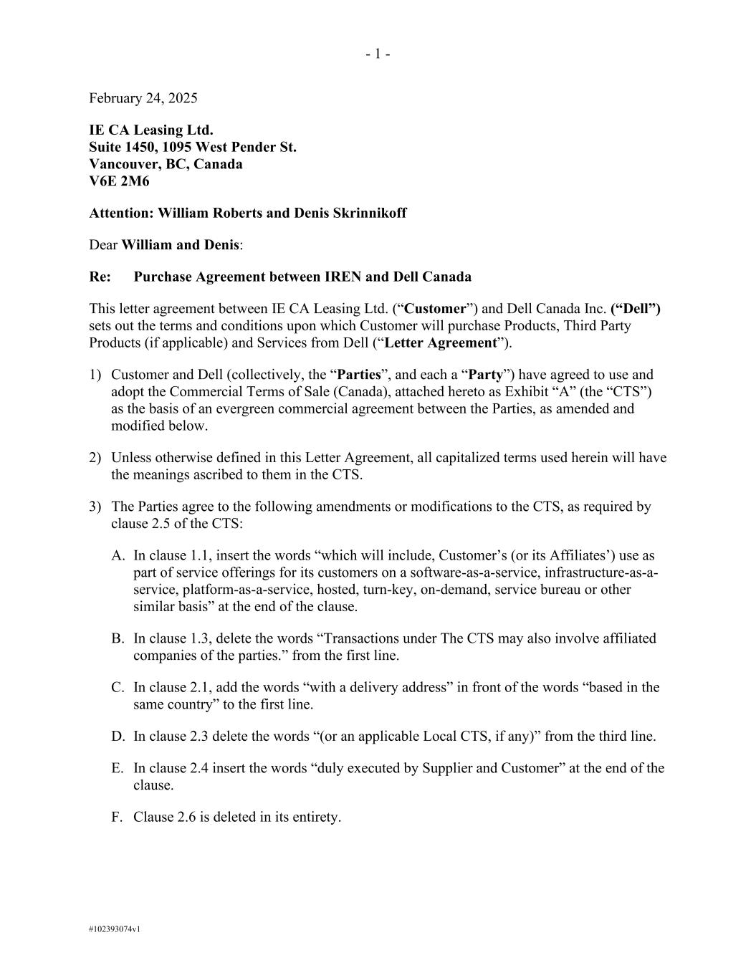
67
- 1 - #102393074v1 February 24, 2025 IE CA Leasing Ltd. Suite 1450, 1095 West Pender St. Vancouver, BC, Canada V6E 2M6 Attention: William Roberts and Denis Skrinnikoff Dear William and Denis: Re: Purchase Agreement between IREN and Dell Canada This letter agreement between IE CA Leasing Ltd. (“Customer”) and Dell Canada Inc. (“Dell”) sets out the terms and conditions upon which Customer will purchase Products, Third Party Products (if applicable) and Services from Dell (“Letter Agreement”). 1) Customer and Dell (collectively, the “Parties”, and each a “Party”) have agreed to use and adopt the Commercial Terms of Sale (Canada), attached hereto as Exhibit “A” (the “CTS”) as the basis of an evergreen commercial agreement between the Parties, as amended and modified below. 2) Unless otherwise defined in this Letter Agreement, all capitalized terms used herein will have the meanings ascribed to them in the CTS. 3) The Parties agree to the following amendments or modifications to the CTS, as required by clause 2.5 of the CTS: A. In clause 1.1, insert the words “which will include, Customer’s (or its Affiliates’) use as part of service offerings for its customers on a software-as-a-service, infrastructure-as-a- service, platform-as-a-service, hosted, turn-key, on-demand, service bureau or other similar basis” at the end of the clause. B. In clause 1.3, delete the words “Transactions under The CTS may also involve affiliated companies of the parties.” from the first line. C. In clause 2.1, add the words “with a delivery address” in front of the words “based in the same country” to the first line. D. In clause 2.3 delete the words “(or an applicable Local CTS, if any)” from the third line. E. In clause 2.4 insert the words “duly executed by Supplier and Customer” at the end of the clause. F. Clause 2.6 is deleted in its entirety.

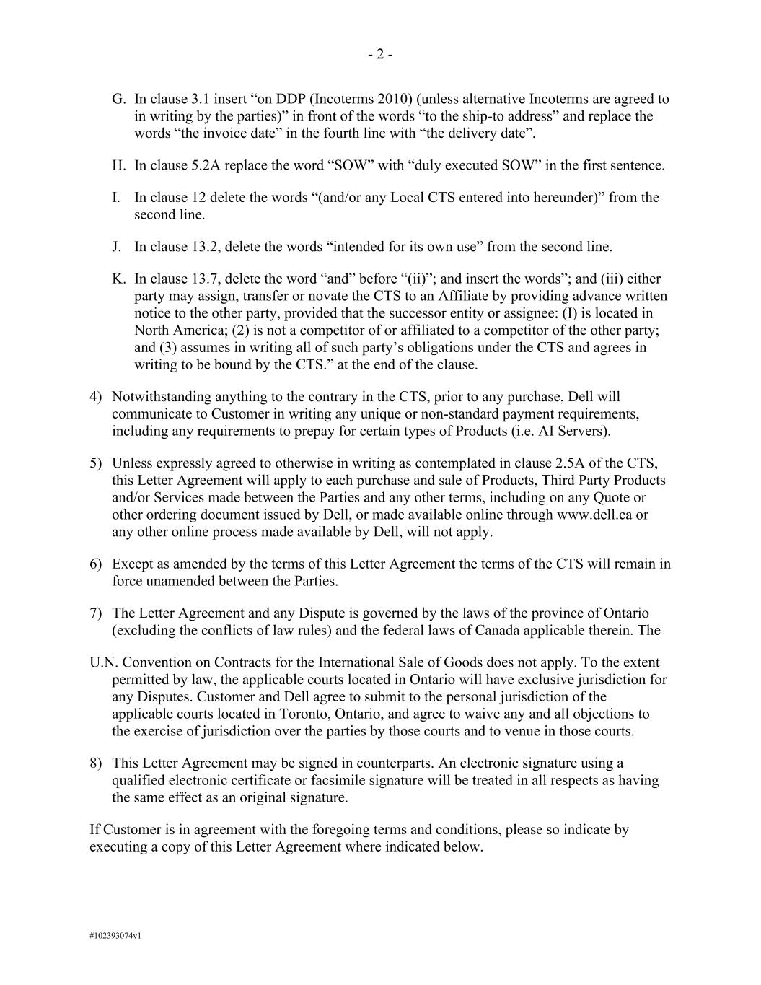
- 2 - #102393074v1 G. In clause 3.1 insert “on DDP (Incoterms 2010) (unless alternative Incoterms are agreed to in writing by the parties)” in front of the words “to the ship-to address” and replace the words “the invoice date” in the fourth line with “the delivery date”. H. In clause 5.2A replace the word “SOW” with “duly executed SOW” in the first sentence. I. In clause 12 delete the words “(and/or any Local CTS entered into hereunder)” from the second line. J. In clause 13.2, delete the words “intended for its own use” from the second line. K. In clause 13.7, delete the word “and” before “(ii)”; and insert the words”; and (iii) either party may assign, transfer or novate the CTS to an Affiliate by providing advance written notice to the other party, provided that the successor entity or assignee: (I) is located in North America; (2) is not a competitor of or affiliated to a competitor of the other party; and (3) assumes in writing all of such party’s obligations under the CTS and agrees in writing to be bound by the CTS.” at the end of the clause. 4) Notwithstanding anything to the contrary in the CTS, prior to any purchase, Dell will communicate to Customer in writing any unique or non-standard payment requirements, including any requirements to prepay for certain types of Products (i.e. AI Servers). 5) Unless expressly agreed to otherwise in writing as contemplated in clause 2.5A of the CTS, this Letter Agreement will apply to each purchase and sale of Products, Third Party Products and/or Services made between the Parties and any other terms, including on any Quote or other ordering document issued by Dell, or made available online through www.dell.ca or any other online process made available by Dell, will not apply. 6) Except as amended by the terms of this Letter Agreement the terms of the CTS will remain in force unamended between the Parties. 7) The Letter Agreement and any Dispute is governed by the laws of the province of Ontario (excluding the conflicts of law rules) and the federal laws of Canada applicable therein. The U.N. Convention on Contracts for the International Sale of Goods does not apply. To the extent permitted by law, the applicable courts located in Ontario will have exclusive jurisdiction for any Disputes. Customer and Dell agree to submit to the personal jurisdiction of the applicable courts located in Toronto, Ontario, and agree to waive any and all objections to the exercise of jurisdiction over the parties by those courts and to venue in those courts. 8) This Letter Agreement may be signed in counterparts. An electronic signature using a qualified electronic certificate or facsimile signature will be treated in all respects as having the same effect as an original signature. If Customer is in agreement with the foregoing terms and conditions, please so indicate by executing a copy of this Letter Agreement where indicated below.

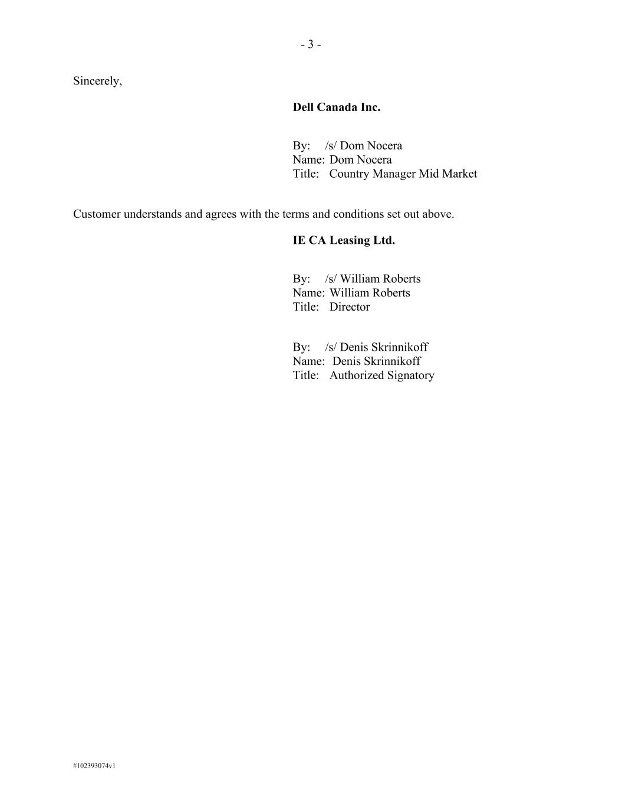
- 3 - #102393074v1 Sincerely, Dell Canada Inc. By: /s/ Dom Nocera Name: Dom Nocera Title: Country Manager Mid Market Customer understands and agrees with the terms and conditions set out above. IE CA Leasing Ltd. By: /s/ William Roberts Name: William Roberts Title: Director By: /s/ Denis Skrinnikoff Name: Denis Skrinnikoff Title: Authorized Signatory


- 4 - #102393074v1 Exhibit A Commercial Terms of Sale To be attached.

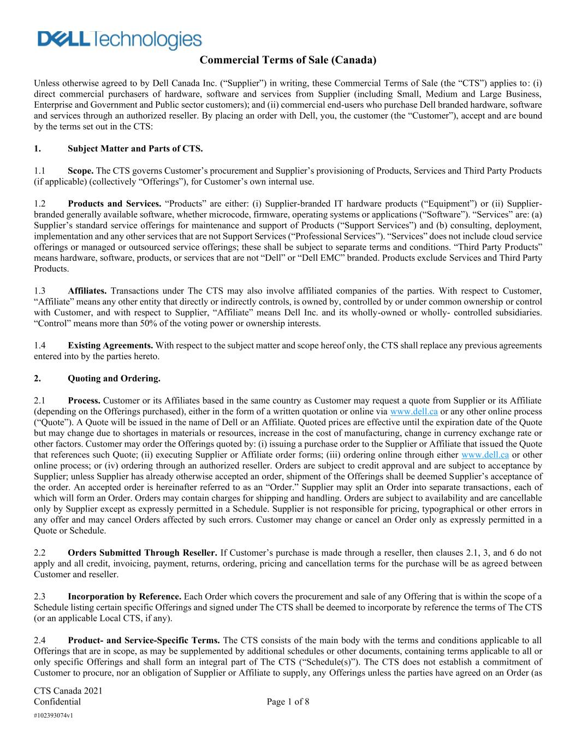
CTS Canada 2021 Confidential Page 1 of 8 #102393074v1 Commercial Terms of Sale (Canada) Unless otherwise agreed to by Dell Canada Inc. (“Supplier”) in writing, these Commercial Terms of Sale (the “CTS”) applies to: (i) direct commercial purchasers of hardware, software and services from Supplier (including Small, Medium and Large Business, Enterprise and Government and Public sector customers); and (ii) commercial end-users who purchase Dell branded hardware, software and services through an authorized reseller. By placing an order with Dell, you, the customer (the “Customer”), accept and are bound by the terms set out in the CTS: 1. Subject Matter and Parts of CTS. 1.1 Scope. The CTS governs Customer’s procurement and Supplier’s provisioning of Products, Services and Third Party Products (if applicable) (collectively “Offerings”), for Customer’s own internal use. 1.2 Products and Services. “Products” are either: (i) Supplier-branded IT hardware products (“Equipment”) or (ii) Supplier- branded generally available software, whether microcode, firmware, operating systems or applications (“Software”). “Services” are: (a) Supplier’s standard service offerings for maintenance and support of Products (“Support Services”) and (b) consulting, deployment, implementation and any other services that are not Support Services (“Professional Services”). “Services” does not include cloud service offerings or managed or outsourced service offerings; these shall be subject to separate terms and conditions. “Third Party Products” means hardware, software, products, or services that are not “Dell” or “Dell EMC” branded. Products exclude Services and Third Party Products. 1.3 Affiliates. Transactions under The CTS may also involve affiliated companies of the parties. With respect to Customer, “Affiliate” means any other entity that directly or indirectly controls, is owned by, controlled by or under common ownership or control with Customer, and with respect to Supplier, “Affiliate” means Dell Inc. and its wholly-owned or wholly- controlled subsidiaries. “Control” means more than 50% of the voting power or ownership interests. 1.4 Existing Agreements. With respect to the subject matter and scope hereof only, the CTS shall replace any previous agreements entered into by the parties hereto. 2. Quoting and Ordering. 2.1 Process. Customer or its Affiliates based in the same country as Customer may request a quote from Supplier or its Affiliate (depending on the Offerings purchased), either in the form of a written quotation or online via www.dell.ca or any other online process (“Quote”). A Quote will be issued in the name of Dell or an Affiliate. Quoted prices are effective until the expiration date of the Quote but may change due to shortages in materials or resources, increase in the cost of manufacturing, change in currency exchange rate or other factors. Customer may order the Offerings quoted by: (i) issuing a purchase order to the Supplier or Affiliate that issued the Quote that references such Quote; (ii) executing Supplier or Affiliate order forms; (iii) ordering online through either www.dell.ca or other online process; or (iv) ordering through an authorized reseller. Orders are subject to credit approval and are subject to acceptance by Supplier; unless Supplier has already otherwise accepted an order, shipment of the Offerings shall be deemed Supplier’s acceptance of the order. An accepted order is hereinafter referred to as an “Order.” Supplier may split an Order into separate transactions , each of which will form an Order. Orders may contain charges for shipping and handling. Orders are subject to availability and are cancellable only by Supplier except as expressly permitted in a Schedule. Supplier is not responsible for pricing, typographical or other errors in any offer and may cancel Orders affected by such errors. Customer may change or cancel an Order only as expressly permitted in a Quote or Schedule. 2.2 Orders Submitted Through Reseller. If Customer’s purchase is made through a reseller, then clauses 2.1, 3, and 6 do not apply and all credit, invoicing, payment, returns, ordering, pricing and cancellation terms for the purchase will be as agreed between Customer and reseller. 2.3 Incorporation by Reference. Each Order which covers the procurement and sale of any Offering that is within the scope of a Schedule listing certain specific Offerings and signed under The CTS shall be deemed to incorporate by reference the terms of The CTS (or an applicable Local CTS, if any). 2.4 Product- and Service-Specific Terms. The CTS consists of the main body with the terms and conditions applicable to all Offerings that are in scope, as may be supplemented by additional schedules or other documents, containing terms applicable to all or only specific Offerings and shall form an integral part of The CTS (“Schedule(s)”). The CTS does not establish a commitment of Customer to procure, nor an obligation of Supplier or Affiliate to supply, any Offerings unless the parties have agreed on an Order (as

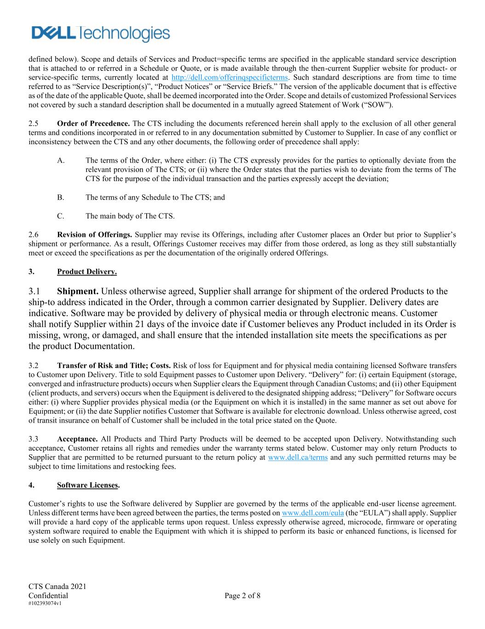
CTS Canada 2021 Confidential Page 2 of 8 #102393074v1 defined below). Scope and details of Services and Product=specific terms are specified in the applicable standard service description that is attached to or referred in a Schedule or Quote, or is made available through the then-current Supplier website for product- or service-specific terms, currently located at http://dell.com/offerinqspecificterms. Such standard descriptions are from time to time referred to as “Service Description(s)”, “Product Notices” or “Service Briefs.” The version of the applicable document that is effective as of the date of the applicable Quote, shall be deemed incorporated into the Order. Scope and details of customized Professional Services not covered by such a standard description shall be documented in a mutually agreed Statement of Work (“SOW”). 2.5 Order of Precedence. The CTS including the documents referenced herein shall apply to the exclusion of all other general terms and conditions incorporated in or referred to in any documentation submitted by Customer to Supplier. In case of any conflict or inconsistency between the CTS and any other documents, the following order of precedence shall apply: A. The terms of the Order, where either: (i) The CTS expressly provides for the parties to optionally deviate from the relevant provision of The CTS; or (ii) where the Order states that the parties wish to deviate from the terms of The CTS for the purpose of the individual transaction and the parties expressly accept the deviation; B. The terms of any Schedule to The CTS; and C. The main body of The CTS. 2.6 Revision of Offerings. Supplier may revise its Offerings, including after Customer places an Order but prior to Supplier’s shipment or performance. As a result, Offerings Customer receives may differ from those ordered, as long as they still substantially meet or exceed the specifications as per the documentation of the originally ordered Offerings. 3. Product Delivery. 3.1 Shipment. Unless otherwise agreed, Supplier shall arrange for shipment of the ordered Products to the ship-to address indicated in the Order, through a common carrier designated by Supplier. Delivery dates are indicative. Software may be provided by delivery of physical media or through electronic means. Customer shall notify Supplier within 21 days of the invoice date if Customer believes any Product included in its Order is missing, wrong, or damaged, and shall ensure that the intended installation site meets the specifications as per the product Documentation. 3.2 Transfer of Risk and Title; Costs. Risk of loss for Equipment and for physical media containing licensed Software transfers to Customer upon Delivery. Title to sold Equipment passes to Customer upon Delivery. “Delivery” for: (i) certain Equipment (storage, converged and infrastructure products) occurs when Supplier clears the Equipment through Canadian Customs; and (ii) other Equipment (client products, and servers) occurs when the Equipment is delivered to the designated shipping address; “Delivery” for Software occurs either: (i) where Supplier provides physical media (or the Equipment on which it is installed) in the same manner as set out above for Equipment; or (ii) the date Supplier notifies Customer that Software is available for electronic download. Unless otherwise agreed, cost of transit insurance on behalf of Customer shall be included in the total price stated on the Quote. 3.3 Acceptance. All Products and Third Party Products will be deemed to be accepted upon Delivery. Notwithstanding such acceptance, Customer retains all rights and remedies under the warranty terms stated below. Customer may only return Products to Supplier that are permitted to be returned pursuant to the return policy at www.dell.ca/terms and any such permitted returns may be subject to time limitations and restocking fees. 4. Software Licenses. Customer’s rights to use the Software delivered by Supplier are governed by the terms of the applicable end-user license agreement. Unless different terms have been agreed between the parties, the terms posted on www.dell.com/eula (the “EULA”) shall apply. Supplier will provide a hard copy of the applicable terms upon request. Unless expressly otherwise agreed, microcode, firmware or operating system software required to enable the Equipment with which it is shipped to perform its basic or enhanced functions, is licensed for use solely on such Equipment.

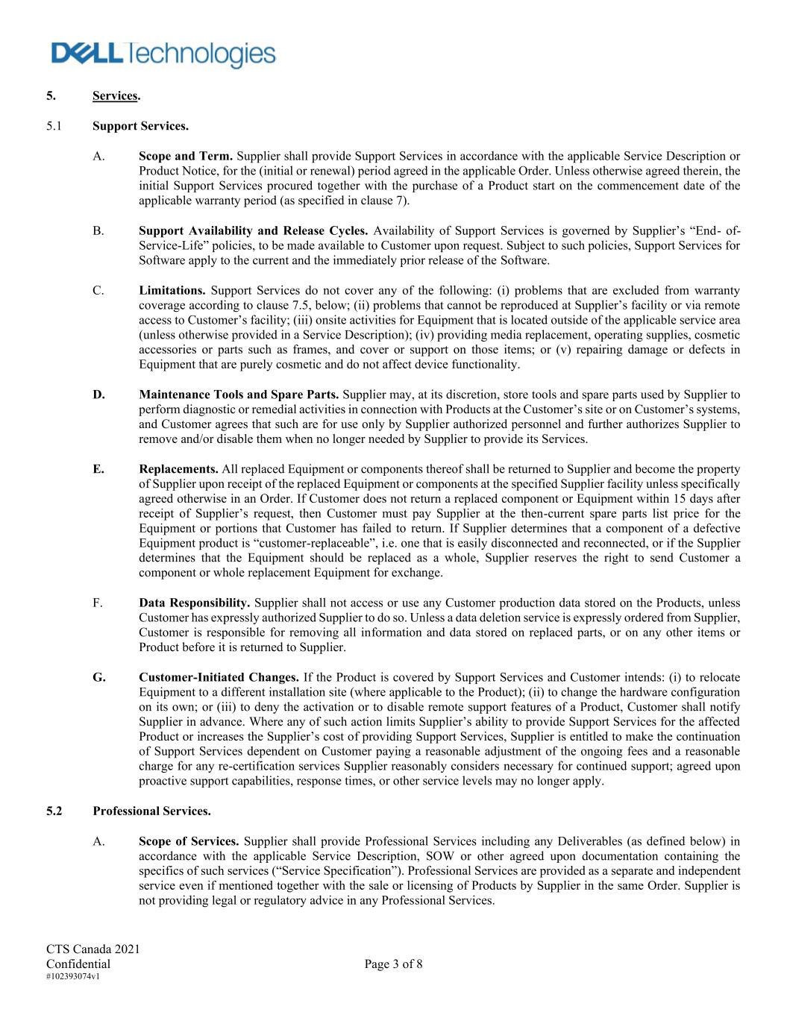
CTS Canada 2021 Confidential Page 3 of 8 #102393074v1 5. Services. 5.1 Support Services. A. Scope and Term. Supplier shall provide Support Services in accordance with the applicable Service Description or Product Notice, for the (initial or renewal) period agreed in the applicable Order. Unless otherwise agreed therein, the initial Support Services procured together with the purchase of a Product start on the commencement date of the applicable warranty period (as specified in clause 7). B. Support Availability and Release Cycles. Availability of Support Services is governed by Supplier’s “End- of- Service-Life” policies, to be made available to Customer upon request. Subject to such policies, Support Services for Software apply to the current and the immediately prior release of the Software. C. Limitations. Support Services do not cover any of the following: (i) problems that are excluded from warranty coverage according to clause 7.5, below; (ii) problems that cannot be reproduced at Supplier’s facility or via remote access to Customer’s facility; (iii) onsite activities for Equipment that is located outside of the applicable service area (unless otherwise provided in a Service Description); (iv) providing media replacement, operating supplies, cosmetic accessories or parts such as frames, and cover or support on those items; or (v) repairing damage or defects in Equipment that are purely cosmetic and do not affect device functionality. D. Maintenance Tools and Spare Parts. Supplier may, at its discretion, store tools and spare parts used by Supplier to perform diagnostic or remedial activities in connection with Products at the Customer’s site or on Customer’s systems, and Customer agrees that such are for use only by Supplier authorized personnel and further authorizes Supplier to remove and/or disable them when no longer needed by Supplier to provide its Services. E. Replacements. All replaced Equipment or components thereof shall be returned to Supplier and become the property of Supplier upon receipt of the replaced Equipment or components at the specified Supplier facility unless specifically agreed otherwise in an Order. If Customer does not return a replaced component or Equipment within 15 days after receipt of Supplier’s request, then Customer must pay Supplier at the then-current spare parts list price for the Equipment or portions that Customer has failed to return. If Supplier determines that a component of a defective Equipment product is “customer-replaceable”, i.e. one that is easily disconnected and reconnected, or if the Supplier determines that the Equipment should be replaced as a whole, Supplier reserves the right to send Customer a component or whole replacement Equipment for exchange. F. Data Responsibility. Supplier shall not access or use any Customer production data stored on the Products, unless Customer has expressly authorized Supplier to do so. Unless a data deletion service is expressly ordered from Supplier, Customer is responsible for removing all information and data stored on replaced parts, or on any other items or Product before it is returned to Supplier. G. Customer-Initiated Changes. If the Product is covered by Support Services and Customer intends: (i) to relocate Equipment to a different installation site (where applicable to the Product); (ii) to change the hardware configuration on its own; or (iii) to deny the activation or to disable remote support features of a Product, Customer shall notify Supplier in advance. Where any of such action limits Supplier’s ability to provide Support Services for the affected Product or increases the Supplier’s cost of providing Support Services, Supplier is entitled to make the continuation of Support Services dependent on Customer paying a reasonable adjustment of the ongoing fees and a reasonable charge for any re-certification services Supplier reasonably considers necessary for continued support; agreed upon proactive support capabilities, response times, or other service levels may no longer apply. 5.2 Professional Services. A. Scope of Services. Supplier shall provide Professional Services including any Deliverables (as defined below) in accordance with the applicable Service Description, SOW or other agreed upon documentation containing the specifics of such services (“Service Specification”). Professional Services are provided as a separate and independent service even if mentioned together with the sale or licensing of Products by Supplier in the same Order. Supplier is not providing legal or regulatory advice in any Professional Services.

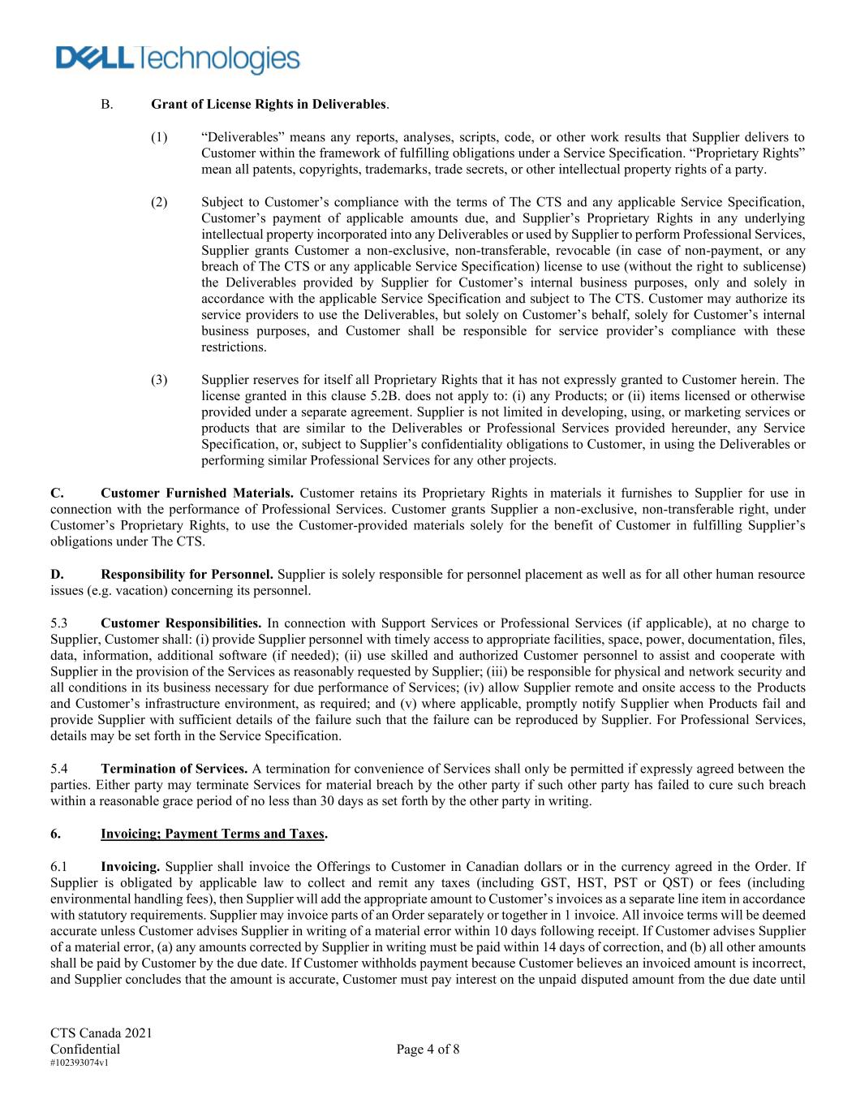
CTS Canada 2021 Confidential Page 4 of 8 #102393074v1 B. Grant of License Rights in Deliverables. (1) “Deliverables” means any reports, analyses, scripts, code, or other work results that Supplier delivers to Customer within the framework of fulfilling obligations under a Service Specification. “Proprietary Rights” mean all patents, copyrights, trademarks, trade secrets, or other intellectual property rights of a party. (2) Subject to Customer’s compliance with the terms of The CTS and any applicable Service Specification, Customer’s payment of applicable amounts due, and Supplier’s Proprietary Rights in any underlying intellectual property incorporated into any Deliverables or used by Supplier to perform Professional Services, Supplier grants Customer a non-exclusive, non-transferable, revocable (in case of non-payment, or any breach of The CTS or any applicable Service Specification) license to use (without the right to sublicense) the Deliverables provided by Supplier for Customer’s internal business purposes, only and solely in accordance with the applicable Service Specification and subject to The CTS. Customer may authorize its service providers to use the Deliverables, but solely on Customer’s behalf, solely for Customer’s internal business purposes, and Customer shall be responsible for service provider’s compliance with these restrictions. (3) Supplier reserves for itself all Proprietary Rights that it has not expressly granted to Customer herein. The license granted in this clause 5.2B. does not apply to: (i) any Products; or (ii) items licensed or otherwise provided under a separate agreement. Supplier is not limited in developing, using, or marketing services or products that are similar to the Deliverables or Professional Services provided hereunder, any Service Specification, or, subject to Supplier’s confidentiality obligations to Customer, in using the Deliverables or performing similar Professional Services for any other projects. C. Customer Furnished Materials. Customer retains its Proprietary Rights in materials it furnishes to Supplier for use in connection with the performance of Professional Services. Customer grants Supplier a non-exclusive, non-transferable right, under Customer’s Proprietary Rights, to use the Customer-provided materials solely for the benefit of Customer in fulfilling Supplier’s obligations under The CTS. D. Responsibility for Personnel. Supplier is solely responsible for personnel placement as well as for all other human resource issues (e.g. vacation) concerning its personnel. 5.3 Customer Responsibilities. In connection with Support Services or Professional Services (if applicable), at no charge to Supplier, Customer shall: (i) provide Supplier personnel with timely access to appropriate facilities, space, power, documentation, files, data, information, additional software (if needed); (ii) use skilled and authorized Customer personnel to assist and cooperate with Supplier in the provision of the Services as reasonably requested by Supplier; (iii) be responsible for physical and network security and all conditions in its business necessary for due performance of Services; (iv) allow Supplier remote and onsite access to the Products and Customer’s infrastructure environment, as required; and (v) where applicable, promptly notify Supplier when Products fail and provide Supplier with sufficient details of the failure such that the failure can be reproduced by Supplier. For Professional Services, details may be set forth in the Service Specification. 5.4 Termination of Services. A termination for convenience of Services shall only be permitted if expressly agreed between the parties. Either party may terminate Services for material breach by the other party if such other party has failed to cure such breach within a reasonable grace period of no less than 30 days as set forth by the other party in writing. 6. Invoicing; Payment Terms and Taxes. 6.1 Invoicing. Supplier shall invoice the Offerings to Customer in Canadian dollars or in the currency agreed in the Order. If Supplier is obligated by applicable law to collect and remit any taxes (including GST, HST, PST or QST) or fees (including environmental handling fees), then Supplier will add the appropriate amount to Customer’s invoices as a separate line item in accordance with statutory requirements. Supplier may invoice parts of an Order separately or together in 1 invoice. All invoice terms will be deemed accurate unless Customer advises Supplier in writing of a material error within 10 days following receipt. If Customer advises Supplier of a material error, (a) any amounts corrected by Supplier in writing must be paid within 14 days of correction, and (b) all other amounts shall be paid by Customer by the due date. If Customer withholds payment because Customer believes an invoiced amount is incorrect, and Supplier concludes that the amount is accurate, Customer must pay interest on the unpaid disputed amount from the due date until

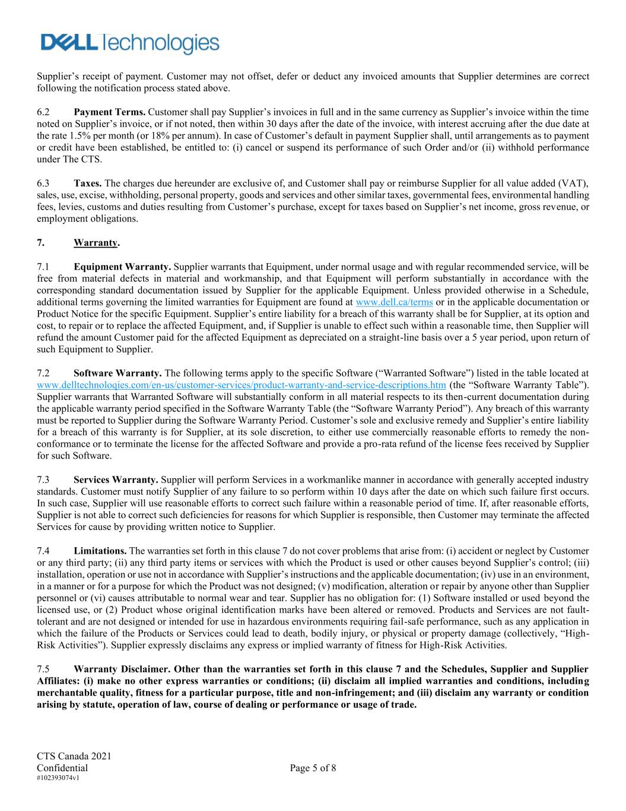
CTS Canada 2021 Confidential Page 5 of 8 #102393074v1 Supplier’s receipt of payment. Customer may not offset, defer or deduct any invoiced amounts that Supplier determines are correct following the notification process stated above. 6.2 Payment Terms. Customer shall pay Supplier’s invoices in full and in the same currency as Supplier’s invoice within the time noted on Supplier’s invoice, or if not noted, then within 30 days after the date of the invoice, with interest accruing after the due date at the rate 1.5% per month (or 18% per annum). In case of Customer’s default in payment Supplier shall, until arrangements as to payment or credit have been established, be entitled to: (i) cancel or suspend its performance of such Order and/or (ii) withhold performance under The CTS. 6.3 Taxes. The charges due hereunder are exclusive of, and Customer shall pay or reimburse Supplier for all value added (VAT), sales, use, excise, withholding, personal property, goods and services and other similar taxes, governmental fees, environmental handling fees, levies, customs and duties resulting from Customer’s purchase, except for taxes based on Supplier’s net income, gross revenue, or employment obligations. 7. Warranty. 7.1 Equipment Warranty. Supplier warrants that Equipment, under normal usage and with regular recommended service, will be free from material defects in material and workmanship, and that Equipment will perform substantially in accordance with the corresponding standard documentation issued by Supplier for the applicable Equipment. Unless provided otherwise in a Schedule, additional terms governing the limited warranties for Equipment are found at www.dell.ca/terms or in the applicable documentation or Product Notice for the specific Equipment. Supplier’s entire liability for a breach of this warranty shall be for Supplier, at its option and cost, to repair or to replace the affected Equipment, and, if Supplier is unable to effect such within a reasonable time, then Supplier will refund the amount Customer paid for the affected Equipment as depreciated on a straight-line basis over a 5 year period, upon return of such Equipment to Supplier. 7.2 Software Warranty. The following terms apply to the specific Software (“Warranted Software”) listed in the table located at www.delltechnoloqies.com/en-us/customer-services/product-warranty-and-service-descriptions.htm (the “Software Warranty Table”). Supplier warrants that Warranted Software will substantially conform in all material respects to its then-current documentation during the applicable warranty period specified in the Software Warranty Table (the “Software Warranty Period”). Any breach of this warranty must be reported to Supplier during the Software Warranty Period. Customer’s sole and exclusive remedy and Supplier’s entire liability for a breach of this warranty is for Supplier, at its sole discretion, to either use commercially reasonable efforts to remedy the non- conformance or to terminate the license for the affected Software and provide a pro-rata refund of the license fees received by Supplier for such Software. 7.3 Services Warranty. Supplier will perform Services in a workmanlike manner in accordance with generally accepted industry standards. Customer must notify Supplier of any failure to so perform within 10 days after the date on which such failure first occurs. In such case, Supplier will use reasonable efforts to correct such failure within a reasonable period of time. If, after reasonable efforts, Supplier is not able to correct such deficiencies for reasons for which Supplier is responsible, then Customer may terminate the affected Services for cause by providing written notice to Supplier. 7.4 Limitations. The warranties set forth in this clause 7 do not cover problems that arise from: (i) accident or neglect by Customer or any third party; (ii) any third party items or services with which the Product is used or other causes beyond Supplier’s control; (iii) installation, operation or use not in accordance with Supplier’s instructions and the applicable documentation; (iv) use in an environment, in a manner or for a purpose for which the Product was not designed; (v) modification, alteration or repair by anyone other than Supplier personnel or (vi) causes attributable to normal wear and tear. Supplier has no obligation for: (1) Software installed or used beyond the licensed use, or (2) Product whose original identification marks have been altered or removed. Products and Services are not fault- tolerant and are not designed or intended for use in hazardous environments requiring fail-safe performance, such as any application in which the failure of the Products or Services could lead to death, bodily injury, or physical or property damage (collectively, “High- Risk Activities”). Supplier expressly disclaims any express or implied warranty of fitness for High-Risk Activities. 7.5 Warranty Disclaimer. Other than the warranties set forth in this clause 7 and the Schedules, Supplier and Supplier Affiliates: (i) make no other express warranties or conditions; (ii) disclaim all implied warranties and conditions, including merchantable quality, fitness for a particular purpose, title and non-infringement; and (iii) disclaim any warranty or condition arising by statute, operation of law, course of dealing or performance or usage of trade.

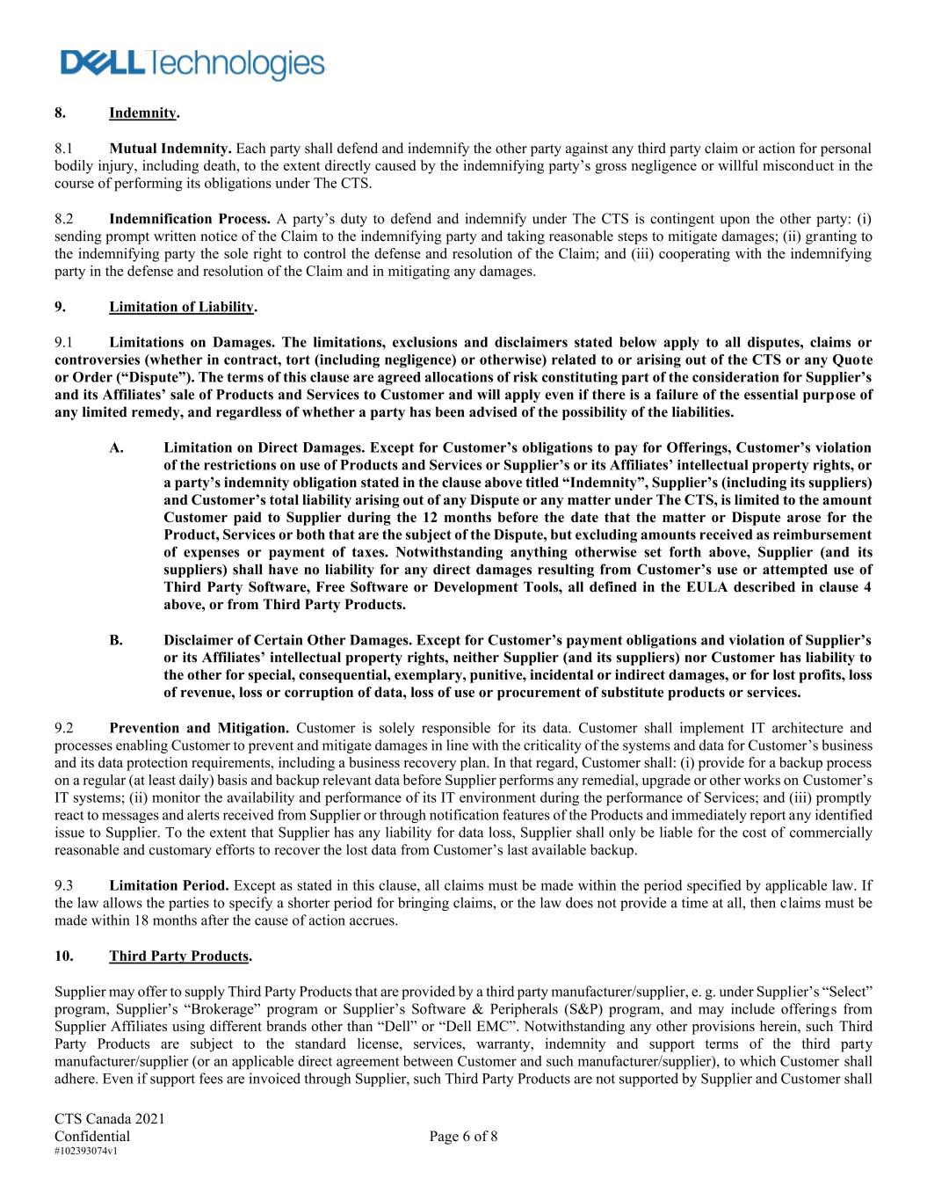
CTS Canada 2021 Confidential Page 6 of 8 #102393074v1 8. Indemnity. 8.1 Mutual Indemnity. Each party shall defend and indemnify the other party against any third party claim or action for personal bodily injury, including death, to the extent directly caused by the indemnifying party’s gross negligence or willful misconduct in the course of performing its obligations under The CTS. 8.2 Indemnification Process. A party’s duty to defend and indemnify under The CTS is contingent upon the other party: (i) sending prompt written notice of the Claim to the indemnifying party and taking reasonable steps to mitigate damages; (ii) granting to the indemnifying party the sole right to control the defense and resolution of the Claim; and (iii) cooperating with the indemnifying party in the defense and resolution of the Claim and in mitigating any damages. 9. Limitation of Liability. 9.1 Limitations on Damages. The limitations, exclusions and disclaimers stated below apply to all disputes, claims or controversies (whether in contract, tort (including negligence) or otherwise) related to or arising out of the CTS or any Quote or Order (“Dispute”). The terms of this clause are agreed allocations of risk constituting part of the consideration for Supplier’s and its Affiliates’ sale of Products and Services to Customer and will apply even if there is a failure of the essential purpose of any limited remedy, and regardless of whether a party has been advised of the possibility of the liabilities. A. Limitation on Direct Damages. Except for Customer’s obligations to pay for Offerings, Customer’s violation of the restrictions on use of Products and Services or Supplier’s or its Affiliates’ intellectual property rights, or a party’s indemnity obligation stated in the clause above titled “Indemnity”, Supplier’s (including its suppliers) and Customer’s total liability arising out of any Dispute or any matter under The CTS, is limited to the amount Customer paid to Supplier during the 12 months before the date that the matter or Dispute arose for the Product, Services or both that are the subject of the Dispute, but excluding amounts received as reimbursement of expenses or payment of taxes. Notwithstanding anything otherwise set forth above, Supplier (and its suppliers) shall have no liability for any direct damages resulting from Customer’s use or attempted use of Third Party Software, Free Software or Development Tools, all defined in the EULA described in clause 4 above, or from Third Party Products. B. Disclaimer of Certain Other Damages. Except for Customer’s payment obligations and violation of Supplier’s or its Affiliates’ intellectual property rights, neither Supplier (and its suppliers) nor Customer has liability to the other for special, consequential, exemplary, punitive, incidental or indirect damages, or for lost profits, loss of revenue, loss or corruption of data, loss of use or procurement of substitute products or services. 9.2 Prevention and Mitigation. Customer is solely responsible for its data. Customer shall implement IT architecture and processes enabling Customer to prevent and mitigate damages in line with the criticality of the systems and data for Customer’s business and its data protection requirements, including a business recovery plan. In that regard, Customer shall: (i) provide for a backup process on a regular (at least daily) basis and backup relevant data before Supplier performs any remedial, upgrade or other works on Customer’s IT systems; (ii) monitor the availability and performance of its IT environment during the performance of Services; and (iii) promptly react to messages and alerts received from Supplier or through notification features of the Products and immediately report any identified issue to Supplier. To the extent that Supplier has any liability for data loss, Supplier shall only be liable for the cost of commercially reasonable and customary efforts to recover the lost data from Customer’s last available backup. 9.3 Limitation Period. Except as stated in this clause, all claims must be made within the period specified by applicable law. If the law allows the parties to specify a shorter period for bringing claims, or the law does not provide a time at all, then claims must be made within 18 months after the cause of action accrues. 10. Third Party Products. Supplier may offer to supply Third Party Products that are provided by a third party manufacturer/supplier, e. g. under Supplier’s “Select” program, Supplier’s “Brokerage” program or Supplier’s Software & Peripherals (S&P) program, and may include offerings from Supplier Affiliates using different brands other than “Dell” or “Dell EMC”. Notwithstanding any other provisions herein, such Third Party Products are subject to the standard license, services, warranty, indemnity and support terms of the third party manufacturer/supplier (or an applicable direct agreement between Customer and such manufacturer/supplier), to which Customer shall adhere. Even if support fees are invoiced through Supplier, such Third Party Products are not supported by Supplier and Customer shall

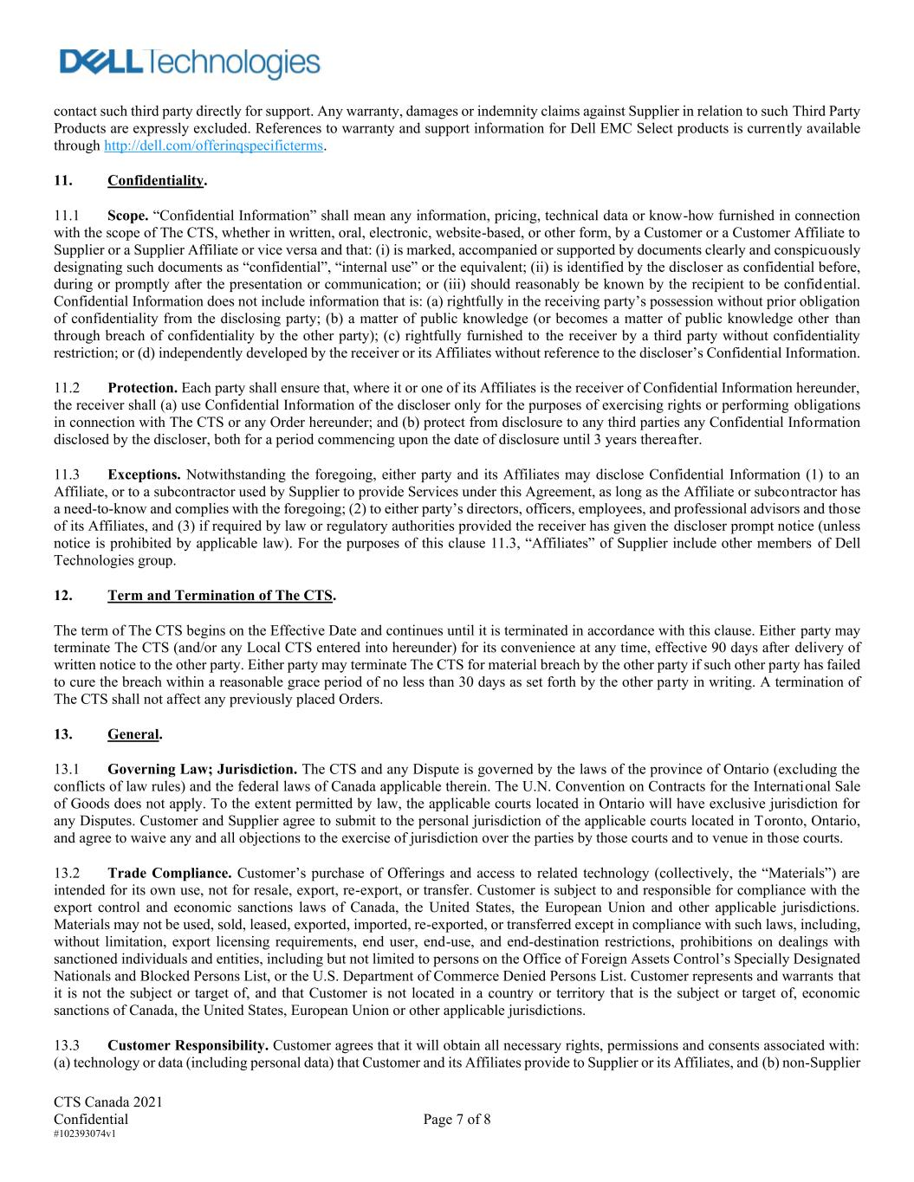
CTS Canada 2021 Confidential Page 7 of 8 #102393074v1 contact such third party directly for support. Any warranty, damages or indemnity claims against Supplier in relation to such Third Party Products are expressly excluded. References to warranty and support information for Dell EMC Select products is currently available through http://dell.com/offerinqspecificterms. 11. Confidentiality. 11.1 Scope. “Confidential Information” shall mean any information, pricing, technical data or know-how furnished in connection with the scope of The CTS, whether in written, oral, electronic, website-based, or other form, by a Customer or a Customer Affiliate to Supplier or a Supplier Affiliate or vice versa and that: (i) is marked, accompanied or supported by documents clearly and conspicuously designating such documents as “confidential”, “internal use” or the equivalent; (ii) is identified by the discloser as confidential before, during or promptly after the presentation or communication; or (iii) should reasonably be known by the recipient to be confidential. Confidential Information does not include information that is: (a) rightfully in the receiving party’s possession without prior obligation of confidentiality from the disclosing party; (b) a matter of public knowledge (or becomes a matter of public knowledge other than through breach of confidentiality by the other party); (c) rightfully furnished to the receiver by a third party without confidentiality restriction; or (d) independently developed by the receiver or its Affiliates without reference to the discloser’s Confidential Information. 11.2 Protection. Each party shall ensure that, where it or one of its Affiliates is the receiver of Confidential Information hereunder, the receiver shall (a) use Confidential Information of the discloser only for the purposes of exercising rights or performing obligations in connection with The CTS or any Order hereunder; and (b) protect from disclosure to any third parties any Confidential Information disclosed by the discloser, both for a period commencing upon the date of disclosure until 3 years thereafter. 11.3 Exceptions. Notwithstanding the foregoing, either party and its Affiliates may disclose Confidential Information (1) to an Affiliate, or to a subcontractor used by Supplier to provide Services under this Agreement, as long as the Affiliate or subcontractor has a need-to-know and complies with the foregoing; (2) to either party’s directors, officers, employees, and professional advisors and those of its Affiliates, and (3) if required by law or regulatory authorities provided the receiver has given the discloser prompt notice (unless notice is prohibited by applicable law). For the purposes of this clause 11.3, “Affiliates” of Supplier include other members of Dell Technologies group. 12. Term and Termination of The CTS. The term of The CTS begins on the Effective Date and continues until it is terminated in accordance with this clause. Either party may terminate The CTS (and/or any Local CTS entered into hereunder) for its convenience at any time, effective 90 days after delivery of written notice to the other party. Either party may terminate The CTS for material breach by the other party if such other party has failed to cure the breach within a reasonable grace period of no less than 30 days as set forth by the other party in writing. A termination of The CTS shall not affect any previously placed Orders. 13. General. 13.1 Governing Law; Jurisdiction. The CTS and any Dispute is governed by the laws of the province of Ontario (excluding the conflicts of law rules) and the federal laws of Canada applicable therein. The U.N. Convention on Contracts for the International Sale of Goods does not apply. To the extent permitted by law, the applicable courts located in Ontario will have exclusive jurisdiction for any Disputes. Customer and Supplier agree to submit to the personal jurisdiction of the applicable courts located in Toronto, Ontario, and agree to waive any and all objections to the exercise of jurisdiction over the parties by those courts and to venue in those courts. 13.2 Trade Compliance. Customer’s purchase of Offerings and access to related technology (collectively, the “Materials”) are intended for its own use, not for resale, export, re-export, or transfer. Customer is subject to and responsible for compliance with the export control and economic sanctions laws of Canada, the United States, the European Union and other applicable jurisdictions. Materials may not be used, sold, leased, exported, imported, re-exported, or transferred except in compliance with such laws, including, without limitation, export licensing requirements, end user, end-use, and end-destination restrictions, prohibitions on dealings with sanctioned individuals and entities, including but not limited to persons on the Office of Foreign Assets Control’s Specially Designated Nationals and Blocked Persons List, or the U.S. Department of Commerce Denied Persons List. Customer represents and warrants that it is not the subject or target of, and that Customer is not located in a country or territory that is the subject or target of, economic sanctions of Canada, the United States, European Union or other applicable jurisdictions. 13.3 Customer Responsibility. Customer agrees that it will obtain all necessary rights, permissions and consents associated with: (a) technology or data (including personal data) that Customer and its Affiliates provide to Supplier or its Affiliates, and (b) non-Supplier

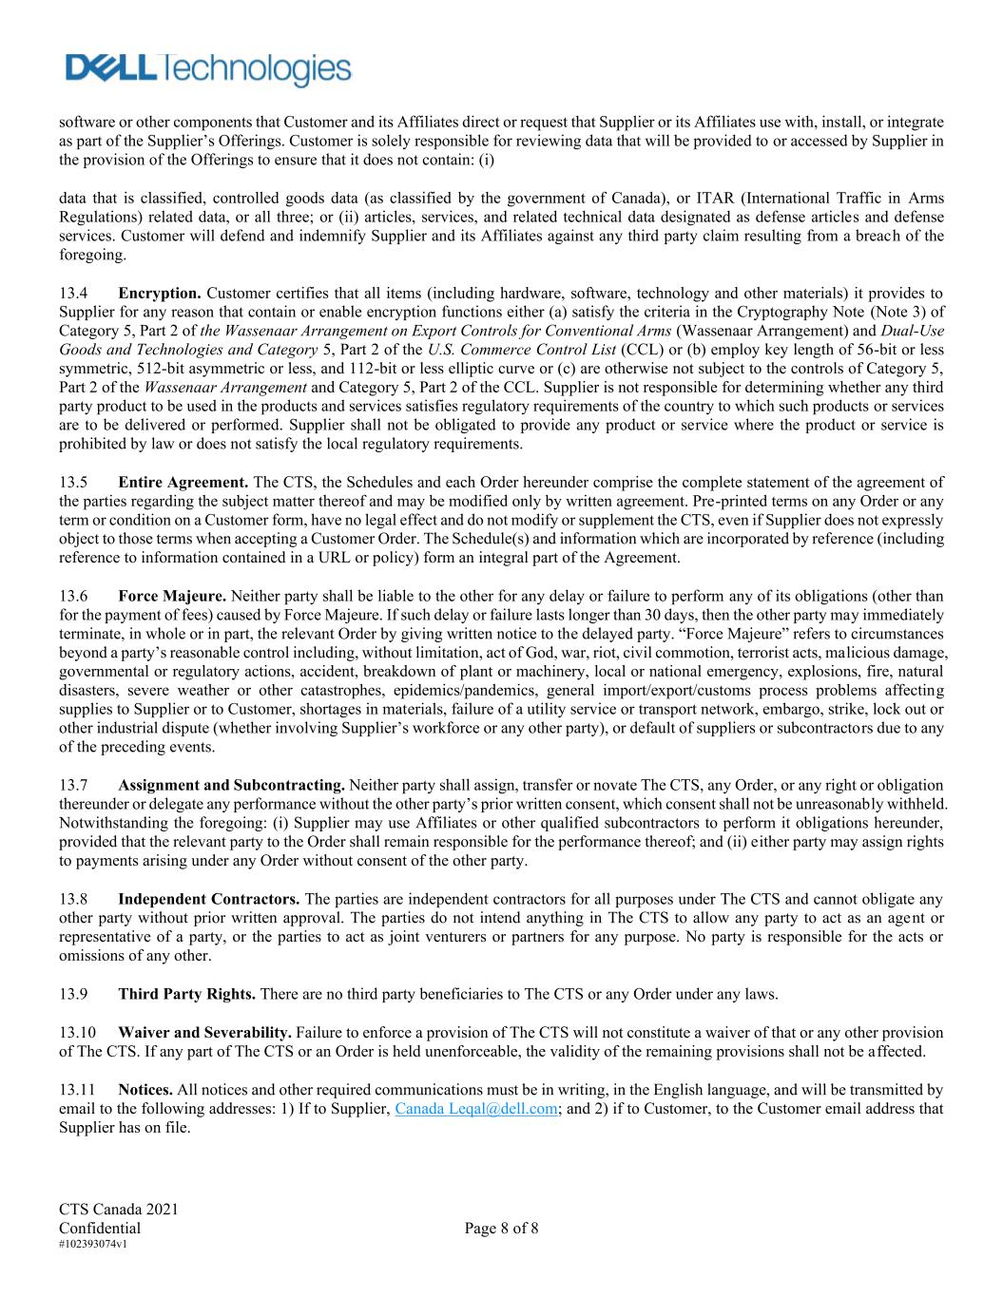
CTS Canada 2021 Confidential Page 8 of 8 #102393074v1 software or other components that Customer and its Affiliates direct or request that Supplier or its Affiliates use with, install, or integrate as part of the Supplier’s Offerings. Customer is solely responsible for reviewing data that will be provided to or accessed by Supplier in the provision of the Offerings to ensure that it does not contain: (i) data that is classified, controlled goods data (as classified by the government of Canada), or ITAR (International Traffic in Arms Regulations) related data, or all three; or (ii) articles, services, and related technical data designated as defense articles and defense services. Customer will defend and indemnify Supplier and its Affiliates against any third party claim resulting from a breach of the foregoing. 13.4 Encryption. Customer certifies that all items (including hardware, software, technology and other materials) it provides to Supplier for any reason that contain or enable encryption functions either (a) satisfy the criteria in the Cryptography Note (Note 3) of Category 5, Part 2 of the Wassenaar Arrangement on Export Controls for Conventional Arms (Wassenaar Arrangement) and Dual-Use Goods and Technologies and Category 5, Part 2 of the U.S. Commerce Control List (CCL) or (b) employ key length of 56-bit or less symmetric, 512-bit asymmetric or less, and 112-bit or less elliptic curve or (c) are otherwise not subject to the controls of Category 5, Part 2 of the Wassenaar Arrangement and Category 5, Part 2 of the CCL. Supplier is not responsible for determining whether any third party product to be used in the products and services satisfies regulatory requirements of the country to which such products or services are to be delivered or performed. Supplier shall not be obligated to provide any product or service where the product or service is prohibited by law or does not satisfy the local regulatory requirements. 13.5 Entire Agreement. The CTS, the Schedules and each Order hereunder comprise the complete statement of the agreement of the parties regarding the subject matter thereof and may be modified only by written agreement. Pre-printed terms on any Order or any term or condition on a Customer form, have no legal effect and do not modify or supplement the CTS, even if Supplier does not expressly object to those terms when accepting a Customer Order. The Schedule(s) and information which are incorporated by reference (including reference to information contained in a URL or policy) form an integral part of the Agreement. 13.6 Force Majeure. Neither party shall be liable to the other for any delay or failure to perform any of its obligations (other than for the payment of fees) caused by Force Majeure. If such delay or failure lasts longer than 30 days, then the other party may immediately terminate, in whole or in part, the relevant Order by giving written notice to the delayed party. “Force Majeure” refers to circumstances beyond a party’s reasonable control including, without limitation, act of God, war, riot, civil commotion, terrorist acts, malicious damage, governmental or regulatory actions, accident, breakdown of plant or machinery, local or national emergency, explosions, fire, natural disasters, severe weather or other catastrophes, epidemics/pandemics, general import/export/customs process problems affecting supplies to Supplier or to Customer, shortages in materials, failure of a utility service or transport network, embargo, strike, lock out or other industrial dispute (whether involving Supplier’s workforce or any other party), or default of suppliers or subcontractors due to any of the preceding events. 13.7 Assignment and Subcontracting. Neither party shall assign, transfer or novate The CTS, any Order, or any right or obligation thereunder or delegate any performance without the other party’s prior written consent, which consent shall not be unreasonably withheld. Notwithstanding the foregoing: (i) Supplier may use Affiliates or other qualified subcontractors to perform it obligations hereunder, provided that the relevant party to the Order shall remain responsible for the performance thereof; and (ii) either party may assign rights to payments arising under any Order without consent of the other party. 13.8 Independent Contractors. The parties are independent contractors for all purposes under The CTS and cannot obligate any other party without prior written approval. The parties do not intend anything in The CTS to allow any party to act as an agent or representative of a party, or the parties to act as joint venturers or partners for any purpose. No party is responsible for the acts or omissions of any other. 13.9 Third Party Rights. There are no third party beneficiaries to The CTS or any Order under any laws. 13.10 Waiver and Severability. Failure to enforce a provision of The CTS will not constitute a waiver of that or any other provision of The CTS. If any part of The CTS or an Order is held unenforceable, the validity of the remaining provisions shall not be affected. 13.11 Notices. All notices and other required communications must be in writing, in the English language, and will be transmitted by email to the following addresses: 1) If to Supplier, Canada Leqal@dell.com; and 2) if to Customer, to the Customer email address that Supplier has on file.

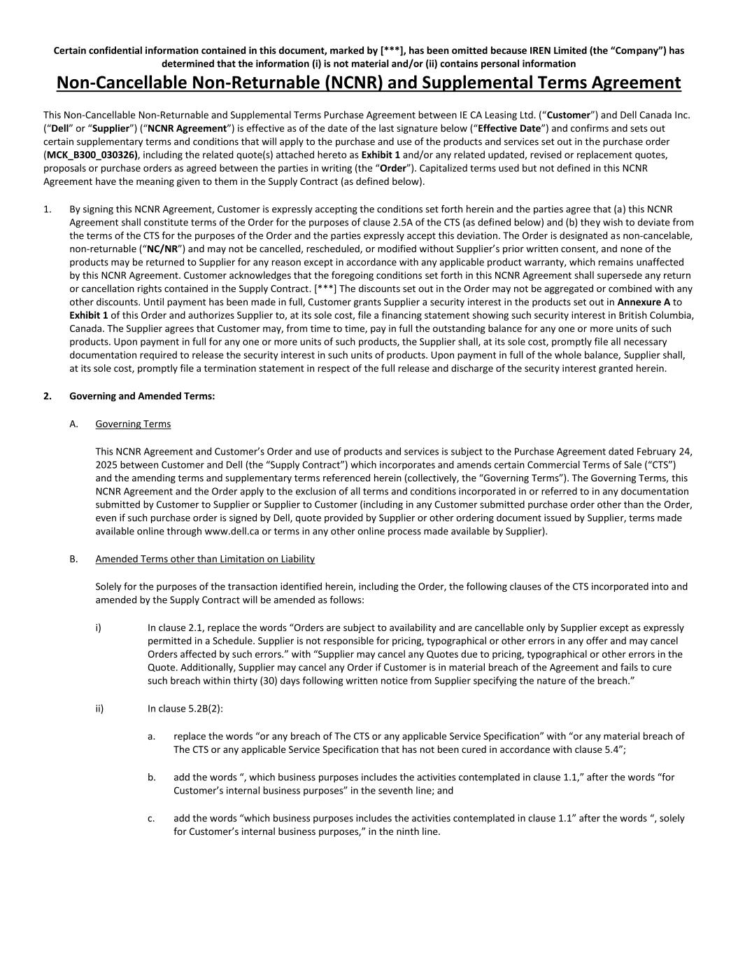
Certain confidential information contained in this document, marked by [***], has been omitted because IREN Limited (the “Company”) has determined that the information (i) is not material and/or (ii) contains personal information Non-Cancellable Non-Returnable (NCNR) and Supplemental Terms Agreement This Non-Cancellable Non-Returnable and Supplemental Terms Purchase Agreement between IE CA Leasing Ltd. (“Customer”) and Dell Canada Inc. (“Dell” or “Supplier”) (“NCNR Agreement”) is effective as of the date of the last signature below (“Effective Date”) and confirms and sets out certain supplementary terms and conditions that will apply to the purchase and use of the products and services set out in the purchase order (MCK_B300_030326), including the related quote(s) attached hereto as Exhibit 1 and/or any related updated, revised or replacement quotes, proposals or purchase orders as agreed between the parties in writing (the “Order”). Capitalized terms used but not defined in this NCNR Agreement have the meaning given to them in the Supply Contract (as defined below). 1. By signing this NCNR Agreement, Customer is expressly accepting the conditions set forth herein and the parties agree that (a) this NCNR Agreement shall constitute terms of the Order for the purposes of clause 2.5A of the CTS (as defined below) and (b) they wish to deviate from the terms of the CTS for the purposes of the Order and the parties expressly accept this deviation. The Order is designated as non-cancelable, non-returnable (“NC/NR”) and may not be cancelled, rescheduled, or modified without Supplier’s prior written consent, and none of the products may be returned to Supplier for any reason except in accordance with any applicable product warranty, which remains unaffected by this NCNR Agreement. Customer acknowledges that the foregoing conditions set forth in this NCNR Agreement shall supersede any return or cancellation rights contained in the Supply Contract. [***] The discounts set out in the Order may not be aggregated or combined with any other discounts. Until payment has been made in full, Customer grants Supplier a security interest in the products set out in Annexure A to Exhibit 1 of this Order and authorizes Supplier to, at its sole cost, file a financing statement showing such security interest in British Columbia, Canada. The Supplier agrees that Customer may, from time to time, pay in full the outstanding balance for any one or more units of such products. Upon payment in full for any one or more units of such products, the Supplier shall, at its sole cost, promptly file all necessary documentation required to release the security interest in such units of products. Upon payment in full of the whole balance, Supplier shall, at its sole cost, promptly file a termination statement in respect of the full release and discharge of the security interest granted herein. 2. Governing and Amended Terms: A. Governing Terms This NCNR Agreement and Customer’s Order and use of products and services is subject to the Purchase Agreement dated February 24, 2025 between Customer and Dell (the “Supply Contract”) which incorporates and amends certain Commercial Terms of Sale (“CTS”) and the amending terms and supplementary terms referenced herein (collectively, the “Governing Terms”). The Governing Terms, this NCNR Agreement and the Order apply to the exclusion of all terms and conditions incorporated in or referred to in any documentation submitted by Customer to Supplier or Supplier to Customer (including in any Customer submitted purchase order other than the Order, even if such purchase order is signed by Dell, quote provided by Supplier or other ordering document issued by Supplier, terms made available online through www.dell.ca or terms in any other online process made available by Supplier). B. Amended Terms other than Limitation on Liability Solely for the purposes of the transaction identified herein, including the Order, the following clauses of the CTS incorporated into and amended by the Supply Contract will be amended as follows: i) In clause 2.1, replace the words “Orders are subject to availability and are cancellable only by Supplier except as expressly permitted in a Schedule. Supplier is not responsible for pricing, typographical or other errors in any offer and may cancel Orders affected by such errors.” with “Supplier may cancel any Quotes due to pricing, typographical or other errors in the Quote. Additionally, Supplier may cancel any Order if Customer is in material breach of the Agreement and fails to cure such breach within thirty (30) days following written notice from Supplier specifying the nature of the breach.” ii) In clause 5.2B(2): a. replace the words “or any breach of The CTS or any applicable Service Specification” with “or any material breach of The CTS or any applicable Service Specification that has not been cured in accordance with clause 5.4”; b. add the words “, which business purposes includes the activities contemplated in clause 1.1,” after the words “for Customer’s internal business purposes” in the seventh line; and c. add the words “which business purposes includes the activities contemplated in clause 1.1” after the words “, solely for Customer’s internal business purposes,” in the ninth line.

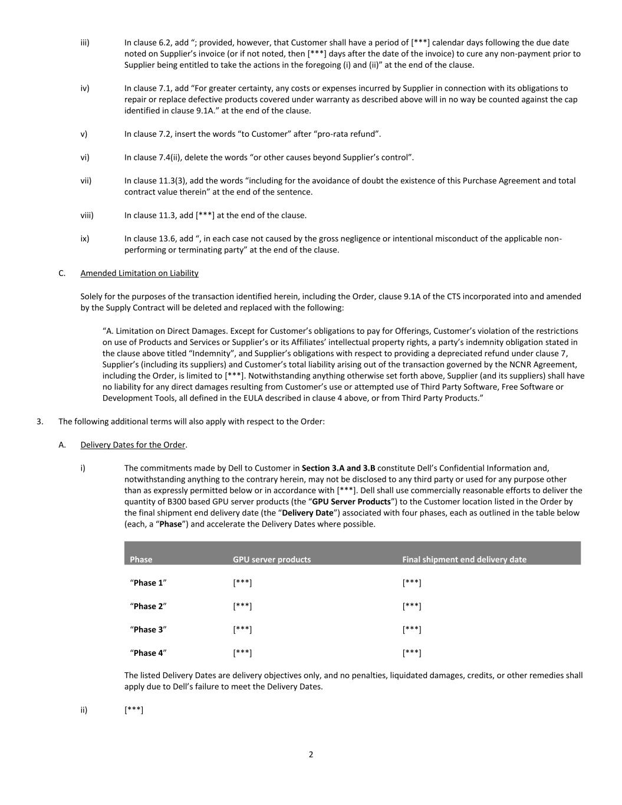
2 iii) In clause 6.2, add “; provided, however, that Customer shall have a period of [***] calendar days following the due date noted on Supplier’s invoice (or if not noted, then [***] days after the date of the invoice) to cure any non-payment prior to Supplier being entitled to take the actions in the foregoing (i) and (ii)” at the end of the clause. iv) In clause 7.1, add “For greater certainty, any costs or expenses incurred by Supplier in connection with its obligations to repair or replace defective products covered under warranty as described above will in no way be counted against the cap identified in clause 9.1A.” at the end of the clause. v) In clause 7.2, insert the words “to Customer” after “pro-rata refund”. vi) In clause 7.4(ii), delete the words “or other causes beyond Supplier’s control”. vii) In clause 11.3(3), add the words “including for the avoidance of doubt the existence of this Purchase Agreement and total contract value therein” at the end of the sentence. viii) In clause 11.3, add [***] at the end of the clause. ix) In clause 13.6, add “, in each case not caused by the gross negligence or intentional misconduct of the applicable non- performing or terminating party” at the end of the clause. C. Amended Limitation on Liability Solely for the purposes of the transaction identified herein, including the Order, clause 9.1A of the CTS incorporated into and amended by the Supply Contract will be deleted and replaced with the following: “A. Limitation on Direct Damages. Except for Customer’s obligations to pay for Offerings, Customer’s violation of the restrictions on use of Products and Services or Supplier’s or its Affiliates’ intellectual property rights, a party’s indemnity obligation stated in the clause above titled “Indemnity”, and Supplier’s obligations with respect to providing a depreciated refund under clause 7, Supplier’s (including its suppliers) and Customer’s total liability arising out of the transaction governed by the NCNR Agreement, including the Order, is limited to [***]. Notwithstanding anything otherwise set forth above, Supplier (and its suppliers) shall have no liability for any direct damages resulting from Customer’s use or attempted use of Third Party Software, Free Software or Development Tools, all defined in the EULA described in clause 4 above, or from Third Party Products.” 3. The following additional terms will also apply with respect to the Order: A. Delivery Dates for the Order. i) The commitments made by Dell to Customer in Section 3.A and 3.B constitute Dell’s Confidential Information and, notwithstanding anything to the contrary herein, may not be disclosed to any third party or used for any purpose other than as expressly permitted below or in accordance with [***]. Dell shall use commercially reasonable efforts to deliver the quantity of B300 based GPU server products (the “GPU Server Products”) to the Customer location listed in the Order by the final shipment end delivery date (the “Delivery Date”) associated with four phases, each as outlined in the table below (each, a “Phase”) and accelerate the Delivery Dates where possible. Phase GPU server products Final shipment end delivery date “Phase 1” [***] [***] “Phase 2” [***] [***] “Phase 3” [***] [***] “Phase 4” [***] [***] The listed Delivery Dates are delivery objectives only, and no penalties, liquidated damages, credits, or other remedies shall apply due to Dell’s failure to meet the Delivery Dates. ii) [***]

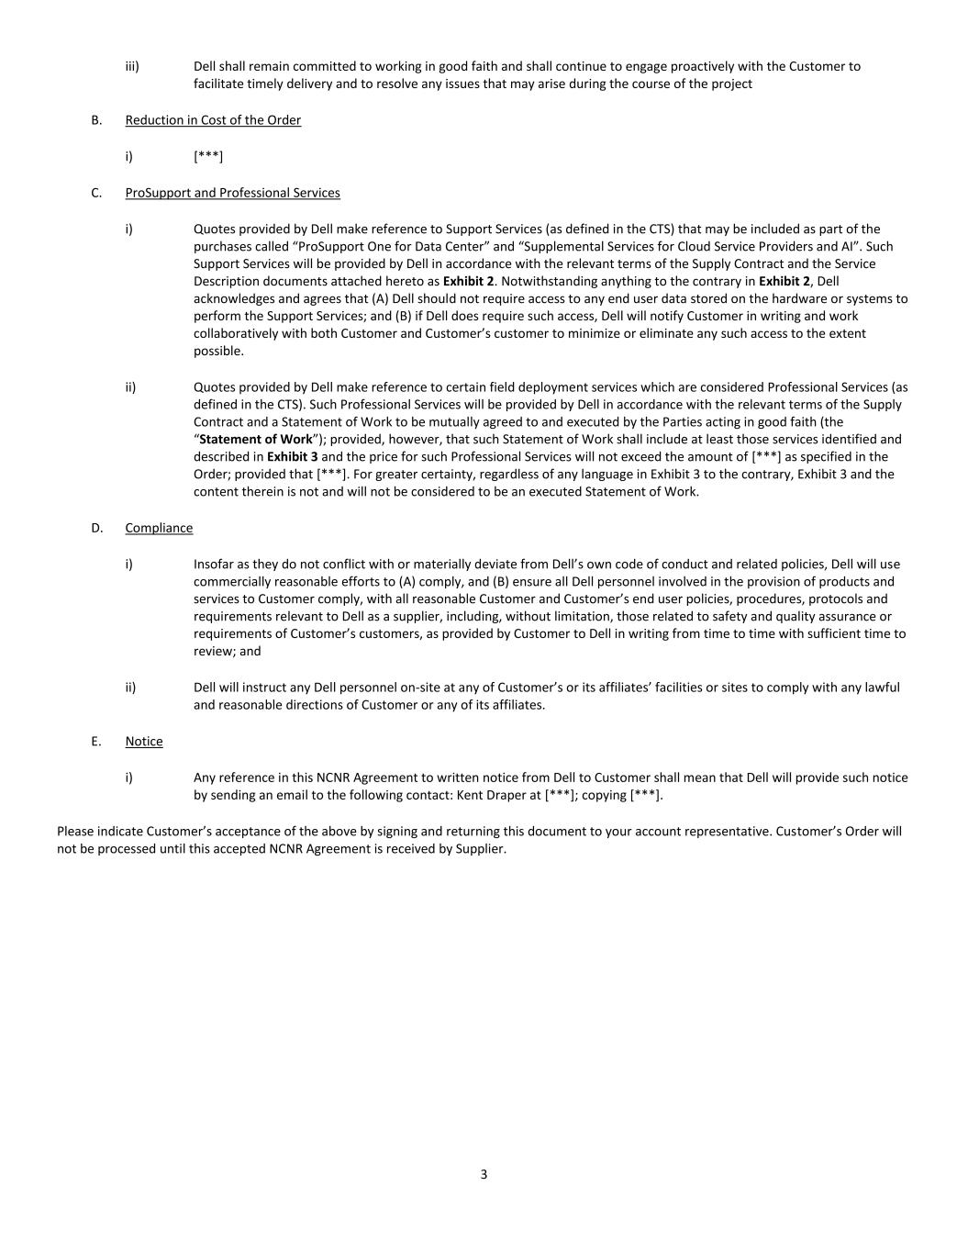
3 iii) Dell shall remain committed to working in good faith and shall continue to engage proactively with the Customer to facilitate timely delivery and to resolve any issues that may arise during the course of the project B. Reduction in Cost of the Order i) [***] C. ProSupport and Professional Services i) Quotes provided by Dell make reference to Support Services (as defined in the CTS) that may be included as part of the purchases called “ProSupport One for Data Center” and “Supplemental Services for Cloud Service Providers and AI”. Such Support Services will be provided by Dell in accordance with the relevant terms of the Supply Contract and the Service Description documents attached hereto as Exhibit 2. Notwithstanding anything to the contrary in Exhibit 2, Dell acknowledges and agrees that (A) Dell should not require access to any end user data stored on the hardware or systems to perform the Support Services; and (B) if Dell does require such access, Dell will notify Customer in writing and work collaboratively with both Customer and Customer’s customer to minimize or eliminate any such access to the extent possible. ii) Quotes provided by Dell make reference to certain field deployment services which are considered Professional Services (as defined in the CTS). Such Professional Services will be provided by Dell in accordance with the relevant terms of the Supply Contract and a Statement of Work to be mutually agreed to and executed by the Parties acting in good faith (the “Statement of Work”); provided, however, that such Statement of Work shall include at least those services identified and described in Exhibit 3 and the price for such Professional Services will not exceed the amount of [***] as specified in the Order; provided that [***]. For greater certainty, regardless of any language in Exhibit 3 to the contrary, Exhibit 3 and the content therein is not and will not be considered to be an executed Statement of Work. D. Compliance i) Insofar as they do not conflict with or materially deviate from Dell’s own code of conduct and related policies, Dell will use commercially reasonable efforts to (A) comply, and (B) ensure all Dell personnel involved in the provision of products and services to Customer comply, with all reasonable Customer and Customer’s end user policies, procedures, protocols and requirements relevant to Dell as a supplier, including, without limitation, those related to safety and quality assurance or requirements of Customer’s customers, as provided by Customer to Dell in writing from time to time with sufficient time to review; and ii) Dell will instruct any Dell personnel on-site at any of Customer’s or its affiliates’ facilities or sites to comply with any lawful and reasonable directions of Customer or any of its affiliates. E. Notice i) Any reference in this NCNR Agreement to written notice from Dell to Customer shall mean that Dell will provide such notice by sending an email to the following contact: Kent Draper at [***]; copying [***]. Please indicate Customer’s acceptance of the above by signing and returning this document to your account representative. Customer’s Order will not be processed until this accepted NCNR Agreement is received by Supplier.

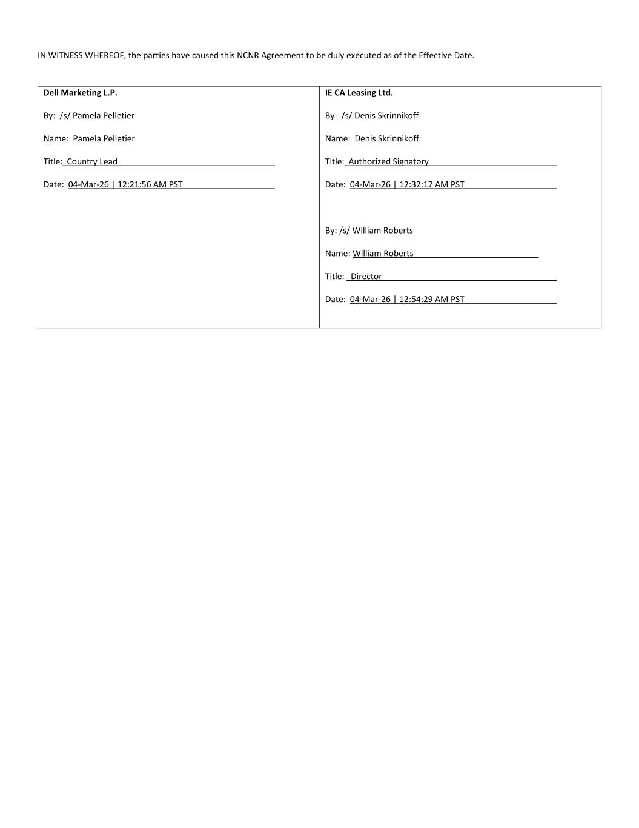
IN WITNESS WHEREOF, the parties have caused this NCNR Agreement to be duly executed as of the Effective Date. Dell Marketing L.P. By: /s/ Pamela Pelletier Name: Pamela Pelletier Title: Country Lead Date: 04-Mar-26 | 12:21:56 AM PST IE CA Leasing Ltd. By: /s/ Denis Skrinnikoff Name: Denis Skrinnikoff Title: Authorized Signatory Date: 04-Mar-26 | 12:32:17 AM PST By: /s/ William Roberts Name: William Roberts Title: Director Date: 04-Mar-26 | 12:54:29 AM PST


Dell Customer Communication - Confidential Exhibit 1 Purchase Order (MCK_B300_030326)

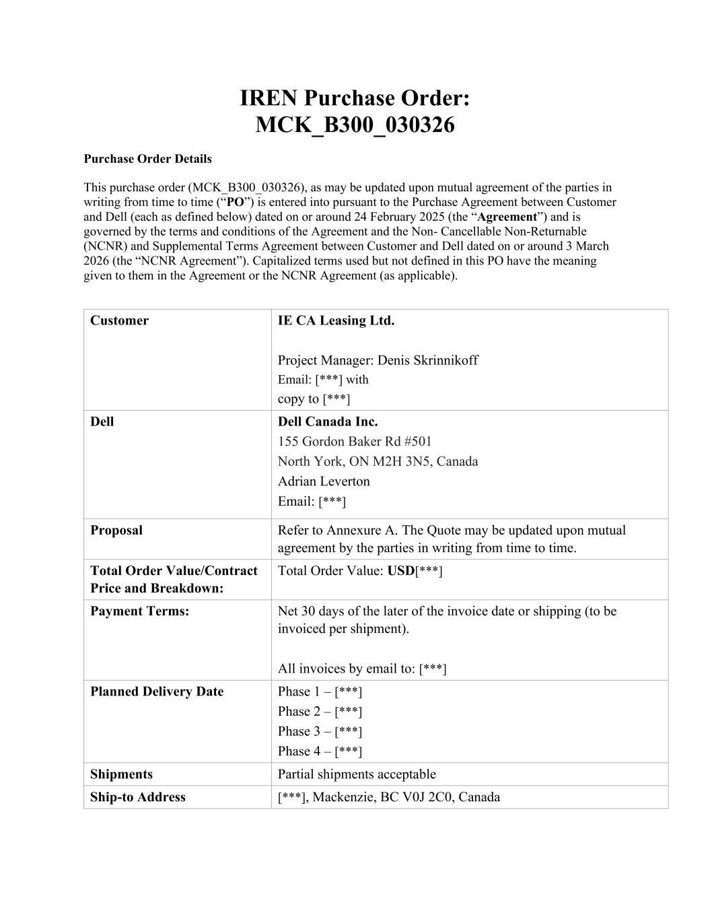
IREN Purchase Order: MCK_B300_030326 Purchase Order Details This purchase order (MCK_B300_030326), as may be updated upon mutual agreement of the parties in writing from time to time (“PO”) is entered into pursuant to the Purchase Agreement between Customer and Dell (each as defined below) dated on or around 24 February 2025 (the “Agreement”) and is governed by the terms and conditions of the Agreement and the Non- Cancellable Non-Returnable (NCNR) and Supplemental Terms Agreement between Customer and Dell dated on or around 3 March 2026 (the “NCNR Agreement”). Capitalized terms used but not defined in this PO have the meaning given to them in the Agreement or the NCNR Agreement (as applicable). Customer IE CA Leasing Ltd. Project Manager: Denis Skrinnikoff Email: [***] with copy to [***] Dell Dell Canada Inc. 155 Gordon Baker Rd #501 North York, ON M2H 3N5, Canada Adrian Leverton Email: [***] Proposal Refer to Annexure A. The Quote may be updated upon mutual agreement by the parties in writing from time to time. Total Order Value/Contract Price and Breakdown: Total Order Value: USD[***] Payment Terms: Net 30 days of the later of the invoice date or shipping (to be invoiced per shipment). All invoices by email to: [***] Planned Delivery Date Phase 1 – [***] Phase 2 – [***] Phase 3 – [***] Phase 4 – [***] Shipments Partial shipments acceptable Ship-to Address [***], Mackenzie, BC V0J 2C0, Canada


Annexure A – Quote [***]


Exhibit 2 Support Services Description [***]


Exhibit 3 Scope of Professional Services [***]

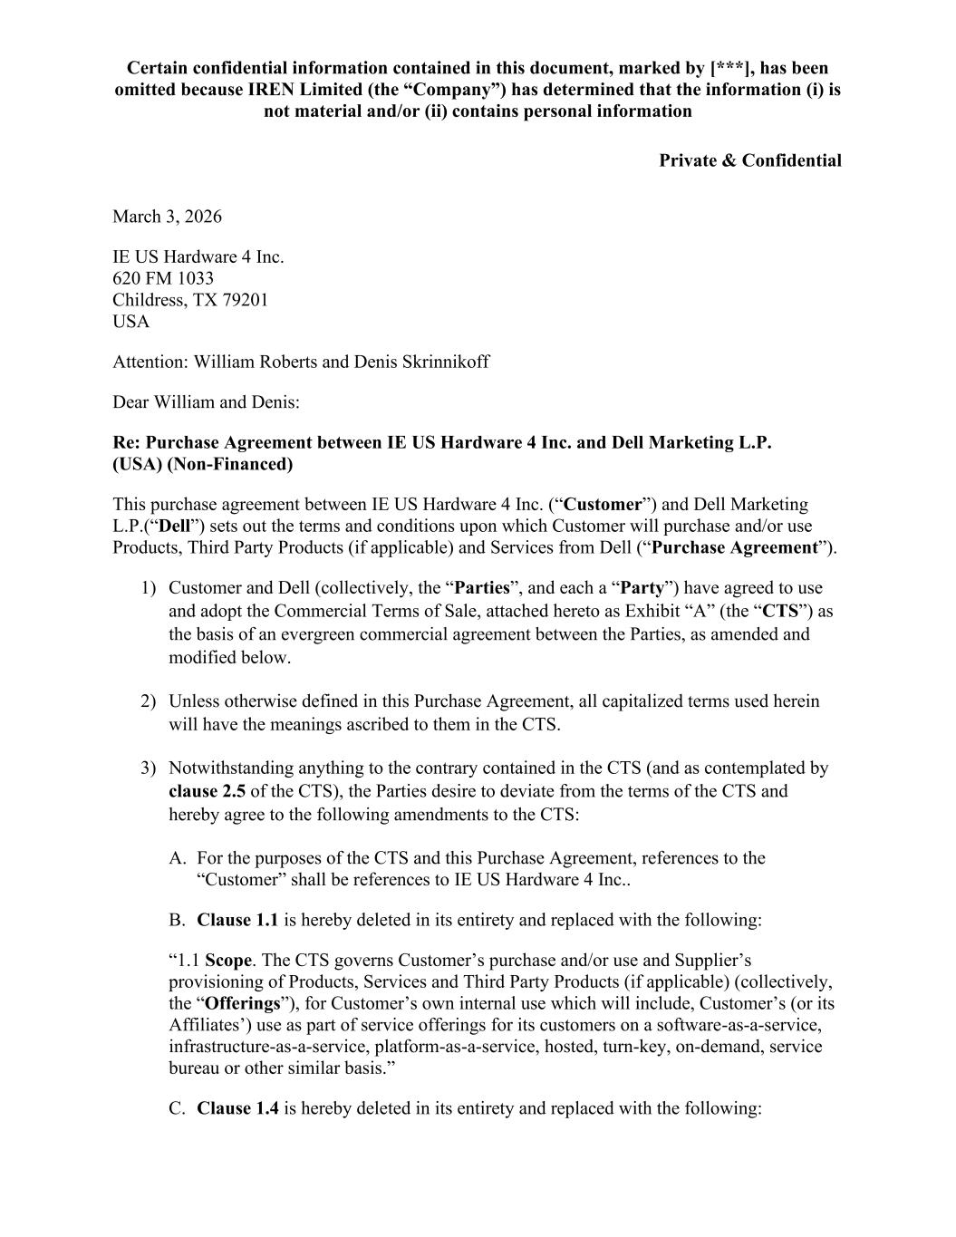
Certain confidential information contained in this document, marked by [***], has been omitted because IREN Limited (the “Company”) has determined that the information (i) is not material and/or (ii) contains personal information Private & Confidential March 3, 2026 IE US Hardware 4 Inc. 620 FM 1033 Childress, TX 79201 USA Attention: William Roberts and Denis Skrinnikoff Dear William and Denis: Re: Purchase Agreement between IE US Hardware 4 Inc. and Dell Marketing L.P. (USA) (Non-Financed) This purchase agreement between IE US Hardware 4 Inc. (“Customer”) and Dell Marketing L.P.(“Dell”) sets out the terms and conditions upon which Customer will purchase and/or use Products, Third Party Products (if applicable) and Services from Dell (“Purchase Agreement”). 1) Customer and Dell (collectively, the “Parties”, and each a “Party”) have agreed to use and adopt the Commercial Terms of Sale, attached hereto as Exhibit “A” (the “CTS”) as the basis of an evergreen commercial agreement between the Parties, as amended and modified below. 2) Unless otherwise defined in this Purchase Agreement, all capitalized terms used herein will have the meanings ascribed to them in the CTS. 3) Notwithstanding anything to the contrary contained in the CTS (and as contemplated by clause 2.5 of the CTS), the Parties desire to deviate from the terms of the CTS and hereby agree to the following amendments to the CTS: A. For the purposes of the CTS and this Purchase Agreement, references to the “Customer” shall be references to IE US Hardware 4 Inc.. B. Clause 1.1 is hereby deleted in its entirety and replaced with the following: “1.1 Scope. The CTS governs Customer’s purchase and/or use and Supplier’s provisioning of Products, Services and Third Party Products (if applicable) (collectively, the “Offerings”), for Customer’s own internal use which will include, Customer’s (or its Affiliates’) use as part of service offerings for its customers on a software-as-a-service, infrastructure-as-a-service, platform-as-a-service, hosted, turn-key, on-demand, service bureau or other similar basis.” C. Clause 1.4 is hereby deleted in its entirety and replaced with the following:

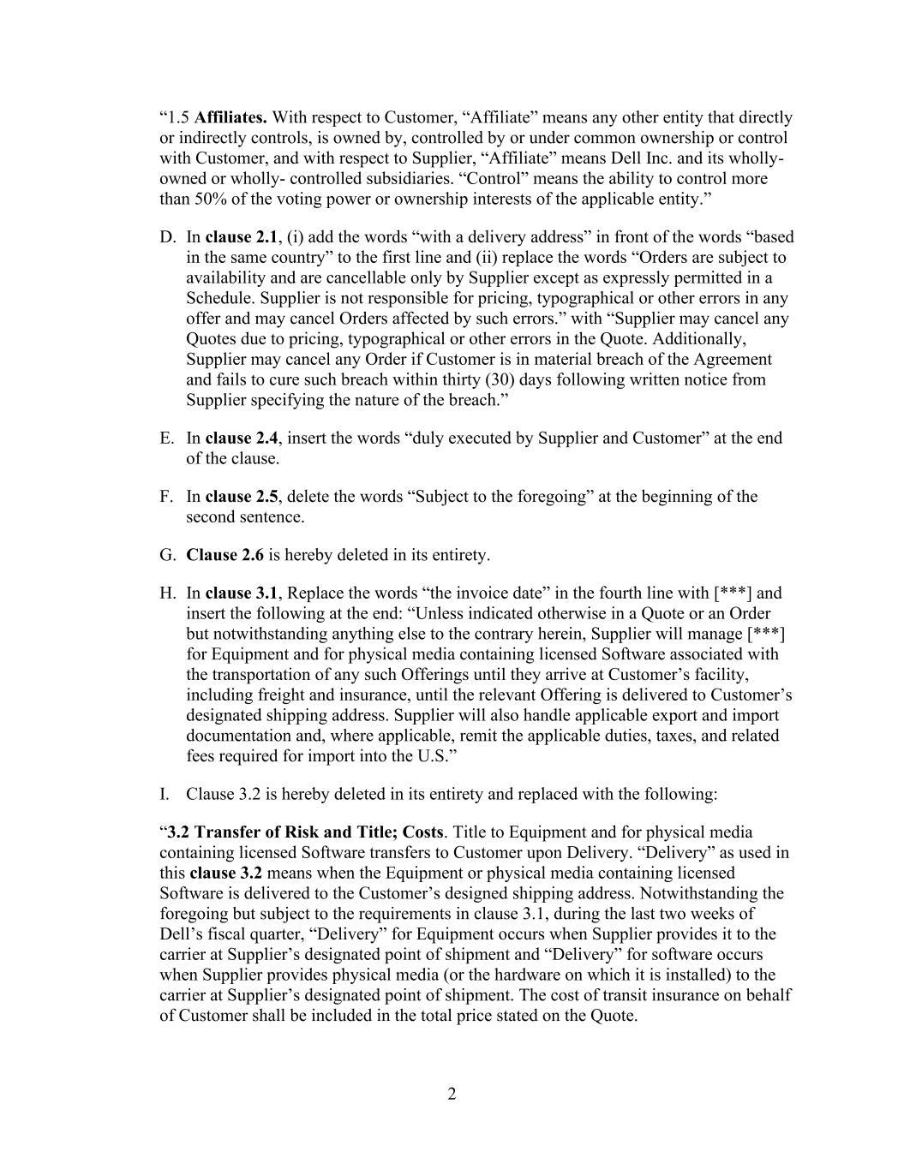
2 “1.5 Affiliates. With respect to Customer, “Affiliate” means any other entity that directly or indirectly controls, is owned by, controlled by or under common ownership or control with Customer, and with respect to Supplier, “Affiliate” means Dell Inc. and its wholly- owned or wholly- controlled subsidiaries. “Control” means the ability to control more than 50% of the voting power or ownership interests of the applicable entity.” D. In clause 2.1, (i) add the words “with a delivery address” in front of the words “based in the same country” to the first line and (ii) replace the words “Orders are subject to availability and are cancellable only by Supplier except as expressly permitted in a Schedule. Supplier is not responsible for pricing, typographical or other errors in any offer and may cancel Orders affected by such errors.” with “Supplier may cancel any Quotes due to pricing, typographical or other errors in the Quote. Additionally, Supplier may cancel any Order if Customer is in material breach of the Agreement and fails to cure such breach within thirty (30) days following written notice from Supplier specifying the nature of the breach.” E. In clause 2.4, insert the words “duly executed by Supplier and Customer” at the end of the clause. F. In clause 2.5, delete the words “Subject to the foregoing” at the beginning of the second sentence. G. Clause 2.6 is hereby deleted in its entirety. H. In clause 3.1, Replace the words “the invoice date” in the fourth line with [***] and insert the following at the end: “Unless indicated otherwise in a Quote or an Order but notwithstanding anything else to the contrary herein, Supplier will manage [***] for Equipment and for physical media containing licensed Software associated with the transportation of any such Offerings until they arrive at Customer’s facility, including freight and insurance, until the relevant Offering is delivered to Customer’s designated shipping address. Supplier will also handle applicable export and import documentation and, where applicable, remit the applicable duties, taxes, and related fees required for import into the U.S.” I. Clause 3.2 is hereby deleted in its entirety and replaced with the following: “3.2 Transfer of Risk and Title; Costs. Title to Equipment and for physical media containing licensed Software transfers to Customer upon Delivery. “Delivery” as used in this clause 3.2 means when the Equipment or physical media containing licensed Software is delivered to the Customer’s designed shipping address. Notwithstanding the foregoing but subject to the requirements in clause 3.1, during the last two weeks of Dell’s fiscal quarter, “Delivery” for Equipment occurs when Supplier provides it to the carrier at Supplier’s designated point of shipment and “Delivery” for software occurs when Supplier provides physical media (or the hardware on which it is installed) to the carrier at Supplier’s designated point of shipment. The cost of transit insurance on behalf of Customer shall be included in the total price stated on the Quote.

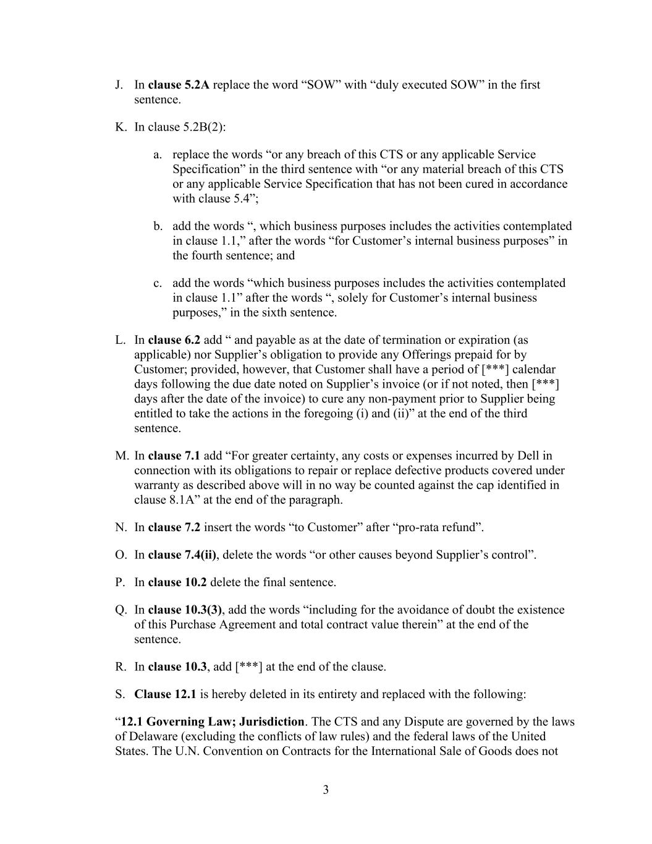
3 J. In clause 5.2A replace the word “SOW” with “duly executed SOW” in the first sentence. K. In clause 5.2B(2): a. replace the words “or any breach of this CTS or any applicable Service Specification” in the third sentence with “or any material breach of this CTS or any applicable Service Specification that has not been cured in accordance with clause 5.4”; b. add the words “, which business purposes includes the activities contemplated in clause 1.1,” after the words “for Customer’s internal business purposes” in the fourth sentence; and c. add the words “which business purposes includes the activities contemplated in clause 1.1” after the words “, solely for Customer’s internal business purposes,” in the sixth sentence. L. In clause 6.2 add “ and payable as at the date of termination or expiration (as applicable) nor Supplier’s obligation to provide any Offerings prepaid for by Customer; provided, however, that Customer shall have a period of [***] calendar days following the due date noted on Supplier’s invoice (or if not noted, then [***] days after the date of the invoice) to cure any non-payment prior to Supplier being entitled to take the actions in the foregoing (i) and (ii)” at the end of the third sentence. M. In clause 7.1 add “For greater certainty, any costs or expenses incurred by Dell in connection with its obligations to repair or replace defective products covered under warranty as described above will in no way be counted against the cap identified in clause 8.1A” at the end of the paragraph. N. In clause 7.2 insert the words “to Customer” after “pro-rata refund”. O. In clause 7.4(ii), delete the words “or other causes beyond Supplier’s control”. P. In clause 10.2 delete the final sentence. Q. In clause 10.3(3), add the words “including for the avoidance of doubt the existence of this Purchase Agreement and total contract value therein” at the end of the sentence. R. In clause 10.3, add [***] at the end of the clause. S. Clause 12.1 is hereby deleted in its entirety and replaced with the following: “12.1 Governing Law; Jurisdiction. The CTS and any Dispute are governed by the laws of Delaware (excluding the conflicts of law rules) and the federal laws of the United States. The U.N. Convention on Contracts for the International Sale of Goods does not

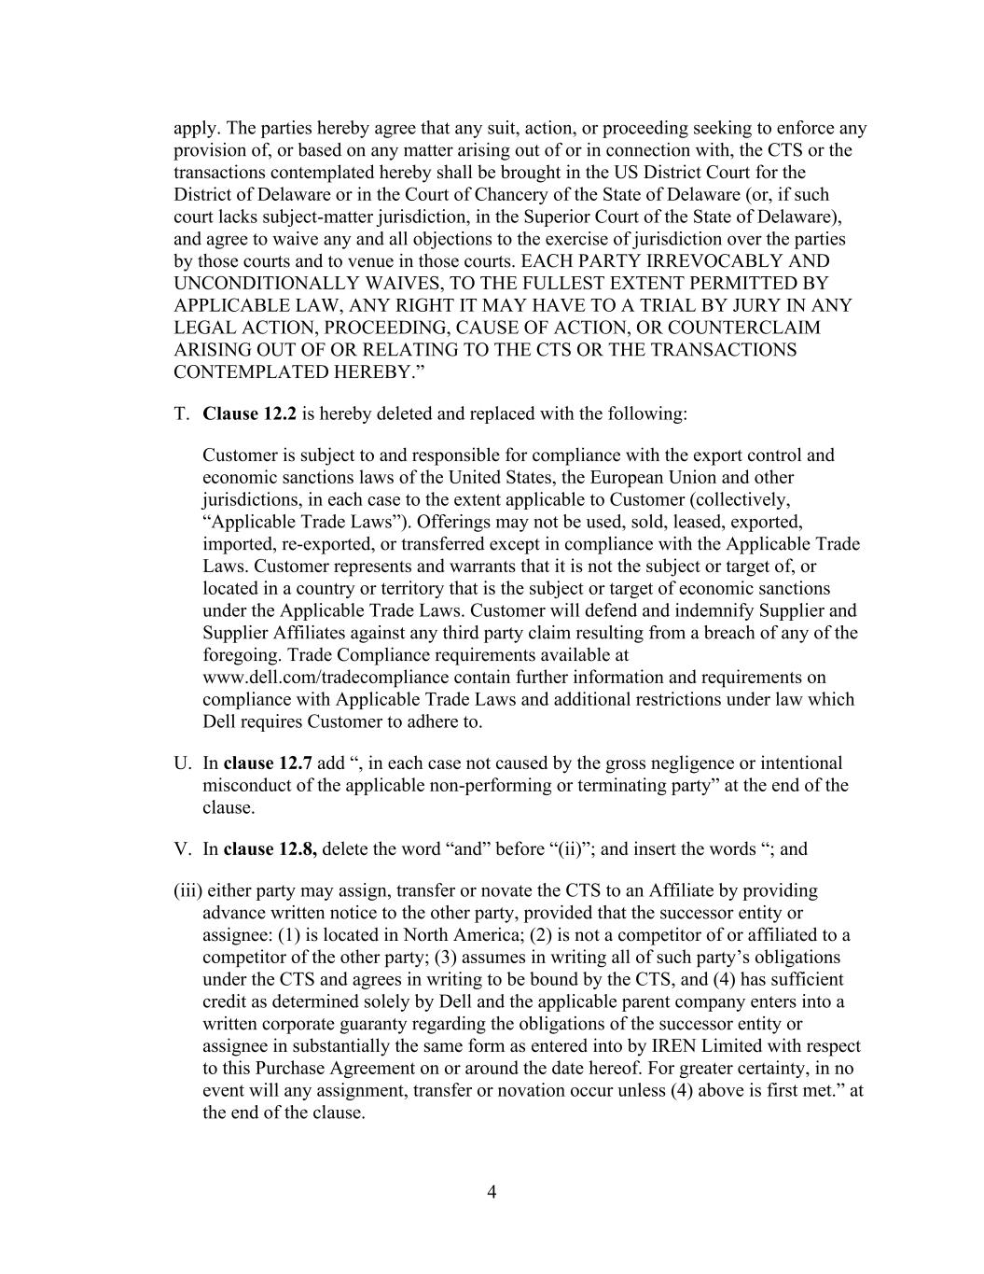
4 apply. The parties hereby agree that any suit, action, or proceeding seeking to enforce any provision of, or based on any matter arising out of or in connection with, the CTS or the transactions contemplated hereby shall be brought in the US District Court for the District of Delaware or in the Court of Chancery of the State of Delaware (or, if such court lacks subject-matter jurisdiction, in the Superior Court of the State of Delaware), and agree to waive any and all objections to the exercise of jurisdiction over the parties by those courts and to venue in those courts. EACH PARTY IRREVOCABLY AND UNCONDITIONALLY WAIVES, TO THE FULLEST EXTENT PERMITTED BY APPLICABLE LAW, ANY RIGHT IT MAY HAVE TO A TRIAL BY JURY IN ANY LEGAL ACTION, PROCEEDING, CAUSE OF ACTION, OR COUNTERCLAIM ARISING OUT OF OR RELATING TO THE CTS OR THE TRANSACTIONS CONTEMPLATED HEREBY.” T. Clause 12.2 is hereby deleted and replaced with the following: Customer is subject to and responsible for compliance with the export control and economic sanctions laws of the United States, the European Union and other jurisdictions, in each case to the extent applicable to Customer (collectively, “Applicable Trade Laws”). Offerings may not be used, sold, leased, exported, imported, re-exported, or transferred except in compliance with the Applicable Trade Laws. Customer represents and warrants that it is not the subject or target of, or located in a country or territory that is the subject or target of economic sanctions under the Applicable Trade Laws. Customer will defend and indemnify Supplier and Supplier Affiliates against any third party claim resulting from a breach of any of the foregoing. Trade Compliance requirements available at www.dell.com/tradecompliance contain further information and requirements on compliance with Applicable Trade Laws and additional restrictions under law which Dell requires Customer to adhere to. U. In clause 12.7 add “, in each case not caused by the gross negligence or intentional misconduct of the applicable non-performing or terminating party” at the end of the clause. V. In clause 12.8, delete the word “and” before “(ii)”; and insert the words “; and (iii) either party may assign, transfer or novate the CTS to an Affiliate by providing advance written notice to the other party, provided that the successor entity or assignee: (1) is located in North America; (2) is not a competitor of or affiliated to a competitor of the other party; (3) assumes in writing all of such party’s obligations under the CTS and agrees in writing to be bound by the CTS, and (4) has sufficient credit as determined solely by Dell and the applicable parent company enters into a written corporate guaranty regarding the obligations of the successor entity or assignee in substantially the same form as entered into by IREN Limited with respect to this Purchase Agreement on or around the date hereof. For greater certainty, in no event will any assignment, transfer or novation occur unless (4) above is first met.” at the end of the clause.

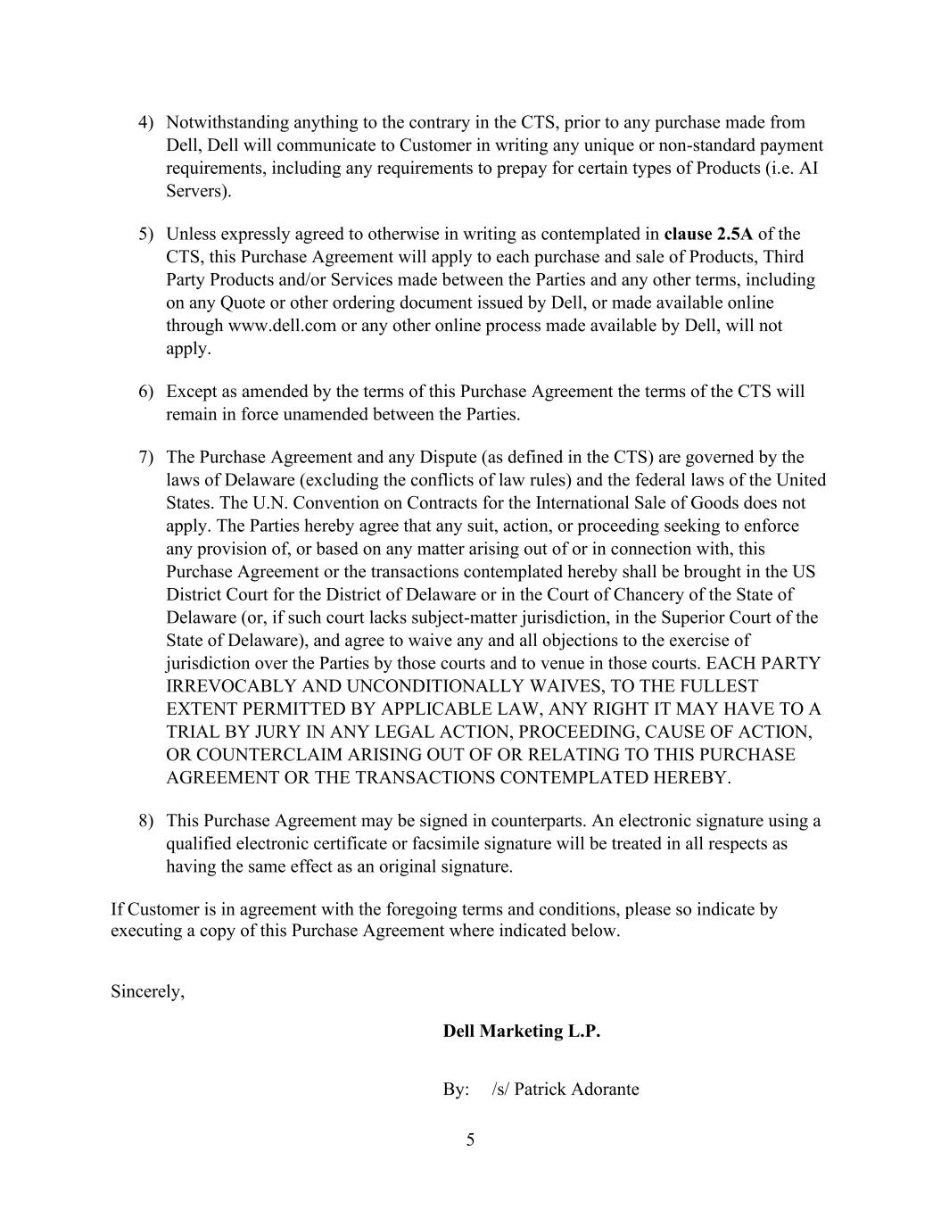
5 4) Notwithstanding anything to the contrary in the CTS, prior to any purchase made from Dell, Dell will communicate to Customer in writing any unique or non-standard payment requirements, including any requirements to prepay for certain types of Products (i.e. AI Servers). 5) Unless expressly agreed to otherwise in writing as contemplated in clause 2.5A of the CTS, this Purchase Agreement will apply to each purchase and sale of Products, Third Party Products and/or Services made between the Parties and any other terms, including on any Quote or other ordering document issued by Dell, or made available online through www.dell.com or any other online process made available by Dell, will not apply. 6) Except as amended by the terms of this Purchase Agreement the terms of the CTS will remain in force unamended between the Parties. 7) The Purchase Agreement and any Dispute (as defined in the CTS) are governed by the laws of Delaware (excluding the conflicts of law rules) and the federal laws of the United States. The U.N. Convention on Contracts for the International Sale of Goods does not apply. The Parties hereby agree that any suit, action, or proceeding seeking to enforce any provision of, or based on any matter arising out of or in connection with, this Purchase Agreement or the transactions contemplated hereby shall be brought in the US District Court for the District of Delaware or in the Court of Chancery of the State of Delaware (or, if such court lacks subject-matter jurisdiction, in the Superior Court of the State of Delaware), and agree to waive any and all objections to the exercise of jurisdiction over the Parties by those courts and to venue in those courts. EACH PARTY IRREVOCABLY AND UNCONDITIONALLY WAIVES, TO THE FULLEST EXTENT PERMITTED BY APPLICABLE LAW, ANY RIGHT IT MAY HAVE TO A TRIAL BY JURY IN ANY LEGAL ACTION, PROCEEDING, CAUSE OF ACTION, OR COUNTERCLAIM ARISING OUT OF OR RELATING TO THIS PURCHASE AGREEMENT OR THE TRANSACTIONS CONTEMPLATED HEREBY. 8) This Purchase Agreement may be signed in counterparts. An electronic signature using a qualified electronic certificate or facsimile signature will be treated in all respects as having the same effect as an original signature. If Customer is in agreement with the foregoing terms and conditions, please so indicate by executing a copy of this Purchase Agreement where indicated below. Sincerely, Dell Marketing L.P. By: /s/ Patrick Adorante

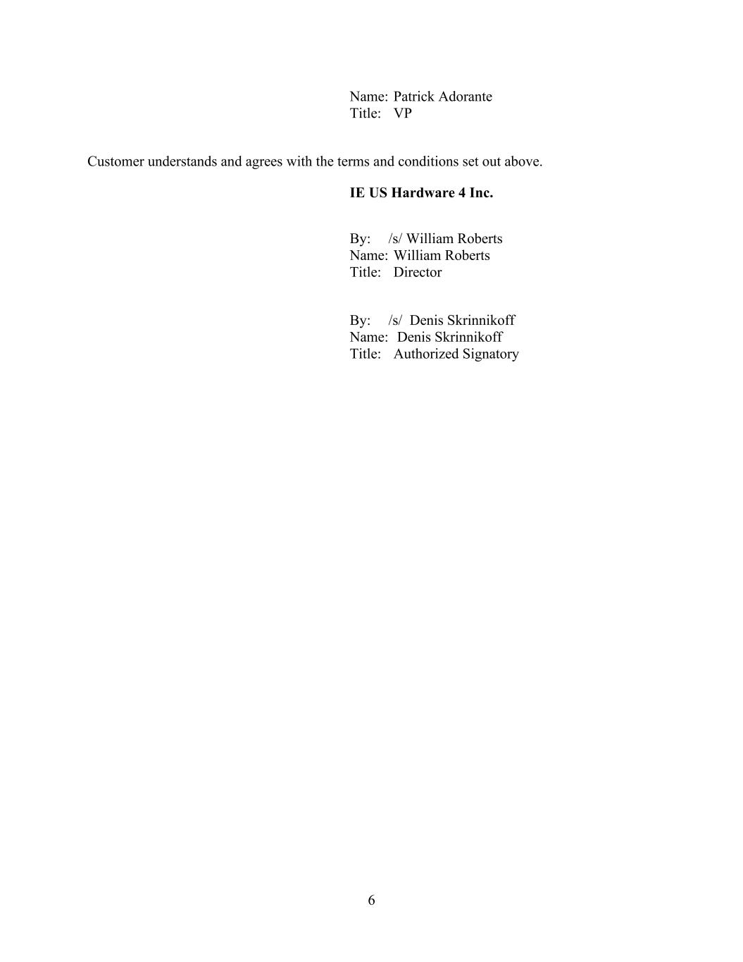
6 Name: Patrick Adorante Title: VP Customer understands and agrees with the terms and conditions set out above. IE US Hardware 4 Inc. By: /s/ William Roberts Name: William Roberts Title: Director By: /s/ Denis Skrinnikoff Name: Denis Skrinnikoff Title: Authorized Signatory


Exhibit A Commercial Terms of Sale (to be attached)

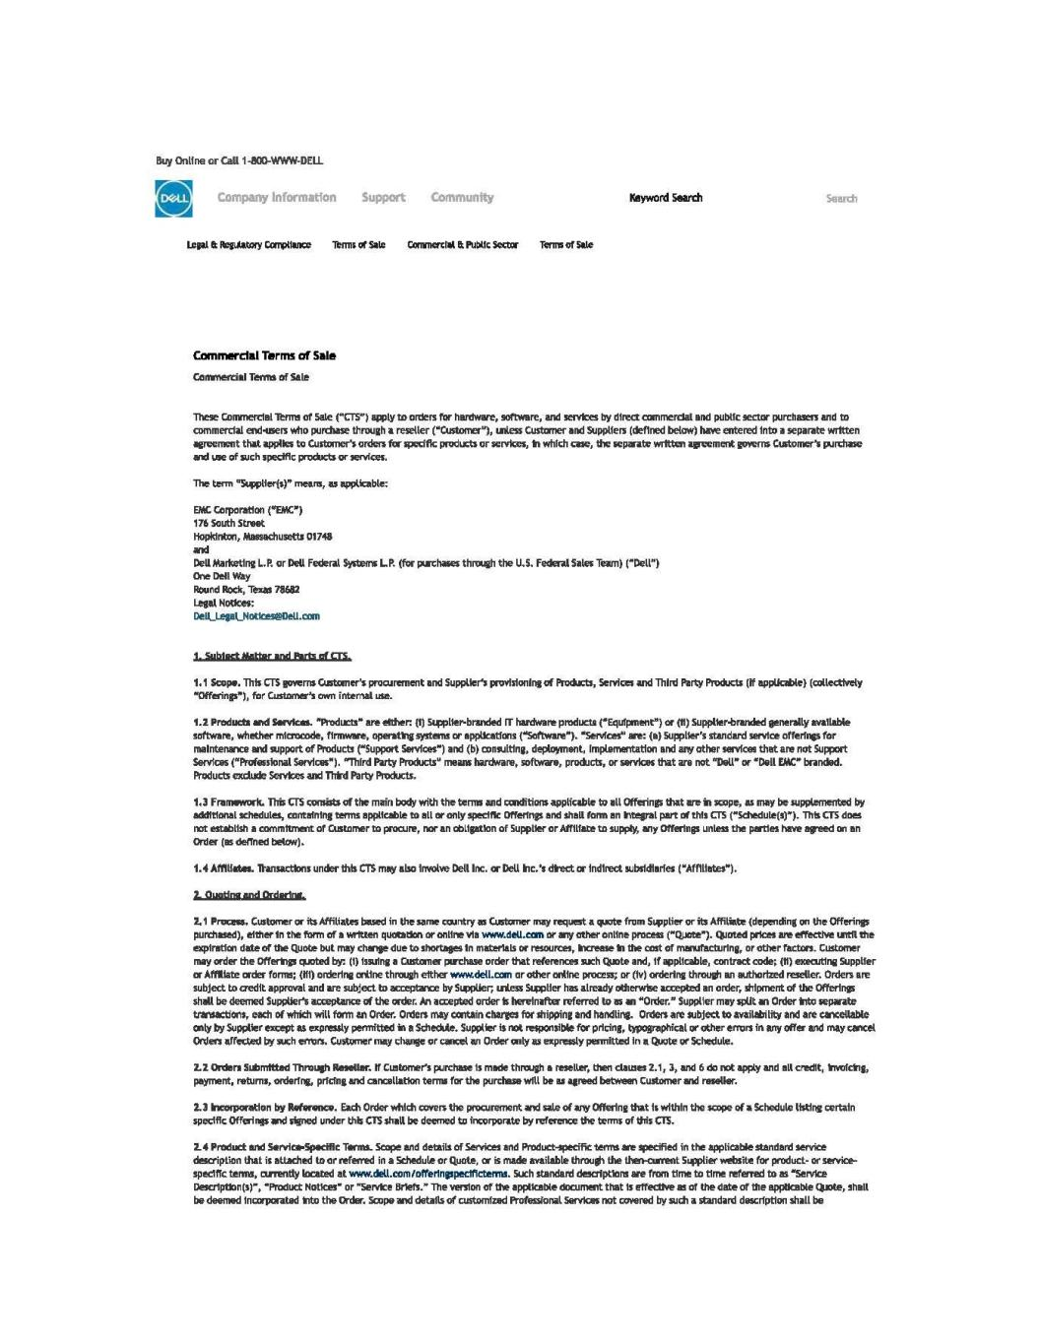

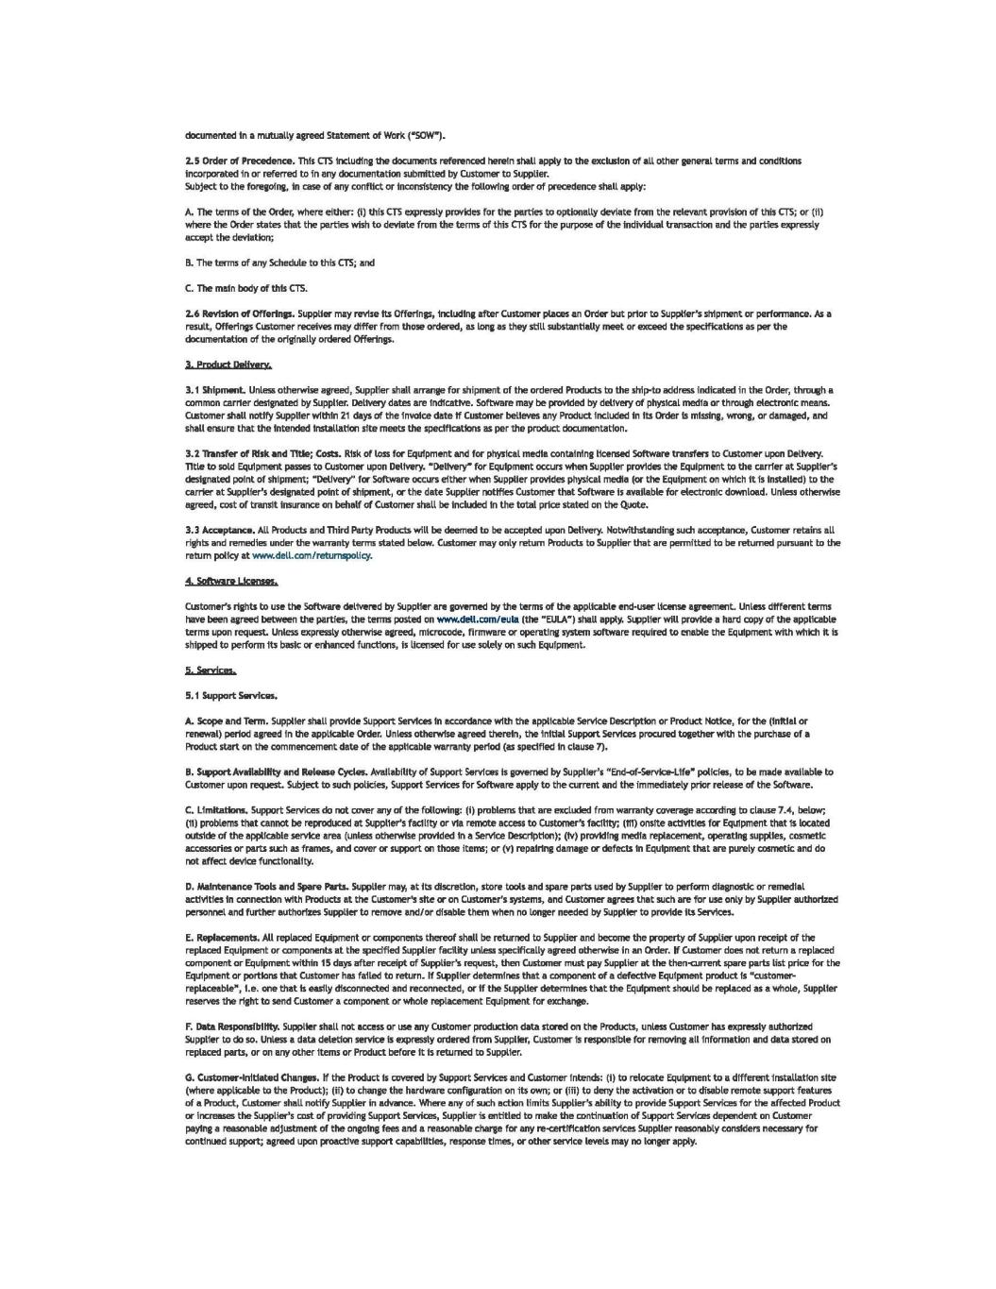

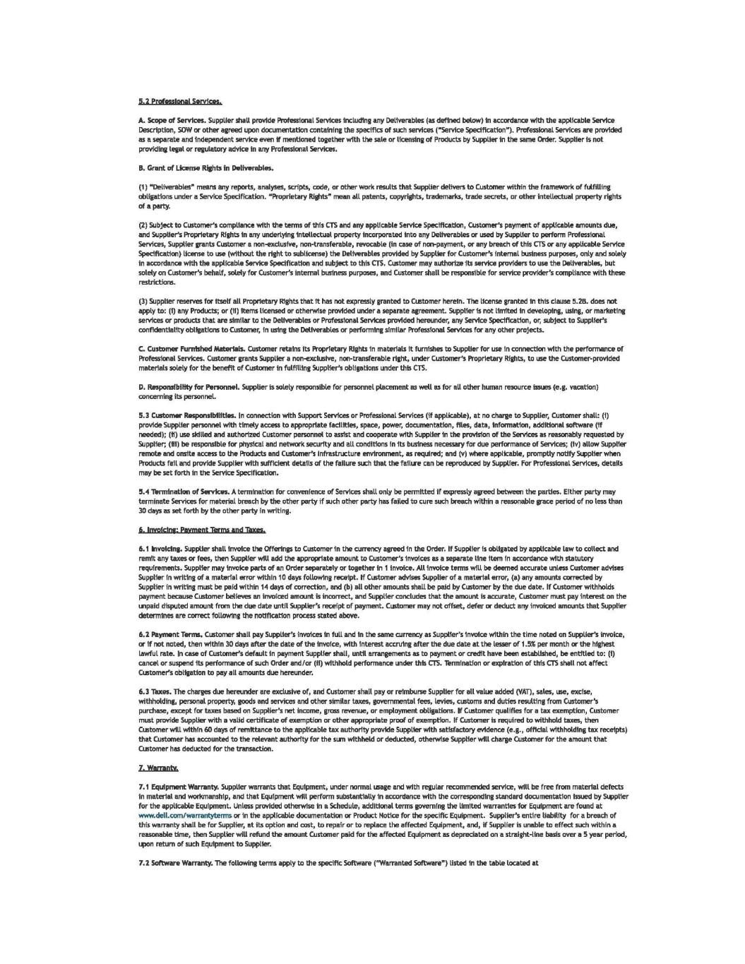

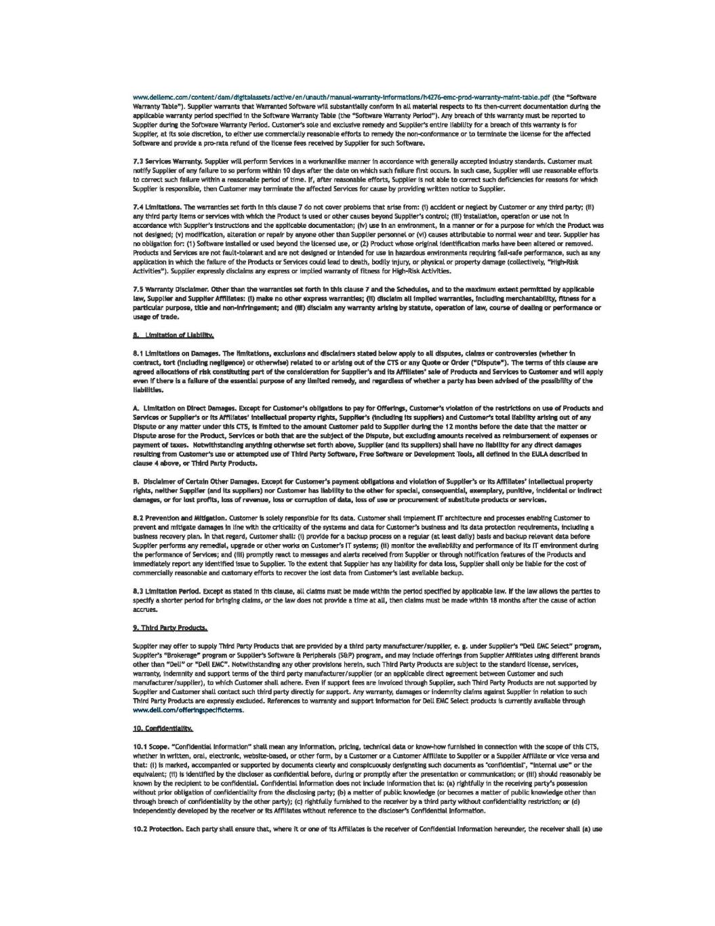

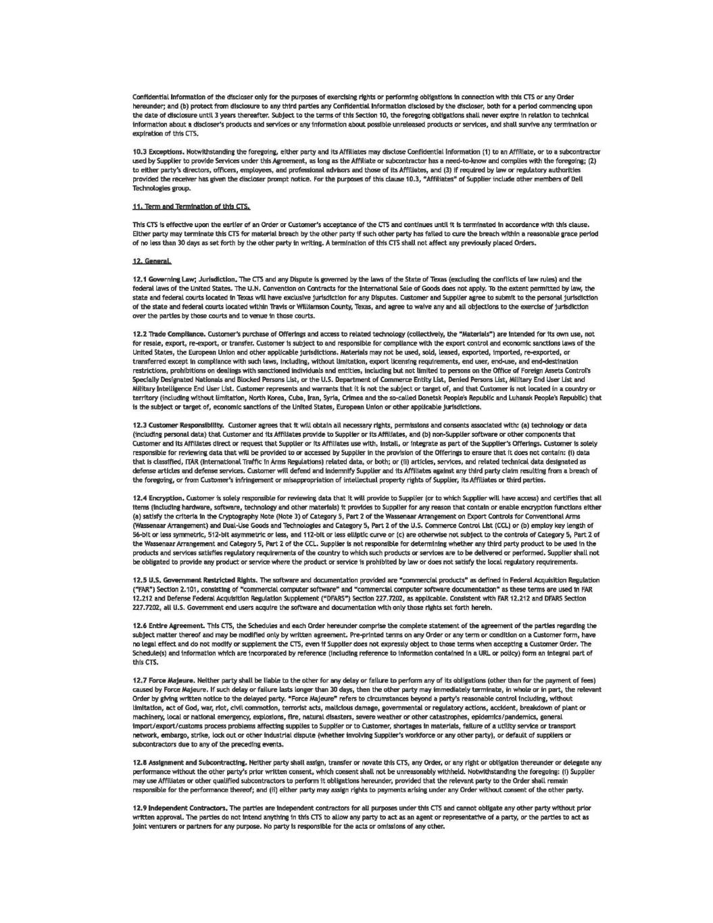

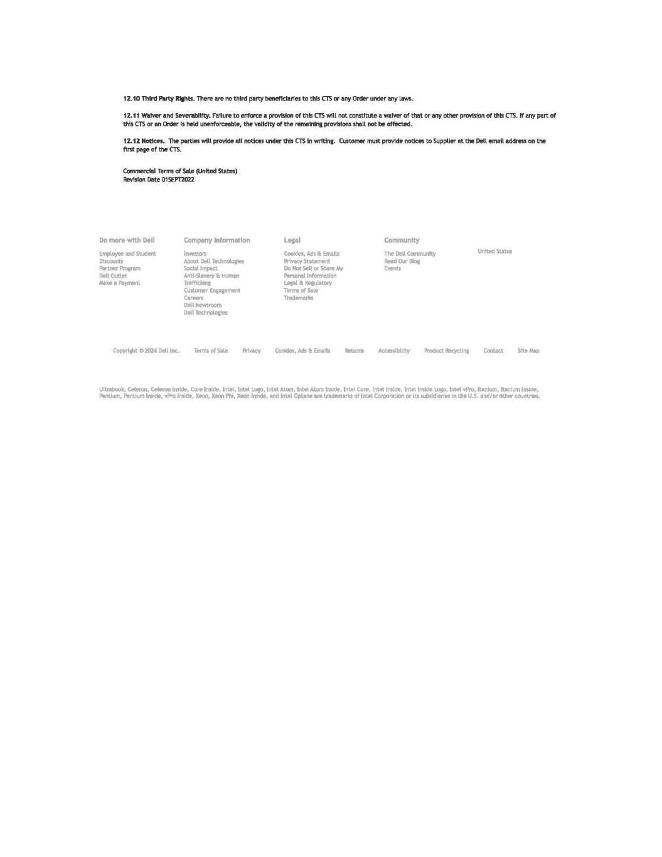

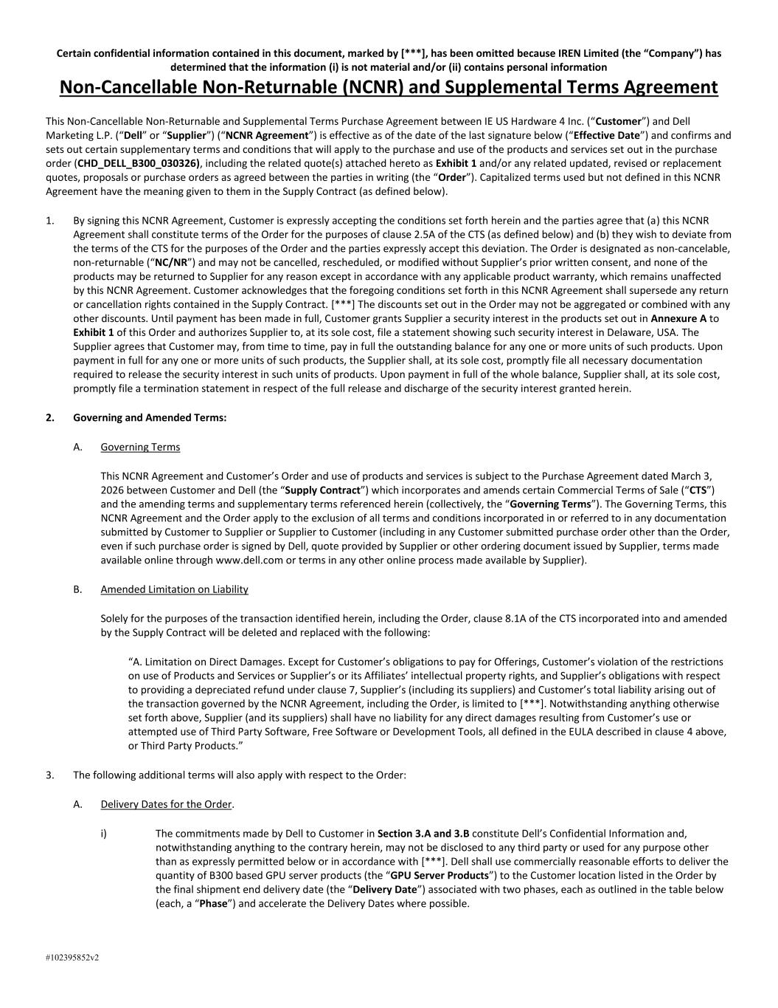
Certain confidential information contained in this document, marked by [***], has been omitted because IREN Limited (the “Company”) has determined that the information (i) is not material and/or (ii) contains personal information #102395852v2 Non-Cancellable Non-Returnable (NCNR) and Supplemental Terms Agreement This Non-Cancellable Non-Returnable and Supplemental Terms Purchase Agreement between IE US Hardware 4 Inc. (“Customer”) and Dell Marketing L.P. (“Dell” or “Supplier”) (“NCNR Agreement”) is effective as of the date of the last signature below (“Effective Date”) and confirms and sets out certain supplementary terms and conditions that will apply to the purchase and use of the products and services set out in the purchase order (CHD_DELL_B300_030326), including the related quote(s) attached hereto as Exhibit 1 and/or any related updated, revised or replacement quotes, proposals or purchase orders as agreed between the parties in writing (the “Order”). Capitalized terms used but not defined in this NCNR Agreement have the meaning given to them in the Supply Contract (as defined below). 1. By signing this NCNR Agreement, Customer is expressly accepting the conditions set forth herein and the parties agree that (a) this NCNR Agreement shall constitute terms of the Order for the purposes of clause 2.5A of the CTS (as defined below) and (b) they wish to deviate from the terms of the CTS for the purposes of the Order and the parties expressly accept this deviation. The Order is designated as non-cancelable, non-returnable (“NC/NR”) and may not be cancelled, rescheduled, or modified without Supplier’s prior written consent, and none of the products may be returned to Supplier for any reason except in accordance with any applicable product warranty, which remains unaffected by this NCNR Agreement. Customer acknowledges that the foregoing conditions set forth in this NCNR Agreement shall supersede any return or cancellation rights contained in the Supply Contract. [***] The discounts set out in the Order may not be aggregated or combined with any other discounts. Until payment has been made in full, Customer grants Supplier a security interest in the products set out in Annexure A to Exhibit 1 of this Order and authorizes Supplier to, at its sole cost, file a statement showing such security interest in Delaware, USA. The Supplier agrees that Customer may, from time to time, pay in full the outstanding balance for any one or more units of such products. Upon payment in full for any one or more units of such products, the Supplier shall, at its sole cost, promptly file all necessary documentation required to release the security interest in such units of products. Upon payment in full of the whole balance, Supplier shall, at its sole cost, promptly file a termination statement in respect of the full release and discharge of the security interest granted herein. 2. Governing and Amended Terms: A. Governing Terms This NCNR Agreement and Customer’s Order and use of products and services is subject to the Purchase Agreement dated March 3, 2026 between Customer and Dell (the “Supply Contract”) which incorporates and amends certain Commercial Terms of Sale (“CTS”) and the amending terms and supplementary terms referenced herein (collectively, the “Governing Terms”). The Governing Terms, this NCNR Agreement and the Order apply to the exclusion of all terms and conditions incorporated in or referred to in any documentation submitted by Customer to Supplier or Supplier to Customer (including in any Customer submitted purchase order other than the Order, even if such purchase order is signed by Dell, quote provided by Supplier or other ordering document issued by Supplier, terms made available online through www.dell.com or terms in any other online process made available by Supplier). B. Amended Limitation on Liability Solely for the purposes of the transaction identified herein, including the Order, clause 8.1A of the CTS incorporated into and amended by the Supply Contract will be deleted and replaced with the following: “A. Limitation on Direct Damages. Except for Customer’s obligations to pay for Offerings, Customer’s violation of the restrictions on use of Products and Services or Supplier’s or its Affiliates’ intellectual property rights, and Supplier’s obligations with respect to providing a depreciated refund under clause 7, Supplier’s (including its suppliers) and Customer’s total liability arising out of the transaction governed by the NCNR Agreement, including the Order, is limited to [***]. Notwithstanding anything otherwise set forth above, Supplier (and its suppliers) shall have no liability for any direct damages resulting from Customer’s use or attempted use of Third Party Software, Free Software or Development Tools, all defined in the EULA described in clause 4 above, or Third Party Products.” 3. The following additional terms will also apply with respect to the Order: A. Delivery Dates for the Order. i) The commitments made by Dell to Customer in Section 3.A and 3.B constitute Dell’s Confidential Information and, notwithstanding anything to the contrary herein, may not be disclosed to any third party or used for any purpose other than as expressly permitted below or in accordance with [***]. Dell shall use commercially reasonable efforts to deliver the quantity of B300 based GPU server products (the “GPU Server Products”) to the Customer location listed in the Order by the final shipment end delivery date (the “Delivery Date”) associated with two phases, each as outlined in the table below (each, a “Phase”) and accelerate the Delivery Dates where possible.

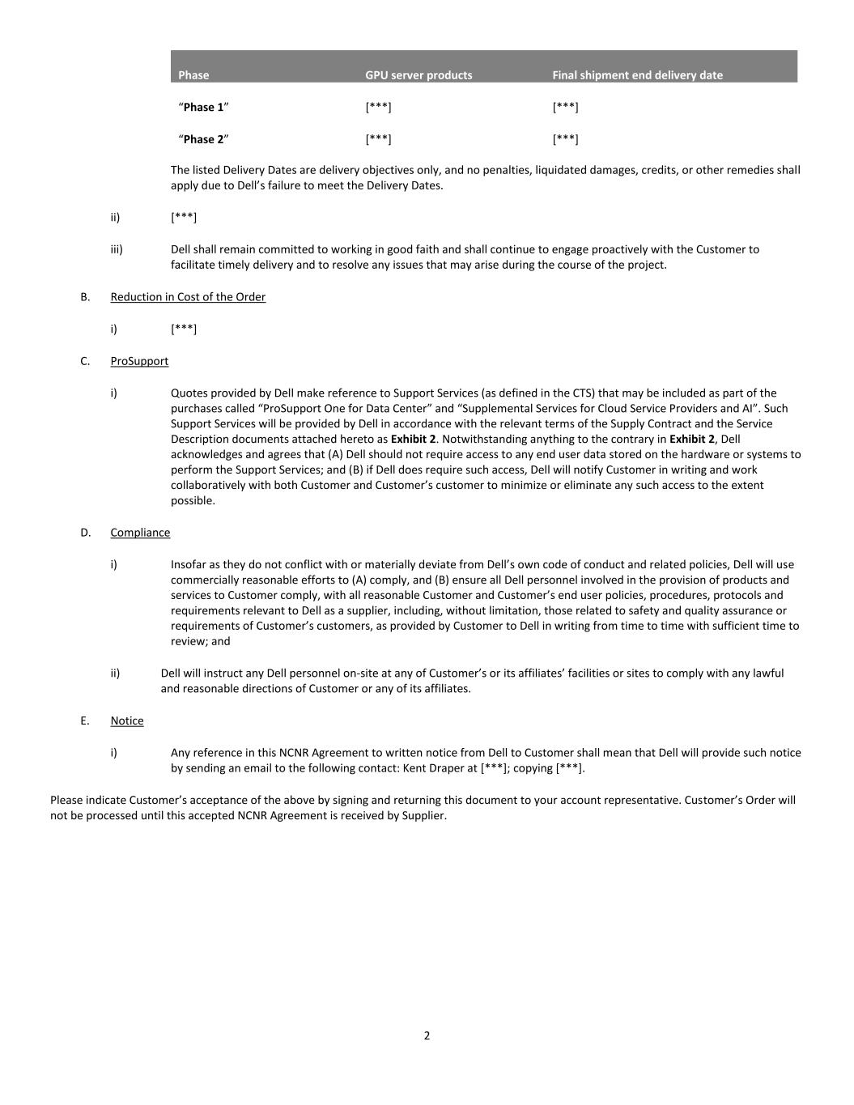
2 Phase GPU server products Final shipment end delivery date “Phase 1” [***] [***] “Phase 2” [***] [***] The listed Delivery Dates are delivery objectives only, and no penalties, liquidated damages, credits, or other remedies shall apply due to Dell’s failure to meet the Delivery Dates. ii) [***] iii) Dell shall remain committed to working in good faith and shall continue to engage proactively with the Customer to facilitate timely delivery and to resolve any issues that may arise during the course of the project. B. Reduction in Cost of the Order i) [***] C. ProSupport i) Quotes provided by Dell make reference to Support Services (as defined in the CTS) that may be included as part of the purchases called “ProSupport One for Data Center” and “Supplemental Services for Cloud Service Providers and AI”. Such Support Services will be provided by Dell in accordance with the relevant terms of the Supply Contract and the Service Description documents attached hereto as Exhibit 2. Notwithstanding anything to the contrary in Exhibit 2, Dell acknowledges and agrees that (A) Dell should not require access to any end user data stored on the hardware or systems to perform the Support Services; and (B) if Dell does require such access, Dell will notify Customer in writing and work collaboratively with both Customer and Customer’s customer to minimize or eliminate any such access to the extent possible. D. Compliance i) Insofar as they do not conflict with or materially deviate from Dell’s own code of conduct and related policies, Dell will use commercially reasonable efforts to (A) comply, and (B) ensure all Dell personnel involved in the provision of products and services to Customer comply, with all reasonable Customer and Customer’s end user policies, procedures, protocols and requirements relevant to Dell as a supplier, including, without limitation, those related to safety and quality assurance or requirements of Customer’s customers, as provided by Customer to Dell in writing from time to time with sufficient time to review; and ii) Dell will instruct any Dell personnel on-site at any of Customer’s or its affiliates’ facilities or sites to comply with any lawful and reasonable directions of Customer or any of its affiliates. E. Notice i) Any reference in this NCNR Agreement to written notice from Dell to Customer shall mean that Dell will provide such notice by sending an email to the following contact: Kent Draper at [***]; copying [***]. Please indicate Customer’s acceptance of the above by signing and returning this document to your account representative. Customer’s Order will not be processed until this accepted NCNR Agreement is received by Supplier.

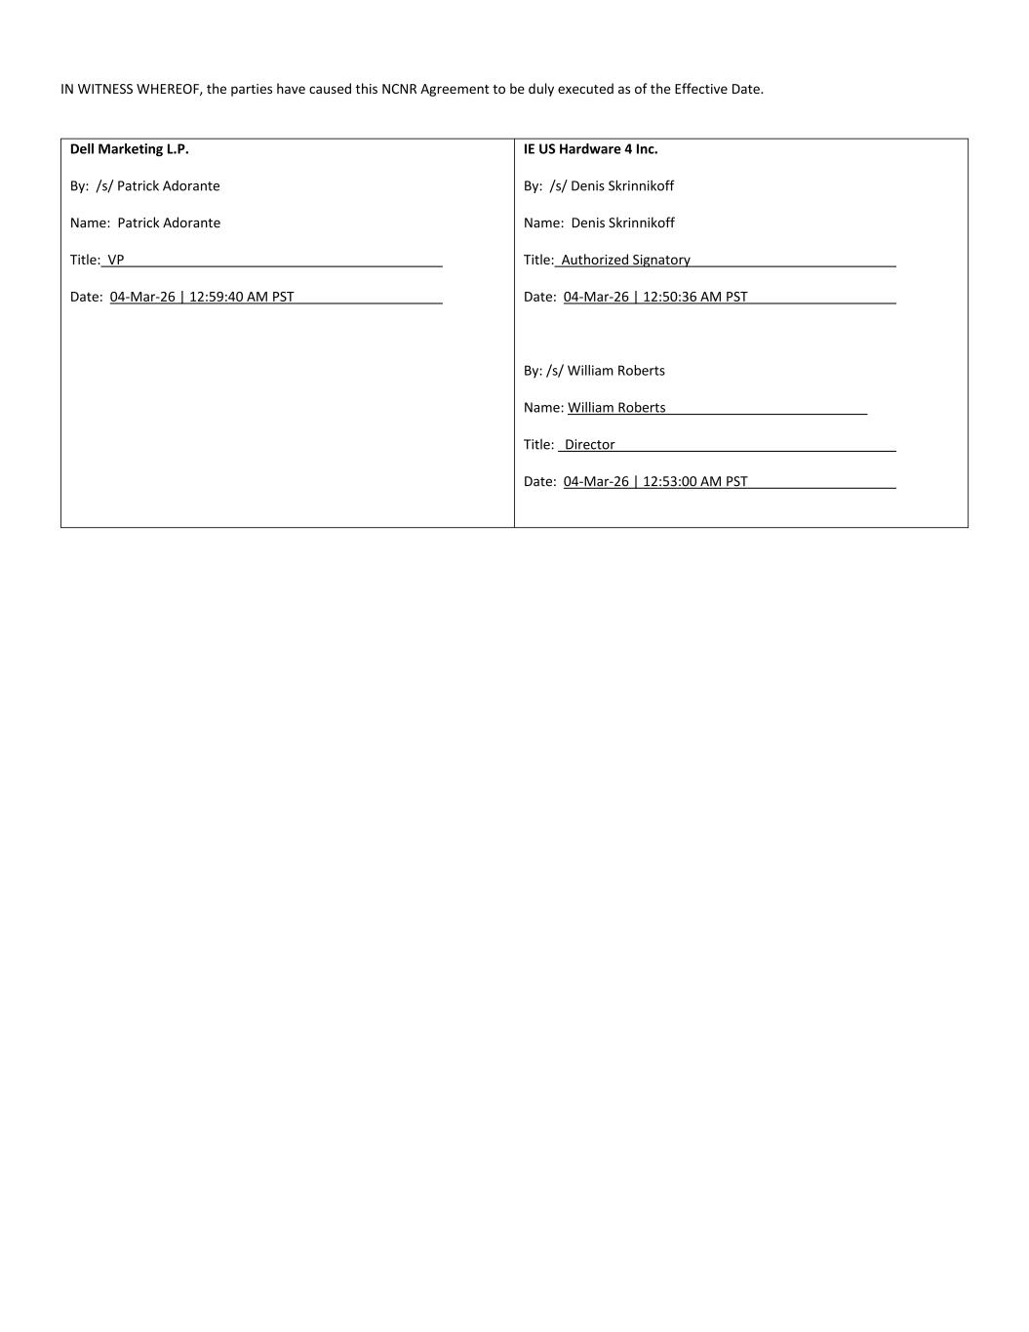
IN WITNESS WHEREOF, the parties have caused this NCNR Agreement to be duly executed as of the Effective Date. Dell Marketing L.P. By: /s/ Patrick Adorante Name: Patrick Adorante Title: VP Date: 04-Mar-26 | 12:59:40 AM PST IE US Hardware 4 Inc. By: /s/ Denis Skrinnikoff Name: Denis Skrinnikoff Title: Authorized Signatory Date: 04-Mar-26 | 12:50:36 AM PST By: /s/ William Roberts Name: William Roberts Title: Director Date: 04-Mar-26 | 12:53:00 AM PST


Dell Customer Communication - Confidential Exhibit 1 Purchase Order (CHD_DELL_B300_030326)

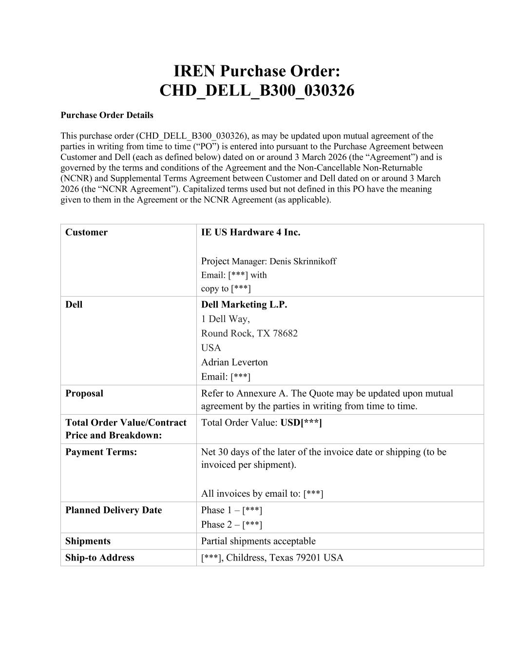
IREN Purchase Order: CHD_DELL_B300_030326 Purchase Order Details This purchase order (CHD_DELL_B300_030326), as may be updated upon mutual agreement of the parties in writing from time to time (“PO”) is entered into pursuant to the Purchase Agreement between Customer and Dell (each as defined below) dated on or around 3 March 2026 (the “Agreement”) and is governed by the terms and conditions of the Agreement and the Non-Cancellable Non-Returnable (NCNR) and Supplemental Terms Agreement between Customer and Dell dated on or around 3 March 2026 (the “NCNR Agreement”). Capitalized terms used but not defined in this PO have the meaning given to them in the Agreement or the NCNR Agreement (as applicable). Customer IE US Hardware 4 Inc. Project Manager: Denis Skrinnikoff Email: [***] with copy to [***] Dell Dell Marketing L.P. 1 Dell Way, Round Rock, TX 78682 USA Adrian Leverton Email: [***] Proposal Refer to Annexure A. The Quote may be updated upon mutual agreement by the parties in writing from time to time. Total Order Value/Contract Price and Breakdown: Total Order Value: USD[***] Payment Terms: Net 30 days of the later of the invoice date or shipping (to be invoiced per shipment). All invoices by email to: [***] Planned Delivery Date Phase 1 – [***] Phase 2 – [***] Shipments Partial shipments acceptable Ship-to Address [***], Childress, Texas 79201 USA

Annexure A – Quote [***]

Exhibit 2 Support Services Description [***]

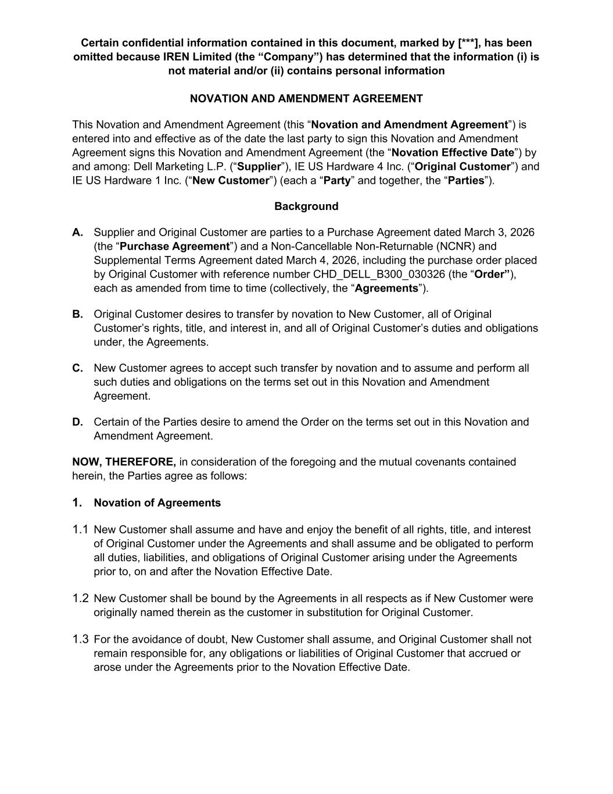
Certain confidential information contained in this document, marked by [***], has been omitted because IREN Limited (the “Company”) has determined that the information (i) is not material and/or (ii) contains personal information NOVATION AND AMENDMENT AGREEMENT This Novation and Amendment Agreement (this “Novation and Amendment Agreement”) is entered into and effective as of the date the last party to sign this Novation and Amendment Agreement signs this Novation and Amendment Agreement (the “Novation Effective Date”) by and among: Dell Marketing L.P. (“Supplier”), IE US Hardware 4 Inc. (“Original Customer”) and IE US Hardware 1 Inc. (“New Customer”) (each a “Party” and together, the “Parties”). Background A. Supplier and Original Customer are parties to a Purchase Agreement dated March 3, 2026 (the “Purchase Agreement”) and a Non-Cancellable Non-Returnable (NCNR) and Supplemental Terms Agreement dated March 4, 2026, including the purchase order placed by Original Customer with reference number CHD_DELL_B300_030326 (the “Order”), each as amended from time to time (collectively, the “Agreements”). B. Original Customer desires to transfer by novation to New Customer, all of Original Customer’s rights, title, and interest in, and all of Original Customer’s duties and obligations under, the Agreements. C. New Customer agrees to accept such transfer by novation and to assume and perform all such duties and obligations on the terms set out in this Novation and Amendment Agreement. D. Certain of the Parties desire to amend the Order on the terms set out in this Novation and Amendment Agreement. NOW, THEREFORE, in consideration of the foregoing and the mutual covenants contained herein, the Parties agree as follows: 1. Novation of Agreements 1.1 New Customer shall assume and have and enjoy the benefit of all rights, title, and interest of Original Customer under the Agreements and shall assume and be obligated to perform all duties, liabilities, and obligations of Original Customer arising under the Agreements prior to, on and after the Novation Effective Date. 1.2 New Customer shall be bound by the Agreements in all respects as if New Customer were originally named therein as the customer in substitution for Original Customer. 1.3 For the avoidance of doubt, New Customer shall assume, and Original Customer shall not remain responsible for, any obligations or liabilities of Original Customer that accrued or arose under the Agreements prior to the Novation Effective Date.

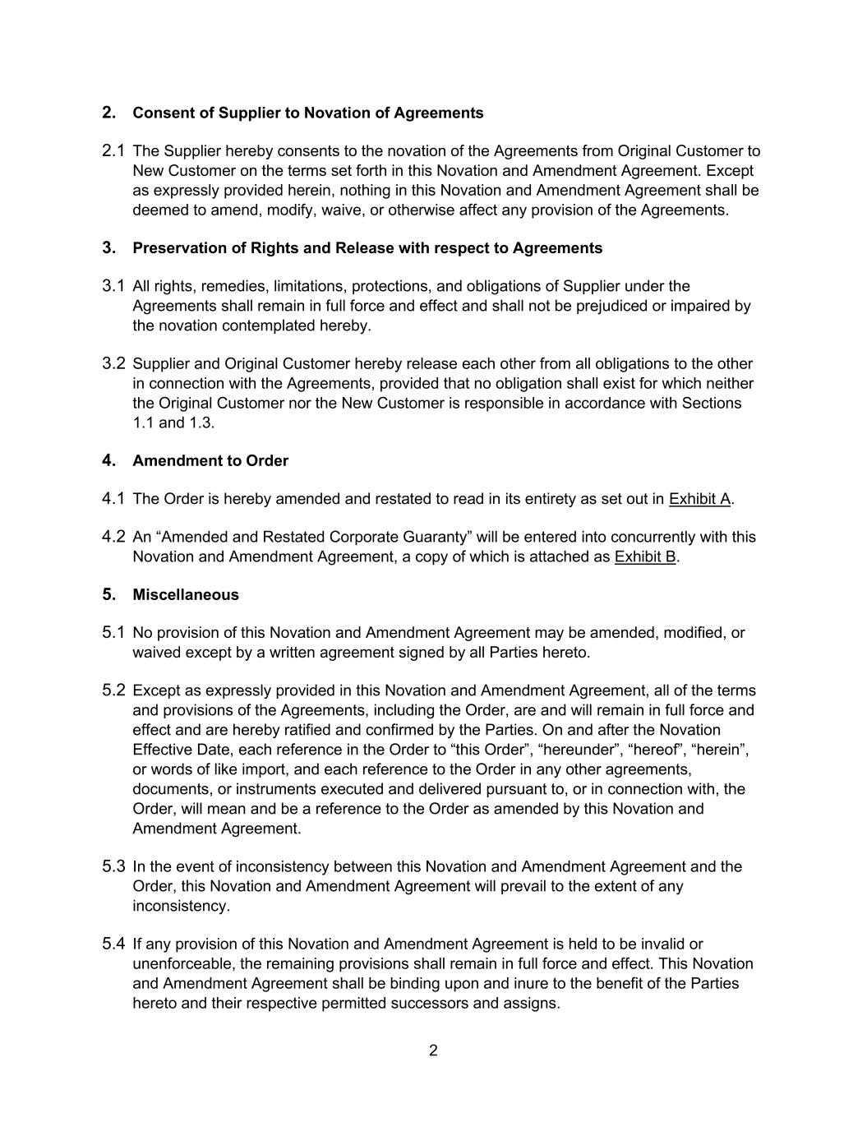
2 2. Consent of Supplier to Novation of Agreements 2.1 The Supplier hereby consents to the novation of the Agreements from Original Customer to New Customer on the terms set forth in this Novation and Amendment Agreement. Except as expressly provided herein, nothing in this Novation and Amendment Agreement shall be deemed to amend, modify, waive, or otherwise affect any provision of the Agreements. 3. Preservation of Rights and Release with respect to Agreements 3.1 All rights, remedies, limitations, protections, and obligations of Supplier under the Agreements shall remain in full force and effect and shall not be prejudiced or impaired by the novation contemplated hereby. 3.2 Supplier and Original Customer hereby release each other from all obligations to the other in connection with the Agreements, provided that no obligation shall exist for which neither the Original Customer nor the New Customer is responsible in accordance with Sections 1.1 and 1.3. 4. Amendment to Order 4.1 The Order is hereby amended and restated to read in its entirety as set out in Exhibit A. 4.2 An “Amended and Restated Corporate Guaranty” will be entered into concurrently with this Novation and Amendment Agreement, a copy of which is attached as Exhibit B. 5. Miscellaneous 5.1 No provision of this Novation and Amendment Agreement may be amended, modified, or waived except by a written agreement signed by all Parties hereto. 5.2 Except as expressly provided in this Novation and Amendment Agreement, all of the terms and provisions of the Agreements, including the Order, are and will remain in full force and effect and are hereby ratified and confirmed by the Parties. On and after the Novation Effective Date, each reference in the Order to “this Order”, “hereunder”, “hereof”, “herein”, or words of like import, and each reference to the Order in any other agreements, documents, or instruments executed and delivered pursuant to, or in connection with, the Order, will mean and be a reference to the Order as amended by this Novation and Amendment Agreement. 5.3 In the event of inconsistency between this Novation and Amendment Agreement and the Order, this Novation and Amendment Agreement will prevail to the extent of any inconsistency. 5.4 If any provision of this Novation and Amendment Agreement is held to be invalid or unenforceable, the remaining provisions shall remain in full force and effect. This Novation and Amendment Agreement shall be binding upon and inure to the benefit of the Parties hereto and their respective permitted successors and assigns.

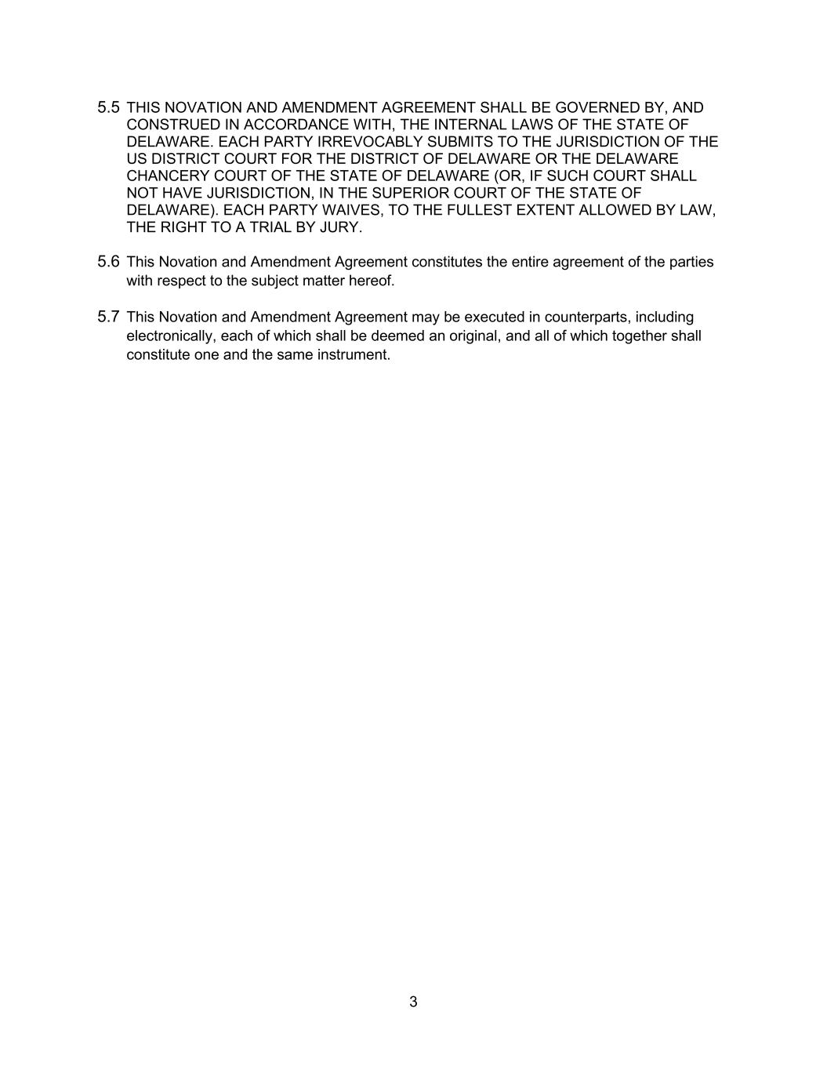
3 5.5 THIS NOVATION AND AMENDMENT AGREEMENT SHALL BE GOVERNED BY, AND CONSTRUED IN ACCORDANCE WITH, THE INTERNAL LAWS OF THE STATE OF DELAWARE. EACH PARTY IRREVOCABLY SUBMITS TO THE JURISDICTION OF THE US DISTRICT COURT FOR THE DISTRICT OF DELAWARE OR THE DELAWARE CHANCERY COURT OF THE STATE OF DELAWARE (OR, IF SUCH COURT SHALL NOT HAVE JURISDICTION, IN THE SUPERIOR COURT OF THE STATE OF DELAWARE). EACH PARTY WAIVES, TO THE FULLEST EXTENT ALLOWED BY LAW, THE RIGHT TO A TRIAL BY JURY. 5.6 This Novation and Amendment Agreement constitutes the entire agreement of the parties with respect to the subject matter hereof. 5.7 This Novation and Amendment Agreement may be executed in counterparts, including electronically, each of which shall be deemed an original, and all of which together shall constitute one and the same instrument.

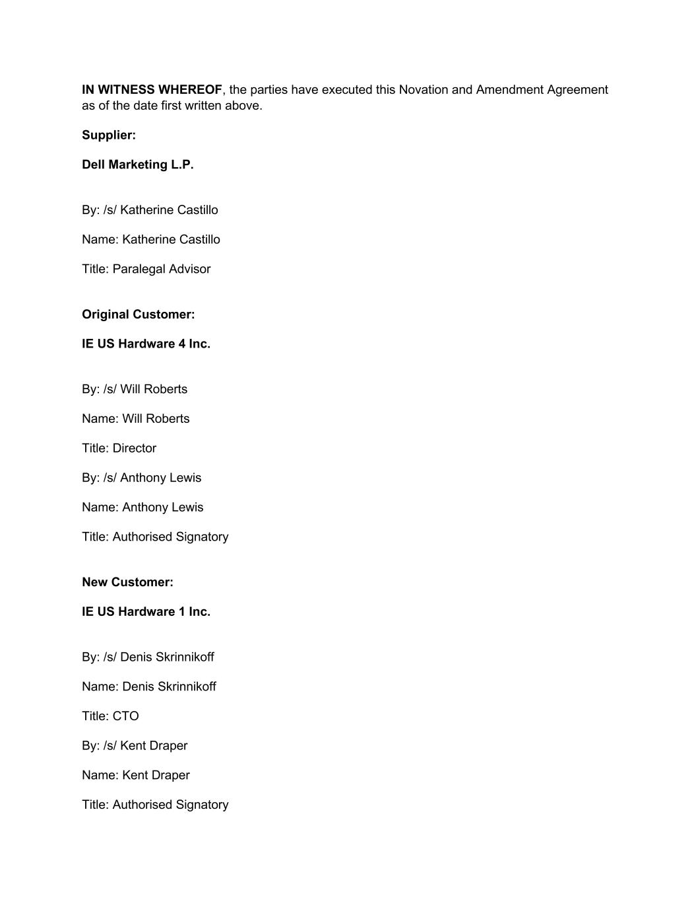
IN WITNESS WHEREOF, the parties have executed this Novation and Amendment Agreement as of the date first written above. Supplier: Dell Marketing L.P. By: /s/ Katherine Castillo Name: Katherine Castillo Title: Paralegal Advisor Original Customer: IE US Hardware 4 Inc. By: /s/ Will Roberts Name: Will Roberts Title: Director By: /s/ Anthony Lewis Name: Anthony Lewis Title: Authorised Signatory New Customer: IE US Hardware 1 Inc. By: /s/ Denis Skrinnikoff Name: Denis Skrinnikoff Title: CTO By: /s/ Kent Draper Name: Kent Draper Title: Authorised Signatory


Exhibit A – Amended and Restated Order

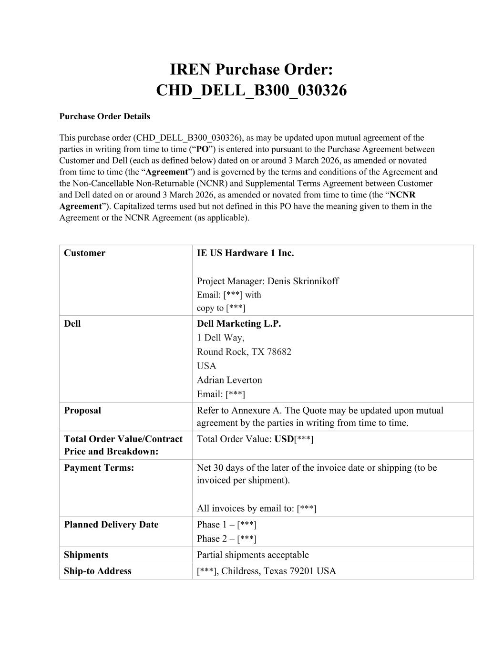
IREN Purchase Order: CHD_DELL_B300_030326 Purchase Order Details This purchase order (CHD_DELL_B300_030326), as may be updated upon mutual agreement of the parties in writing from time to time (“PO”) is entered into pursuant to the Purchase Agreement between Customer and Dell (each as defined below) dated on or around 3 March 2026, as amended or novated from time to time (the “Agreement”) and is governed by the terms and conditions of the Agreement and the Non-Cancellable Non-Returnable (NCNR) and Supplemental Terms Agreement between Customer and Dell dated on or around 3 March 2026, as amended or novated from time to time (the “NCNR Agreement”). Capitalized terms used but not defined in this PO have the meaning given to them in the Agreement or the NCNR Agreement (as applicable). Customer IE US Hardware 1 Inc. Project Manager: Denis Skrinnikoff Email: [***] with copy to [***] Dell Dell Marketing L.P. 1 Dell Way, Round Rock, TX 78682 USA Adrian Leverton Email: [***] Proposal Refer to Annexure A. The Quote may be updated upon mutual agreement by the parties in writing from time to time. Total Order Value/Contract Price and Breakdown: Total Order Value: USD[***] Payment Terms: Net 30 days of the later of the invoice date or shipping (to be invoiced per shipment). All invoices by email to: [***] Planned Delivery Date Phase 1 – [***] Phase 2 – [***] Shipments Partial shipments acceptable Ship-to Address [***], Childress, Texas 79201 USA

Annexure A – Quote [***]


Exhibit B – Amended and Restated Corporate Guaranty [***]

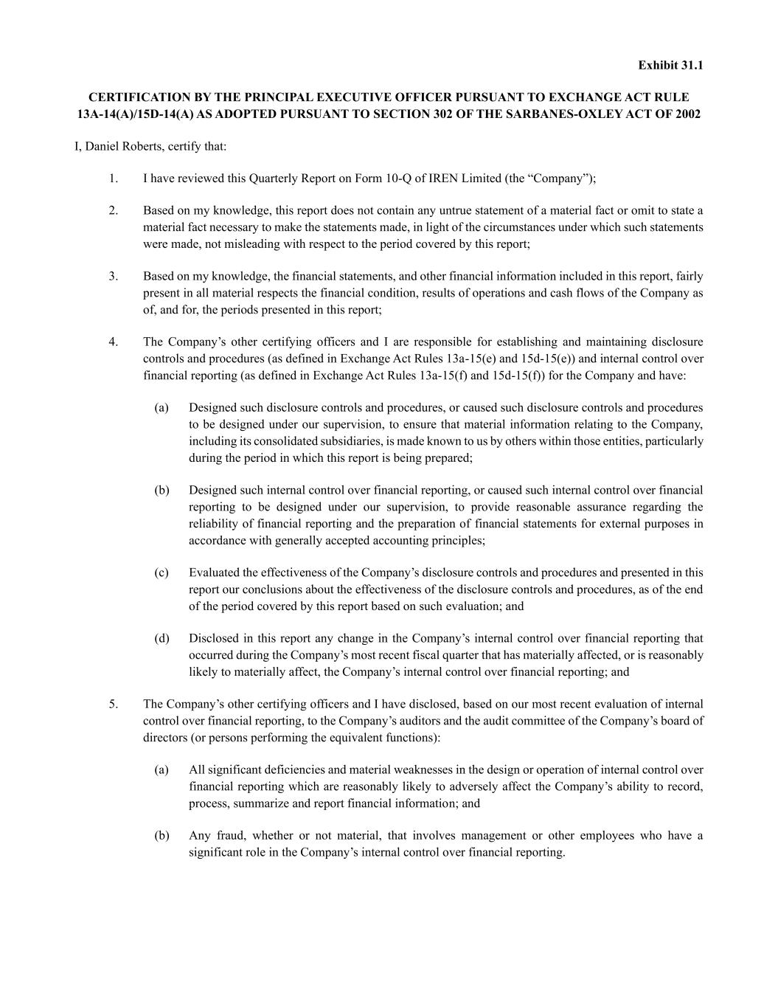
Exhibit 31.1 CERTIFICATION BY THE PRINCIPAL EXECUTIVE OFFICER PURSUANT TO EXCHANGE ACT RULE 13A-14(A)/15D-14(A) AS ADOPTED PURSUANT TO SECTION 302 OF THE SARBANES-OXLEY ACT OF 2002 I, Daniel Roberts, certify that: 1. I have reviewed this Quarterly Report on Form 10-Q of IREN Limited (the “Company”); 2. Based on my knowledge, this report does not contain any untrue statement of a material fact or omit to state a material fact necessary to make the statements made, in light of the circumstances under which such statements were made, not misleading with respect to the period covered by this report; 3. Based on my knowledge, the financial statements, and other financial information included in this report, fairly present in all material respects the financial condition, results of operations and cash flows of the Company as of, and for, the periods presented in this report; 4. The Company’s other certifying officers and I are responsible for establishing and maintaining disclosure controls and procedures (as defined in Exchange Act Rules 13a-15(e) and 15d-15(e)) and internal control over financial reporting (as defined in Exchange Act Rules 13a-15(f) and 15d-15(f)) for the Company and have: (a) Designed such disclosure controls and procedures, or caused such disclosure controls and procedures to be designed under our supervision, to ensure that material information relating to the Company, including its consolidated subsidiaries, is made known to us by others within those entities, particularly during the period in which this report is being prepared; (b) Designed such internal control over financial reporting, or caused such internal control over financial reporting to be designed under our supervision, to provide reasonable assurance regarding the reliability of financial reporting and the preparation of financial statements for external purposes in accordance with generally accepted accounting principles; (c) Evaluated the effectiveness of the Company’s disclosure controls and procedures and presented in this report our conclusions about the effectiveness of the disclosure controls and procedures, as of the end of the period covered by this report based on such evaluation; and (d) Disclosed in this report any change in the Company’s internal control over financial reporting that occurred during the Company’s most recent fiscal quarter that has materially affected, or is reasonably likely to materially affect, the Company’s internal control over financial reporting; and 5. The Company’s other certifying officers and I have disclosed, based on our most recent evaluation of internal control over financial reporting, to the Company’s auditors and the audit committee of the Company’s board of directors (or persons performing the equivalent functions): (a) All significant deficiencies and material weaknesses in the design or operation of internal control over financial reporting which are reasonably likely to adversely affect the Company’s ability to record, process, summarize and report financial information; and (b) Any fraud, whether or not material, that involves management or other employees who have a significant role in the Company’s internal control over financial reporting.


Date: May 7, 2026 /s/ Daniel Roberts Signature Co-Chief Executive Officer Title

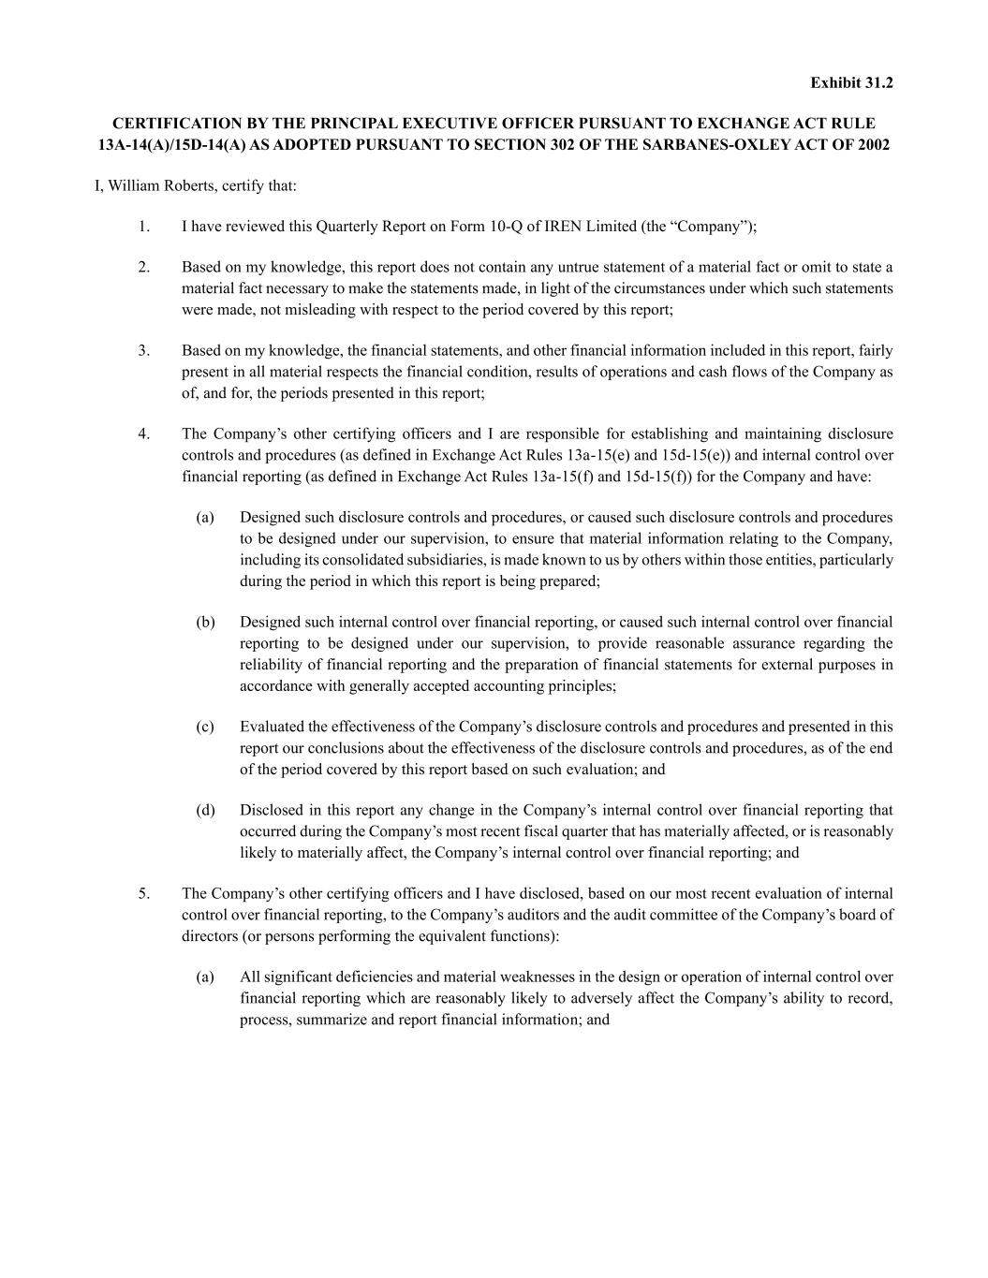
Exhibit 31.2 CERTIFICATION BY THE PRINCIPAL EXECUTIVE OFFICER PURSUANT TO EXCHANGE ACT RULE 13A-14(A)/15D-14(A) AS ADOPTED PURSUANT TO SECTION 302 OF THE SARBANES-OXLEY ACT OF 2002 I, William Roberts, certify that: 1. I have reviewed this Quarterly Report on Form 10-Q of IREN Limited (the “Company”); 2. Based on my knowledge, this report does not contain any untrue statement of a material fact or omit to state a material fact necessary to make the statements made, in light of the circumstances under which such statements were made, not misleading with respect to the period covered by this report; 3. Based on my knowledge, the financial statements, and other financial information included in this report, fairly present in all material respects the financial condition, results of operations and cash flows of the Company as of, and for, the periods presented in this report; 4. The Company’s other certifying officers and I are responsible for establishing and maintaining disclosure controls and procedures (as defined in Exchange Act Rules 13a-15(e) and 15d-15(e)) and internal control over financial reporting (as defined in Exchange Act Rules 13a-15(f) and 15d-15(f)) for the Company and have: (a) Designed such disclosure controls and procedures, or caused such disclosure controls and procedures to be designed under our supervision, to ensure that material information relating to the Company, including its consolidated subsidiaries, is made known to us by others within those entities, particularly during the period in which this report is being prepared; (b) Designed such internal control over financial reporting, or caused such internal control over financial reporting to be designed under our supervision, to provide reasonable assurance regarding the reliability of financial reporting and the preparation of financial statements for external purposes in accordance with generally accepted accounting principles; (c) Evaluated the effectiveness of the Company’s disclosure controls and procedures and presented in this report our conclusions about the effectiveness of the disclosure controls and procedures, as of the end of the period covered by this report based on such evaluation; and (d) Disclosed in this report any change in the Company’s internal control over financial reporting that occurred during the Company’s most recent fiscal quarter that has materially affected, or is reasonably likely to materially affect, the Company’s internal control over financial reporting; and 5. The Company’s other certifying officers and I have disclosed, based on our most recent evaluation of internal control over financial reporting, to the Company’s auditors and the audit committee of the Company’s board of directors (or persons performing the equivalent functions): (a) All significant deficiencies and material weaknesses in the design or operation of internal control over financial reporting which are reasonably likely to adversely affect the Company’s ability to record, process, summarize and report financial information; and


(b) Any fraud, whether or not material, that involves management or other employees who have a significant role in the Company’s internal control over financial reporting. Date: May 7, 2026 /s/ William Roberts Signature Co-Chief Executive Officer Title

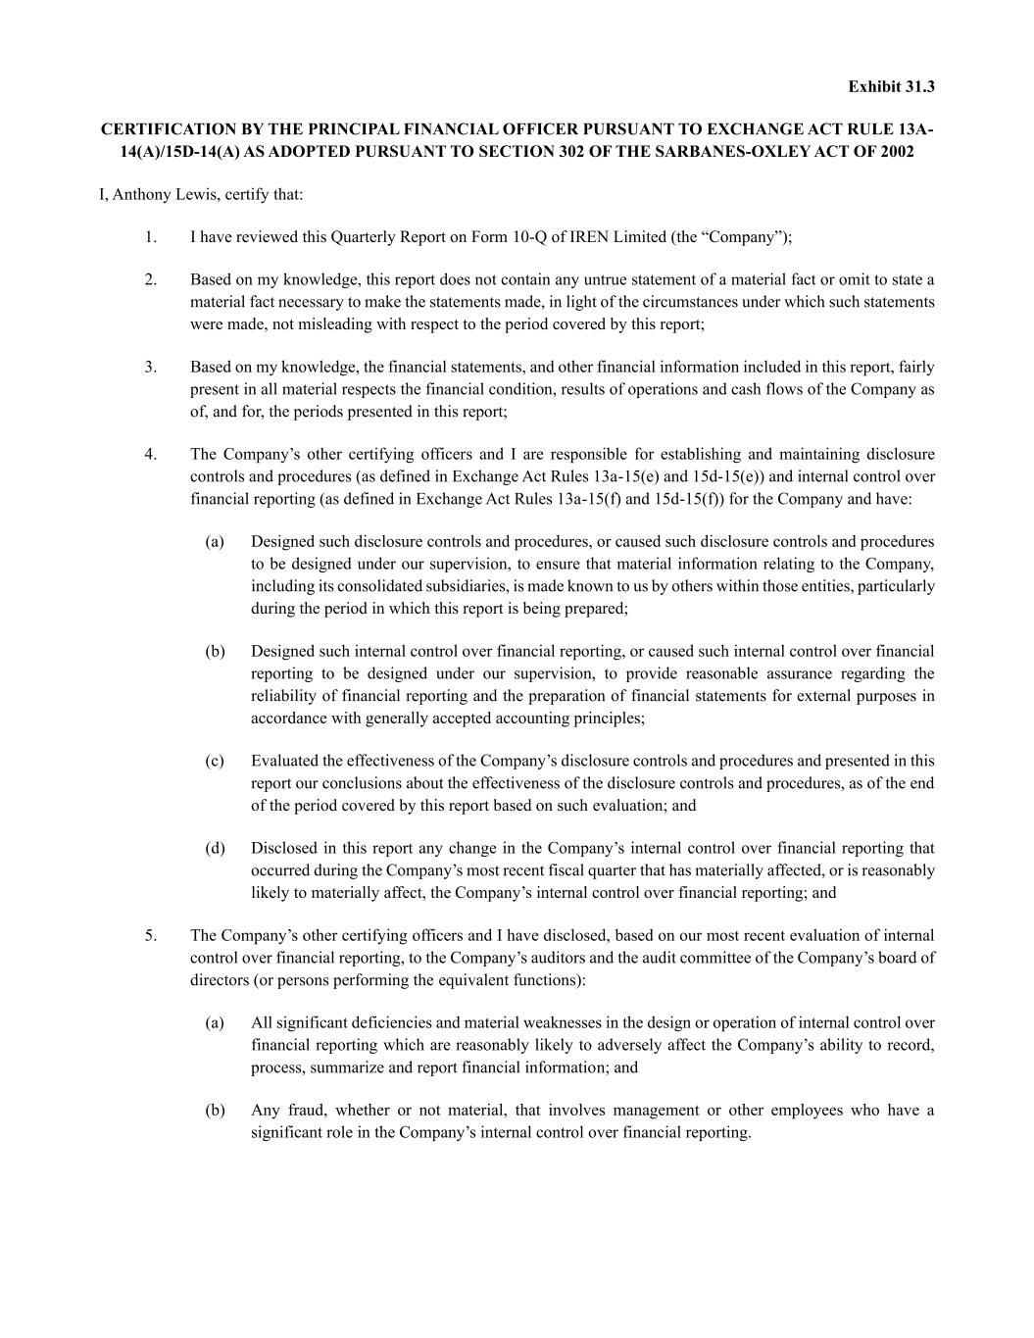
Exhibit 31.3 CERTIFICATION BY THE PRINCIPAL FINANCIAL OFFICER PURSUANT TO EXCHANGE ACT RULE 13A- 14(A)/15D-14(A) AS ADOPTED PURSUANT TO SECTION 302 OF THE SARBANES-OXLEY ACT OF 2002 I, Anthony Lewis, certify that: 1. I have reviewed this Quarterly Report on Form 10-Q of IREN Limited (the “Company”); 2. Based on my knowledge, this report does not contain any untrue statement of a material fact or omit to state a material fact necessary to make the statements made, in light of the circumstances under which such statements were made, not misleading with respect to the period covered by this report; 3. Based on my knowledge, the financial statements, and other financial information included in this report, fairly present in all material respects the financial condition, results of operations and cash flows of the Company as of, and for, the periods presented in this report; 4. The Company’s other certifying officers and I are responsible for establishing and maintaining disclosure controls and procedures (as defined in Exchange Act Rules 13a-15(e) and 15d-15(e)) and internal control over financial reporting (as defined in Exchange Act Rules 13a-15(f) and 15d-15(f)) for the Company and have: (a) Designed such disclosure controls and procedures, or caused such disclosure controls and procedures to be designed under our supervision, to ensure that material information relating to the Company, including its consolidated subsidiaries, is made known to us by others within those entities, particularly during the period in which this report is being prepared; (b) Designed such internal control over financial reporting, or caused such internal control over financial reporting to be designed under our supervision, to provide reasonable assurance regarding the reliability of financial reporting and the preparation of financial statements for external purposes in accordance with generally accepted accounting principles; (c) Evaluated the effectiveness of the Company’s disclosure controls and procedures and presented in this report our conclusions about the effectiveness of the disclosure controls and procedures, as of the end of the period covered by this report based on such evaluation; and (d) Disclosed in this report any change in the Company’s internal control over financial reporting that occurred during the Company’s most recent fiscal quarter that has materially affected, or is reasonably likely to materially affect, the Company’s internal control over financial reporting; and 5. The Company’s other certifying officers and I have disclosed, based on our most recent evaluation of internal control over financial reporting, to the Company’s auditors and the audit committee of the Company’s board of directors (or persons performing the equivalent functions): (a) All significant deficiencies and material weaknesses in the design or operation of internal control over financial reporting which are reasonably likely to adversely affect the Company’s ability to record, process, summarize and report financial information; and (b) Any fraud, whether or not material, that involves management or other employees who have a significant role in the Company’s internal control over financial reporting.


Date: May 7, 2026 /s/ Anthony Lewis Signature Chief Financial Officer Title

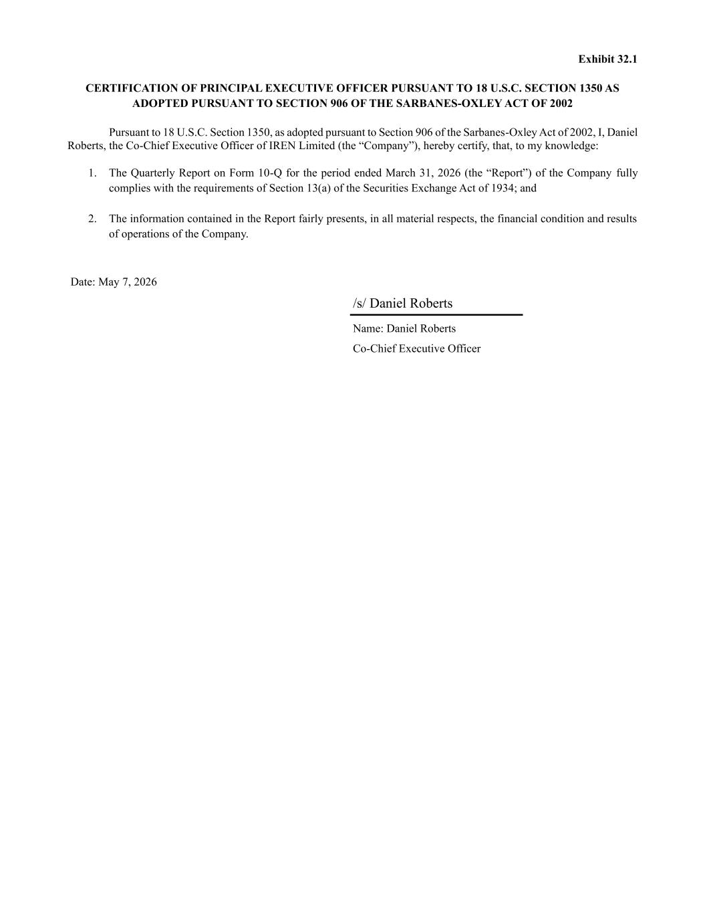
Exhibit 32.1 CERTIFICATION OF PRINCIPAL EXECUTIVE OFFICER PURSUANT TO 18 U.S.C. SECTION 1350 AS ADOPTED PURSUANT TO SECTION 906 OF THE SARBANES-OXLEY ACT OF 2002 Pursuant to 18 U.S.C. Section 1350, as adopted pursuant to Section 906 of the Sarbanes-Oxley Act of 2002, I, Daniel Roberts, the Co-Chief Executive Officer of IREN Limited (the “Company”), hereby certify, that, to my knowledge: 1. The Quarterly Report on Form 10-Q for the period ended March 31, 2026 (the “Report”) of the Company fully complies with the requirements of Section 13(a) of the Securities Exchange Act of 1934; and 2. The information contained in the Report fairly presents, in all material respects, the financial condition and results of operations of the Company. Date: May 7, 2026 /s/ Daniel Roberts Name: Daniel Roberts Co-Chief Executive Officer

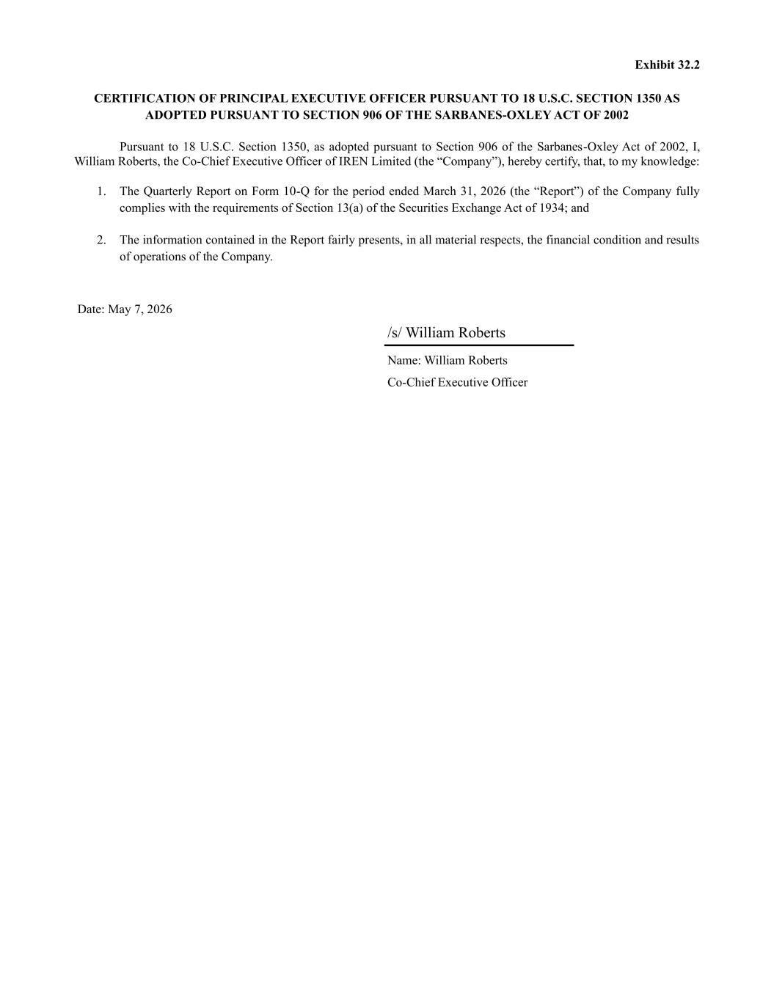
Exhibit 32.2 CERTIFICATION OF PRINCIPAL EXECUTIVE OFFICER PURSUANT TO 18 U.S.C. SECTION 1350 AS ADOPTED PURSUANT TO SECTION 906 OF THE SARBANES-OXLEY ACT OF 2002 Pursuant to 18 U.S.C. Section 1350, as adopted pursuant to Section 906 of the Sarbanes-Oxley Act of 2002, I, William Roberts, the Co-Chief Executive Officer of IREN Limited (the “Company”), hereby certify, that, to my knowledge: 1. The Quarterly Report on Form 10-Q for the period ended March 31, 2026 (the “Report”) of the Company fully complies with the requirements of Section 13(a) of the Securities Exchange Act of 1934; and 2. The information contained in the Report fairly presents, in all material respects, the financial condition and results of operations of the Company. Date: May 7, 2026 /s/ William Roberts Name: William Roberts Co-Chief Executive Officer

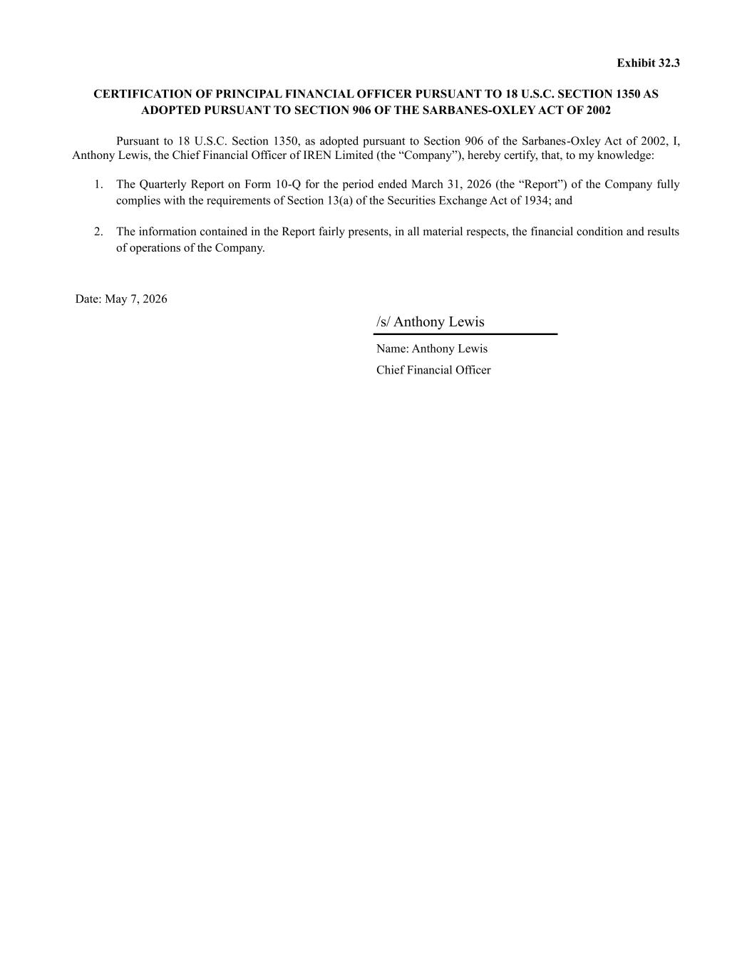
Exhibit 32.3 CERTIFICATION OF PRINCIPAL FINANCIAL OFFICER PURSUANT TO 18 U.S.C. SECTION 1350 AS ADOPTED PURSUANT TO SECTION 906 OF THE SARBANES-OXLEY ACT OF 2002 Pursuant to 18 U.S.C. Section 1350, as adopted pursuant to Section 906 of the Sarbanes-Oxley Act of 2002, I, Anthony Lewis, the Chief Financial Officer of IREN Limited (the “Company”), hereby certify, that, to my knowledge: 1. The Quarterly Report on Form 10-Q for the period ended March 31, 2026 (the “Report”) of the Company fully complies with the requirements of Section 13(a) of the Securities Exchange Act of 1934; and 2. The information contained in the Report fairly presents, in all material respects, the financial condition and results of operations of the Company. Date: May 7, 2026 /s/ Anthony Lewis Name: Anthony Lewis Chief Financial Officer

