UNITED STATES
SECURITIES AND EXCHANGE COMMISSION
Washington, D.C. 20549
Form 8-K
CURRENT REPORT
Pursuant to Section 13 or 15(d) of the Securities Exchange Act of 1934
Date of Report (Date of earliest event reported): May 07, 2026
IREN LIMITED
(Exact name of registrant as specified in its charter)
Commission File Number: 001-41072

Australia |  |  |  |  |  | Not Applicable
(State or other jurisdiction of  incorporation) |  |  |  |  |  | (IRS Employer  Identification No.)
Level 5, 55 Market Street, Sydney, NSW 2000 Australia
(Address of principal executive offices, including zip code)
+61 2 7906 8301
(Registrant’s telephone number, including area code)
(Former name or former address, if changed since last report)
Check the appropriate box below if the Form 8-K filing is intended to simultaneously satisfy the filing obligation of the registrant under any of the following provisions:
☐ |  |  | Written communications pursuant to Rule 425 under the Securities Act (17 CFR 230.425)
☐ |  |  | Soliciting material pursuant to Rule 14a-12 under the Exchange Act (17 CFR 240.14a-12)
☐ |  |  | Pre-commencement communications pursuant to Rule 14d-2(b) under the Exchange Act (17 CFR 240.14d-2(b))
☐ |  |  | Pre-commencement communications pursuant to Rule 13c-4(c) under the Exchange Act (17 CFR 240.13e-4(c))
Securities Registered Pursuant to Section 12(b) of the Act:
Title of each class |  |  |  |  |  | Trading symbol(s) |  |  |  |  |  | Name of each exchange on which registered
Ordinary shares, no par value |  |  |  |  |  | IREN |  |  |  |  |  | The Nasdaq Stock Market LLC
Indicate by check mark whether the registrant is an emerging growth company as defined in Rule 405 of the Securities Act of 1933 (§230.405 of this chapter) or Rule 12b-2 of the Securities Exchange Act of 1934 (§240.12b-2 of this chapter).
Emerging growth company ☐
If an emerging growth company, indicate by check mark if the registrant has elected not to use the extended transition period for complying with any new or revised financial accounting standards provided pursuant to Section 13(a) of the Exchange Act. ☐

Item 2.02 |  |  | Results of Operations and Financial Condition.
On May 7, 2026, IREN Limited (the “Company”) reported its financial results for the three months ended March 31, 2026. A copy of the related press release is furnished herewith as Exhibit 99.1 and is incorporated herein by reference.
The information contained in this Item 2.02 and Exhibit 99.1 attached hereto shall not be deemed to be “filed” for purposes of Section 18 of the Securities Exchange Act of 1934, as amended (the “Exchange Act”), or otherwise subject to the liabilities of that section, nor shall it be deemed incorporated by reference in any filing under the Securities Act of 1933, as amended, or the Exchange Act, except as shall be expressly set forth by specific reference in such filing.
Item 9.01 |  |  | Financial Statements and Exhibits.
Item 9.01(d) |  |  | Exhibits
Exhibit No. |  |  |  |  |  | Description
99.1 |  |  |  |  |  | Press Release, dated May 7, 2026, issued by IREN Limited.
104 |  |  |  |  |  | Cover Page Interactive Data File (embedded within the Inline XBRL document)

SIGNATURES
Pursuant to the requirements of the Securities Exchange Act of 1934, the registrant has duly caused this report to be signed on its behalf by the undersigned hereunto duly authorized.
IREN LIMITED
By: |  |  | /s/ Daniel Roberts
Daniel Roberts
Co-Chief Executive Officer and Director
Date: 7 May 2026
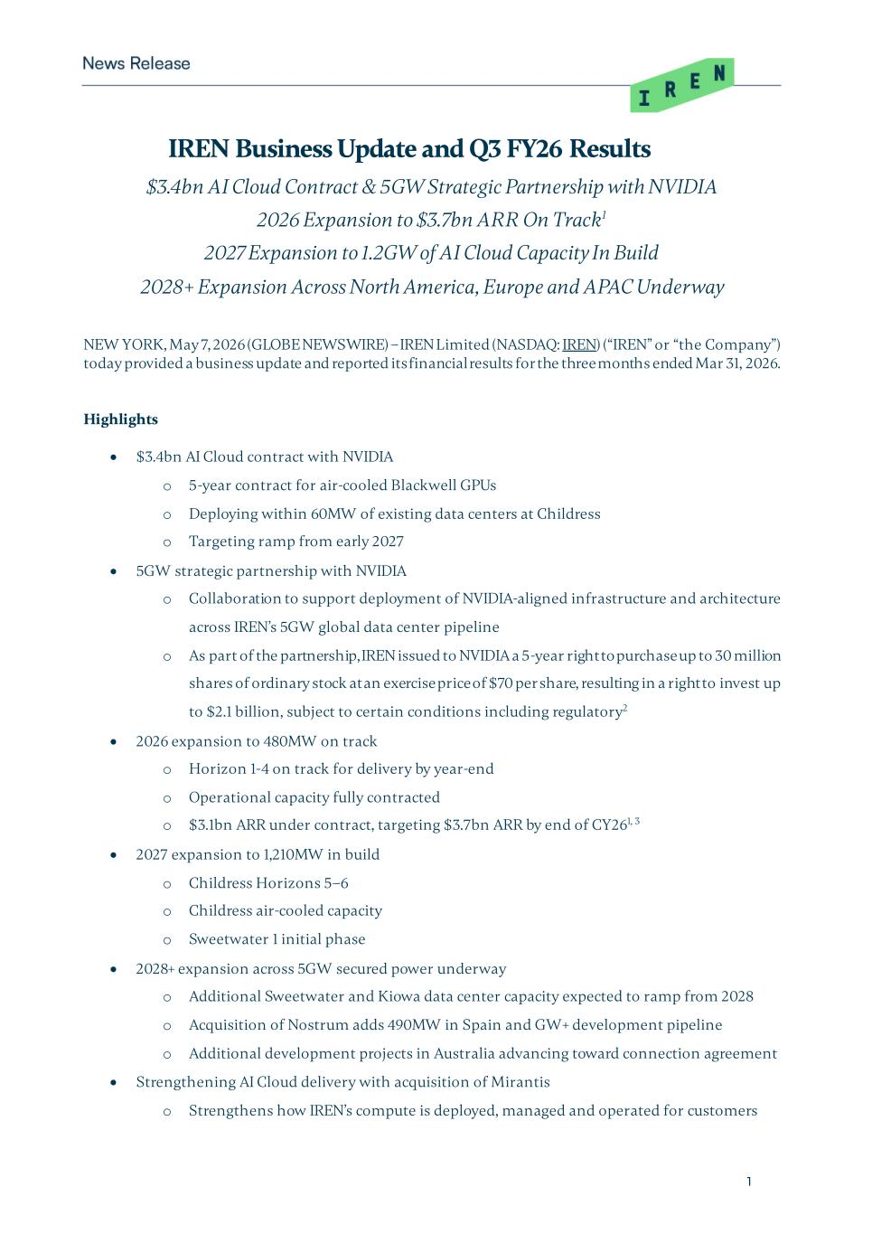

1 IREN Business Update and Q3 FY26 Results $3.4bn AI Cloud Contract & 5GW Strategic Partnership with NVIDIA 2026 Expansion to $3.7bn ARR On Track1 2027 Expansion to 1.2GW of AI Cloud Capacity In Build 2028+ Expansion Across North America, Europe and APAC Underway NEW YORK, May 7, 2026 (GLOBE NEWSWIRE) – IREN Limited (NASDAQ: IREN) (“IREN” or “the Company”) today provided a business update and reported its financial results for the three months ended Mar 31, 2026. Highlights • $3.4bn AI Cloud contract with NVIDIA o 5-year contract for air-cooled Blackwell GPUs o Deploying within 60MW of existing data centers at Childress o Targeting ramp from early 2027 • 5GW strategic partnership with NVIDIA o Collaboration to support deployment of NVIDIA-aligned infrastructure and architecture across IREN’s 5GW global data center pipeline o As part of the partnership, IREN issued to NVIDIA a 5-year right to purchase up to 30 million shares of ordinary stock at an exercise price of $70 per share, resulting in a right to invest up to $2.1 billion, subject to certain conditions including regulatory2 • 2026 expansion to 480MW on track o Horizon 1-4 on track for delivery by year-end o Operational capacity fully contracted o $3.1bn ARR under contract, targeting $3.7bn ARR by end of CY261, 3 • 2027 expansion to 1,210MW in build o Childress Horizons 5–6 o Childress air-cooled capacity o Sweetwater 1 initial phase • 2028+ expansion across 5GW secured power underway o Additional Sweetwater and Kiowa data center capacity expected to ramp from 2028 o Acquisition of Nostrum adds 490MW in Spain and GW+ development pipeline o Additional development projects in Australia advancing toward connection agreement • Strengthening AI Cloud delivery with acquisition of Mirantis o Strengthens how IREN’s compute is deployed, managed and operated for customers

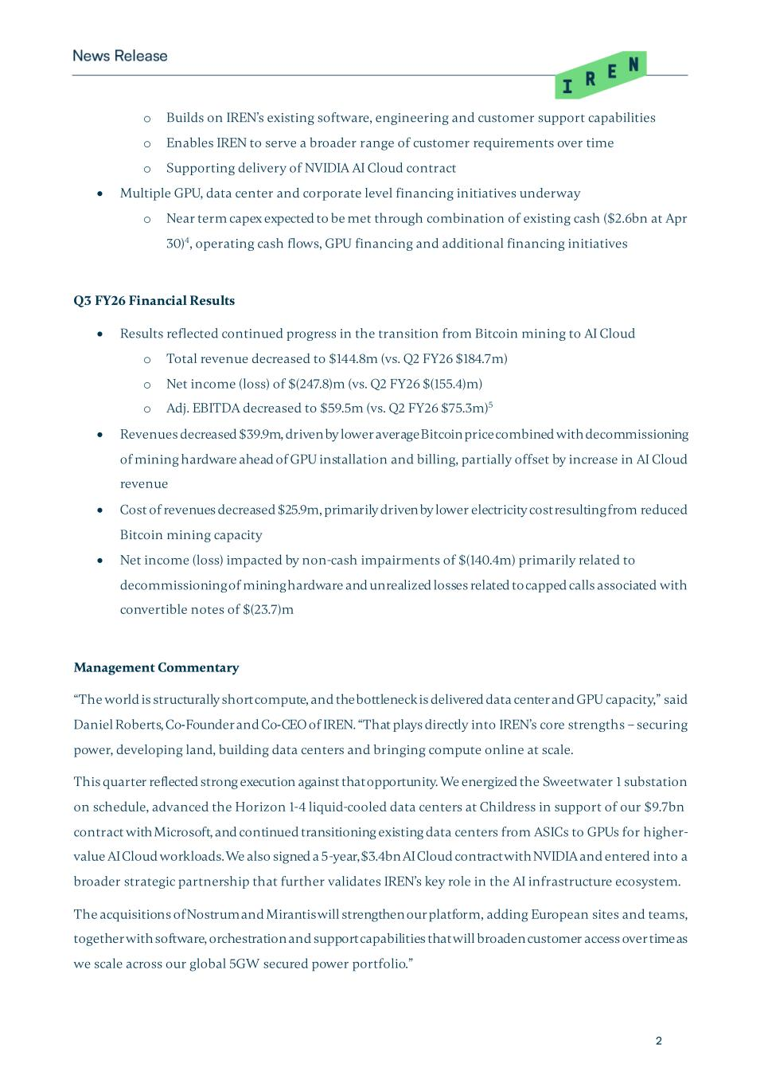
2 o Builds on IREN’s existing software, engineering and customer support capabilities o Enables IREN to serve a broader range of customer requirements over time o Supporting delivery of NVIDIA AI Cloud contract • Multiple GPU, data center and corporate level financing initiatives underway o Near term capex expected to be met through combination of existing cash ($2.6bn at Apr 30)4, operating cash flows, GPU financing and additional financing initiatives Q3 FY26 Financial Results • Results reflected continued progress in the transition from Bitcoin mining to AI Cloud o Total revenue decreased to $144.8m (vs. Q2 FY26 $184.7m) o Net income (loss) of $(247.8)m (vs. Q2 FY26 $(155.4)m) o Adj. EBITDA decreased to $59.5m (vs. Q2 FY26 $75.3m)5 • Revenues decreased $39.9m, driven by lower average Bitcoin price combined with decommissioning of mining hardware ahead of GPU installation and billing, partially offset by increase in AI Cloud revenue • Cost of revenues decreased $25.9m, primarily driven by lower electricity cost resulting from reduced Bitcoin mining capacity • Net income (loss) impacted by non-cash impairments of $(140.4m) primarily related to decommissioning of mining hardware and unrealized losses related to capped calls associated with convertible notes of $(23.7)m Management Commentary “The world is structurally short compute, and the bottleneck is delivered data center and GPU capacity,” said Daniel Roberts, Co-Founder and Co-CEO of IREN. “That plays directly into IREN’s core strengths – securing power, developing land, building data centers and bringing compute online at scale. This quarter reflected strong execution against that opportunity. We energized the Sweetwater 1 substation on schedule, advanced the Horizon 1-4 liquid-cooled data centers at Childress in support of our $9.7bn contract with Microsoft, and continued transitioning existing data centers from ASICs to GPUs for higher- value AI Cloud workloads. We also signed a 5-year, $3.4bn AI Cloud contract with NVIDIA and entered into a broader strategic partnership that further validates IREN’s key role in the AI infrastructure ecosystem. The acquisitions of Nostrum and Mirantis will strengthen our platform, adding European sites and teams, together with software, orchestration and support capabilities that will broaden customer access over time as we scale across our global 5GW secured power portfolio.”

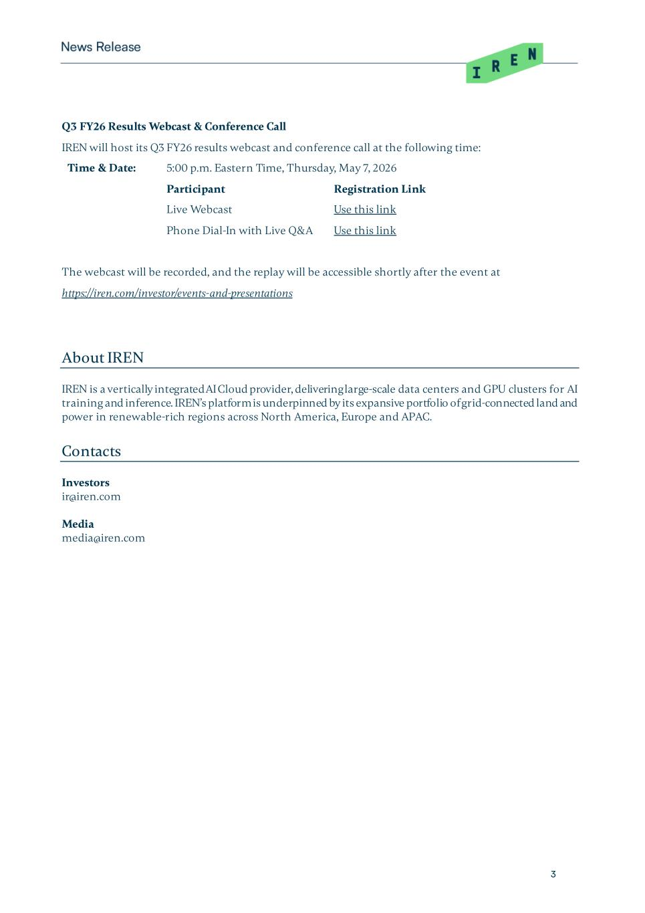
3 Q3 FY26 Results Webcast & Conference Call IREN will host its Q3 FY26 results webcast and conference call at the following time: Time & Date: 5:00 p.m. Eastern Time, Thursday, May 7, 2026 Participant Registration Link Live Webcast Use this link Phone Dial-In with Live Q&A Use this link The webcast will be recorded, and the replay will be accessible shortly after the event at https://iren.com/investor/events-and-presentations About IREN IREN is a vertically integrated AI Cloud provider, delivering large-scale data centers and GPU clusters for AI training and inference. IREN’s platform is underpinned by its expansive portfolio of grid-connected land and power in renewable-rich regions across North America, Europe and APAC. Contacts Investors ir@iren.com Media media@iren.com

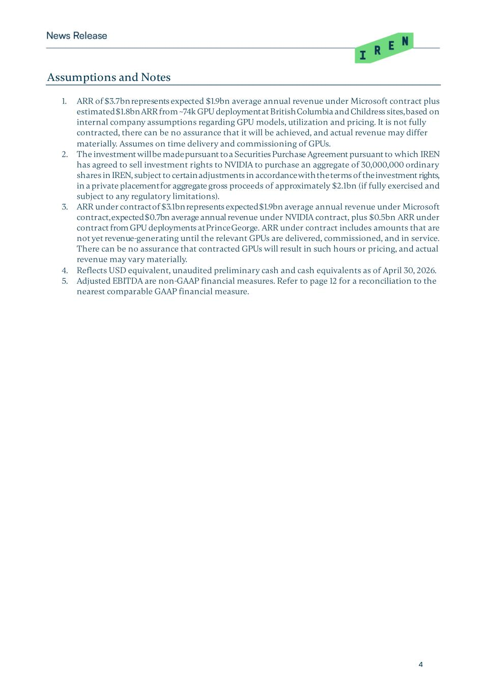
4 Assumptions and Notes 1. ARR of $3.7bn represents expected $1.9bn average annual revenue under Microsoft contract plus estimated $1.8bn ARR from ~74k GPU deployment at British Columbia and Childress sites, based on internal company assumptions regarding GPU models, utilization and pricing. It is not fully contracted, there can be no assurance that it will be achieved, and actual revenue may differ materially. Assumes on time delivery and commissioning of GPUs. 2. The investment will be made pursuant to a Securities Purchase Agreement pursuant to which IREN has agreed to sell investment rights to NVIDIA to purchase an aggregate of 30,000,000 ordinary shares in IREN, subject to certain adjustments in accordance with the terms of the investment rights, in a private placement for aggregate gross proceeds of approximately $2.1bn (if fully exercised and subject to any regulatory limitations). 3. ARR under contract of $3.1bn represents expected $1.9bn average annual revenue under Microsoft contract, expected $0.7bn average annual revenue under NVIDIA contract, plus $0.5bn ARR under contract from GPU deployments at Prince George. ARR under contract includes amounts that are not yet revenue-generating until the relevant GPUs are delivered, commissioned, and in service. There can be no assurance that contracted GPUs will result in such hours or pricing, and actual revenue may vary materially. 4. Reflects USD equivalent, unaudited preliminary cash and cash equivalents as of April 30, 2026. 5. Adjusted EBITDA are non-GAAP financial measures. Refer to page 12 for a reconciliation to the nearest comparable GAAP financial measure.

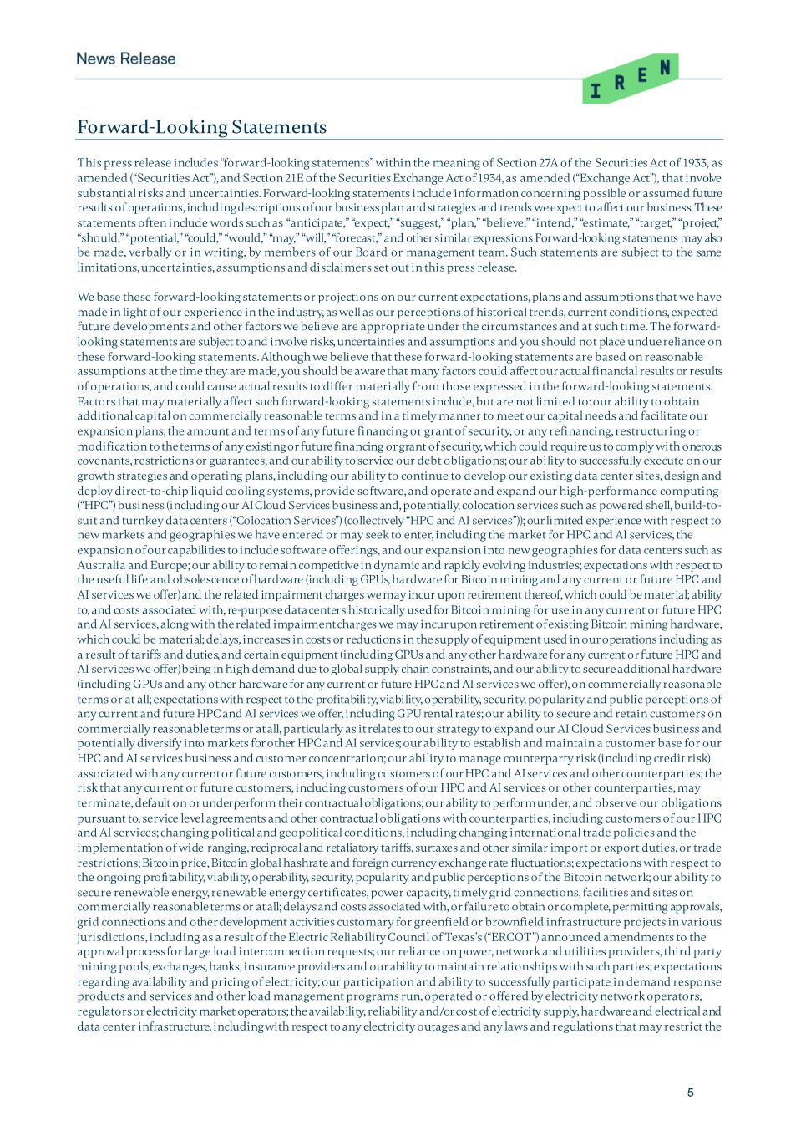
5 Forward-Looking Statements This press release includes “forward-looking statements” within the meaning of Section 27A of the Securities Act of 1933, as amended (“Securities Act”), and Section 21E of the Securities Exchange Act of 1934, as amended (“Exchange Act”), that involve substantial risks and uncertainties. Forward-looking statements include information concerning possible or assumed future results of operations, including descriptions of our business plan and strategies and trends we expect to affect our business. These statements often include words such as “anticipate,” “expect,” “suggest,” “plan,” “believe,” “intend,” “estimate,” “target,” “project,” “should,” “potential,” “could,” “would,” “may,” “will,” “forecast,” and other similar expressions Forward-looking statements may also be made, verbally or in writing, by members of our Board or management team. Such statements are subject to the same limitations, uncertainties, assumptions and disclaimers set out in this press release. We base these forward-looking statements or projections on our current expectations, plans and assumptions that we have made in light of our experience in the industry, as well as our perceptions of historical trends, current conditions, expected future developments and other factors we believe are appropriate under the circumstances and at such time. The forward- looking statements are subject to and involve risks, uncertainties and assumptions and you should not place undue reliance on these forward-looking statements. Although we believe that these forward-looking statements are based on reasonable assumptions at the time they are made, you should be aware that many factors could affect our actual financial results or results of operations, and could cause actual results to differ materially from those expressed in the forward-looking statements. Factors that may materially affect such forward-looking statements include, but are not limited to: our ability to obtain additional capital on commercially reasonable terms and in a timely manner to meet our capital needs and facilitate our expansion plans; the amount and terms of any future financing or grant of security, or any refinancing, restructuring or modification to the terms of any existing or future financing or grant of security, which could require us to comply with onerous covenants, restrictions or guarantees, and our ability to service our debt obligations; our ability to successfully execute on our growth strategies and operating plans, including our ability to continue to develop our existing data center sites, design and deploy direct-to-chip liquid cooling systems, provide software, and operate and expand our high-performance computing (“HPC”) business (including our AI Cloud Services business and, potentially, colocation services such as powered shell, build-to- suit and turnkey data centers (“Colocation Services”) (collectively “HPC and AI services”)); our limited experience with respect to new markets and geographies we have entered or may seek to enter, including the market for HPC and AI services, the expansion of our capabilities to include software offerings, and our expansion into new geographies for data centers such as Australia and Europe; our ability to remain competitive in dynamic and rapidly evolving industries; expectations with respect to the useful life and obsolescence of hardware (including GPUs, hardware for Bitcoin mining and any current or future HPC and AI services we offer) and the related impairment charges we may incur upon retirement thereof, which could be material; ability to, and costs associated with, re-purpose data centers historically used for Bitcoin mining for use in any current or future HPC and AI services, along with the related impairment charges we may incur upon retirement of existing Bitcoin mining hardware, which could be material; delays, increases in costs or reductions in the supply of equipment used in our operations including as a result of tariffs and duties, and certain equipment (including GPUs and any other hardware for any current or future HPC and AI services we offer) being in high demand due to global supply chain constraints, and our ability to secure additional hardware (including GPUs and any other hardware for any current or future HPC and AI services we offer), on commercially reasonable terms or at all; expectations with respect to the profitability, viability, operability, security, popularity and public perceptions of any current and future HPC and AI services we offer, including GPU rental rates; our ability to secure and retain customers on commercially reasonable terms or at all, particularly as it relates to our strategy to expand our AI Cloud Services business and potentially diversify into markets for other HPC and AI services; our ability to establish and maintain a customer base for our HPC and AI services business and customer concentration; our ability to manage counterparty risk (including credit risk) associated with any current or future customers, including customers of our HPC and AI services and other counterparties; the risk that any current or future customers, including customers of our HPC and AI services or other counterparties, may terminate, default on or underperform their contractual obligations; our ability to perform under, and observe our obligations pursuant to, service level agreements and other contractual obligations with counterparties, including customers of our HPC and AI services; changing political and geopolitical conditions, including changing international trade policies and the implementation of wide-ranging, reciprocal and retaliatory tariffs, surtaxes and other similar import or export duties, or trade restrictions; Bitcoin price, Bitcoin global hashrate and foreign currency exchange rate fluctuations; expectations with respect to the ongoing profitability, viability, operability, security, popularity and public perceptions of the Bitcoin network; our ability to secure renewable energy, renewable energy certificates, power capacity, timely grid connections, facilities and sites on commercially reasonable terms or at all; delays and costs associated with, or failure to obtain or complete, permitting approvals, grid connections and other development activities customary for greenfield or brownfield infrastructure projects in various jurisdictions, including as a result of the Electric Reliability Council of Texas’s (“ERCOT”) announced amendments to the approval process for large load interconnection requests; our reliance on power, network and utilities providers, third party mining pools, exchanges, banks, insurance providers and our ability to maintain relationships with such parties; expectations regarding availability and pricing of electricity; our participation and ability to successfully participate in demand response products and services and other load management programs run, operated or offered by electricity network operators, regulators or electricity market operators; the availability, reliability and/or cost of electricity supply, hardware and electrical and data center infrastructure, including with respect to any electricity outages and any laws and regulations that may restrict the

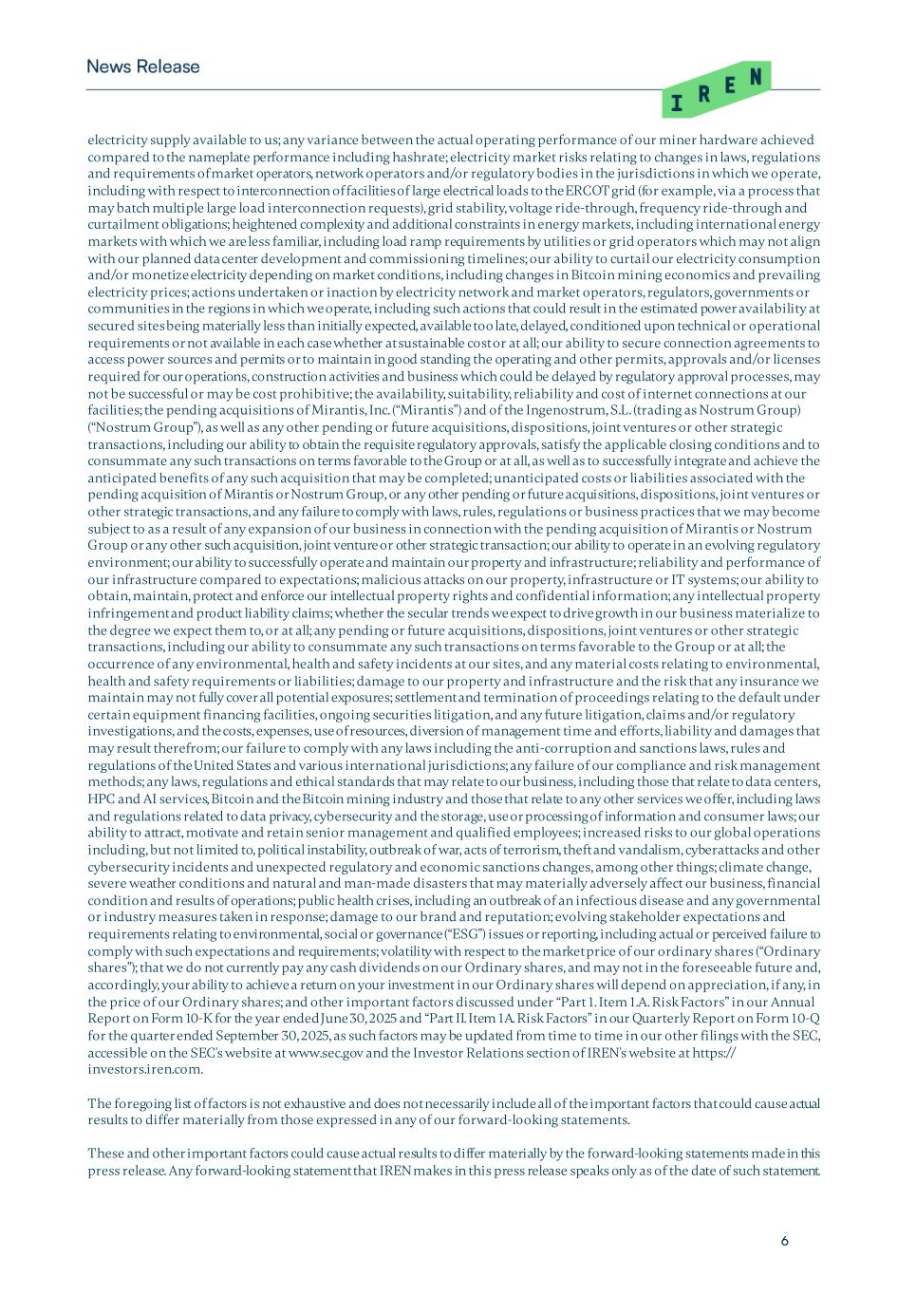
6 electricity supply available to us; any variance between the actual operating performance of our miner hardware achieved compared to the nameplate performance including hashrate; electricity market risks relating to changes in laws, regulations and requirements of market operators, network operators and/or regulatory bodies in the jurisdictions in which we operate, including with respect to interconnection of facilities of large electrical loads to the ERCOT grid (for example, via a process that may batch multiple large load interconnection requests), grid stability, voltage ride-through, frequency ride-through and curtailment obligations; heightened complexity and additional constraints in energy markets, including international energy markets with which we are less familiar, including load ramp requirements by utilities or grid operators which may not align with our planned data center development and commissioning timelines; our ability to curtail our electricity consumption and/or monetize electricity depending on market conditions, including changes in Bitcoin mining economics and prevailing electricity prices; actions undertaken or inaction by electricity network and market operators, regulators, governments or communities in the regions in which we operate, including such actions that could result in the estimated power availability at secured sites being materially less than initially expected, available too late, delayed, conditioned upon technical or operational requirements or not available in each case whether at sustainable cost or at all; our ability to secure connection agreements to access power sources and permits or to maintain in good standing the operating and other permits, approvals and/or licenses required for our operations, construction activities and business which could be delayed by regulatory approval processes, may not be successful or may be cost prohibitive; the availability, suitability, reliability and cost of internet connections at our facilities; the pending acquisitions of Mirantis, Inc. (“Mirantis”) and of the Ingenostrum, S.L. (trading as Nostrum Group) (“Nostrum Group”), as well as any other pending or future acquisitions, dispositions, joint ventures or other strategic transactions, including our ability to obtain the requisite regulatory approvals, satisfy the applicable closing conditions and to consummate any such transactions on terms favorable to the Group or at all, as well as to successfully integrate and achieve the anticipated benefits of any such acquisition that may be completed; unanticipated costs or liabilities associated with the pending acquisition of Mirantis or Nostrum Group, or any other pending or future acquisitions, dispositions, joint ventures or other strategic transactions, and any failure to comply with laws, rules, regulations or business practices that we may become subject to as a result of any expansion of our business in connection with the pending acquisition of Mirantis or Nostrum Group or any other such acquisition, joint venture or other strategic transaction; our ability to operate in an evolving regulatory environment; our ability to successfully operate and maintain our property and infrastructure; reliability and performance of our infrastructure compared to expectations; malicious attacks on our property, infrastructure or IT systems; our ability to obtain, maintain, protect and enforce our intellectual property rights and confidential information; any intellectual property infringement and product liability claims; whether the secular trends we expect to drive growth in our business materialize to the degree we expect them to, or at all; any pending or future acquisitions, dispositions, joint ventures or other strategic transactions, including our ability to consummate any such transactions on terms favorable to the Group or at all; the occurrence of any environmental, health and safety incidents at our sites, and any material costs relating to environmental, health and safety requirements or liabilities; damage to our property and infrastructure and the risk that any insurance we maintain may not fully cover all potential exposures; settlement and termination of proceedings relating to the default under certain equipment financing facilities, ongoing securities litigation, and any future litigation, claims and/or regulatory investigations, and the costs, expenses, use of resources, diversion of management time and efforts, liability and damages that may result therefrom; our failure to comply with any laws including the anti-corruption and sanctions laws, rules and regulations of the United States and various international jurisdictions; any failure of our compliance and risk management methods; any laws, regulations and ethical standards that may relate to our business, including those that relate to data centers, HPC and AI services, Bitcoin and the Bitcoin mining industry and those that relate to any other services we offer, including laws and regulations related to data privacy, cybersecurity and the storage, use or processing of information and consumer laws; our ability to attract, motivate and retain senior management and qualified employees; increased risks to our global operations including, but not limited to, political instability, outbreak of war, acts of terrorism, theft and vandalism, cyberattacks and other cybersecurity incidents and unexpected regulatory and economic sanctions changes, among other things; climate change, severe weather conditions and natural and man-made disasters that may materially adversely affect our business, financial condition and results of operations; public health crises, including an outbreak of an infectious disease and any governmental or industry measures taken in response; damage to our brand and reputation; evolving stakeholder expectations and requirements relating to environmental, social or governance (“ESG”) issues or reporting, including actual or perceived failure to comply with such expectations and requirements; volatility with respect to the market price of our ordinary shares (“Ordinary shares”); that we do not currently pay any cash dividends on our Ordinary shares, and may not in the foreseeable future and, accordingly, your ability to achieve a return on your investment in our Ordinary shares will depend on appreciation, if any, in the price of our Ordinary shares; and other important factors discussed under “Part 1. Item 1.A. Risk Factors” in our Annual Report on Form 10-K for the year ended June 30, 2025 and “Part II. Item 1A. Risk Factors” in our Quarterly Report on Form 10-Q for the quarter ended September 30, 2025, as such factors may be updated from time to time in our other filings with the SEC, accessible on the SEC's website at www.sec.gov and the Investor Relations section of IREN's website at https:// investors.iren.com. The foregoing list of factors is not exhaustive and does not necessarily include all of the important factors that could cause actual results to differ materially from those expressed in any of our forward-looking statements. These and other important factors could cause actual results to differ materially by the forward-looking statements made in this press release. Any forward-looking statement that IREN makes in this press release speaks only as of the date of such statement.

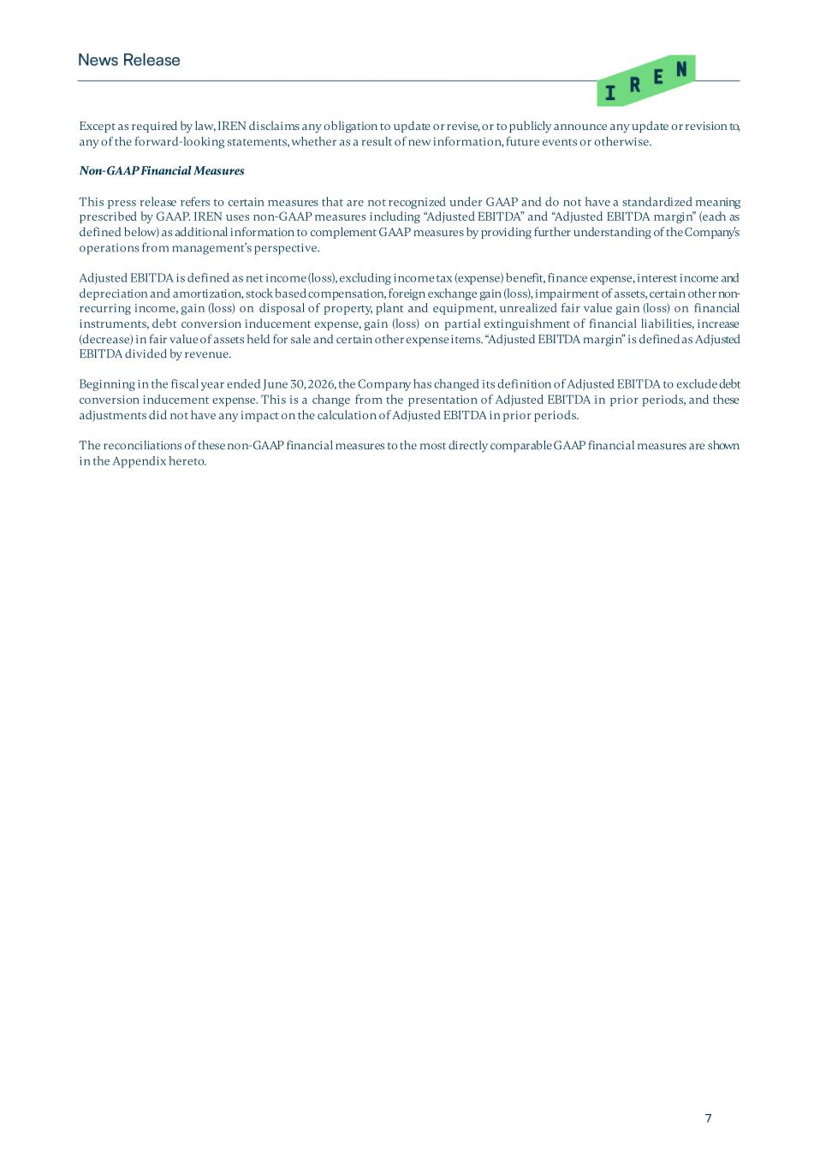
7 Except as required by law, IREN disclaims any obligation to update or revise, or to publicly announce any update or revision to, any of the forward-looking statements, whether as a result of new information, future events or otherwise. Non-GAAP Financial Measures This press release refers to certain measures that are not recognized under GAAP and do not have a standardized meaning prescribed by GAAP. IREN uses non-GAAP measures including “Adjusted EBITDA” and “Adjusted EBITDA margin” (each as defined below) as additional information to complement GAAP measures by providing further understanding of the Company’s operations from management’s perspective. Adjusted EBITDA is defined as net income (loss), excluding income tax (expense) benefit, finance expense, interest income and depreciation and amortization, stock based compensation, foreign exchange gain (loss), impairment of assets, certain other non- recurring income, gain (loss) on disposal of property, plant and equipment, unrealized fair value gain (loss) on financial instruments, debt conversion inducement expense, gain (loss) on partial extinguishment of financial liabilities, increase (decrease) in fair value of assets held for sale and certain other expense items. “Adjusted EBITDA margin” is defined as Adjusted EBITDA divided by revenue. Beginning in the fiscal year ended June 30, 2026, the Company has changed its definition of Adjusted EBITDA to exclude debt conversion inducement expense. This is a change from the presentation of Adjusted EBITDA in prior periods, and these adjustments did not have any impact on the calculation of Adjusted EBITDA in prior periods. The reconciliations of these non-GAAP financial measures to the most directly comparable GAAP financial measures are shown in the Appendix hereto.

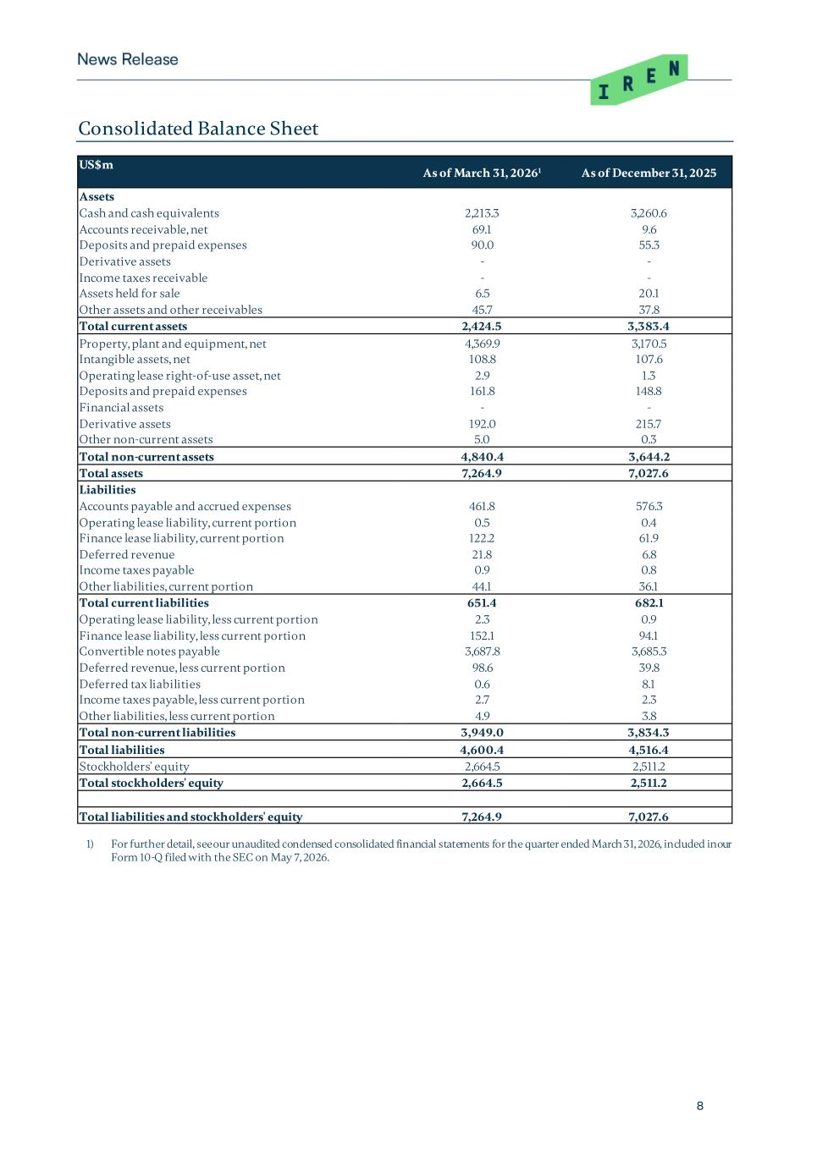
8 Consolidated Balance Sheet US$m As of March 31, 20261 As of December 31, 2025 Assets Cash and cash equivalents 2,213.3 3,260.6 Accounts receivable, net 69.1 9.6 Deposits and prepaid expenses 90.0 55.3 Derivative assets - - Income taxes receivable - - Assets held for sale 6.5 20.1 Other assets and other receivables 45.7 37.8 Total current assets 2,424.5 3,383.4 Property, plant and equipment, net 4,369.9 3,170.5 Intangible assets, net 108.8 107.6 Operating lease right-of-use asset, net 2.9 1.3 Deposits and prepaid expenses 161.8 148.8 Financial assets - - Derivative assets 192.0 215.7 Other non-current assets 5.0 0.3 Total non-current assets 4,840.4 3,644.2 Total assets 7,264.9 7,027.6 Liabilities Accounts payable and accrued expenses 461.8 576.3 Operating lease liability, current portion 0.5 0.4 Finance lease liability, current portion 122.2 61.9 Deferred revenue 21.8 6.8 Income taxes payable 0.9 0.8 Other liabilities, current portion 44.1 36.1 Total current liabilities 651.4 682.1 Operating lease liability, less current portion 2.3 0.9 Finance lease liability, less current portion 152.1 94.1 Convertible notes payable 3,687.8 3,685.3 Deferred revenue, less current portion 98.6 39.8 Deferred tax liabilities 0.6 8.1 Income taxes payable, less current portion 2.7 2.3 Other liabilities, less current portion 4.9 3.8 Total non-current liabilities 3,949.0 3,834.3 Total liabilities 4,600.4 4,516.4 Stockholders' equity 2,664.5 2,511.2 Total stockholders' equity 2,664.5 2,511.2 Total liabilities and stockholders' equity 7,264.9 7,027.6 1) For further detail, see our unaudited condensed consolidated financial statements for the quarter ended March 31, 2026, included in our Form 10-Q filed with the SEC on May 7, 2026.

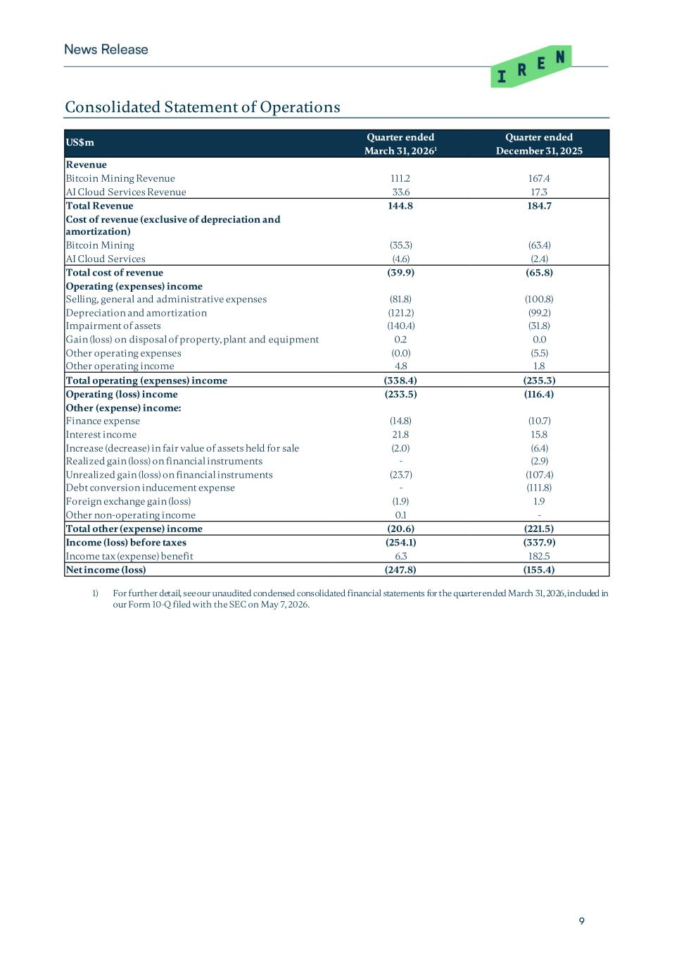
9 Consolidated Statement of Operations US$m Quarter ended Quarter ended March 31, 20261 December 31, 2025 Revenue Bitcoin Mining Revenue 111.2 167.4 AI Cloud Services Revenue 33.6 17.3 Total Revenue 144.8 184.7 Cost of revenue (exclusive of depreciation and amortization) Bitcoin Mining (35.3) (63.4) AI Cloud Services (4.6) (2.4) Total cost of revenue (39.9) (65.8) Operating (expenses) income Selling, general and administrative expenses (81.8) (100.8) Depreciation and amortization (121.2) (99.2) Impairment of assets (140.4) (31.8) Gain (loss) on disposal of property, plant and equipment 0.2 0.0 Other operating expenses (0.0) (5.5) Other operating income 4.8 1.8 Total operating (expenses) income (338.4) (235.3) Operating (loss) income (233.5) (116.4) Other (expense) income: Finance expense (14.8) (10.7) Interest income 21.8 15.8 Increase (decrease) in fair value of assets held for sale (2.0) (6.4) Realized gain (loss) on financial instruments - (2.9) Unrealized gain (loss) on financial instruments (23.7) (107.4) Debt conversion inducement expense - (111.8) Foreign exchange gain (loss) (1.9) 1.9 Other non-operating income 0.1 - Total other (expense) income (20.6) (221.5) Income (loss) before taxes (254.1) (337.9) Income tax (expense) benefit 6.3 182.5 Net income (loss) (247.8) (155.4) 1) For further detail, see our unaudited condensed consolidated financial statements for the quarter ended March 31, 2026, included in our Form 10-Q filed with the SEC on May 7, 2026.

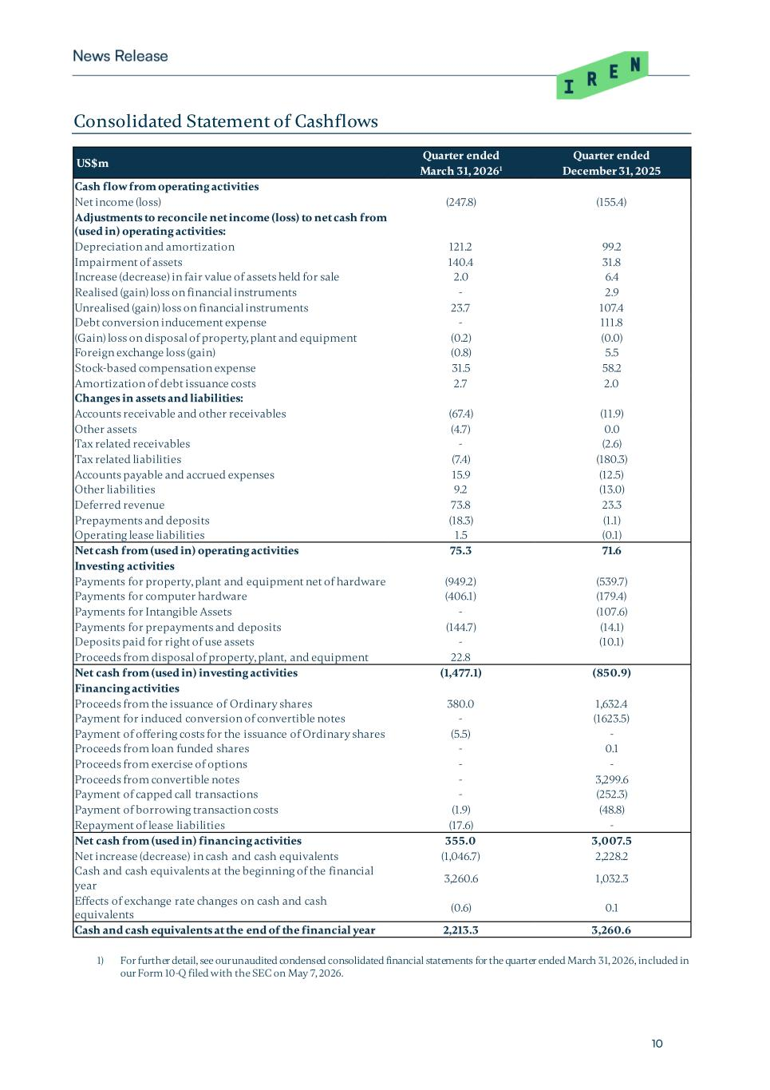
10 Consolidated Statement of Cashflows US$m Quarter ended Quarter ended March 31, 20261 December 31, 2025 Cash flow from operating activities Net income (loss) (247.8) (155.4) Adjustments to reconcile net income (loss) to net cash from (used in) operating activities: Depreciation and amortization 121.2 99.2 Impairment of assets 140.4 31.8 Increase (decrease) in fair value of assets held for sale 2.0 6.4 Realised (gain) loss on financial instruments - 2.9 Unrealised (gain) loss on financial instruments 23.7 107.4 Debt conversion inducement expense - 111.8 (Gain) loss on disposal of property, plant and equipment (0.2) (0.0) Foreign exchange loss (gain) (0.8) 5.5 Stock-based compensation expense 31.5 58.2 Amortization of debt issuance costs 2.7 2.0 Changes in assets and liabilities: Accounts receivable and other receivables (67.4) (11.9) Other assets (4.7) 0.0 Tax related receivables - (2.6) Tax related liabilities (7.4) (180.3) Accounts payable and accrued expenses 15.9 (12.5) Other liabilities 9.2 (13.0) Deferred revenue 73.8 23.3 Prepayments and deposits (18.3) (1.1) Operating lease liabilities 1.5 (0.1) Net cash from (used in) operating activities 75.3 71.6 Investing activities Payments for property, plant and equipment net of hardware (949.2) (539.7) Payments for computer hardware (406.1) (179.4) Payments for Intangible Assets - (107.6) Payments for prepayments and deposits (144.7) (14.1) Deposits paid for right of use assets - (10.1) Proceeds from disposal of property, plant, and equipment 22.8 Net cash from (used in) investing activities (1,477.1) (850.9) Financing activities Proceeds from the issuance of Ordinary shares 380.0 1,632.4 Payment for induced conversion of convertible notes - (1623.5) Payment of offering costs for the issuance of Ordinary shares (5.5) - Proceeds from loan funded shares - 0.1 Proceeds from exercise of options - - Proceeds from convertible notes - 3,299.6 Payment of capped call transactions - (252.3) Payment of borrowing transaction costs (1.9) (48.8) Repayment of lease liabilities (17.6) - Net cash from (used in) financing activities 355.0 3,007.5 Net increase (decrease) in cash and cash equivalents (1,046.7) 2,228.2 Cash and cash equivalents at the beginning of the financial year 3,260.6 1,032.3 Effects of exchange rate changes on cash and cash equivalents (0.6) 0.1 Cash and cash equivalents at the end of the financial year 2,213.3 3,260.6 1) For further detail, see our unaudited condensed consolidated financial statements for the quarter ended March 31, 2026, included in our Form 10-Q filed with the SEC on May 7, 2026.

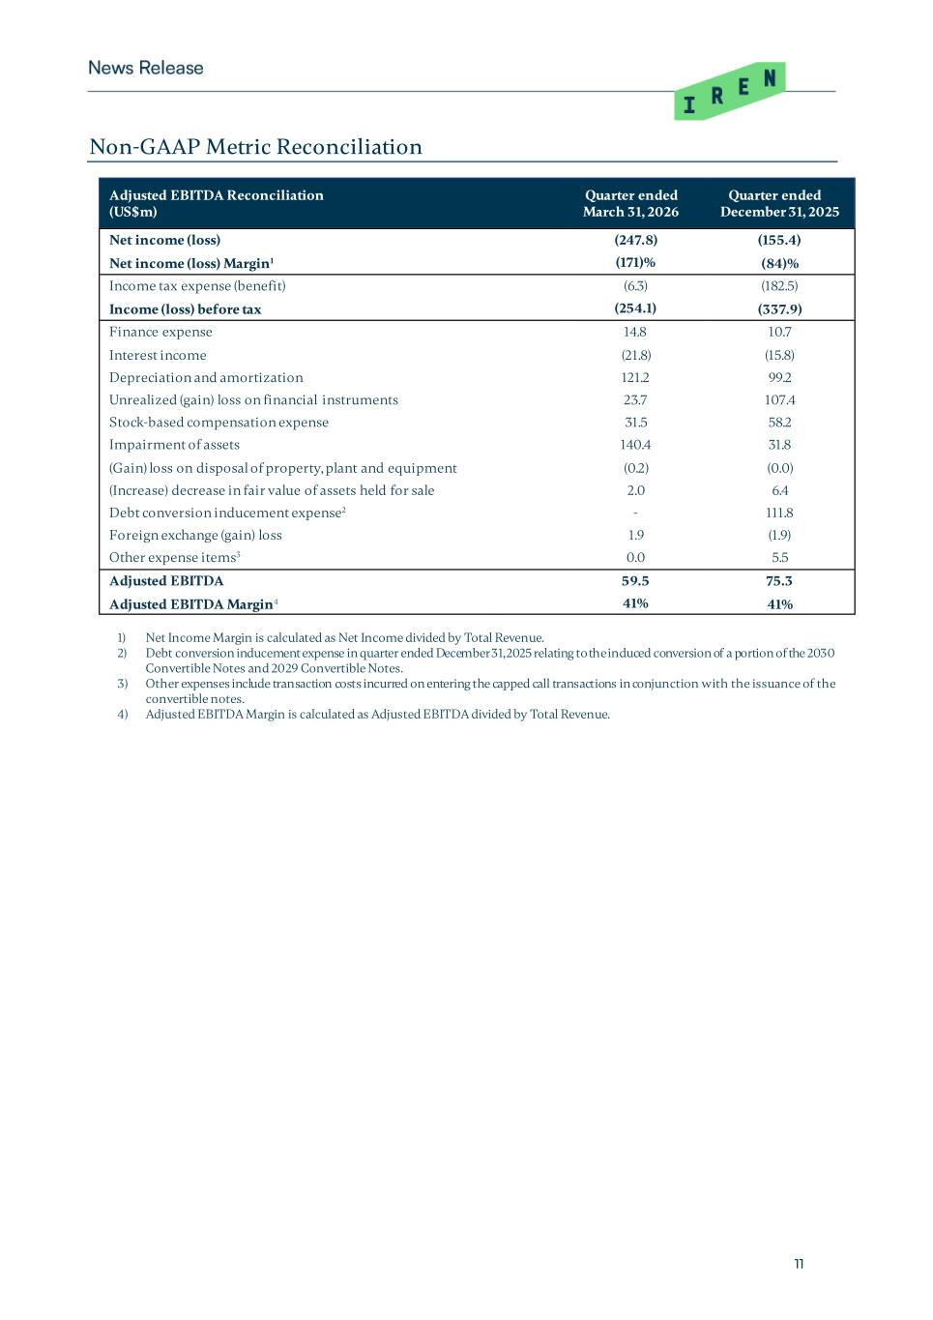
11 Non-GAAP Metric Reconciliation Adjusted EBITDA Reconciliation (US$m) Quarter ended March 31, 2026 Quarter ended December 31, 2025 Net income (loss) (247.8) (155.4) Net income (loss) Margin1 (171)% (84)% Income tax expense (benefit) (6.3) (182.5) Income (loss) before tax (254.1) (337.9) Finance expense 14.8 10.7 Interest income (21.8) (15.8) Depreciation and amortization 121.2 99.2 Unrealized (gain) loss on financial instruments 23.7 107.4 Stock-based compensation expense 31.5 58.2 Impairment of assets 140.4 31.8 (Gain) loss on disposal of property, plant and equipment (0.2) (0.0) (Increase) decrease in fair value of assets held for sale 2.0 6.4 Debt conversion inducement expense2 - 111.8 Foreign exchange (gain) loss 1.9 (1.9) Other expense items3 0.0 5.5 Adjusted EBITDA 59.5 75.3 Adjusted EBITDA Margin4 41% 41% 1) Net Income Margin is calculated as Net Income divided by Total Revenue. 2) Debt conversion inducement expense in quarter ended December 31, 2025 relating to the induced conversion of a portion of the 2030 Convertible Notes and 2029 Convertible Notes. 3) Other expenses include transaction costs incurred on entering the capped call transactions in conjunction with the issuance of the convertible notes. 4) Adjusted EBITDA Margin is calculated as Adjusted EBITDA divided by Total Revenue.

